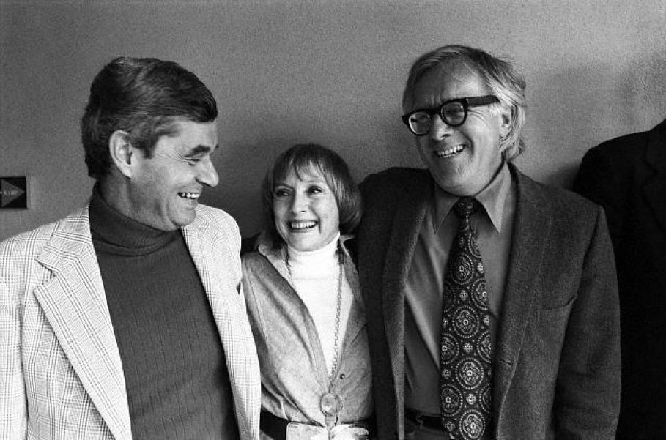

The Lake, Ray Bradbury

The Lake

THEY cut the sky down to my size and threw it over the Michigan Lake, put some kids yelling on yellow sand with bouncing balls, a gull or two, a criticizing parent, and me breaking out of a wet wave, finding this world very bleary and moist.

I ran up on the beach.

Mamma swabbed me with a furry towel. 'Stand there and dry,' she said.

I stood there, watching the sun take away the water beads on my arms. I replaced them with goose-pimples.

'My, there's a wind,' said Mamma. 'Put on your sweater.'

'Wait'll I watch my goose-bumps,' I said.

'Harold,' said Mamma.

I put the sweater on and watched the waves come up and fall down on the beach. But not clumsily. On purpose, with a green sort of elegance. Even a drunken man could not collapse with such elegance as those waves.

It was September. In the last days when things are getting sad for no reason. The beach was so long and lonely with only about six people on it. The kids quit bouncing the ball because somehow the wind made them sad, too, whistling the way it did, and the kids sat down and felt autumn come along the endless shore.

All of the hot-dog stands were boarded up with strips of golden planking, sealing in all the mustard, onion, meat odours of the long, joyful summer. It was like nailing summer into a series of coffins.

One by one the places slammed their covers down, padlocked their doors, and the wind came and touched the sand, blowing away all of the million footprints of July and August. It got so that now, in September, there was nothing but the mark of my rubber tennis shoes and Donald and Delaus Schabold's feet, down by the water curve.

Sand blew up in curtains on the sidewalks, and the merry-go-round was hidden with canvas, all of the horses frozen in mid-air on their brass poles, showing teeth, galloping on. With only the wind for music, slipping through canvas.

I stood there. Everyone else was in school. I was not. Tomorrow I would be on my way west across the United States on a train. Mom and I had come to the beach for one last brief moment.

There was something about the loneliness that made me want to get away by myself. 'Mamma, I want to run up the beach aways,' I said.

'All right, but hurry back, and don't go near the water.'

I ran. Sand spun under me and the wind lifted me. You know how it is, running, arms out so you feel veils from your fingers, caused by wind. Like wings.

Mamma withdrew into the distance, sitting. Soon she was only a brown speck and I was all alone.

Being alone is a newness to a twelve-year-old child. He is so used to people about. The only way he can be alone is in his mind. There are so many real people around, telling children what and how to do, that a boy has to run off down a beach, even if it's only in his head, to get by himself in his own world, with his own miniature values.

So now I was really alone.

I went down to the water and let it cool up to my stomach. Always before, with the crowd, I hadn't dared to look, to come to this spot and search around in the water and call a certain name. But now —

Water is like a magician. Sawing you in half. It feels as if you were cut half in two, part of you, the lower part, sugar, melting, dissolving away. Cool water, and once in a while a very elegantly stumbling wave that fell with a flourish of lace.

I called her name. A dozen times I called it.

'Tally! Tally! Oh, Tally!'

Funny, but you really expect answers to your calling when you are young. You feel that whatever you may think can be real. And sometimes maybe that is not so wrong.

I thought of Tally, swimming out into the water last May, with her pigtails trailing, blonde. She went laughing, and the sun was on her small twelve-year-old shoulders. I thought of the water settling quiet, of the life-guard leaping into it, of Tally's mother screaming, and of how Tally never came out. . .

The life-guard tried to persuade her to come out, but she did not. He came back with only bits of waterweed in his big-knuckled fingers, and Tally was gone. She would not sit across from me at school any longer, or chase indoor balls on the brick streets on summer nights. She had gone too far out, and the lake would not let her return.

And now in the lonely autumn when the sky was huge and the water was huge and the beach was so very long, I had come down for the last time, alone.

I called her name over and over. Tally, oh, Tally!

The wind blew so very softly over my ears, the way wind blows over the mouths of sea-shells to set them whispering. The water rose, embraced my chest, then my knees, up and down, one way and another, sucking under my heels.

'Tally! Come back, Tally!'

I was only twelve. But I know how much I loved her. It was that love that comes before all significance of body and morals. It was that love that is no more bad than wind and sea and sand lying side by side forever. It was made of all the warm long days together at the beach, and the humming quiet days of droning education at the school. All the long autumn days of the years past when I had carried her books home from school.

Tally!

I called her name for the last time. I shivered. I felt water on my face and did not know how it got there. The waves had not splashed that high.

Turning, I retreated to the sand and stood there for half an hour, hoping for one glimpse, one sign, one little bit of Tally to remember. Then, I knelt and built a sandcastle, shaping it fine, building it as Tally and I had often built so many of them. But this time, I only built half of it. Then I got up.

'Tally, if you hear me, come in and build the rest.'

I walked off towards that far away speck that was Mamma. The water came in, blended the sandcastle circle by circle, mashing it down little by little into the original smoothness.

Silently, I walked along the shore.

Far away, a merry-go-round jangled faintly, but it was only the wind.

The next day, I went away on the train.

A train has a poor memory; it soon puts all behind it. It forgets the cornlands of Illinois, the rivers of childhood, the bridges, the lakes, the valleys, the cottages, the hurts and the joys. It spreads them out behind and they drop behind a horizon.

I lengthened my bones, put flesh on them, changed my young mind for an older one, threw away clothes as they no longer fitted, shifted from grammar to high-school, to college books, to law books. And then there was a young woman in Sacramento. I knew her for a time, and we were married.

I continued my law study. By the time I was twenty-two, I had almost forgotten what the East was like.

Margaret suggested that our delayed honeymoon be taken back in that direction.

Like a memory, a train works both ways. A train can bring rushing back all those things you left behind so many years before.

Lake Bluff, population 10,000, came up over the sky. Margaret looked so handsome in her fine new clothes. She watched me as I felt my old world gather me back into its living. She held my arm as the train slid into Bluff Station and our baggage was escorted out.

So many years, and the things they do to people's faces and bodies. When we walked through the town together I saw no one I recognized. There were faces with echoes in them. Echoes of hikes on ravine trails.

Faces with small laughter in them from closed grammar schools and swinging on metal-linked swings and going up and down on teeter-totters. But I didn't speak. I walked and looked and filled up inside with all those memories, like leaves stacked for autumn burning.

We stayed on two weeks in all, revisiting all the places together. The days were happy. I thought I loved Margaret well. At least I thought I did.

It was on one of the last days that we walked down by the shore. It was not quite as late in the year as that day so many years before, but the first evidences of desertion were coming upon the beach. People were thinning out, several of the hot-dog stands had been shuttered and nailed, and the wind, as always, waited there to sing for us.

I almost saw Mamma sitting on the sand as she used to sit. I had that feeling again of wanting to be alone. But I could not force myself to speak of this to Margaret. I only held on to her and waited.

It got late in the day. Most of the children had gone home and only a few men and women remained basking in the windy sun.

The life-guard boat pulled up on the shore. The life-guard stepped out of it, slowly, with something in his arms.

I froze there. I held my breath and I felt small, only twelve years old, very little, very infinitesimal and afraid. The wind howled. I could not see Margaret. I could see only the beach, the life-guard slowly emerging from the boat with a grey sack in his hands, not very heavy, and his face almost as grey and lined.

'Stay here, Margaret,' I said. I don't know why I said it.

'But, why?'

'Just stay here, that's all — '

I walked slowly down the sand to where the life-guard stood. He looked at me.

'What is it?' I asked.

The life-guard kept looking at me for a long time and he couldn't speak. He put the grey sack down on the sand, and water whispered wet up around it and went back.

'What is it?' I insisted.

'She's dead,' said the life-guard, quietly.

I waited.

'Funny,' he said, softly. 'Funniest thing I ever saw. She's been dead. A long time.'

I repeated his words.

He nodded. 'Ten years, I'd say. There haven't been any children drowned here this year. There were twelve children drowned here since 1933, but we recovered all of them before a few hours had passed. All except one, I remember. This body here, why it must be ten years in the water. It's not — pleasant.'

I stared at the grey sack in his arms. 'Open it,' I said. I don't know why I said it. The wind was louder.

He fumbled with the sack. 'The way I know it's a little girl, is because she's still wearing a locket. There's nothing much else to tell by — '

'Hurry, man, open it!' I cried.

'I better not do that,' he said. Then perhaps he saw the way my face must have looked. 'She was such a little girl — '

He opened it only part way. That was enough.

The beach was deserted. There was only the sky and the wind and the water and the autumn coming on lonely. I looked down at her there.

I said something over and over. A name. The life-guard looked at me. 'Where did you find her?' I asked.

'Down the beach, that way, in the shallow water. It's a long long time for her, ain't it?'

I shook my head.

'Yes, it is. Oh God, yes it is.'

I thought: people grow. I have grown. But she has not changed. She is still small. She is still young. Death does not permit growth or change. She still has golden hair. She will be forever young and I will love her forever, oh God, I will love her forever.

The life-guard tied up the sack again.

Down the beach, a few moments later, I walked by myself. I stopped, and looked down at something. This is where the lifeguard found her, I said to myself.

There, at the water's edge, lay a sandcastle, only half-built. Just like Tally and I used to build them. She half and I half.

I looked at it, I knelt beside the sandcastle and saw the little prints of feet coming in from the lake and going back out to the lake again and not ever returning.

Then — I knew.

'I'll help you to finish it,' I said.

I did. I built the rest of it up very slowly, then I arose and turned away and walked off, so as not to watch it crumble in the waves, as all things crumble.

I walked back up the beach to where a strange woman named Margaret was waiting for me, smiling. . .

The end