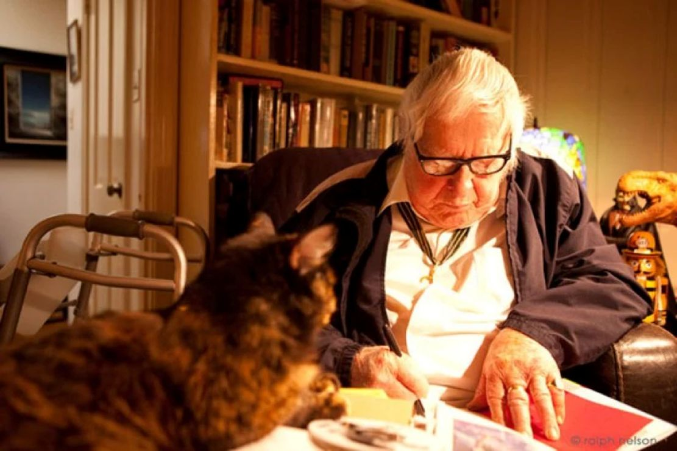

The Little Mice, Ray Bradbury

The Little Mice

‘THEY’RE very odd,’ I said. ‘The little Mexican couple.’

‘How do you mean?’ asked my wife.

"Never a sound,’ I said. ‘Listen.’

Ours was a house deep back in among tenements, to which another half-house had been added. When my wife and I purchased the house, we rented the additional quarter which lay walled up against one side of our parlour. Now, listening at this particular wall, we heard our hearts beat.

‘I know they’re home,’ I whispered. ‘But in the three years they’ve lived here I’ve never heard a dropped pan, a spoken word, or the sound of a light switch. Good God, what are they doing in there?’

‘I’d never thought,’ said my wife. ‘It is peculiar.’

‘Only one light on, that same dim little blue 25-watt bulb they burn in the parlour. If you walk by and peer in their front door, there he is, sitting in his armchair, not saying a word, his hands in his lap. There she is, sitting in the other armchair, looking at him, saying nothing. They don’t move.’

‘At first glance I always think they’re not home,’ said my wife. ‘Their parlour’s so dark. But if you stare long enough, your eyes get used to it and you can make them out, sitting there.’

‘Some day,’ I said, ‘I’m going to run in, turn on their lights, and yell! My God, if I can’t stand their silence, how can they? They can talk, can’t they?’

‘When he pays the rent each month, he says hello.’

‘What else?’

‘Good-bye.’

I shook my head. ‘When we meet in the alley he smiles and runs.’

My wife and I sat down for an evening of reading, the radio, and talk. ‘Do they have a radio?’

‘No radio, television, telephone. Not a book, magazine, or paper in their house.’

‘Ridiculous!’

‘Don’t get so excited.’

‘I know, but you can’t sit in a dark room two or three years and not speak, not listen to a radio, not read or even eat, can you? I’ve never smelled a steak, or an egg frying. Damn it, I don’t believe I’ve ever heard them go to bed!’

‘They’re doing it to mystify us, dear.’

‘They’re succeeding!’

I went for a walk around the block. It was a nice summer evening. Returning I glanced idly in their front door. The dark silence was there, and the heavy shapes, sitting, and the little blue light burning. I stood a long time, finishing my cigarette. It was only in turning to go that I saw him in the doorway, looking out with his bland, plump face. He didn’t move. He just stood there, watching me.

‘Evening,’ I said.

Silence. After a moment, he turned, moving away into the dark room.

In the morning, the little Mexican left the house at seven o’clock alone, hurrying down the alley, observing the same silence he kept in his rooms. She followed at eight o’clock, walking carefully, all lumpy under her dark coat, a black hat balanced on her frizzy, beauty parlour hair. They had gone to work this way, remote and silent, for years.

‘Where do they work?’ I asked, at breakfast.

‘He’s a blast furnaceman at U.S. Steel here. She sews in a dress loft somewhere.’

‘That’s hard work.’

I typed a few pages of my novel, read, idled, typed some more. At five in the afternoon I saw the little Mexican woman come home, unlock her door, hurry inside, hook the screen, and lock the door tight.

He arrived at six sharp, in a rush. Once on their back porch, however, he became infinitely patient. Quietly, raking his hand over the screen, lightly, like a fat mouse scrabbling, he waited. At last she let him in. I did not see their mouths move.

Not a sound during supper time. No frying. No rattle of dishes. Nothing.

I saw the small blue lamp go on.

‘That’s how he is,’ said my wife, ‘when he pays the rent. Raps so quietly I don’t hear. I just happen to glance out of the window and there he is. God knows how long he’s waited, standing, sort of “nibbling” at the door.’

Two nights later, on a beautiful July evening the little Mexican man came out on the back porch and looked at me, working in the garden and said, ‘You’re crazy!’ He turned to my wife. ‘You’re crazy, too!’ He waved his plump hand, quietly. ‘I don’t like you. Too much noise. I don’t like you. You’re crazy.’

He went back into his little house.

August, September, October, November. The ‘mice’, as we now referred to them, lay quietly in their dark nest. Once, my wife gave him some old magazines with his rent receipt. He accepted these politely, with a smile and a bow, but no word. An hour later she saw him put the magazines in the yard incinerator and strike a match.

The next day he paid the rent three months in advance, no doubt figuring that he would only have to see us up close once every twelve weeks. When I saw him on the street, he crossed quickly to the other side to greet an imaginary friend.

She, similarly, ran by me, smiling wildly, bewildered, nodding. I never got nearer than twenty yards to her. If there was plumbing to be fixed in their house, they went silently forth on their own, not telling us, and brought back a plumber who worked, it seemed, with a flashlight.

‘God damnedest thing,’ he told me when I saw him in the alley. ‘Damn fool place there hasn’t got any light bulbs in the sockets. When I asked where they all were, damn it, they just smiled at me!’

I lay at night thinking about the little mice. Where were they from? Mexico, yes. What part? A farm, a small village, somewhere by a river? Certainly no city or town. But a place where there were stars and the normal lights and darknesses, the goings and comings of the moon and the sun they had known the better part of their lives.

Yet here they were, far far away from home, in an impossible city, he sweating out the hell of blast furnaces all day, she bent to jittering needles in a sewing loft. They came home then to this block, through a loud city, avoided clanging street-cars and saloons that screamed like red parrots along their way.

Through a million shriekings they ran back to their parlour, their blue light, their comfortable chairs, and their silence. I often thought of this. Late at night I felt if I put out my hand, in the dark of my own bedroom, I might feel adobe, and hear a cricket, and a river running by under the moon, and someone singing, softly, to a faint guitar.

Late one December evening the next door tenement burned. Flames roared at the sky, bricks fell in avalanches, and sparks littered the roof where the quiet mice lived.

I pounded their door.

‘Fire!’ I cried. ‘Fire!’

They sat motionless, in their blue-lighted room.

I pounded violently. ‘You hear? Fire!’

The fire engines arrived. They gushed water into the tenement. More bricks fell. Four of them smashed holes in the little house. I climbed to the roof, extinguished the small fires there and scrambled down, my face dirty and my hands cut. The door to the little house opened. The quiet little Mexican and his wife stood in the doorway, solid and unmoved.

‘Let me in!’ I cried. ‘There’s a hole in your roof; some sparks may have fallen in your bedroom!’

I pulled the door wide, pushed past them.

‘No!’ the little man grunted.

‘Ah!’ the little woman ran in a circle like a broken toy.

I was inside with a flashlight. The little man seized my arm.

I smelled his breath.

And then my flashlight shot through the rooms of their house. Light sparkled on a hundred wine bottles standing in the hall, two hundred bottles shelved in the kitchen, six dozen along the parlour wall-boards, more of the same on bedroom bureaus and in closets.

I do not know if I was more impressed with the hole in the bedroom ceiling or the endless glitter of so many bottles. I lost count. It was like an invasion of gigantic shining beetles, struck dead, deposited, and left by some ancient disease.

In the bedroom, I felt the little man and woman behind me in the doorway. I heard their loud breathing and I could feel their eyes. I raised the beam of my flashlight away from the glittering bottles, I focused it, carefully, and for the rest of my visit, on the hole in the yellow ceiling.

The little woman began to cry. She cried softly. Nobody moved.

The next morning they left.

Before we even knew they were going, they were half down the alley at six a.m. carrying their luggage, which was light enough to be entirely empty. I tried to stop them. I talked to them. They were old friends, I said. Nothing had changed, I said.

They had nothing to do with the fire, I said, or the roof. They were innocent bystanders, I insisted ! I would fix the roof myself, no charge, no charge to them! But they did not look at me. They looked at the house and at the open end of the alley, ahead of them, while I talked.

Then, when I stopped they nodded to the alley as if agreeing that it was time to go, and walked off, and then began to run, it seemed, away from me, towards the street where there were street-cars and buses and automobiles and many loud avenues stretching in a maze. They hurried proudly, though, heads up, not looking back.

It was only by accident I ever met them again. At Christmastime, one evening, I saw the little man running quietly along the twilight street ahead of me. On a personal whim, I followed. When he turned, I turned.

At last, five blocks away from our old neighbourhood, he scratched quietly at the door of a little white house. I saw the door open, shut, and lock him in. As night settled over the tenement city, a small light burned like blue mist in the tiny living-room as I passed.

I thought I saw, but probably imagined, two silhouettes there, he on his side of the room in his own particular chair, and she on her side of the room, sitting, sitting in the dark, and one or two bottles beginning to collect on the floor behind the chairs, and not a sound, not a sound between them. Only the silence.

I did not go up and knock. I strolled by. I walked on along the avenue, listening to the parrot Cafés scream. I bought a newspaper, a magazine, and a quarter-edition book. Then I went home to where all the lights were lit and there was warm food upon the table.

The end