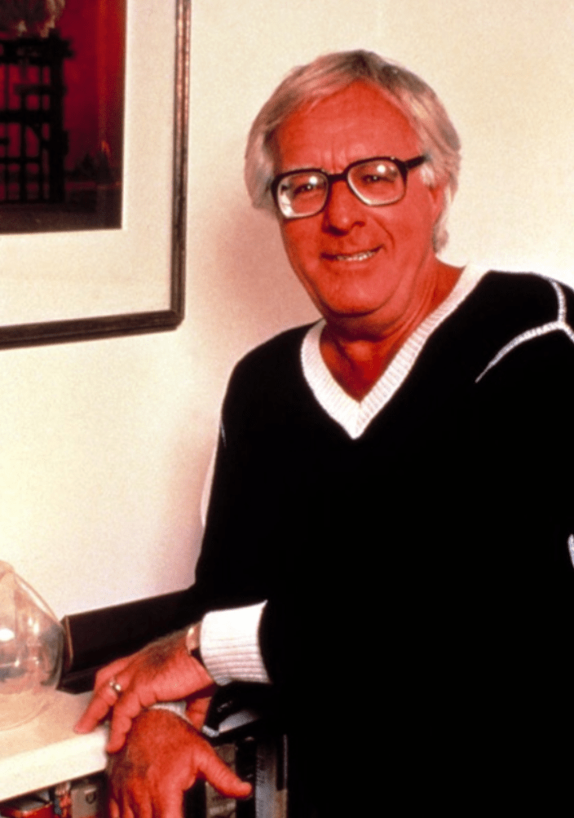

The Marriage Mender, Ray Bradbury

The Marriage Mender

IN the sun, the headboard was like a fountain,, tossing up plumes of clear light. It was carved with lions and gargoyles and bearded goats. It was an awe-inspiring object even at midnight, as Antonio sat on the bed and unlaced his shoes, and put his large calloused hand out to touch its shimmering harp. Then he rolled over into this fabulous machine for dreaming, and he lay breathing heavily, his eyes beginning to close.

'Every night,' his wife's voice said, 'we sleep in the mouth of a calliope.'

Her complaint shocked him. He lay a long while before daring to reach up his hard-tipped fingers to stroke the cold metal of the intricate headboard, the threads of this lyre that had sung many wild and beautiful songs down the years.

'This is no calliope,' he said.

'It cries like one,' Maria said. 'A billion people on this world tonight have beds. Why, I ask the saints, not us?'

'This,' said Antonio gently, 'is a bed.' He plucked a little tune on the imitation brass harp behind his head. To his ears it was Santa Lucia.

'This bed has humps like a herd of camels was under it.'

'Now, Mama,' Antonio said. He called her Mama when she was mad, though they had no children. 'You were never this way,' he went on, 'until five months ago when Mrs Brancozzi downstairs bought her new bed.'

Maria said wistfully, 'Mrs Brancozzi's bed. It's like snow. It's all flat and white and smooth.'

'I don't want any damn snow, all flat and white and smooth! These springs — feel them!' he cried angrily. 'They know me. They recognize that this hour of night I lie thus, at two o'clock, so! Three o'clock this way, four o'clock that. We are like a tumbling act, we've worked together for years, and know all the holds and falls.'

Maria sighed and said, 'Sometimes, I dream we're in the taffy machine at Bartole's candy store.'

'This bed,' he announced to the darkness, 'served our family before Garibaldi! From this wellspring alone came precincts of honest voters, a squad of clean-saluting Army men, two con¬fectioners, a barber, four second-leads for Il Trovatore and Rigoletto, and two geniuses so complex they never could de¬cide what to do in their lifetime! Not to forget enough beauti¬ful women to provide ballrooms with their finest decoration. A cornucopia of plenty, this bed! A veritable harvesting machine!'

'We have been married two years,' she said, with dreadful control over her voice. 'Where are our second-leads for Rigo¬letto, our geniuses, our ballroom decorations?' 'Patience, Mama.'

'Don't call me Mama! While this bed is busy favouring you all night, never once has it done for me. Not even so much as a baby girl!'

He sat up. 'You've let these women in this tenement ruin you with their dollar-down, dollar-a-week talk. Has Mrs Brancozzi children? Her and her new bed that she's had for five months?'

'No! But soon! Mrs Brancozzi says . . . and her bed, so beautiful.'

He slammed himself down and yanked the covers over him. The bed screamed like all the Furies rushing through the night sky, fading away towards the dawn.

The moon changed the shape of the window pattern on the floor. Antonio awoke. Maria was not beside him.

He got up and went to peer through the half-open door of the bathroom. His wife stood at the mirror looking at her tired face.

'I don't feel well,' she said.

'We argued.' He put out his hand to pat her. 'I'm sorry. We'll think it over. About the bed, I mean. We'll see how the money goes. And if you're not well tomorrow, see the doctor, eh? Now, come back to bed.'

At noon the next day, Antonio walked from the lumber-yard to a window where stood fine new beds with their covers in¬vitingly turned back.

'I,' he whispered to himself, 'am a beast.'

He checked his watch. Maria, at this time, would be going to the doctor's. She had been like cold milk this morning; he had told her to go. He walked on to the candy-store window and watched the taffy machine folding and threading and pulling. Does taffy scream? he wondered. Perhaps, but so high we can¬not hear it. He laughed. Then, in the stretched taffy, he saw Maria. Frowning, he turned and walked back to the furniture store. No. Yes. No. Yes! He pressed his nose to the icy win¬dow. Bed, he thought, you in there, new bed, do you know me? Will you be kind to my back, nights?

He took out his wallet, slowly, and peered at the money. He sighed, gazed for a long time at that flat marble-top, that un¬familiar enemy, that new bed. Then, shoulders sagging, he walked into the store, his money held loosely in his hand.

'Maria!' He ran up the steps two at a time. It was nine o'clock at night and he had managed to beg off in the middle of his overtime at the lumber-yard to rush home. He rushed through the open doorway smiling.

The apartment was empty.

'Ah,' he said disappointedly. He laid the receipt for the new bed on top of the bureau where Maria might see it when she entered. On those few evenings when he worked late she visited with any one of several neighbours downstairs.

I'll go find her, he thought, and stopped. No. I want to tell her alone, I'll wait. He sat on the bed. 'Old bed,' he said, 'good¬bye to you. I am very sorry.' He patted the brass lions ner¬vously. He paced the floor. Come on, Maria. He imagined her smile.

He listened for her quick running on the stair, but he heard only a slow, measured tread. He thought: That's not my Maria, slow like that, no.

The doorknob turned.

'Maria!'

'You're early!' She smiled happily at him. Did she guess? Was it written on his face? 'I've been downstairs,' she cried, 'telling everyone!'

'Telling everyone?'

'The doctor! I saw the doctor!'

'The doctor?' He looked bewildered. 'And?'

'And, Papa, and — '

'Do you mean — Papa?'

'Papa, Papa, Papa, Papa!'

'Oh,' he said, gently, 'you walked so carefully on the stairs.'

He took hold of her, but not too tight, and he kissed her cheeks, and he shut his eyes and he yelled. Then he had to wake a few neighbours and tell them, shake them, tell them again. There had to be a little wine and a careful waltz around, an embracing, a trembling, a kissing of brow, eyelids, nose, lips, temples, ears, hair, chin — and then it was past midnight.

'A miracle,' he sighed.

They were alone in their room again, the air warm from the people who had been there a minute before, laughing, talking. But now they were alone again.

Turning out the light, he saw the receipt on the bureau. Stunned, he tried to decide in what subtle and delicious way to break this additional news to her.

Maria sat upon her side of the bed in the dark, hypnotized with wonder. She moved her hands as if her body was a strange doll, taken apart, and now to be put back together again, limb by limb, her motions as slow as if she lived beneath a warm sea at midnight. Now, at last, careful not to break herself, she lay back, upon the pillow.

'Maria, I have something to tell you.'

'Yes?' she said faintly.

'Now that you are as you are,' he squeezed her hand, 'you deserve the comfort, the rest, the beauty of a new bed.'

She did not cry out happily or turn to him or seize him. Her silence was a thinking silence.

He was forced to continue. 'This bed is nothing but a pipe organ, a calliope.'

'It is a bed,' she said.

'A herd of camels sleep under it.'

'No,' she said quietly, 'from it will come precincts of honest voters, captains enough for three armies, two ballerinas, a famous lawyer, a very tall policeman, and seven basso pro-fundos, altos, and sopranos.'

He squinted across the dimly lighted room at the receipt upon the bureau. He touched the worn mattress under him. The springs moved softly to recognize each limb, each tired muscle, each aching bone.

He sighed. 'I never argue with you, little one.'

'Mama,' she said.

'Mama,' he said.

And then as he closed his eyes and drew the covers to his chest and lay in the darkness by the great fountain, in the sight of a jury of fierce metal lions and amber goats and smiling gar-goyles, he listened. And he heard it. It was very far away at first, very tentative, but it came clearer as he listened.

Softly, her arm back over her head, Maria's finger-tips began to tap a little dance on the gleaming harp strings, on the shim¬mering brass pipes of the ancient bed. The music was — yes, of course: Santa Lucia! His lips moved to it in a warm whisper. Santa Lucia! Santa Lucia!

It was very beautiful.

1954

The end