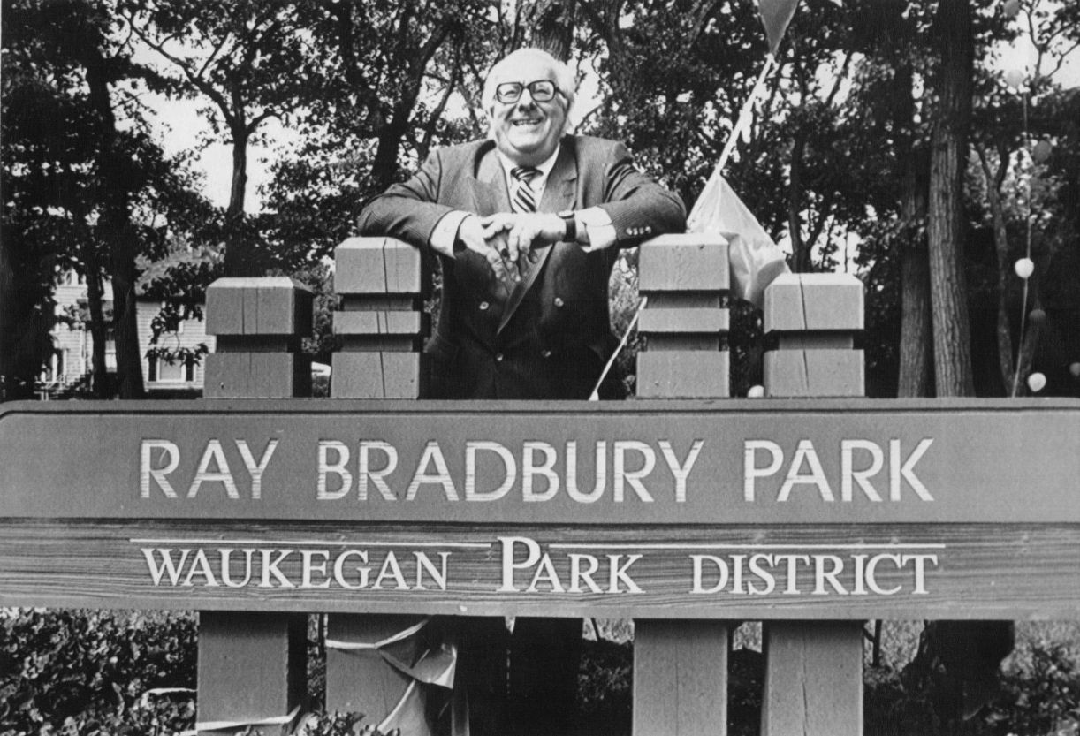

The Mirror, Ray Bradbury

The Mirror

Lord, there must be a thousand ways to tell of these two ladies. When they were girls, in yellow dresses, they could stand and comb their hair looking at each other.

If life was a great Swiss clock, then these were the sprightliest cuckoos thateverjumped out of two doors at once, announcing the exact same time, each of them, not a second lost between.

They blinked as if one cord was pulled by a great magician hidden behind the scenes. They wore the same shoes, tilted their heads in the same direction, and trailed their hands like white ribbons on the air as they floated by. Two bottles of cool milk, two new Lincoln pennies were never more the same.

Whenever they entered the school proms the dancers halted as if someone had suddenly removed all of the air from the ballroom; everyone gasped.

"The twins," everyone said. Not a name was mentioned. What matter if their name was Wycherly; the parts were interchangeable, you didn't love one, you loved a corporative enterprise. The twins, the twins, how they floated down the great river of years, like two daisies tossed upon the waters.

"They'll marry the kings of the world," people said.

But they sat upon their porch for twenty years, they were as much a part of the park as the swans, you saw their faces uplifted and thrust forward like winter ghosts in the dark night of the film theater.

Oh, once there'd been men, or a man in their life. The word "life" is suggested because a plural noun would not do justice to their oneness. A man had tipped his hat to them here or there, only to have the hat returned to him as he was floated to the door.

"Twins is what we're looking for!" you could hear the older sister saying across the twilight lawns. "We've two of everything in the house, beds, shoes, sun-chairs, dark glasses; and now how wonderful if we could find twins like ourselves, for only twins would understand what it is to be an individual and a mirror reflection—"

The older sister. Born nine minutes before the younger, and the divine right of elegant queens in her veins. "Sister do this, sister do that, sister do the other thing!"

"I'm the mirror," said Julia, the youngest, at the age of twenty-nine. "Oh, I've always known. Coral, everything went to her, the sense, the tongue, the mind, the coloring … "

"Alike as two vanilla cones, both of you."

"No, you don't see what I see. My pores are larger and my skin redder and my elbows are rough. Coral says sandpaper is talcum by comparison. No, she's the person, and I only stand here and act out what she is and what she does, like a mirror, but always knowing I'm not real, I'm only so many waves of light, an optical illusion. Anyone who hit me with a rock would have seven years bad luck."

"Both of you will be married come spring, no doubt, no doubtofit!"

"Coral maybe, not me. I'll just go along to talk evenings when Coral has a headache and make the tea, that's a natural-born gift I have, making tea."

In 1934 there was a man, the town remembers, and not with Coral at all, but with the younger Julia.

"It was like a siren, the night Julia brought her young man home. I thought the tannery had gone down in flames.

Came out on my front porch half-dressed with shock. And there was Coral on the front porch making a spell on the young man across half the lawn, and asking the earth to swallow her, and Julia hidden inside the screen door, and the young man just standing there with his hat on the wet grass. The next morning I saw Julia sneak out and grab it and run in.

After that, didn't see the twins for, well, a week, and after that, there they were, sailing like boats again, down the sidewalk, the two of them, but after that I always knew which was Julia—yes, you could tell every year after that which was Julia by looking in her face."

Only last week they turned forty, the old and the young Wycherly. There must have been something about that day which broke a harp-thread so quick and so loud you could hear the clear sound of it across town.

On that morning, Julia Wycherly awoke and did not comb her hair. At breakfast the oldest one looked in her faithful mirror and said, "What's the matter with your comb?"

"Comb?"

"Your hair, your hair, it's a bird's nest." The older put her delicate porcelain hands to her own coiffure which was like gold spun and molded to her regal head, not a plait ajar, not a strand afloat, not so much as a fleck of lint or a fragment of microscopic flesh in sight. She was so clean she smelled of alcohol burning in a brass bowl. "Here, let me fix it." But Julia rose and left the room.

That afternoon another thread broke.

Julia went downtown alone.

People on the street did not recognize her. After all, you do not recognize one of a pair when for forty years you've seen only the two, like a couple of dainty shoes promenading in the downtown store-window reflections. People everywhere gave that little move of the head which meant they expected to shift their gaze from one image to its painstaking duplicate.

"Who's there?" asked the druggist, as if he'd been wakened at midnight and was peering out the door. "I mean, is that you, Coral, or Julia? Is Julia or Coral sick, Julia? I mean—damn it!" He talked in a loud voice as if a phone connection was giving him trouble. "Well?"

"This is—" The younger twin had to stop and feel herself, and see herself in the gleaming side of the apothecary vat which held green mint-colored juice in it. "This is Julia," she said, as if returning the call. "And I want, I want—"

"Is Coral dead, my God, how horrible, how terrible!" cried the druggist. "You poor child!"

"Oh, no, she's home. I want, I want—" She moistened her lips and put out a hand like vapor on the air. "I want some red tint for my hair, the color of carrots or tomatoes, I guess, the color of wine, yes, wine; I think I'd like that better. Wine."

"Two packages, of course."

"What, what?"

"Two packages of tint. One for each of you?"

Julia looked as if she might fly off, so much milkweed, and then she said, "No. Only one package. It's for me. It's for Julia. It's for Julia all by herself."

"Julia!" screamed Coral at the front door as Julia came up the walk. "Where've you been? Running off, I thought you'd been killed by a car, or kidnapped or some horrible thing! Good God!" The older sister stopped and fell back against the side of the porch rail. "Your hair, your lovely golden hair, thirty-nine inches it was, one for every year almost, one for every year." She stared at the woman who waltzed and curtsied and turned on the front lawn sidewalk, her eyes closed. "Julia, Julia, Julia!" she shrieked.

"It's the color of wine," said Julia. "And oh my ithasgone to my head!"

"Julia, the sun, you went without your hat, and no lunch, you ate no lunch, it stands to reason. Here, let me help you in. We'll go to the bathroom and wash out that terrible color. A clown for the circus, that's what you are!"

"I'm Julia," said the younger sister. "I'm Julia, and look—" She snatched open a parcel she carried beneath her arm. She held up a dress as bright as the grass of summer, green to complement her hair, green like the trees and green like the eyes of every cat on back to the pharaohs.

"You know I can't wear green," said Coral. "Wasting our heritage money, buying dresses like that."

"One dress."

"One dress?"

"One, one, one," said Julia quietly, smiling. "One." She went in to put it on, standing in the hall. "And one pair of new shoes."

"With open toes! How ridiculous!"

"You can buy a pair just like them if you want."

"I willnot!"

"And a dress like this."

"Ha!"

"And now," said Julia, "it's time for tea, we're due at the Applemans', remember? Come along."

"You're not serious!"

"Tea is so nice, and it's a lovely day."

"Not until you rinse your hair!"

"No, no, and I might even let it grow out, in the next six months, all gray."

"Shh, the neighbors," cried Coral, then, lower: "Your hair's not gray."

"Yes, gray as a mouse, and I'll let it grow out, we've been coloring it for years."

"Only to bring out the natural highlights, the highlights!"

They went off to tea together.

Things went quickly after that: after one explosion, another, another, another, a string, a bunch of ladyfinger firecracker explosions. Julia bought floppy flowered hats, Julia wore perfume, Julia got fat, Julia turned gray, Julia went out alone nights, pulling on her gloves like a workman approaching a fascinating job at the foundry.

And Coral?

"I'm nervous," said Coral. "Nervous, nervous, nervous. Look at her stockings, all runs. Look at her smeared lipstick, and us always neat as pins, look at her cheeks, no powder over the freckles, and her hair all dirty snow; nervous, nervous, nervous, oh, I'm nervous.

"Julia," she said at last, "the time's come. I won't be seen with you anymore.

"Julia," she said, a month later, "I've got my bags packed. I've taken room and board at Mrs. Appleman's, where you can call me if you need me. Oh, you'll call, you'll come sniveling, alone, and it'll be a long night of talking to get me home."

And Coral sailed away like a great white skiff across the sea of summer afternoon.

There was a thundershower next week. The largest single bolt of green-bolt lightning jumped around in the sky, picked its spot, and rammed itself feet-first into the center of the town, shaking birds from their nests in insane confettis, launching three children into the world two weeks ahead of time, and short-circuiting a hundred conversations by women in storm-darkened homes in mid-gallop on their way through sin and torment and domestic melodrama.

This thunderbolt which jumped back up at the sky in a billion fragments was nothing to the following morning's item in the paper which said that Henry Crummitt (the man with his arm around the shoulder of the cigar-store wooden Indian) was marrying one Julia Wycherly on that self-same day.

"Someone marry Julia!"

And Coral sat down to gasp and laugh and then gasp again at the incredible lie.

"What? With her ragged seams and her dirty linens, and her awful white hair and her unplucked brows and her shoes run over? Julia? Someone take Julia to the license bureau? Oh, oh!"

But just to satisfy her humor which veered wildly between comedy and sheer slapstick which was not funny at all, she went round to the little church that afternoon and was startled to see the rice in the air and the handful of people all shouting and laughing, and there, coming out of the church, was Henry Crummitt and linked to his arm ...

A woman with a trim figure, a woman dressed in taste, with golden hair beautifully combed, not a fleck of lint or a scrap of dandruff visible, a woman with neat stocking seams and well-delineated lipstick and powder on her cheeks like the first cool fall of snow at the beginning of a lovely winter.

And as they passed, the younger sister glanced over and saw her older sister there. She stopped. Everyone stopped. Everyone waited. Everyone held their breaths.

The younger sister took one step, took two steps forward and peered into the face of this other woman in the crowd.

Then, as if she were making up in a mirror, she adjusted her veil, smoothed her lipstick, and refurbished her powder, delicately, carefully, and with no trace of hurry. Then, to this mirror she said, or it was reliably passed on she said:

"I'm Julia; who areyou?"

And after that there was so much rice nobody saw anything until the cars had driven off.

The end