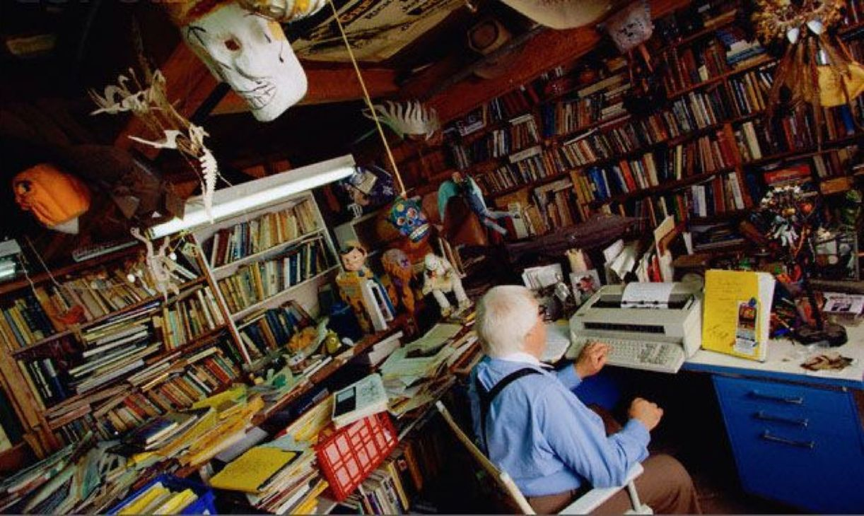

The Other Highway, Ray Bradbury

The Other Highway

They drove into green Sunday-morning country, away from the hot aluminum city, and watched as the sky was set free and moved over them like a lake they had never known was there, amazingly blue and with white breakers above them as they traveled.

Clarence Travers slowed the car and felt the cool wind move over his face with the smell of cut grass. He reached over to grasp his wife's hand and glanced at his son and daughter in the backseat, not fighting, at least for this moment, as the car moved through one quiet beauty after another in what might be a Sunday so lush and green it would never end.

"Thank God we're doing this," said Cecelia Travers. "It's been a million years since we got away." He felt her hand hug his and then relax completely. "when I think of all those ladies dropping dead from the heat at the cocktail parry this afternoon, welt"

"Well, indeed," said Clarence Travers. "Onward!"

He pressed the gas pedal and they moved faster. Their progress out of the city had been mildly hysterical, with cars shrieking and shoving them toward islands of wilderness praying for picnics that might not be found. Seeing that he had put the car in the fast lane, he slowed to gradually move himself and his family through the banshee traffic until they were idling along at an almost reasonable fifty miles an hour. The scents of flowers and trees that blew in the window made his move worthwhile. He laughed at nothing at all and said:

“Sometimes, when I get this far out, I think let's just keep driving, never go back to the damned city."

"Let's drive a hundred miles," shouted his son.

"A thousand!" cried his daughter.

"A thousand!" said Clarence Travers. "But one slow mile at a time." And then said, softly, “Hey!”

And as suddenly as if they had dreamed it up, the lost highway came into view. "Wonderful!" said Mr. Clarence Travers.

"What?" asked the children.

"Look!" said Clarence Travers, leaning over his wife, pointing. "That's the Old road. The one they used a long time ago."

"That?" said his wife.

"It's awfully small," said his son.

"Well, there weren't many cars then, they didn't need much."

"It looks like a big snake," said his daughter.

"Yeah, the old roads used to twist and turn, all right. Remember?"

Cecelia Travers nodded. The car had slowed and they gazed over at that narrow concrete strip with the green grass buckling it gently here or there and sprays of wildflowers nestling up close to either side and the morning sunlight coming down through the high elms and maples and oaks that led the way toward the forest.

"I know it like the nose on my face," said Clarence Travers. "How would you like to ride on it?"

"Oh, Clarence, now

"I mean it."

"Oh, Daddy, could we?"

"All right, we'll do it," he said decisively.

"We can't!" said Cecelia Travers. "It's probably against the law. It can't be safe."

But before his wife could finish, he turned off the freeway and let all the swift cars rush on while he drove, smiling at each bump, down over a small ditch, toward the old road.

"Clarence, please! we'll be arrested!"

"For going ten miles an hour on a highway nobody uses anymore? Let's not kick over any beehives, it's too nice a day. I'll buy you all soda pops if you behave."

They reached the old road.

"See how simple? Now which way, kids?"

"That way, that way!"

"Easy as pie!"

And he let the car take them away on the old highway, the great white-gray boa constrictor that lashed now slowly this way in green moss-velvet meadows, looped over gentle hills, and lowered itself majestically into caves of moist-smelling trees, through the odor of cricks and spring mud and crystal water that rustled like sheets of cellophane over small stone falls. They drove slow enough to see the waterspiders' enigmatic etchings on quiet pools behind dams of last October's leaves.

"Daddy, what are those?"

"What, the water-skaters? No one has ever caught one. You wait and wait and put your hand out and bang! The spider's gone. They're the first things in life you can't grab onto. The list gets bigger as you grow old, so start small. Don't believe in them. They're not really there."

"It's fun thinking they are."

“You have just stated a deep philosophical truth. Now, drive on, Mr. Travers.” And obeying his own command with good humor, he drove on.

And they came to a forest that had been like November all through the winter and now, reluctantly, was putting out green flags to welcome the season. Butterflies in great tosses of confetti leaped from the deeps of the forest to ramble drunkenly on the air, their thousand torn shadows following over grass and water.

"Let's go back now," said Cecelia Travers.

"Aw, Mom," said the son and daughter.

"Why?" said Clarence Travers. "My God, how many kids back in that damned hot town can say they drove on a road nobody else has used in years? Not one! Not one with a father brave enough to cross a little grass to take the old way. Right?"

Mrs. Travers lapsed into silence.

"Right there," said Clarence Travers, "over that hill, the highway turns left, then right, then left again, an S curve, and another S. Wait and see."

"Left."

"Right."

"Left."

"An S curve."

The car purred.

"Another S!"

"Just like you said!"

"Look." Clarence Travers pointed. A hundred yards across the way from them, the freeway suddenly appeared for a few yards before it vanished, screaming behind stacks of playing-card billboards. Clarence Travers stared fixedly at it and the grass between it and this shadowed path, this silent place like the bottom of an old stream where tides used to come but came no more, where the wind ran through nights making the old sound of far traffic.

"You know something," said the wife. "That freeway over there scares me."

"Can we drive home on this old road instead, Dad?" said the son.

"I wish we could."

"I've always been scared," said the wife, watching that other traffic roaring by, gone before it arrived.

"We're all afraid," said Clarence Travers. "But you pay your money and take your chance. Well?"

His wife sighed. "Damn, get back on that dreadful thing."

"Not quite yet," said Clarence Travers and drove to reach a small, very small village, all quite unexpected, a settlement no more than a dozen white clapboard houses mossed under giant trees, dreaming in a green tide of water and leaf-shadow, with wind shaking the rocking chairs on weathered porches and dogs sleeping in the cool nap of grass-carpeting at noon, and a small general store with a dirty red gas pump out front.

They drew up there and got out and stood, unreal in the sudden lack of motion, not quite accepting these houses lost in the wilderness.

The door to the general store squealed open and an old man stepped out, blinked at them, and said, "Say, did you folks just come down that old road?"

Clarence Travers avoided his wife's accusing eyes. "Yes, sir.

"No one on that road in twenty years."

"We were out for a lark," said Mr. Travers. "And found a peacock," he added.

“A sparrow,“ said his wife.

"The freeway passed us by, a mile over there, if you want it," said the old man. "When the new road opened, this town just died on the vine. We got nothing here now but people like me. That is: old."

"Looks like there'd be places here to rent."

"Mister, just walk in, knock out the bats, stomp the spiders, and any place is yours for thirty bucks a month. I own the whole town."

"Oh, we're not really interested," said Cecelia Travers.

"Didn't think you would be," said the old man. "Too far out from the city, too far off the freeway. And that dirt road there slops over when it rains, all muck and mud. And, heck, it's against the law to use that path. Not that they ever patrol it." The old man snorted, shaking his head. "And not that I'll turn you in. But it gave me a nice start just now to see you coming down that rut. J had to give a quick look at my calendar, by God, and make sure it wasn't 1929!"

Lord, I remember, thought Clarence Travers. This is Fox Hill. A thousand people lived here. I was a kid, we passed through on summer nights. We used to stop here late late, and me sleeping in the backseat in the moonlight. My grandmother and grandfather in back with me. It's nice to sleep in a car driving late and the road all white, watching the stars turn as you take the curves, listening to the grown-ups' voices underwater, remote, talking, talking, laughing, murmuring, whispering.

My father driving, so stolid. Just to be driving in the summer dark, up along the lake to the Dunes, where the poison ivy grew out on the lonely beach and the wind stayed all the time and never went away.

And us driving by that lonely graveyard place of sand and moonlight and poison ivy and the waves tumbling in like dusty ash on the shore, the lake pounding like a locomotive on the sand, coming and going.

And me crumpled down and smelling Grandmother's wind-cooled coat and the voices comforting and blanketing me with their solidity and their always-will-be-here sounds that would go on forever, myself always young and us always riding on a summer night in our old Kissel with the side flaps down.

And stopping here at nine or ten for Pistachio and Tutti-frutti ice cream that tasted, faintly, beautifully, of gasoline. All of us licking and biting the cones and smelling the gasoline and driving on, sleepy and snug, toward home, Green Town, thirty years ago.

He caught himself and said:

"About these houses, would it be much trouble fixing them up?" He squinted at the old man.

"Well, yes and no, most of 'em over fifty years old, lots of dust. You could buy one off me for ten thousand, a real bargain now, you'll admit. If you were an artist, now, a painter, or something like that."

"I write copy in an advertising firm."

"Write stories, too, no doubt? Well, now, you get a writer out here, quiet, no neighbors, you'd do lots of writing."

Cecelia Travers stood silently between the old man and her husband. Clarence Travers did not look at her, but looked at the cinders around the porch of the general store. "I imagine I could work here."

"Sure," said the old man.

"I've often thought," said Mr. Travers, "it's time we got away from the city and took it a little easy."

"Sure," said the old man.

Mrs. Travers said nothing but searched in her purse and took out a minor.

"Would you like some drinks?" asked Clarence Travers with exaggerated concern. "Three Orange Crushes, make it four," he told the old man. The old man moved inside the store, which smelled of nails and crackers and dust.

When the old man was gone, Mr. Travers turned to his wife, and his eyes were shining. "We've always wanted to do it! Let's!"

"Do what?" she said.

"Move out here, snap decision, why not? Why? We've promised ourselves every year: get away from the noise, the confusion, so the kids'd have a place to play. And . .

“Good grief" the wife cried.

The old man moved inside the store, coughing. "Ridiculous." She lowered her voice. "We've got the apartment paid up, you've got a fine job, the kids have school with friends, I belong to some fine clubs. And we've just spent a bundle redecorating. We-"

"Listen," he said, as if she were really listening. " None of that's important. Out here, we can breathe. Back in town, hell, you complain ...”

"Just to have something to complain about."

"Your clubs can't be that important."

"It's not clubs, it's friends!"

"How many would care if we dropped dead tomorrow?" he said. "If I got hit in that traffic, how many thousand cars would run over me before one stopped to see if I was a man or dog left in the road?"

"Your job . . ." she started to say.

"My God, ten years ago we said, in two more years we'll have enough money to quit and write my novel! But each year we've said next year! and next year and next year!"

"We've had fun, haven't we?"

"Sure! Subways are fun, buses are fun, martinis and drunken friends are fun. Advertising? Yeah! But I've used all the fun there is! I want to write about what I've seen now, and there's no better place than this. Look at that house over there! Can't you just see me in the front window banging the hell out of my typewriter?"

"Stop hyperventilating!"

"Hyperventilate? God, I'd jump for joy to quit. I've gone as far as I can go. Come on, Cecelia, let's get back some of the spunk in our marriage, take a chance!"

"The children

"We'd love it here!" said the son.

"I think," said the daughter.

"I'm not getting any younger," said Clarence Travers.

"Nor am I," she said, touching his arm. "But we can't play hopscotch now. When the children leave, yes, we'll think about it."

"Children, hopscotch, my God, I'll take my typewriter to the grave!"

"It won't be long. We-"

The shop door squealed open again and whether the old man had been standing in the screen shadow for the last minute, there was no telling. It did not show in his face. He stepped out with four lukewarm bottles of Orange Crush in his rust-spotted hands.

"Here you are," he said.

Clarence and Cecelia Travers turned to stare at him as if he were a stranger come out to bring them drinks. They smiled and took the bottles.

The four of them stood drinking the soda pop in the warm sunlight. The summer wind blew through the grottoes of trees in the old, shady town. It was like being in a great green church, a cathedral, the trees so high that the people and cottages were lost far down below. All night long you would imagine those trees rustling Their leaves like an ocean on an unending shore. God, thought Clarence Travers, you could really sleep here, the sleep of the dead and the peace-fill-of-heart.

He finished his drink and his wife half finished hers and gave it to the children to argue over, inch by compared inch. The old man stood silent, embarrassed by the thing he may have stirred up among them.

"Well, if you're ever out this way, drop in," he said. Clarence Travers reached for his wallet.

"No, no!" said the old man. "It's on the house."

"Thank you, thank you very much."

"A pleasure."

They climbed back into their car.

"If you want to get to the freeway," said the old man, peering through the front window into the cooked-upholstery smell of the car, "just take your old dirt road back. Don't rush, or you'll break an axle."

Clarence Travers looked straight ahead at the radiator fixture on the car front and started the motor.

"Good-bye," said the old man.

"Good-bye," the children yelled, and waved. The car moved away through the town.

"Did you hear what the old man said?" asked the wife.

"What?"

"Did you hear him say which way to the freeway?"

"I heard."

He drove through the cool, shady town, staring at the porches and the windows with the colored glass fringing them. If you looked from the inside of those windows out, people had different-colored faces for each pane you looked through. They were Chinese if you looked through one, Indian through another, pink, green, violet, burgundy, wine, chartreuse, the candy colors, the lemon-lime cool colors, the water colors of the windows looking out on lawns and trees and this car slowly driving past.

"Yes, I heard him," said Clarence Travers.

They left the town behind and took the dirt road to the freeway. They waited their chance, saw an interval between floods of cars hurtling by, swerved out into the stream, and, at fifty miles an hour, were soon hurtling toward the city.

"That's better," said Cecelia Travers brightly. She did not look over at her husband. "Now I know where we are."

Billboards flashed by; a mortuary, a pie crust, a cereal, a garage, a hotel. A hotel in the tar pits of the city, where one day is the pitiless glare of the noon sun, thought Mr. Travers, all of the great Erector-set buildings, like prehistoric dinosaurs, will sink down into the bubbling tar-lava and be encased, bone by bone, for future civilizations.

And in the stomachs of the electric lizards, inside the iron dinosaurs, the probing scientists of A.D. One Million will find the little ivory bones, the thinly articulated skeletons of advertising executives and clubwomen and children. Mr. Travers felt his eyes flinch, watering.

And the scientists will say, so this is what the iron cities fed on, is it? and give the bones a kick. So this is what kept the iron stomachs full, eh? Poor things, they never had a chance. Probably kept by the iron monsters who needed them in order to survive, who needed them for breakfast, lunch, and dinner. Aphids, in a way, aphids, kept in a great metal cage.

"Look, Daddy, look, look, before it's too late!"

The children pointed, yelling. Cecelia Travers did not look. Only the children saw it.

The old highway, two hundred yards away, at their left, sprang back into sight for an instant, wandered aimlessly through field, meadow, and stream, gentle and cool and quiet.

Mr. Travers swung his head sharply to see, but in that instant it was gone. Billboards, trees, hills rushed it away. A thousand cars, honking, shrieking, shouldered them, and bore Clarence and Cecelia Travers and their captive children stunned and silent down the concourse, onward ever onward into a city that had not seen them leave and did not look to see them return

“Let’s see if this car will do sixty or sixty-five,” said Clarence Travers.

It could and did.

The end