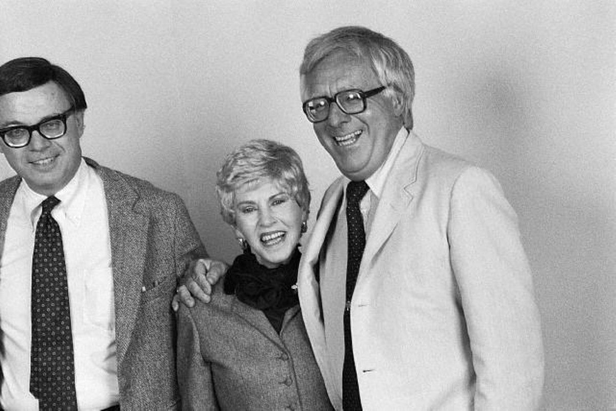

The Rocket Man, Ray Bradbury

The Rocket Man

The electrical fireflies were hovering above Mother's dark hair to light her path. She stood in her bedroom door looking out at me as I passed in the silent hall.

"You will help me keep him here this time, won't you?" she asked.

"I guess so," I said.

"Please." The fireflies cast moving bits of light on her white face. "This time he mustn't go away again."

"All right," I said, after standing there a moment. "But it won't do any good; it's no use."

She went away, and the fireflies, on their electric circuits, fluttered after her like an errant constellation, showing her how to walk in darkness.

I heard her say, faintly, "We've got to try, anyway."

Other fireflies followed me to my room. When the weight of my body cut a circuit in the bed, the fireflies winked out. It was midnight, and my mother and I waited, our rooms separated by darkness, in bed. The bed began to rock me and sing to me. I touched a switch; the singing and rocking stopped. I didn't want to sleep. I didn't want to sleep at all.

This night was no different from a thousand others in our time. We would wake nights and feel the cool air turn hot, feel the fire in the wind, or see the walls burned a bright color for an instant, and then we knew his rocket was over our house - his rocket, and the oak trees swaying from the concussion.

And I would lie there, eyes wide, panting, and mother in her room.

Her voice would come to me over the interroom radio: "Did you feel it?"

And I would answer, "That was him, all right."

That was my father's ship passing over our town, a small town where space rockets never came, and we would lie awake for the next two hours, thinking, "Now Dad's landed in Springfield, now he's on the tarmac, now he's signing the papers, now he's in the helicopter, now he's over the river, now the hills, now he's settling the helicopter in at the little airport at Green Village here... And the night would be half over when, in our separate cool beds, Mother and I would be listening, listening.

"Now he's walking down Bell Street. He always walks… never takes a cab… now across the park, now turning the corner of Oakhurst and now…

I lifted my head from my pillow. Far down the street, coming closer and closer, smartly, quickly, briskly - footsteps. Now turning in at our house, up the porch steps. And we were both smiling in the cool darkness, Mom and I, when we heard the front door open in recognition, speak a quiet word of welcome, and shot downstairs…

Three hours later I turned the brass knob to their room quietly, holding my breath, balancing in a darkness as big as the space between the planets, my hand out to reach the small black case at the foot of my parents' sleeping bed.

Taking it, I ran silently to my room, thinking, He won't tell me, he doesn't want me to know.

And from the opened case spilled his black uniform, like a black nebula, stars glittering here or there, distantly, in the material. I kneaded the dark stuff in my warm hands; I smelled the planet Mars, an iron smell, and the planet Venus, a green ivy smell, and the planet Mercury, a scent of sulphur and fire; and I could smell the milky moon and the hardness of stars.

I pushed the uniform into a centrifuge machine I'd built in my ninth-grade shop that year, set it whirling. Soon a fine powder precipitated into a retort. This I slid under a microscope.

And while my parents slept unaware, and while our house was asleep, all the automatic bakers and servers and robot cleaners in an electric slumber, I stared down upon brilliant motes of meteor dust, comet tail, and loam from far Jupiter glistening like worlds themselves which drew me down the tube a billion miles into space, at terrific accelerations.

At dawn, exhausted with my journey and fearful of discovery, I returned the boxed uniform to their sleeping room.

Then I slept, only to waken at the sound of the horn of the dry-cleaning car which stopped in the yard below. They took the black uniform box with them. It's good I didn't wait, I thought. For the uniform would be back in an hour, clean of all its destiny and travel.

I slept again, with the little vial of magical dust in my pajama pocket, over my beating heart.

When I came downstairs, there was Dad at the breakfast table, biting into his toast.

"Sleep good, Doug?" he said, as if he had been here all the time, and hadn't been

gone for three months.

"All right," I said.

"Toast?"

He pressed a button and the breakfast table made me four pieces, golden brown. I remember my father that afternoon, digging and digging in the garden, like an animal after something, it seemed.

There he was with his long dark arms moving swiftly, planting, tamping, fixing, cutting, pruning, his dark face always down to the soil, his eyes always down to what he was doing, never up to the sky, never looking at me, or Mother, even, unless we knelt with him to feel the earth soak up through the overalls at our knees, to put our hands into the black dirt and not look at the bright, crazy sky.

Then he would glance to either side, to Mother or me, and give us a gentle wink, and go on, bent down, face down, the sky staring at his back.

That night we sat on the mechanical porch swing which swung us and blew a wind upon us and sang to us.

It was summer and moonlight and we had lemonade to drink, and we held the cold glasses in our hands, and Dad read the stereo-newspapers inserted into the special hat you put on your head and which turned the microscopic page in front of the magnifying lens if you blinked three times in succession.

Dad smoked cigarettes and told me about how it was when he was a boy in the year 1997.

After a while he said, as he had always said, "Why aren't you out playing kick-the-can, Doug?"

I didn't say anything, but Mom said, "He does, on nights when you're not here."

Dad looked at me and then, for the first time that day, at the sky. Mother always watched him when he glanced at the stars. The first day and night when he got home he wouldn't look at the sky much.

I thought about him gardening and gardening so furiously, his face almost driven into the earth. But the second night he looked at the stars a little more. Mother wasn't afraid of the sky in the day so much, but it was the night stars that she wanted to turn off, and sometimes I could almost see her reaching for a switch in her mind, but never finding it.

And by the third night maybe Dad'd be out here on the porch until 'way after we were all ready for bed, and then I'd hear Mom call him in, almost like she called me from the street at times.

And then I would hear Dad fitting the electric-eye door lock in place, with a sigh. And the next morning at breakfast I'd glance down and see his little black case near his feet as he buttered his toast and Mother slept late.

"Well, be seeing you, Doug," he'd say, and we'd shake hands.

"In about three months?"

"Right."

And he'd walk away down the street, not taking a helicopter or beetle or bus, just walking with his uniform hidden in his small underarm case; he didn't want anyone to think he was vain about being a Rocket Man.

Mother would come out to eat breakfast, one piece of dry toast, about an hour later.

But now it was tonight, the first night, the good night, and he wasn't looking at the stars much at all.

"Let's go to the television carnival," I said.

"Fine," said Dad.

Mother smiled at me.

And we rushed off to town in a helicopter and took Dad through a thousand exhibits, to keep his face and head down with us and not looking anywhere else.

And as we laughed at the funny things and looked serious at the serious ones, I thought, My father goes to Saturn and Neptune and Pluto, but he never brings me presents. Other boys whose fathers go into space bring back bits of ore from Callisto and hunks of black meteor or blue sand.

But I have to get my own collection, trading from other boys, the Martian rocks and Mercurian sands which filled my room, but about which Dad would never comment.

On occasion, I remembered, he brought something for Mother. He planted some Martian sunflowers once in our yard, but after he was gone a month and the sunflowers grew large, Mom ran out one day and cut them all down.

Without thinking, as we paused at one of the three-dimensional exhibits, I asked Dad the question I always asked, "What's it like, out in space?"

Mother shot me a frightened glance. It was too late.

Dad stood there for a full half minute trying to find an answer, then he shrugged.

"It's the best thing in a lifetime of best things." Then he caught himself. "Oh, it's really nothing at all. Routine. You wouldn't like it."

He looked at me, apprehensively.

"But you always go back."

"Habit."

"Where're you going next?"

"I haven't decided yet. I'll think it over."

He always thought it over. In those days rocket pilots were rare and he could pick and choose work when he liked. On the third night of his homecoming you could see him picking and choosing among the stars.

"Come on," said Mother, "let's go home."

It was still early when we got home. I wanted Dad to put on his uniform. I shouldn't have asked - it always made Mother unhappy - but I could not help myself.

I kept at him, though he had always refused.

I had never seen him in it, and at last he said, "Oh, all right."

We waited in the parlor while he went upstairs in the air flue. Mother looked at me dully, as if she couldn't believe that her own son could do this to her.

I glanced away. "I'm sorry," I said.

"You're not helping at all," she said. "At all."

There was a whisper in the air flue a moment later.

"Here I am," said Dad quietly.

We looked at him in his uniform.

It was glossy black with silver buttons and silver rims to the heels of the black boots, and it looked as if someone had cut the arms and legs and body from a dark nebula, with little faint stars glowing through it. It fit as close as a glove fits to a slender long hand, and it smelled like cool air and metal and space. It smelled of fire and time.

Father stood, smiling awkwardly, in the center of the room.

"Turn around," said Mother.

Her eyes were remote, looking at him.

When he was gone, she never talked of him. She never said anything about anything but the weather or the condition of my neck and the need of a washcloth for it, or the fact that she didn't sleep nights. Once she said the light was too strong at night.

"But there's no moon this week," I said.

"There's starlight," she said.

I went to the store and bought her some darker, greener shades. As I lay in bed at night, I could hear her pull them down tight to the bottom of the windows. It made a long rustling noise.

Once I tried to mow the lawn.

"No." Mom stood in the door. "Put the mower away."

So the grass went three months at a time without cutting. Dad cut it when he came home.

She wouldn't let me do anything else either, like repairing the electrical breakfast maker or the mechanical book reader. She saved everything up, as if for Christmas. And then I would see Dad hammering or tinkering, and always smiling at his work, and Mother smiling over him, happy.

No, she never talked of him when he was gone. And as for Dad, he never did anything to make a contact across the millions of miles.

He said once, "If I called you, I'd want to be with you. I wouldn't be happy."

Once Dad said to me, "Your mother treats me, sometimes, as if I weren't here - as if I were invisible."

I had seen her do it. She would look just beyond him, over his shoulder, at his chin or hands, but never into his eyes. If she did look at his eyes, her eyes were covered with a film, like an animal going to sleep. She said yes at the right times, and smiled, but always a half second later than expected.

"I'm not there for her," said Dad.

But other days she would be there and he would be there for her, and they would hold hands and walk around the block, or take rides, with Mom's hair flying like a girl's behind her, and she would cut off all the mechanical devices in the kitchen and bake him incredible cakes and pies and cookies, looking deep into his face, her smile a real smile. But at the end of such days when he was there to her, she would always cry. And Dad would stand helpless, gazing about the room as if to find the answer, but never finding it.

Dad turned slowly, in his uniform, for us to see.

"Turn around again," said Mom.

The next morning Dad came rushing into the house with handfuls of tickets. Pink rocket tickets for California, blue tickets for Mexico.

"Come on!" he said. "We'll buy disposable clothes and burn them when they're soiled. Look, we take the noon rocket to L.A., the two-o'clock helicopter to Santa Barbara, the nine-o'clock plane to Ensenada, sleep overnight!"

And we went to California and up and down the Pacific Coast for a day and a half, settling at last on the sands of Malibu to cook wieners at night. Dad was always listening or singing or watching things on all sides of him, holding onto things as if the world were a centrifuge going so swiftly that he might be flung off away from us at any instant.

The last afternoon at Malibu Mom was up in the hotel room. Dad lay on the sand beside me for a long time in the hot sun.

"Ah," he sighed, "this is it."

His eyes were gently closed; he lay on his back, drinking the sun.

"You miss this," he said.

He meant "on the rocket," of course. But he never said "the rocket" or mentioned the rocket and all the things you couldn't have on the rocket. You couldn't have a salt wind on the rocket or a blue sky or a yellow sun or Mom's cooking. You couldn't talk to your fourteen-year-old boy on a rocket.

"Let's hear it," he said at last.

And I knew that now we would talk, as we had always talked, for three hours straight. All afternoon we would murmur back and forth in the lazy sun about my school grades, how high I could jump, how fast I could swim.

Dad nodded each time I spoke and smiled and slapped my chest lightly in approval. We talked. We did not talk of rockets or space, but we talked of Mexico, where we had driven once in an ancient car, and of the butterflies we had caught in the rain forests of green warm Mexico at noon, seeing the hundred butterflies sucked to our radiator, dying there, beating their blue and crimson wings, twitching, beautiful, and sad. We talked of such Things instead of the things I wanted to talk about. And he listened to me.

That was the thing he did, as if he was trying to fill himself up with all the sounds he could hear. He listened to the wind and the falling ocean and my voice, always with a rapt attention, a concentration that almost excluded physical bodies themselves and kept only the sounds.

He shut his eyes to listen. I would see him listening to the lawn mower as he cut the grass by hand instead of using the remote-control device, and I would see him smelling the cut grass as it sprayed up at him behind the mower in a green fount.

"Doug," be said, about five in the afternoon, as we were picking up our towels and heading back along the beach near the surf, "I want you to promise me something."

"What?"

"Don't ever be a Rocket Man."

I stopped.

"I mean it," he said. "Because when you're out there you want to be here, and when you're here you want to be out there. Don't start that. Don't let it get hold of you."

"But..."

"You don't know what it is. Every time I'm out there I think, If I ever get back to Earth I'll stay there; I'll never go out again. But I go out, and I guess I'll always go out."

"I've thought about being a Rocket Man for a long time," I said,

He didn't hear me.

"I try to stay here. Last Saturday when I got home I started trying so damned hard to stay here."

I remembered him in the garden, sweating, and all the traveling and doing and listening, and I knew that he did this to convince himself that the sea and the towns and the land and his family were the only real things and the good things. But I knew where he would be tonight: looking at the jewelry in Orion from our front porch.

"Promise me you won't be like me," he said.

I hesitated awhile. "Okay," I said.

He shook my hand. "Good boy," he said.

The dinner was fine that night. Mom had run about the kitchen with handfuls of cinnamon and dough and pots and pans tinkling, and now a great turkey fumed on the table, with dressing, cranberry sauce, peas, and pumpkin pie.

"In the middle of August?" said Dad, amazed.

"You won't be here for Thanksgiving."

"So I won't."

He sniffed it. He lifted each lid from each tureen and let the flavor steam over his sunburned face. He said "Ah" to each. He looked at the room and his hands.

He gazed at the pictures on the wall, the chairs, the table, me, and Mom. He cleared his throat. I saw him make up his mind.

"Lilly?"

"Yes?" Mom looked across her table which she had set like a wonderful silver trap, a miraculous gravy pit into which, like a struggling beast of the past caught in a tar pool, her husband might at last be caught and held, gazing out through a jail of wishbones, safe forever. Her eyes sparkled.

"Lilly," said Dad.

Go on, I thought crazily. Say it, quick; say you'll stay home this time, for good, and never go away; say it!

Just then a passing helicopter jarred the room and the windowpane shook with a crystal sound. Dad glanced at the window.

The blue stars of evening were there, and the red planet Mars was rising in the East.

Dad looked at Mars a full minute. Then he put his hand out blindly toward me.

"May I have some peas," he said.

"Excuse me," said Mother. "I'm going to get some bread."

She rushed out into the kitchen.

"But there's bread on the table," I said.

Dad didn't look at me as he began his meal.

I couldn't sleep that night. I came downstairs at one in the morning and the moonlight was like ice on all the housetops, and dew glittered in a snow field on our grass. I stood in the doorway in my pajamas, feeling the warm night wind, and then I knew that Dad was sitting in the mechanical porch swing, gliding gently. I could see his profile tilted back, and he was watching the stars wheel over the sky. His eyes were like gray crystal there, the moon in each one.

I went out and sat beside him.

We glided awhile in the swing.

At last I said, "How many ways are there to die in space?"

"A million."

"Name some."

"The meteors hit you. The air goes out of your rocket. Or comets take you along with them. Concussion. Strangulation. Explosion. Centrifugal force. Too much acceleration. Too little. The heat, the cold, the sun, the moon, the stars, the planets, the asteroids, the planetoids, radiation..."

"And do they bury you?"

"They never find you."

"Where do you go?"

"A billion miles away. Traveling graves, they call them. You become a meteor or a planetoid traveling forever through space."

I said nothing.

"One thing," he said later, "it's quick in space. Death. It's over like that. You don't linger. Most of the time you don't even know it. You're dead and that's it."

We went up to bed.

It was morning.

Standing in the doorway, Dad listened to the yellow canary singing in its golden cage.

"Well, I've decided," he said. "Next time I come home, I'm home to stay."

"Dad!" I said.

"Tell your mother that when she gets up," he said.

"You mean it!"

He nodded gravely. "See you in about three months."

And there he went off down the street, carrying his uniform in its secret box, whistling and looking at the tall green trees and picking chinaberries off the chinaberry bush as he brushed by, tossing them ahead of him as he walked away into the bright shade of early morning....

I asked Mother about a few things that morning after Father had been gone a number of hours.

"Dad said that sometimes you don't act as if you hear or see him," I said.

And then she explained everything to me quietly.

"When he went off into space ten years ago, I said to myself, 'He's dead.' Or as good as dead. So think of him dead. And when he comes back, three or four times a year, it's not him at all, it's only a pleasant little memory or a dream. And if a memory stops or a dream stops, it can't hurt half as much. So most of the time I think of him dead…"

"But other times…"

"Other times I can't help myself. I bake pies and treat him as if he were alive, and then it hurts. No, it's better to think he hasn't been here for ten years and I'll never see him again. It doesn't hurt as much."

"Didn't he say next time he'd settle down."

She shook her head slowly. "No, he's dead. I'm very sure of that."

"He'll come alive again, then," I said.

"Ten years ago," said Mother, "I thought, What if he dies on Venus? Then we'll never be able to see Venus again. What if he dies on Mars? We'll never be able to look at Mars again, all red in the sky, without wanting to go in and lock the door. Or what if he died on Jupiter or Saturn or Neptune? On those nights when those planets were high in the sky, we wouldn't want to have anything to do with the stars."

"I guess not," I said.

The message came the next day.

The messenger gave it to me and I read it standing on the porch. The sun was setting. Mom stood in the screen door behind me, watching me fold the message and put it in my pocket.

"Mom," I said.

"Don't tell me anything I don't already know," she said.

She didn't cry.

Well, it wasn't Mars, and it wasn't Venus, and it wasn't Jupiter or Saturn that killed him. We wouldn't have to think of him every time Jupiter or Saturn or Mars lit up the evening sky.

This was different.

His ship had fallen into the sun.

And the sun was big and fiery and merciless, and it was always in the sky and you couldn't get away from it.

So for a long time after my father died my mother slept through the days and wouldn't go out. We had breakfast at midnight and lunch at three in the morning, and dinner at the cold dim hour of 6 A.M. We went to all-night shows and went to bed at sunrise.

And, for a long while, the only days we ever went out to walk were the days when it was raining and there was no sun.

The end