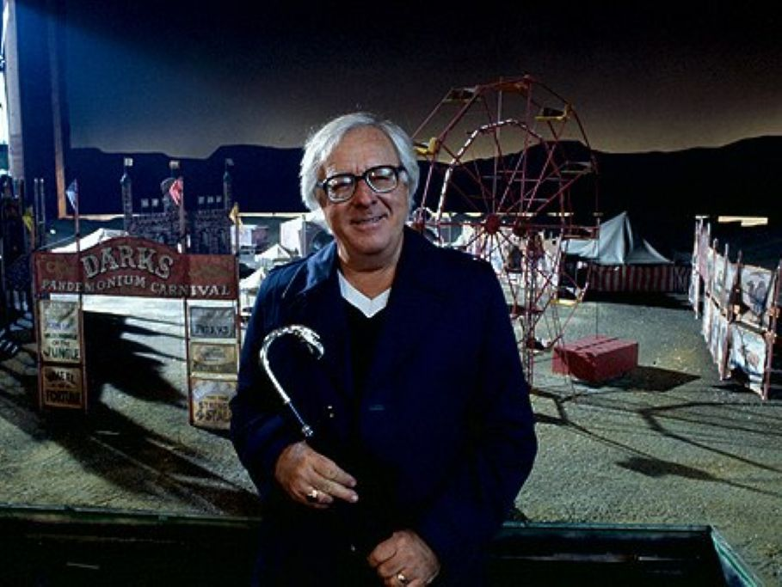

The Town Where No One Got Off, Ray Bradbury

The Town Where No One Got Off

Crossing the continental United States by night, by day, on the train, you flash past town after wilderness town where nobody ever gets off. Or rather, no person who doesn’t belong, no person who hasn’t roots in these country graveyards ever bothers to visit their lonely stations or attend their lonely views.

I spoke of this to a fellow passenger, another salesman like myself, on the Chicago-Los Angeles train as we crossed Iowa.

‘True,’ he said. ‘People get off in Chicago; everyone gets off there. People get off in New York, get off in Boston, get off in L.A. People who don’t live there go there to see and come back to tell. But what tourist ever just got off at Fox Hill, Nebraska, to look at it? You? Me? No! I don’t know anyone, got no business there, it’s no health resort, so why bother?’

‘Wouldn’t it be a fascinating change,’ I said, ‘some year to plan a really different vacation? Pick some village lost on the plains where you don’t know a soul and go there for the hell of it?’

‘You’d be bored stiff.’

‘I’m not bored thinking of it!’ I peered out the window. ‘What’s the next town coming up on this line?’

‘Rampart Junction.’

I smiled. ‘Sounds good. I might get off there.’

‘You’re a liar and a fool. What you want? Adventure? Romance? Go ahead, jump off the train. Ten seconds later you’ll call yourself an idiot, grab a taxi, and race us to the next town.’

‘Maybe.’

I watched telephone poles flick by, flick by, flick by. Far ahead I could see the first faint outlines of a town.

‘But I don’t think so,’ I heard myself say.

The salesman across from me looked faintly surprised.

For slowly, very slowly, I was rising to stand. I reached for my hat. I saw my hand fumble for my one suitcase. I was surprised myself.

‘Hold on!’ said the salesman. ‘What’re you doing?’

The train rounded a curve suddenly. I swayed. Far ahead I saw one church spire, a deep forest, a field of summer wheat.

‘It looks like I’m getting off the train,’ I said.

‘Sit down,’ he said.

‘No,’ I said. ‘There’s something about that town up ahead. I’ve got to go see. I’ve got the time. I don’t have to be in L.A., really, until next Monday. If I don’t get off the train now, I’ll always wonder what I missed, what I let slip by when I had the chance to see it.’

‘We were just talking. There’s nothing there.’

‘You’re wrong,’ I said. ‘There is.’

I put my hat on my head and lifted the suitcase in my hand.

‘By God,’ said the salesman, ‘I think you’re really going to do it.’

My heart beat quickly. My face was flushed.

The train whistled. The train rushed down the track. The town was near!

‘Wish me luck,’ I said.

‘Luck!’ he cried.

I ran for the porter, yelling.

There was an ancient flake-painted chair tilted back against the stationplatform wall. In this chair, completely relaxed so he sank into his clothes, was a man of some seventy years whose timbers looked as if he’d been nailed there since the station was built. The sun had burned his face dark and tracked his cheek with lizard folds and stitches that held his eyes in a perpetual squint.

His hair smoked ash-white in the summer wind. His blue shirt, open at the neck to show white clock springs, was bleached like the staring late afternoon sky. His shoes were blistered as if he had held them, uncaring, in the mouth of a stove, motionless, forever. His shadow under him was stenciled a permanent black.

As I stepped down, the old man’s eyes flicked every door on the train and stopped, surprised, at me.

I thought he might wave.

But there was only a sudden coloring of his secret eyes; a chemical change that was recognition. Yet he had not twitched so much as his mouth, an eyelid, a finger. An invisible bulk had shifted inside him.

The moving train gave me an excuse to follow it with my eyes. There was no one else on the platform. No autos waited by the cobwebbed, nailed-shut office. I alone had departed the iron thunder to set foot on the choppy waves of platform lumber.

The train whistled over the hill.

Fool! I thought. My fellow passenger had been right. I would panic at the boredom I already sensed in this place. All right, I thought, fool, yes, but run, no!

I walked my suitcase down the platform, not looking at the old man. As I passed, I felt his thin bulk shift again, this time so I could hear it. His feet were coming down to touch and tap the mushy boards.

I kept walking.

‘Afternoon,’ a voice said faintly.

I knew he did not look at me but only at that great cloudless spread of shimmering sky.

‘Afternoon,’ I said.

I started up the dirt road toward the town. One hundred yards away, I glanced back.

The old man, still seated there, stared at the sun, as if posing a question.

I hurried on.

I moved through the dreaming late afternoon town, utterly anonymous and alone, a trout going upstream, not touching the banks of a clearrunning river of life that drifted all about me.

My suspicions were confirmed: it was a town where nothing happened, where occurred only the following events:

At four o’clock sharp, the Honneger Hardware door slammed as a dog came out to dust himself in the road. Four-thirty, a straw sucked emptily at the bottom of a soda glass, making a sound like a great cataract in the drugstore silence. Five o’clock, boys and pebbles plunged in the town river. Five-fifteen, ants paraded in the slanting light under some elm trees.

And yet—I turned in a slow circle—somewhere in this town there must be something worth seeing. I knew it was there. I knew I had to keep walking and looking. I knew I would find it.

I walked. I looked.

All through the afternoon there was only one constant and unchanging factor: the old man in the bleached blue pants and shirt was never far away. When I sat in the drugstore he was out front spitting tobacco that rolled itself into tumblebugs in the dust. When I stood by the river he was crouched downstream making a great thing of washing his hands.

Along about seven-thirty in the evening, I was walking for the seventh or eighth time through the quiet streets when I heard footsteps beside me.

I looked over, and the old man was pacing me, looking straight ahead, a piece of dried grass in his stained teeth.

‘It’s been a long time,’ he said quietly.

We walked along in the twilight.

‘A long time,’ he said, ‘waitin’ on that station platform.’

‘You?’ I said.

‘Me.’ He nodded in the tree shadows.

‘Were you waiting for someone at the station?’

‘Yes,’ he said. ‘You.’

‘Me?’ The surprise must have shown in my voice. ‘But why…? You never saw me before in your life.’

‘Did I say I did? I just said I was waitin’.’

We were on the edge of town now. He had turned and I had turned with him along the darkening riverbank toward the trestle where the night trains ran over going east, going west, but stopping rare few times.

‘You want to know anything about me?’ I asked suddenly. ‘You the sheriff?’

‘No, not the sheriff. And no, I don’t want to know nothin’ about you.’ He put his hands in his pockets. The sun was set now. The air was suddenly cool. ‘I’m just surprised you’re here at last, is all.’

‘Surprised?’

‘Surprised,’ he said, ‘and…pleased.’

I stopped abruptly and looked straight at him.

‘How long have you been sitting on that station platform?’

‘Twenty years, give or take a few.’

I knew he was telling the truth; his voice was as easy and quiet as the river.

‘Waiting for me?’ I said.

‘Or someone like you,’ he said.

We walked on in the growing dark.

‘How you like our town?’

‘Nice, quiet,’ I said.

‘Nice, quiet.’ He nodded. ‘Like the people?’

‘People look nice and quiet.’

‘They are,’ he said. ‘Nice, quiet.’

I was ready to turn back but the old man kept talking and in order to listen and be polite I had to walk with him in the vaster darkness, the tides of field and meadow beyond town.

‘Yes,’ said the old man, ‘the day I retired, twenty years ago, I sat down on that station platform and there I been, sittin’, doin’ nothin’, waitin’ for somethin’ to happen, I didn’t know what, I didn’t know, I couldn’t say. But when it finally happened, I’d know it, I’d look at it and say, Yes, sir, that’s what I was waitin’ for. Train wreck? No. Old woman friend come back to town after fifty years? No. No. It’s hard to say. Someone. Somethin’. And it seems to have somethin’ to do with you. I wish I could say—’

‘Why don’t you try?’ I said.

The stars were coming out. We walked on.

‘Well,’ he said slowly, ‘you know much about your own insides?’

‘You mean my stomach or you mean psychologically?’

‘That’s the word. I mean your head, your brain, you know much about that?’

The grass whispered under my feet. ‘A little.’

‘You hate many people in your time?’

‘Some.’

‘We all do. It’s normal enough to hate, ain’t it, and not only hate but, while we don’t talk about it, don’t we sometimes want to hit people who hurt us, even kill them?’

‘Hardly a week passes we don’t get that feeling,’ I said, ‘and put it away.’

‘We put away all our lives,’ he said. ‘The town says thus and so, Mom and Dad say this and that, the law says such and such. So you put away one killin’ and another and two more after that. By the time you’re my age, you got lots of that kind of stuff between your ears. And unless you went to war, nothin’ ever happened to get rid of it.’

‘Some men trapshoot or hunt ducks,’ I said. ‘Some men box or wrestle.’

‘And some don’t. I’m talkin’ about them that don’t. Me. All my life I’ve been saltin’ down those bodies, puttin ’em away on ice in my head. Sometimes you get mad at a town and the people in it for makin’ you put things aside like that. You like the old cave men who just gave a hell of a yell and whanged someone on the head with a club.’

‘Which all leads up to…?’

‘Which all leads up to: Everybody’d like to do one killin’ in his life, to sort of work off that big load of stuff, all those killin’s in his mind he never did have the guts to do. And once in a while a man has a chance. Someone runs in front of his car and he forgets the brakes and keeps goin’. Nobody can prove nothin’ with that sort of thing. The man don’t even tell himself he did it. He just didn’t get his foot on the brake in time. But you know and I know what really happened, don’t we?’

‘Yes,’ I said.

The town was far away now. We moved over a small stream on a wooden bridge, just near the railway embankment.

‘Now,’ said the old man, looking at the water, ‘the only kind of killin’ worth doin’ is the one where nobody can guess who did it or why they did it or who they did it to, right? Well, I got this idea maybe twenty years ago.

I don’t think about it every day or every week. Sometimes months go by, but the idea’s this: Only one train stops here each day, sometimes not even that. Now, if you wanted to kill someone you’d have to wait, wouldn’t you, for years and years, until a complete and actual stranger came to your town, a stranger who got off the train for no reason, a man nobody knows and who don’t know nobody in the town.

Then, and only then, I thought, sittin’ there on the station chair, you could just go up and when nobody’s around, kill him and throw him in the river. He’d be found miles downstream. Maybe he’d never be found.

Nobody would ever think to come to Rampart Junction to find him. He wasn’t goin’ there. He was on his way someplace else. There, that’s my whole idea. And I’d know that man the minute he got off the train. Know him, just as clear…’

I had stopped walking. It was dark. The moon would not be up for an hour.

‘Would you?’ I said.

‘Yes,’ he said. I saw the motion of his head looking at the stars. ‘Well, I’ve talked enough.’ He sidled close and touched my elbow. His hand was feverish, as if he had held it to a stove before touching me. His other hand, his right hand, was hidden, tight and bunched, in his pocket. ‘I’ve talked enough.’

Something screamed.

I jerked my head.

Above, a fast-flying night express razored along the unseen tracks, flourished light on hill, forest, farm, town dwellings, field, ditch, meadow, plowed earth and water, then, raving high, cut off away, shrieking, gone. The rails trembled for a little while after that. Then, silence.

The old man and I stood looking at each other in the dark. His left hand was still holding my elbow. His other hand was still hidden.

‘May I say something?’ I said at last.

The old man nodded.

‘About myself,’ I said. I had to stop. I could hardly breathe. I forced myself to go on. ‘It’s funny. I’ve often thought the same way as you. Sure, just today, going cross-country, I thought, How perfect, how perfect, how really perfect it could be. Business has been bad for me, lately. Wife sick. Good friend died last week. War in the world. Full of boils, myself. It would do me a world of good—’

‘What?’ the old man said, his hand on my arm.

‘To get off this train in a small town,’ I said, ‘where nobody knows me, with this gun under my arm, and find someone and kill them and bury them and go back down to the station and get on and go home and nobody the wiser and nobody ever to know who did it, ever. Perfect. I thought, a perfect crime. And I got off the train.’

We stood there in the dark for another minute, staring at each other. Perhaps we were listening to each other’s hearts beating very fast, very fast indeed.

The world turned under me. I clenched my fists. I wanted to fall. I wanted to scream like the train.

For suddenly I saw that all the things I had just said were not lies put forth to save my life.

All the things I had just said to this man were true.

And now I knew why I had stepped from the train and walked up through this town. I knew what I had been looking for.

I heard the old man breathing hard and fast. His hand was tight on my arm as if he might fall. His teeth were clenched. He leaned toward me as I leaned toward him. There was a terrible silent moment of immense strain as before an explosion.

He forced himself to speak at last. It was the voice of a man crushed by a monstrous burden.

‘How do I know you got a gun under your arm?’

‘You don’t know.’ My voice was blurred. ‘You can’t be sure.’

He waited. I thought he was going to faint.

‘That’s how it is?’ he said.

‘That’s how it is,’ I said.

He shut his eyes tight. He shut his mouth tight.

After another five seconds, very slowly, heavily, he managed to take his hand away from my own immensely heavy arm. He looked down at his right hand then, and took it, empty, out of his pocket.

Slowly, with great weight, we turned away from each other and started walking blind, completely blind, in the dark.

The midnight passenger-to-be-picked-up flare sputtered on the tracks. Only when the train was pulling out of the station did I lean from the open Pullman door and look back.

The old man was seated there with his chair tilted against the station wall, with his faded blue pants and shirt and his sun-baked face and his sun-bleached eyes. He did not glance at me as the train slid past.

He was gazing east along the empty rails where tomorrow or the next day or the day after the day after that, a train, some train, any train, might fly by here, might slow, might stop. His face was fixed, his eyes were blindly frozen, toward the east. He looked a hundred years old.

The train wailed.

Suddenly old myself, I leaned out, squinting.

Now the darkness that had brought us together stood between. The old man, the station, the town, the forest, were lost in the night.

For an hour I stood in the roaring blast staring back at all that darkness.

The end