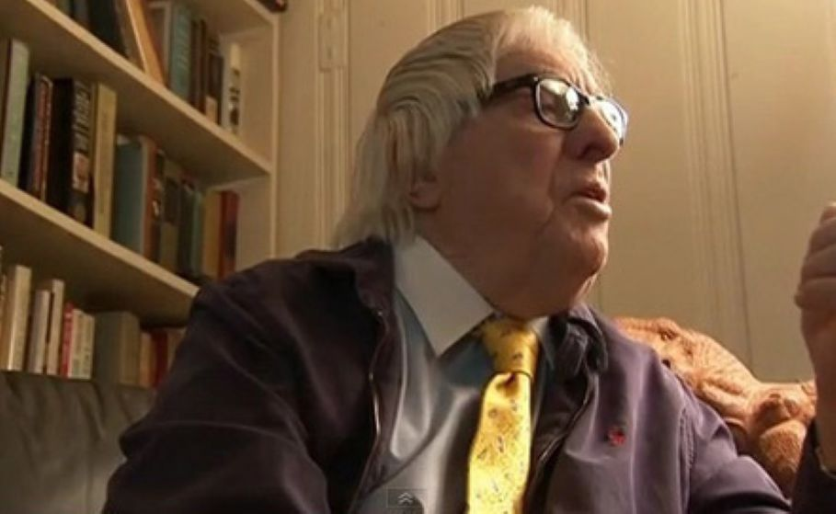

The Vacation, Ray Bradbury

The Vacation

It was a day as fresh as grass growing up and clouds going over and butterflies coming down can make it.

It was a day compounded from silences of bee and flower and ocean and land, which were not silences at all, but motions, stirs, flutters, risings, fallings, each in its own time and matched rhythm. The land did not move, but moved. The sea was no still, yet was still.

Paradox flowed into paradox, stillness mixed with stillness, sound with sound.

The flowers vibrated and the bees fell in separate and small showers of golden rain on the clover.

The seas of hill and the seas of oceans were divided, each from the other's motion, by a rail road track, empty, compounded of rust and iron marrow, track on which, quite obviously, no train had run in many years.

Thirty miles north it swirled on away to further miles of distance, thirty miles south it tunneled islands of cloud shadow that changed their continental positions on the side of far mountains as you watched.

Now, suddenly, the railroad track began to tremble. A blackbird, standing on the rail, felt a rhythm grow, faintly, miles away, like a heart beginning to beat.

The blackbird leaped up over the sea. The rail continued to vibrate softly until, at long last around a curve and along the shore came a small handcar, its two-cylinder engine popping and spluttering in the great silence.

On top of this small four-wheeled car, on a double-side bench facing in two directions and with a little surrey row above for shade, sat a man, his wife and their small seven year-old son.

As the handcar traveled through lonely stretch after lonely stretch, the wind whipped their eyes and blew their hair, but they did not look back but only ahead. Sometimes they looked eagerly as a curve unwound itself, sometimes with great sadness, but always watchful, ready for the next scene.

As they hit a level straightaway, the machine engine gasped and stopped abruptly. In the now crushing silence, it seemed that the quiet of earth, sky and sea itself, by its friction, brought the car to a wheeling halt.

"Out of gas." The man, sighing, reached for the extra can in the small storage bin and began to pour it into the tank.

His wife and son sat quietly looking at the sea, listening to the muted thunder, the whisper, the drawing back of huge tapestries of sand, gravel, green weed, and foam. "Isn't the sea nice?" said the woman.

"I like it," said the boy. "Shall we picnic here, while we're at it?"

The man focused some binoculars on the green peninsula ahead.

"Might as well. The rails have rusted badly. There's a break ahead. We may have to wait while I set a few back in place."

"As many as there are," said the boy, "we’ll have picnics!"

The woman tried to smile at this, then turned her grave attention to the man. "How far have we come today?"

"Not ninety miles." The man still peered through the glasses, squinting, "I don't like to go farther than that any one day, anyway. If you rush, there's no time to see. We’ll reach Monterey day after tomorrow, Palo Alto the next day, if you want."

The woman removed her great shadowing straw bat, which had been tied over her golden hair with a bright yellow ribbon, and stood perspiring faintly, away from the machine. They had ridden so steadily on the shuddering rail car that the motion was sewn into their bodies.

Now, with the stopping, they felt odd, on the verge of unraveling.

"Let’s eat!" The boy ran the wicker lunch basket down to the shore.

The boy and the woman were already seated by a spread tablecloth when the man came down to them, dressed in his business suit and vest and tie and hat as if he expected to meet someone along the way.

As he dealt out the sandwiches and exhumed the pickles from their cool green Mason jars, he began to loosen his tie and unbutton his vest, always looking around as if he should be careful and ready to button up again.

"Are we all alone, Papa?" said the boy, eating.

"Yes.

"No one else, anywhere?"

"No one else."

"Were there people before?"

"Why do you keep asking that? It wasn't that long ago. Just a few months. You remember."

"Almost. If I try hard, then I don't remember at all." The boy let a handful of sand fall through his fingers. "Were there as many people as there is sand here on the beach? What happened to them?" "I don't know," the man said, and it was true.

They had wakened one morning and the world was empty. The neighbors' clothesline was still strung with blowing white wash, cars gleamed in front of other 7-A.m. cottages, but there were no farewells, the city did not hum with it mighty arterial traffics, phones did not alarm themselves children, did not wail in sunflower wildernesses.

Only the night before, he and his wife had been sitting at the front porch when the evening paper was delivered, and not even daring to open the headlines out, he had said, "I wonder when He will get tired of us and just rub us all out?"

"It has gone pretty far," she said. "On and on. We're such fools, aren't we?"

"Wouldn't it be nice-" he lit his pipe and puffed it "if we woke tomorrow and everyone in the world was gone and everything was starting over?" He sat smoking, the paper folded in his hand, his head resting back on the chair.

"If you could press a button right now and make it happen, would you?"

"I think I would," he said. "Nothing violent. Just hey everyone vanish off the face of the earth. Just leave the land and the sea and the growing things, like flowers and grass and fruit trees. And the animals, of course, let them stay. Everything except man, who hunts when he isn't hungry, cruel when full, and is mean when no one's bothered him."

"Naturally, we would be left." She smiled quietly.

"I’d like that," he mused. "All of time ahead. The longest summer vacation in history. And us out for the longest picnic-basket lunch in memory. Just you, me and Jim. No commuting. No keeping up with the Joneses.

Not even a car, I’d like to find another way of traveling, an older way. Then, a hamper full of sandwiches, three bottles of pop, pick up supplies where you need them from empty grocery stores in empty towns, and summertime forever up ahead ..."

They sat a long while on the porch in silence, the newspaper folded between them.

At last she opened her mouth. "Wouldn't we be lonely?" she said.

So that's how it was the morning of the new world. They had awakened to the soft sounds of an earth that was now no more than a meadow, and the cities of the earth sinking back into seas of saber-grass, marigold, marguerite and morning-glory. They had taken it with remarkable calm at first, perhaps because they had not liked the city for so many years, and had had so many friends who were not truly friends, and had lived a boxed and separate life of their own within a mechanical hive.

The husband arose and looked out the window and observed very calmly, as if it were a weather condition, "Everyone's gone," knowing this just by the sounds the city had ceased to make.

They took their time over breakfast, for the boy was still asleep, and then the husband sat back and said, "Now I must plan what to do."

"Do? Why ... why, you'll go to work, of course."

"You still don't believe it, do you?" He laughed. "That I won't be rushing off each day at eight-ten, that Jim won't go to school again ever. Schools are out for all of us! No more pencils, no more books, no more boss’s sassy looks! We’re let out, darling, and we'll never come back to the silly damn dull routines. Come on!" And he had walked her through the still and empty city streets.

"They didn’t die," he said. "They just went away."

"What about the other cities?" He went to an outdoor phone booth and dialed Chicago, then New York, then San Francisco.

Silence, Silence. Silence.

"That’s it," he said, replacing the receiver.

"I feel guilty," she said. "Them gone and us here. And I feel happy. Why? I should be unhappy."

"Should you? There's no tragedy. They weren't tortured or blasted or burned. They went easily and they didn't know. And now we owe nothing to no-one. Our only responsibility is being happy. Thirty more years of happiness, wouldn't that be good?"

"But... then we must have more children!"

"To repopulate the world?" He shook his head slowly, calmly. "No. Let Jim be the last. After he's grown and gone let the horses and cows and ground squirrels and garden spiders have the world.

They'll get on. And someday some other species that can combine a natural happiness with a natural curiosity will build cities that won't even look like cities to us, and survive. Right now, let's go pack a basket, wake Jim, and get going on that long thirty-year summer vacation. I'll beat you to the house!"

He took a sledge hammer from the small rail car, and while he worked alone for half an hour fixing the rusted rails into place the woman and the boy ran along the shore.

They came back with dripping shells, a dozen or more, and some beautiful pink pebbles, and sat and the boy took school from the mother, doing homework on a pad with a pencil for a time, and then at high noon the man came down, his coat off, his tie thrown aside, and they drank orange pop, watching the bubbles surge up, glutting, inside the bottles. It was quiet.

They listened to the sun time the old iron rails. The smell of hot tar on the ties moved about them in the salt wind, as the husband tapped his atlas map lightly and gently.

"We'll go to Sacramento next month, May, then work up toward Seattle. Should make that by July first, July's a good month in Washington, then back down as the weather cools, to Yellowstone, a few miles a day, hunt here, fish there..."

The boy, bored, moved away to throw sticks into the sea and wade out like a dog to retrieve them.

The man went on: "Winter in Tucson, then, part of the winter, moving toward Florida, up the coast in the spring, and maybe New York by June. Two years from now, Chicago in the summer.

Winter, three years from now, what about Mexico City? Anywhere the rails lead us, anywhere at all and if we come to an old offshoot rail line we don't know anything about, what the hell, we'll just take it, go down it, to see where it goes.

And some year, by God, we'll boat down the Mississippi, always wanted to do that. Enough to cost us a lifetime. And that's just how long I want to take to do it all..."

His voice faded. He started to fumble the map shut, but, before he could move, a bright thing fell through the air and hit the paper.

It rolled off into the sand and made a wet lump.

His wife glanced at the wet place in the sand and then swiftly searched his face. His solemn eyes were too bright. And down one cheek was a track of wetness.

She gasped. She took his hand and held it, tight. He clenched her hand very hard, his eyes shut now, and slowly he said, with difficulty, "Wouldn’t it be nice if we went to sleep tonight and in the night, somehow, it all came back.

All the foolishness, all the noise, all the hate, all the terrible things, all the nightmares, all the wicked people and stupid children, all the mess, all the smallness, all the confusion, all the hope, all the need, all the love. Wouldn't it be nice."

She waited and nodded her head once.

Then both of them started.

For standing between them, they knew not for how long, was their son, an empty pop bottle in one hand.

The boy's face was pale. With his free hand he reached out to touch his father's cheek, where the single tear had made its track.

"You," he said. "Oh, Dad, you.. You haven’t anyone to play with, either."

The wife started to speak. The husband moved to take the boy's hand.

The boy jerked back. "Silly! Oh, silly! Silly fools! Oh, you dumb, dumb!" And, whirling, he rushed down to the ocean and stood there crying loudly.

The wife rose to follow, but the husband stopped her. "No. Let him."

And then they both grew cold and quiet. For the boy, below on the shore, crying steadily, now was writing on a piece of paper and stuffing it in the pop bottle and ramming the tin cap back on and taking the bottle and giving it a great glittering heave up in the air and out into the tidal sea.

What, thought the wife, what did he write on the note? What's in the bottle?

The bottle moved out in the waves. The boy stopped crying.

After a long while he walked up the shore, to stand looking at his parents. His face was neither bright nor dark, alive nor dead, ready nor resigned; it seemed a curious mixture that simply made do with time, weather and these people. They looked at him and beyond to the bay, where the bottle taming the scribbled note was almost out of sight now, shining in the waves.

Did he write what we wanted? thought the woman, did he write what he heard us just wish, just say?

Or did he write something for only himself, she wondered, that tomorrow he might wake and find himself alone in an empty world, no one around, no man, no woman, no father, no mother, no fool grownups with fool wishes, so he could trudge up to the railroad tracks and take the handcar motoring, a solitary boy, across the continental wilderness, on eternal voyages and picnics?

Is that what he wrote in the note? Which? She searched his colorless eyes, could not read the answer; dared not ask.

Gull shadows sailed over and kited their faces with sudden passing coolness. "Time to go," someone said.

They loaded the wicker basket onto the rail car. The woman tied her large bonnet securely in place with its yellow ribbon, they set the boy's pail of shells on the floorboards, then the husband put on his tie, his vest, his coat, his hat, and they all sat on the benches of the car looking out at the sea where the bottled note was far out, blinking, on the horizon. "Is asking enough?" said the boy. "Does wishing work?"

"Sometimes ... too well."

"It depends on what you ask for."

The boy nodded, his eyes far away. They looked back at where they had come from, and then ahead to where they were going. "Goodbye, place," said the boy, and waved.

The car rolled down the rusty rails. The sound of it dwindled, faded.

The man, the woman, the boy dwindled with it in distance, among the hills.

After they were gone, the rail trembled faintly for two minutes, and ceased. A flake of rust fell. A flower nodded.

The sea was very loud.

1963

The end