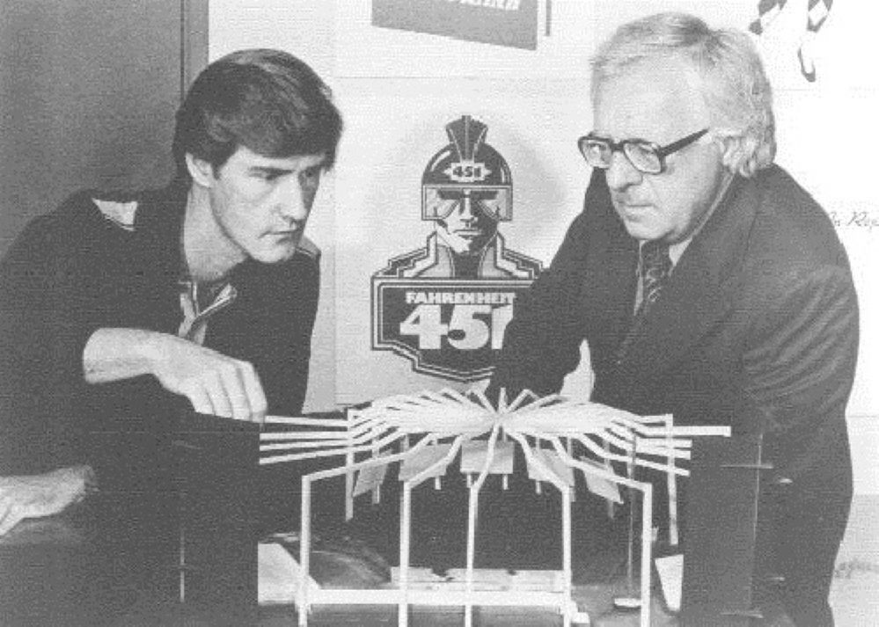

Thunder in the Morning, Ray Bradbury

Thunder in the Morning

At first it was like a storm, far away, a touch of thunder, a kind of wind and a stirring. The streets had been emptied by the courthouse clock. People had looked at the great white clock face hours ago, folded their newspapers, got up from the porch swings, hooked themselves into their summer night houses, put out the lights, and settled into cool beds.

All this the clock had done, just standing above the courthouse green. Now there was not a thing on the street. Overhead street lights, casting down illumination, made shines upon the asphalt.

On occasion a leaf would break loose from a tree and clatter down. The night was so dark you could not see the stars. Why this was so there was no way of telling. Except that everyone's eyes were closed and that way no stars were seen, that's how dark the night was.

Oh, here and there, behind a window screen, if one peered into a dark room, one might see a red point of light, nothing else; some man sitting up to feed his insomnia with nicotine, rocking in a slow rocker in the dark room.

You might hear a small cough or someone turn under the sheets. But on the street there was not even a policeman swinging along with his club pointed to the earth in one hand.

From far away the small thunder began. First it was far across town. You could hear it across the ravine, going along the street over there, three blocks away across the deep blackness.

It took a direction, it made square cuts, this sound of thunder, then it crossed over the ravine on the Washington Street bridge, under the owl light, and turned a corner and—there it was, at the head of the street!

And with a whiskering, brushing, sucking noise down the street between the houses and trees came the thundering metal cleaning machine of Mr. Britt. It was a tornado, funneling, driving, whispering, murmuring, feeling of the street ahead of it with big whirl-around brushes like sewer lids with rotary brushes under them, spinning, with a big rolling-pin brush turning under all the scattered trivia of the world's men, the ticket stubs from that show at the Elite tonight, and the wrapper from a chewing gum stick that now rested on top of a bureau in one of the houses, a small chewed cannonball of tasteless elasticity, and the candy wrapper from a bar now hidden and folded into the small accordion innards of a boy high in a cupola house in a magic room.

All these things, streetcar transfers to Chessman Park, to Live Oak Mortuary, to North Chicago, to Zion City, giveaway handbills on hairdos at that new chromium shop on Central. All these were whiskered up by the immense moving mustache of the machine, and on top of the machine, like a great god, in his leather-metal saddle, sat Mr. Roland Britt, age thirty-seven, the strange age between yesterday and tomorrow, and he, in his way, was a duplicate of the machine upon which he rode, with his proud hands on the steering wheel.

He had a little curly mustache over his mouth, and little curly hairs that seemed to rotate upon his scalp under the passing lamps, and a little sucking nose that was continually astonished with the world, sucking it all in and blowing it out the astonished mouth.

And he had hands that were always taking things and never giving at all. He and the machine, very much the same. They hadn't begun that way. Britt had neverstartedto be like the machine. But after you rode it awhile it got up through your rump and spread through your system until your digestion roiled and your heart spun like a small pink top in you. But, on the other hand, neither had the machine intended being like Britt. Machines change also, and become like their masters, in imperceptible ways.

The machine was gentler than it used to be under an Irishman named Reilly. They sailed down the midnight streets together, through little streams of water ahead of them to dampen the trivia before combing it into its gullet.

It was like a whale, with a mouth full of bristle, swimming in the moonlight seas, slaking in ticket minnows and gum-wrapper minnows, feeding and feeding in the silvery school of confetti that lived in the shallows of the asphalt river. Mr. Britt felt like a Greek god, even with his concave chest, bringing gentle April showers with him with the sprinklers, cleansing the world of dropped sin.

Halfway up Elm Road, whiskers bristling, great mustache hungrily eating of the street, Mr. Britt, in a fit of sport, swerved his great storm machine from one side of the street to the other, just so he could suck up a rat.

"Got him!"

Mr. Britt had seen the large running gray thing, leprous and horrible, skittering across under a lamp flare. Whisk! And the foul rodent was now inside the machine, being digested by smothering tides of paper and autumn leaf.

He went on down the lonely rivers of night, bringing and taking his storm with him, leaving fresh-whisked and wetted marks behind him.

"Me and my magical broomstick," he thought. "Me a male witch riding under the autumn moon. A good witch. The good witch of the East; wasn't that it, from the old Oz book when I was six with whooping cough in bed?"

He passed over innumerable hopscotch squares which had been made by children drunk with happiness, they were so crooked. He sucked up red playbills and yellow pencils and dimes and sometimes quarters.

"What was that?"

He turned upon his seat and looked behind.

The street was empty. Dark trees whirled past, swishing down branches to tap his brow, swiftly, swiftly. But in the midst of the stiff thunder he had thought he heard a cry for help, a kind of violent screaming.

He looked in all directions.

"No, nothing."

He rode on upon the whirl-away brooms.

"What!"

This time he almost fell from his saddle the cry was so apparent. He looked at the trees to see if some man might be up one, yelling. He looked at the pale streetlights, all bleached out with so many years of shining. He looked at the asphalt, still warm from the heat of the day. The cry came again.

They were on the edge of the ravine. Mr. Britt stopped his machine. The bristles still spun about. He stopped one rotary broom, then the other. The silence was very loud.

"Get me out of here!"

Mr. Britt stared back at the big metal storage tank of the machine.

There was a man inside the machine.

"What did you say?" It was a ridiculous thing to ask, but Mr. Britt asked it.

"Get me out of here, help, help!" said the man inside the machine.

"What happened?" asked Mr. Britt, staring.

"You picked me up in your machine!" cried the man.

"I what?"

"You fool; don't stand there talking, let me out, I'll suffocate to death!"

"But you couldn't possibly have gotten into the machine," said Mr. Britt. He stood first on one foot, then on another. He was very cold, suddenly. "A thing as big as a man couldn't fit in up through the vent, and anyway, the whiskers would have prevented you from behind taken in, and anyway I don't remember seeing you. When did this happen?"

There was a silence from the machine.

"When did this happen?" demanded Mr. Britt.

Still no answer. Mr. Britt tried to think back. The streets had been entirely empty. There had been nothing but leaves and gum-wrappers. There had been no man, anywhere. Mr. Britt was a thoroughly clear-eyed man. He wouldn't miss a pedestrian if one fell.

Still the machine remained strangely silent. "Are you there?" said Mr. Britt.

"I'm here," said the man inside, reluctantly. "And I'm suffocating."

"Answer me, when did you get inside the machine?" said Britt.

"A while ago," said the man.

"Why didn't you scream out then?"

"I was knocked unconscious," said the man, but there was a quality to his voice, a hesitation, a vagueness, a slowness. The man was lying. It came to Mr. Britt as a shock. "Open up the top," said the inside man. "For God's sake, don't stand there like a fool talking, of all the ridiculous inanities, a street cleaner at midnight talking to a man inside his machine, what would people think." He paused to cough violently and spit and sputter. "I'm choking to death, do you want to go up for manslaughter?"

But Mr. Britt was not listening. He was down on his knees looking at the metal equipment, at the brushes under the machine. No, it was quite impossible. That opening was only a foot across, under there, no man could possibly be poked up into it. And anyway he hadn't been going fast. And anyway the rotary brushes would have bounced a man ahead of the machine. And anyway, he hadn'tseena man!

He got to his feet. He noticed for the first time that the top of his forehead was all perspiration. He wiped it off. His hands were trembling. He could hardly stand up.

"Open up, and I'll give you a hundred dollars," said the man inside the machine.

"Why should you be bribing me to let you out?" said Mr. Britt. "When it is only natural that I should let you outfree,after all, if I picked you up I should let you out, shouldn't I? And yet, all of a sudden, you start offering me money, as if I didn'tintendto let you out, as if you knew that I might know a reason fornotletting you out. Why is that?"

"I'm dying," coughed the man, "and you debate. God, God, man!" There was a fierce wrestling and a pounding inside. "This place in here is full of dirt and leaves and paper. I can'tmove!"

Mr. Britt stood there. "It isnot possible," he said, clearly and firmly,atlast, "that a man could be in my machine. I know my machine. You do not belong in there. I did not ask you to be in there. It is your responsibility."

"Bend closer … "

"What?"

"Listen!"

He put his ear to the warm metal.

"I am here," whispered the high voice, the sweet high fading voice. "I am in here and I wear no clothes."

"What!"

He felt his hands jerk, his fingers twitch in on themselves. He felt his eyes squeeze up almost to blind him.

"I am in here and I have no clothes," said the voice. And after a long while, "Don't you want to see me? Don't you? Don't you want to see me? I'm in here now. I'm waiting … "

He stood by the side of the great machine for a full ten seconds. The echo of his breathing jumped off the metal a foot from his face.

"Did you hear what I said?" whispered the voice.

He nodded.

"Well then, open the lid. Let me out. It's late. Late at night. Everyone asleep. Dark. We'll be alone … "

He listened to his heart beating.

"Well?" said the voice.

He swallowed.

"What are you waiting for?" said the voice, lasciviously.

The sweat rolled down his face.

There was no answer. The fierce breathing that had been in the machine for a while now suddenly stopped. The thrashing stopped.

Mr. Britt leaned forward, put his ear to the machine.

He could hear nothing now but a kind of soft inner squeaking under the lid. And a sound like one hand, cut off from the body perhaps, moving, struggling by itself. It sounded like a small thing moving.

"I climbed in to sleep," said the man.

"Oh, now youarelying," said Mr. Britt.

He climbed up on his silent machine and sat in the leather saddle. He put his foot down to start the motor.

"What are you doing?" the voice shouted from under the lid suddenly. There was a dull stir. There was a sound as of a large body again. The heavy breathing returned. It was so sudden it made Mr. Britt almost fall from his perch. He looked back at the lid.

"No, no, I won't let you out," he said.

"Why?" cried the failing voice.

"Because," said Mr. Britt, "I have my work to do." He started the machine and the whisking thunder of the brushes and the roar of the motor drowned out the screams and shouts of the captured man.

Looking ahead, eyes wet, hands hard on the wheel, Mr. Britt took his machine brooming down the silent avenues of the night town, for five minutes, ten minutes, half an hour, an hour, two hours more, sweeping and scouring and never stopping, sucking in tickets and combs and dropped soup-can labels.

At four in the morning, three hours later, he drew up before the vast rubbish heap that slid down the hill in a strange avalanche to the dark ravine. He backed the machine up to the edge of the avalanche and for a moment cut the motor.

There was not the slightest sound from inside the machine.

He waited, but there was nothing but the beat of his heart in his wrists.

He flipped a lever. The entire cargo of branches and dust and paper and tickets and labels and leaves fell back and piled in a neat pile upon the edge of the ravine. He waited until everything had slid out upon the ground. Then he flipped the lever, slamming the lid shut, looked back once at the silent mound of rubbish, and drove off down the street.

He lived only three houses from the ravine. He drove his machine up before his house, parked, and went in to bed. He lay in the quiet room, not able to sleep, from time to time getting up and going to look out the window at the ravine. Once he put his hand on the doorknob, half opened the door, shut it, and went back to bed. But he could not sleep.

It was only at seven in the morning as he was brewing some coffee, when he heard the sound, that he knew any relief. It was the sound of young Jim Smith, the thirteen-year-old boy, who lived across the ravine.

Young Jim came whistling down the street, on his way to the lake to fish. Every morning he came along in mists, whistling, and always he stopped to rummage through the rubbish left by Mr. Britt to seek dimes and quarters and orange bottle caps to pin to his shirtfront.

Mr. Britt moved the window curtains aside to peer out into the early dawn mists to see little Jim Smith walk jauntily by carrying a fish pole over one shoulder, and on the end of the line at the top of the fish pole, swinging back and forth like a gray pendulum in the mists, was a dead rat.

Mr. Britt drank his coffee, crept back in bed, and slept the sleep of the victorious and innocent.

The End