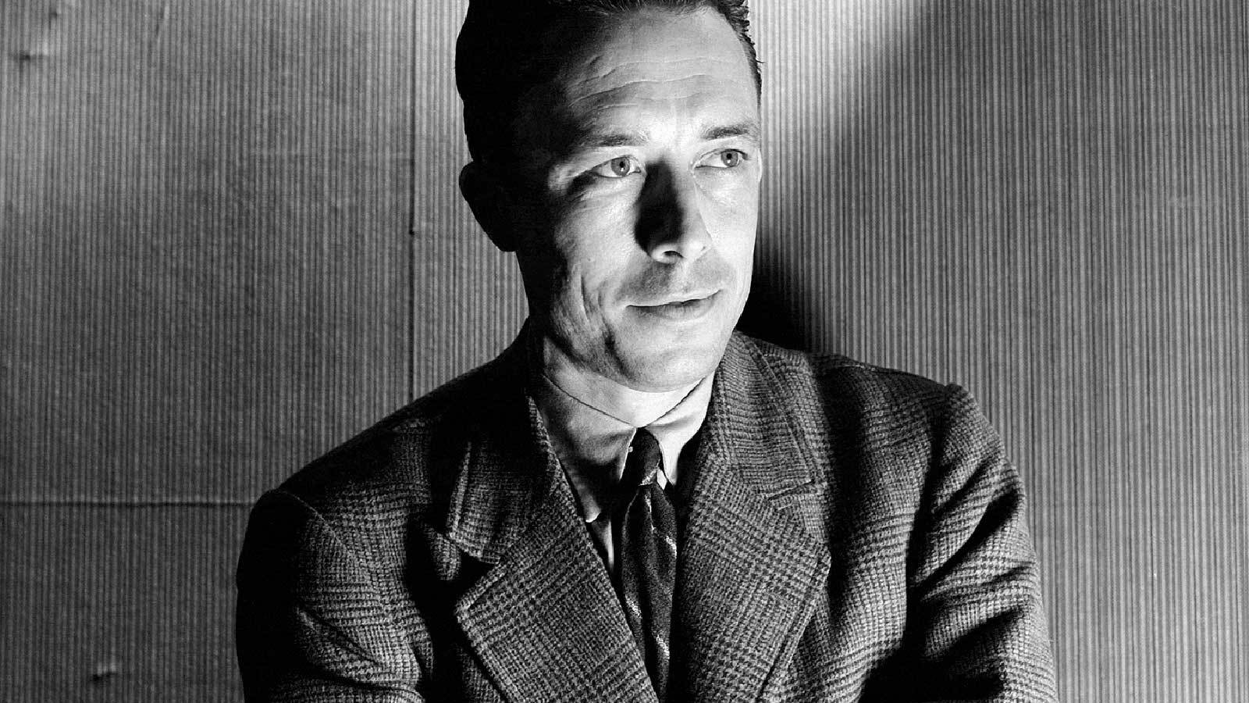

Education, Albert Camus

Education

The Kabyles’ thirst for learning and taste for study have become legendary. In addition to their natural predisposition to learning and practical intelligence, they quickly grasped the fact that education could be an instrument of emancipation. It is not unusual these days for a village to offer to provide a room or funding or free labor for the purpose of creating a school.

Nor is it unusual to see these offers remain without response from the authorities. And Kabyles are not just worried about educating boys. I have not visited a single major town in Kabylia without hearing how eager people are for girls’ schools as well. And there is not a single existing school anywhere in Kabylia that is not obliged to turn students away.

Indeed, a shortage of schools is the educational issue in Kabylia today. The region lacks schools, but it does not lack money for education. I will explain this paradox in a moment. Leaving aside the dozen large schools that have been built in recent years, most Kabyle schools date from the late nineteenth century, when the Algerian budget was decided in metropolitan France.

From 1892 to 1912, no schools were built in the region. At the time, the Joly-Jean-Marie Plan envisioned the construction of numerous schools at 5,000 francs apiece. On February 7, 1914, Governor General Lutaud formally announced that 22 new schools and 62 classrooms would be built in Algeria every year. Had these goals been even half realized, the 900,000 native children who are today without schools would have received an education.

For reasons that I need not go into here, the official plan was scrapped. I will summarize the results of this decision in one figure: today, only one-tenth of school-age Kabyle children actually attend school.

Does this mean that Algerian authorities neglected education entirely? The issue is complex. In a recent speech, M. Le Beau [the governor general] stated that several million francs had been devoted to native education, but the statistics I am about to give prove unequivocally that this spending has done little to improve matters. Hence, to put it bluntly, these millions were badly spent, as I propose to show in what follows. But let me describe the situation first.

As one might expect, the country’s economic and tourist centers are well served. What interests me here, however, is the fate of the douars and people of Kabylia. I might begin by observing that Tizi-Ouzou, which does have a fine native school with room for 600 students, turns away 500 prospective additional students every year.

In one school I visited in Oumalous, the teachers were forced this past October to turn away a dozen applicants for each class. And there were already 60–80 more students per class than the school was really equipped to handle.

In Beni-Douala, one class serves 86 pupils, some of whom must sit on the floor between benches or on the platform at the front of the room, while others are forced to stand. In Djemaa-Saridj, a splendid school with 250 students had to reject 50 additional applicants in October. The school in Adni, with 106 students, turned away another dozen after dismissing all students above the age of 13.

The situation in the vicinity Michelet is even more revealing. The Aguedal douar, with a population of 11,000, has only one school with two classrooms. The Ittomagh douar, with a population of 10,000 Kabyles, has no school at all. In Beni-Ouacif, the Bou-Abderrahmane school has just turned away more than 100 students.

The village of Aït-Aïlem has maintained a classroom for the past two years, but no teacher has yet been assigned to it.

In the Sidi-Aïch region, 200 prospective students turned up at the beginning of the term in the village of Vieux-Marché. Only 15 were accepted.

The douar of Ikedjane, with a population of 15,000, lacks even a single classroom. The douar of Timzrit, with a similar population, has a one-room schoolhouse. Iyadjadjène (pop. 5,000) has no school. Azrou-N’Bechar (pop. 6,000) has no school.

It has been estimated that 80 percent of the children in the region are deprived of education. I would translate this statistic by saying that nearly 10,000 Kabyle children are left to play every day in the mud of the gutters.

As for the commune of Maillot, I am looking at a list of schools per douar and per capita. Even though this essay is not intended for the society pages, I am afraid that it would be tedious to recount this information in detail. I will mention only that there are just nine classrooms in the region for 30,000 Kabyles. In the Dellys region, in the douar of Beni-Sliem, whose extreme poverty I described previously, there is not a single classroom for a population of 9,000.

The laudable decision of the colonial authorities to educate girls was taken only recently, and 9 out of 10 douars are surely not providing female education. It would be ungracious to try to assign responsibility for this failure. What needs to be said, however, is that Kabyles consider the education of girls to be extremely important and unanimously favor its expansion.

Indeed, it is quite moving to see how clearly some Kabyle males recognize the gap that the unilateral education of boys has created between themselves and their women. As one of them told me, “ ‘Home’ is now nothing more than a word, a social convention without living content. We are painfully aware that it is impossible to share our feelings with our wives. Give us girls’ schools or this fracture will upset the equilibrium of life here.”

Does this mean that nothing has been done to educate the Kabyles? Not at all. Some splendid schools have been built—nearly a dozen in all, I believe. Each of these schools cost between 700,000 and one million francs. The most sumptuous are surely the schools in Djemaa-Saridj, Tizi-Rached, Tizi-Ouzou, and Tililit. But these schools regularly turn away prospective students, and they do not meet any of the region’s needs.

What Kabylia needs is not a few palatial establishments. It needs many sound and modest schools. I believe that all teachers will back me up when I say that they can live without tiled walls, and all they need is a clean, comfortable classroom. And I also believe that they love their work well enough, as they prove every day in their lonely and difficult teaching in rural areas, that they would rather have two classrooms than a useless pergola.

I saw a symbol of this absurd educational policy on the Port-Gueydon road in the region of Aghrib, one of the harshest in Kabylia. From a hilltop one glimpsed a patch of ocean nestled in a recess between mountain ranges, but that was the only beauty to be seen. As far as the eye could see, arid, rocky land covered with bright broom and lentisk stretched into the distance beneath the merciless sun. And there, in the midst of this vast wasteland devoid of any visible sign of humanity, stood the sumptuous Aghrib school, a veritable symbol of futility.

Here I feel obliged to explain my thought at some length. I don’t know what one ought to think about what one Kabyle man said to me: “Don’t you see, the goal was to give us the smallest number of classrooms with the maximum expenditure of capital.” In any case, my impression is that these schools were built for tourists and investigating commissions and that they sacrifice the basic needs of the native people on the altar of prestige.

Such a policy strikes me as particularly unfortunate. If there is any justification for prestige, it must come not from impressive appearances but from profound generosity and fraternal understanding.

In the meantime, the same appropriation that built these palatial schools could have been used to build three extra classrooms to serve the students who must be turned away every fall. I have looked into the cost of building a typical two-room schoolhouse of modern and comfortable design along with a couple of adjoining rooms for teachers’ housing. Such a school can be built for 200,000 francs. With what it takes to build one palatial school, one can build three of these old-fashioned schoolhouses. This, I think, is enough to judge a policy that is tantamount to giving a 1,000-franc doll to a child who has not eaten for three days.

The Kabyles want schools, then, as they want bread. But I am also convinced that a more general educational reform is needed. When I put the question to Kabyles, they were unanimous in their answers. They will have more schools on the day that the artificial barrier between European and indigenous schools is removed—on the day when two peoples destined to understand each other begin to make each other’s acquaintance on the benches of a shared schoolhouse.

Of course, I am under no illusions as to the powers of education. But those who speak so easily about the uselessness of teaching have nevertheless benefited from it themselves. If the authorities really want assimilation, and if these worthy Kabyles are indeed French, then it makes no sense to start off by separating them from the French.

If I understand them correctly, this is all they are asking for. And my own feeling is that mutual comprehension will begin only when there is joint schooling. I say “begin” because it must be said that to date there is no mutual understanding, which is why our political authorities have made so many mistakes. All that is needed, however, is a genuinely extended hand—as I have recently discovered for myself. But it is up to us to break down the walls that keep us apart.

The End