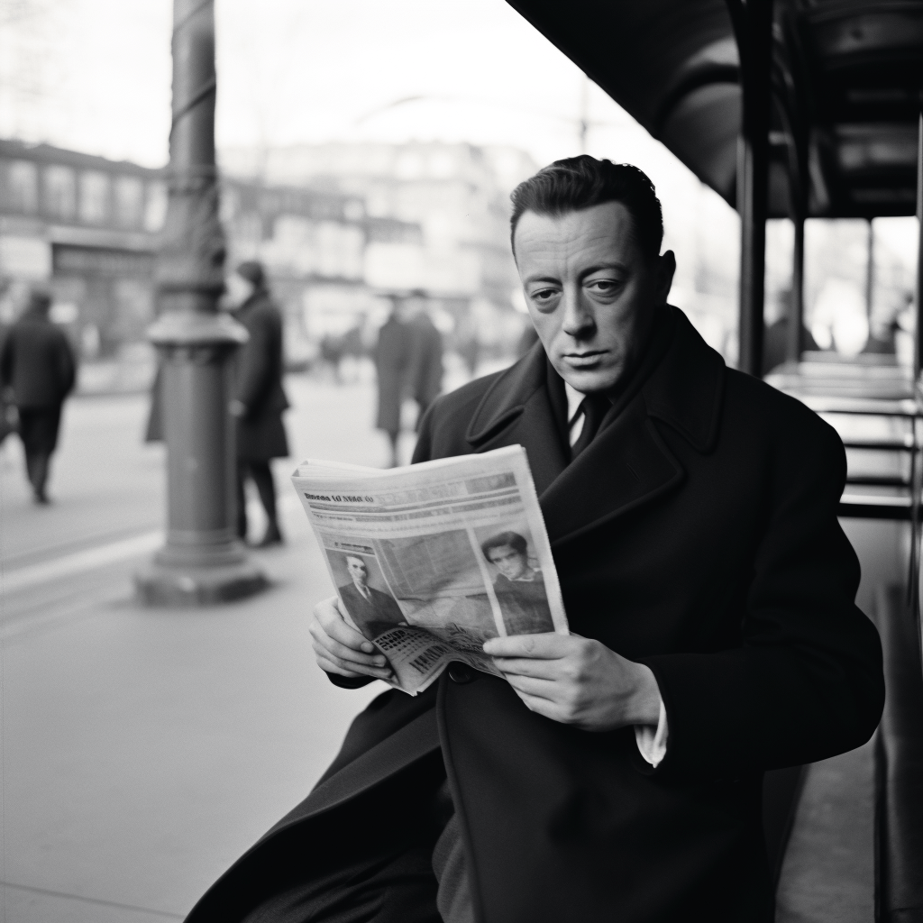

Letter to an Algerian Militant, Albert Camus

Letter to an Algerian Militant.1

My dear Kessous,

I found your letters upon returning from my vacation, and I am afraid that my approval will arrive very late. Yet I need to let you know how I feel. Believe me when I tell you that Algeria is where I hurt at this moment, as others feel pain in their lungs. And since August 20, I have been on the edge of despair.

Only a person who knows nothing of the human heart can think that the French of Algeria can now forget the massacres in Philippeville. Conversely, only a madman can believe that repression, once unleashed, can induce the Arab masses to trust and respect France. So we now find ourselves pitted against one another, with each side determined to inflict as much pain as possible on the other, inexpiably. This thought is unbearable to me, and it poisons my days.

And yet you and I, who are so alike, who share the same culture and the same hopes, who have been brothers for so long, joined in the love we both feel for our country, know that we are not enemies. We know that we could live happily together on this land, which is our land—because it is ours, and because I can no more imagine it without you and your brothers than you can separate it from me and my kind.

You said it very well, better than I will say it: we are condemned to live together. The French of Algeria—who, I thank you for pointing out, are not all wealthy bloodsuckers—have been in Algeria more than a century and number more than a million. That alone is enough to distinguish the Algerian problem from the problems of Tunisia and Morocco, where the French settlement is relatively small and recent. The “French reality” can never be eliminated from Algeria, and the dream that the French will suddenly disappear is childish. By the same token, there is no reason why nine million Arabs should be forgotten on their own soil.

The dream that the Arabs can be forever negated, silenced, and subjugated is equally insane. The French are attached to Algerian soil by roots too old and deep to think of tearing them up. But this does not give the French the right to cut the roots of Arab life and culture. All my life, I have defended the idea that our country stands in need of far-reaching reform (and as you well know, I paid the price in the form of exile). No one believed me, and people continued to pursue the dream of power, which always believes that it is eternal and always forgets that history does not stop. Today reform is more necessary than ever. Your proposals would constitute an indispensable first step and should be implemented without delay, provided they are not drowned beforehand in either French or Arab blood.

But I know from experience that to say these things today is to venture into a no-man’s-land between hostile armies. It is to preach the folly of war as bullets fly. Bloodshed may sometimes lead to progress, but more often it brings only greater barbarity and misery. He who pours his heart into such a plea can expect only laughter and the din of the battlefield in reply. And yet someone must say these things, and since you propose to try, I cannot let you take such an insane and necessary step without standing with you in fraternal solidarity.

Of course, the crucial thing is to leave room for whatever dialogue may still be possible, no matter how limited.

It is to defuse tensions, no matter how tenuous and fleeting the respite may be. To that end, each of us must preach peace to his own side. The inexcusable massacres of French civilians will lead to other equally stupid attacks on Arabs and Arab property. It is as if madmen inflamed by rage found themselves locked in a forced marriage from which no exit was possible and therefore decided on mutual suicide. Forced to live together but incapable of uniting their lives, they chose joint death as the lesser evil. Because each side’s excesses reinforce the reasons—and the excesses—of the other, the deadly storm now lashing our country will only grow until the destruction is general. Constant escalation has caused the blaze to spread, and soon Algeria will be reduced to ruin and littered with corpses. No force or power on earth will be capable of putting the country back together in this century.

The escalation must therefore stop, and it is our duty as Arabs and Frenchmen who refuse to let go of one another’s hands to stop it. We Frenchmen must fight to stop collective repression and to ensure that French law remains generous and clear. We must fight to remind our compatriots of their errors and of the obligations of a great nation, which cannot respond to a xenophobic massacre with a similar paroxysm of rage if it wishes to retain its stature in the world.

And we must fight, finally, to hasten the adoption of necessary and crucial reforms, which will once more set the Franco-Arab community of Algeria on the road to the future. Meanwhile, you Arabs must tirelessly explain to your own people that when terrorism kills civilians, it not only raises doubts about the political maturity of people capable of such acts but also reinforces anti-Arab factions, validates their arguments, and silences French liberals who might be capable of propounding and promoting a compromise solution.

I will be told, as you will be told, that the time for compromise is over and that the goal now must be to wage war and win. But you and I both know that there will be no real winners in this war and that both now and in the future we will always have to live together on the same soil. We know that our destinies are so closely intertwined that any action by one side will bring a riposte by the other, crime leading to crime and insanity responding to madness. If one side abstains, however, the other will wither.

If you Arab democrats fail in your effort to restore peace, then we French liberals will inevitably fail in our own efforts. And if we flag in our duty, your wan words will vanish in the wind and flames of a pitiless war.

That is why I am with you one hundred percent, my dear Kessous. I wish you, I wish us, good luck. I want to believe with all my heart that peace will dawn on our fields, our mountains, and our shores, and that Arabs and Frenchmen, reconciled in liberty and justice, will try hard to forget the bloodshed that divides them today. On that day, we who are together exiles in hatred and despair will together regain our native land.

1. When the rebellion broke out, Mr. Aziz Kessous, an Algeria Socialist and former member of the Party of the Manifesto, had the idea of publishing a newspaper, Communauté Algérienne, the aim of which was to transcend the twin fanaticisms that plague Algeria today and thus help to create a truly free community. This letter appeared in the first issue of the paper on October 1, 1955.

The End