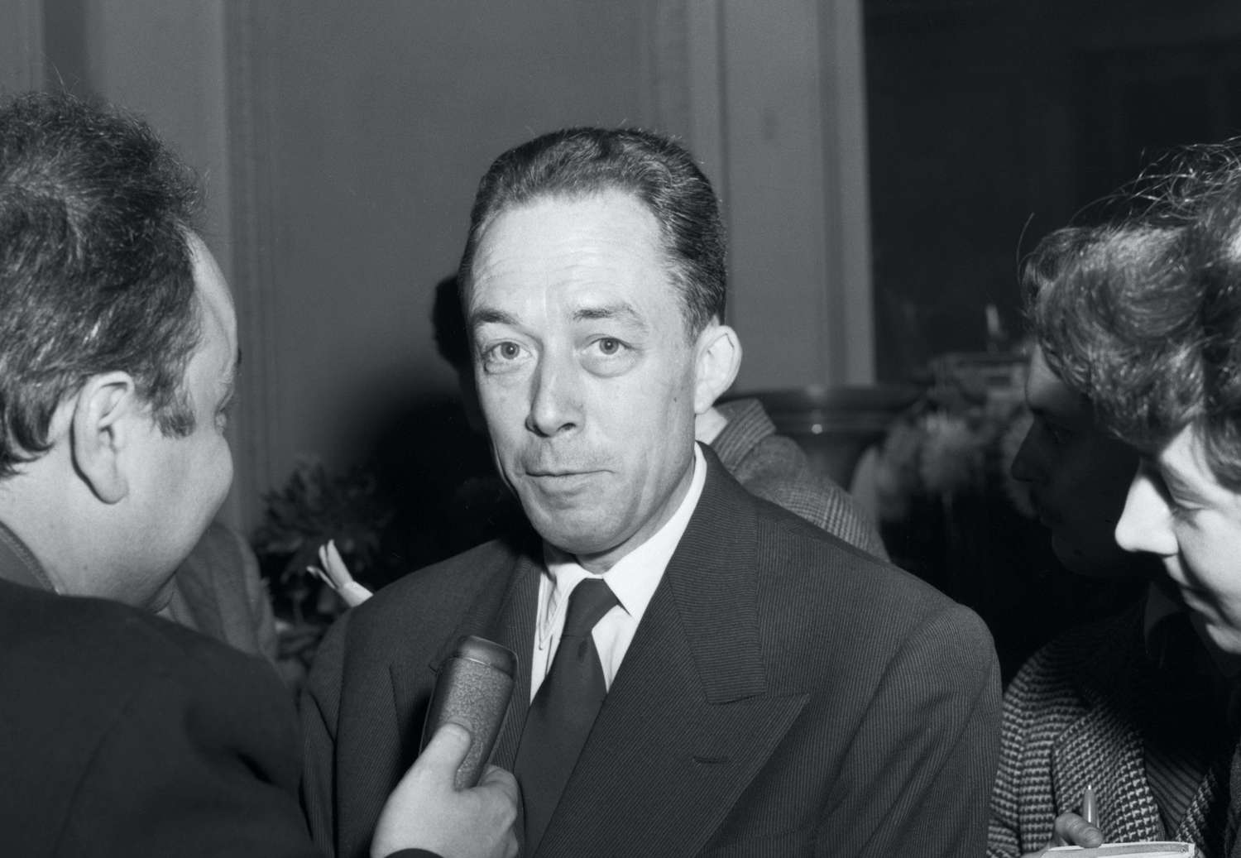

The Political Malaise, Albert Camus

The Political Malaise

As grave and urgent as the economic privation from which North Africa is suffering is, it cannot by itself account for the Algerian political crisis. If we discussed the famine first, it was because hunger is the first priority. But when we have done everything that needs to be done to feed the Algerian population, we still will only have scratched the surface. Or, to put it another way, we will still, at long last, need to come up with a policy for North Africa.

Far be it from me to try to formulate a definitive policy for North Africa in the space of two or three articles. This would please no one, and truth would not be served. But our Algerian policy is so distorted by prejudice and ignorance that to offer an objective account based on accurate information is already to render an important service. That is what I propose to do.

I read in a morning newspaper that 80 percent of the Arabs wished to become French citizens. In contrast, I would sum up the current state of Algerian policy by saying that, indeed, Arabs used to want to become citizens but no longer do. When you have hoped for something for a long time and your hopes are dashed, you avert your eyes, and your erstwhile desire disappears. That is what has happened to the indigenous peoples of Algeria, and the primary responsibility for this is ours.

French colonial doctrine in Algeria since the conquest has not been notable for its coherence. I shall spare the reader the history of its fluctuations, from the notion of an Arab kingdom favored by the Second Empire to that of assimilation. In theory, it was the idea of assimilation that triumphed in the end. For the past 50 years or so, France’s avowed goal in North Africa was gradually to open the way to French citizenship for all Arabs. Let it be said at once that this idea remained theoretical. In Algeria itself, the policy of assimilation met with unremitting hostility, primarily on the part of the most influential colonizers.

There exists a whole arsenal of arguments—some of them apparently convincing at first sight—which have until now sufficed to keep Algeria immobilized in the political situation we have described.

I won’t discuss these arguments. But it is clear that on this issue as on others, someday a choice will have to be made. France had to state clearly whether, on the one hand, it considered Algeria to be a conquered land whose subjects, stripped of all rights and burdened with additional duties, would be forced to live in absolute dependence on us, or, on the other hand, it attributed to its democratic principles a value universal enough to be able to extend them to populations for which it had accepted responsibility.

France, to its credit, chose, and having chosen, it was obliged, if words were to mean anything, to follow the logic of its decision to the end. Special interests opposed this venture and tried to turn back the clock. But time inexorably marches on, and people evolve. No historical situation is ever permanent. If you are unwilling to change quickly enough, you lose control of the situation.

Because French policy in Algeria ignored these elementary truths, it was always 20 years behind the actual situation. An example will help to make this clear.

In 1936, the Blum-Viollette Plan marked a first step toward a policy of assimilation after 17 years of stagnation. It was by no means revolutionary. It would have granted civil rights and voting status to roughly 60,000 Muslims. This relatively modest plan aroused immense hopes among the Arabs. Virtually the entire Arab population, represented by the Algerian Congress, indicated its approval. But leading colonists, banded together in the Financial Delegations and the Association of Mayors of Algeria, mounted a counteroffensive powerful enough to ensure that the plan was never even presented to the chambers.

The dashing of this great hope naturally led to a very radical disaffection. Now the French government is proposing that Algeria accept the ordinance of March 7, 1944, whose electoral provisions more or less emulate those of the Blum-Viollette Plan.

If this ordinance were really enforced, it would give the vote to roughly 80,000 Muslims. It would also eliminate the exceptional legal status of Arabs, a goal for which North African democrats have fought for years. In effect, Arabs were not subject to the same penal code or even the same courts as Frenchmen. Special tribunals, more severe in their punishments and more summary in their procedures, kept Arabs in a permanent state of subjection. The new ordinance has eliminated that abuse, and that is a very good thing.

Arab opinion, much dampened by all that has taken place, remains reserved and wary, however, despite all the good things in the new plan. The problem is quite simply that time marches on. The fall of France was followed by a loss of French prestige. The 1942 landing brought Arabs into contact with other nations and spurred them to make comparisons. Finally, one cannot ignore the fact that the Pan-Arab Federation is a constant temptation for the people of North Africa, whose misery only adds to all their other grievances. As a result of all this, a plan that would have been welcomed enthusiastically in 1936 and would have solved a great many problems is today met only with wariness. Once again we are late.

Peoples generally aspire to political rights only in order to set themselves on the road to social progress. The Arab people wanted the right to vote because they knew that, with it, and through the free exercise of democracy, they could eliminate the injustices that are poisoning the political climate of Algeria today. They knew that they could eliminate inequalities in wages and pensions, as well as more scandalous inequalities in military allowances and, in a more general sense, everything that helped to perpetuate their inferior status. But the Arabs seem to have lost their faith in democracy, of which they were offered only a caricature. They hope to achieve by other means a goal that has never changed: an improvement in their condition.

That is why, to believe my sample, Arab opinion is in its majority indifferent or hostile to the policy of assimilation. This is most unfortunate. But before deciding what ought to be done to improve the situation, we must have a clear sense of what the political climate in Algeria is today.

Arabs today face any number of possibilities, and since, historically, every aspiration of a people finds political expression, Muslims have lately found themselves drawn to a remarkable figure, Ferhat Abbas, and his “Friends of the Manifesto” party. In my next article, I will discuss this important movement, the most important and novel to have appeared in Algeria since the early days of the conquest.

THe End