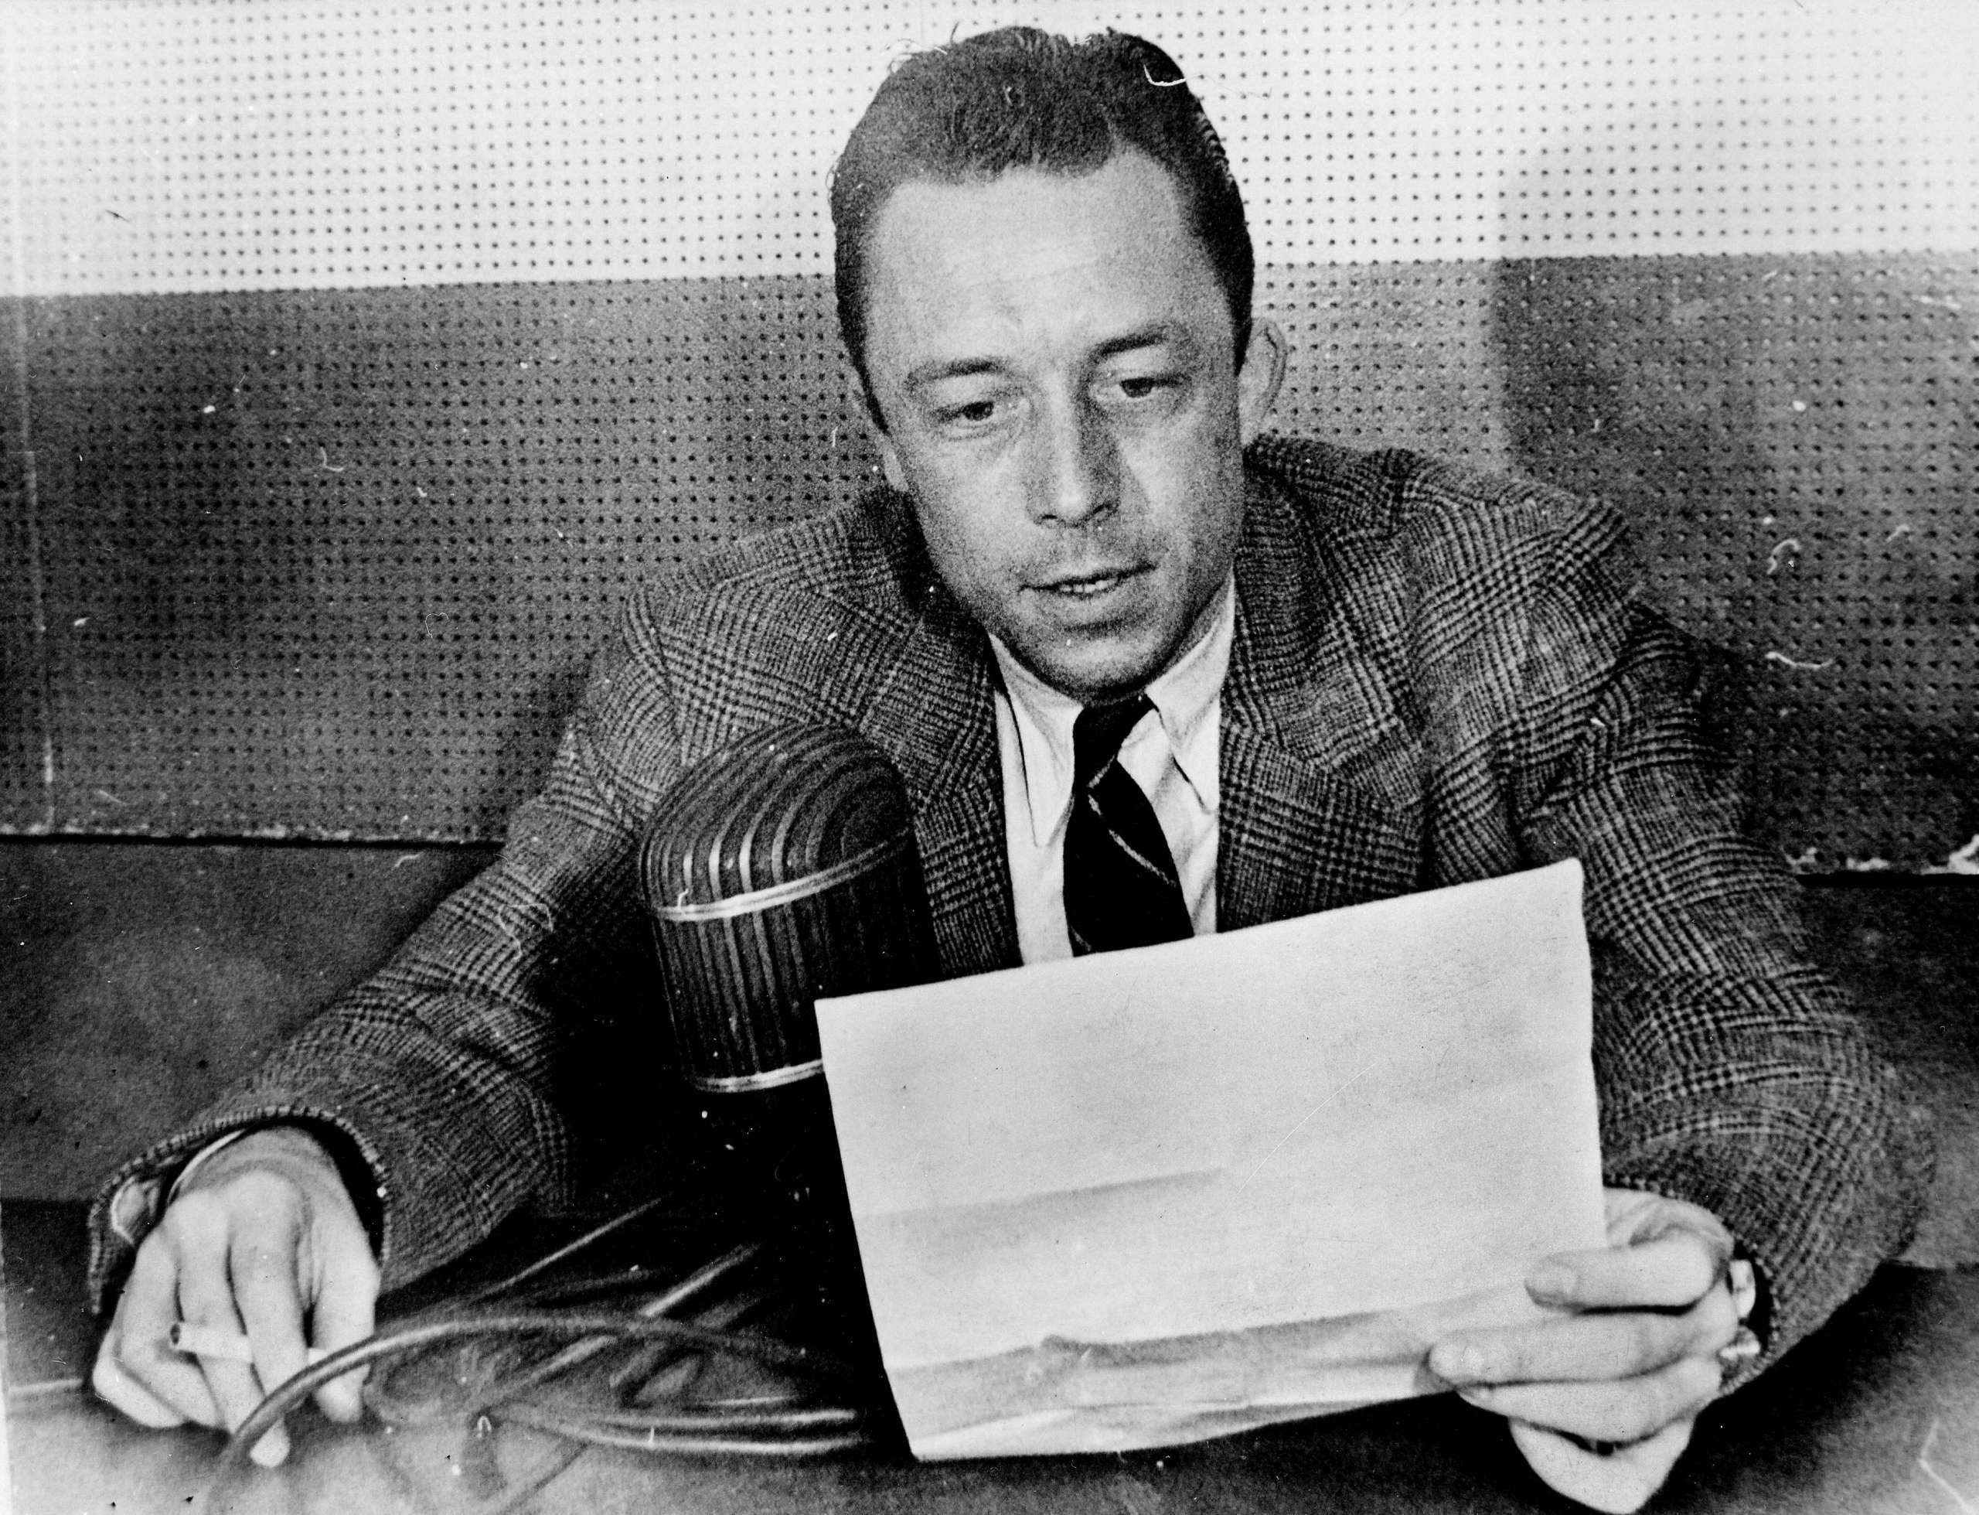

The True Surrender, Albert Camus

The True Surrender

I said that the metropole could help to narrow the gulf between it and Algeria by renouncing demagogic simplifications. But the French of Algeria can help too by restraining their bitterness and overcoming their prejudices.

Mutual recrimination and hateful attacks change nothing of the reality that grips us all. Like it or not, the French of Algeria face a choice. They must choose between the politics of reconquest and the politics of reform. The first option means war and far-reaching repression. For some French settlers, however, the second option would mean surrender.

This is not just a simplification; it is an error, and it could become a fatal error.

For a nation like France, the ultimate form of surrender is called injustice. In Algeria, it was a surrender to injustice that preceded the Arab rebellion and that explains why it occurred, though without justifying its excesses.

To favor reform, moreover, is not—as some odiously maintain—to approve of the massacre of civilian populations, which remains a crime. It is rather to seek to prevent the shedding of innocent blood, be it Arab or French.

It is of course reprehensible to play down the massacres of French men and women in order to focus attention solely on the excesses of the repression. Yet no one is entitled to condemn the massacres unless he or she unreservedly rejects those excesses. On this point, at least, it seems to me that agreement is essential, precisely because it is so painful.

The crux of the matter, ultimately, is that to reject reform is the real surrender. It is a reflex of fear as much as anger, and a denial of reality. The French in Algeria know better than anyone that the policy of assimilation has failed—first because it was never really tried, and second because the Arab people have retained their own character, which is not identical to ours.

Two peoples, tied to each other by circumstances, may choose to enter into a partnership or to destroy each other. The choice in Algeria is a choice not between surrender and reconquest but between a marriage of convenience and a deadly marriage of two xenophobias.

If French Algeria refuses to recognize the Arab character, it will work against its own interests. To reject reform would be tantamount to rejecting the Arab people, who have their rights, and their more lucid militants, who do not deny that we have ours, in favor of feudal Egypt and Franco’s Spain, which have only appetites.

That would be the real surrender, and I cannot believe that the French of Algeria, whom I know to be realists, do not recognize the gravity of the stakes.

Instead of relentlessly attacking the failures of the metropole, it would be better to help it work toward a solution that takes Algerian realities into account. Those realities include the misery and deracination of the Arabs on the one hand and the security of the French settlers on the other.

If the settlers prefer to wait for a plan concocted by four bored politicians between two campaign tours to become the charter of their misfortune, they can choose moral secession.

But if they wish to preserve the essential, to build an Algerian community in a peaceful and just Algeria, a community that will allow both French settlers and Arabs to embark on the road to a shared future, then they should join us, speak out, and propose ideas with the confidence that comes of true strength.

And they should also know—I want to stress this point—that it is not France that holds their destiny in hand but French Algeria that is today deciding not only its own fate but also the fate of France.

The End