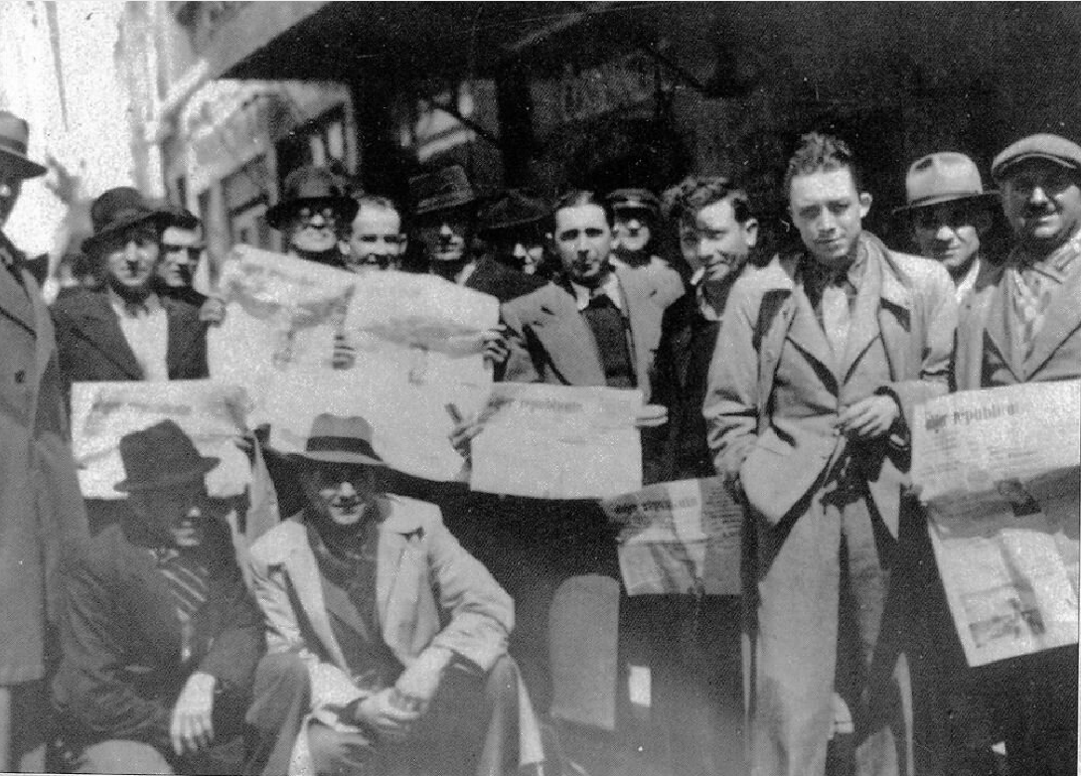

Hungary, Albert Camus

Contents

Hungary

Kadar Had His Day of Fear

Socialism of the Gallows

Hungary

KADAR HAD HIS DAY OF FEAR

The Hungarian Minister of State Marosan, whose name sounds like a program, declared a few days ago that there would be no further counter-revolution in Hungary. For once, one of Kadar’s Ministers has told the truth. How could there be a counter-revolution since it has already seized power? There can be no other revolution in Hungary.

I AM not one of those who long for the Hungarian people to take up arms again in an uprising doomed to be crushed under the eyes of an international society that will spare neither applause nor virtuous tears before returning to their slippers like football enthusiasts on Saturday evening after a big game. There are already too many dead in the stadium, and we can be generous only with our own blood. Hungarian blood has proved to be so valuable to Europe and to freedom that we must try to spare every drop of it.

But I am not one to think there can be even a resigned or provisional compromise with a reign of terror that has as much right to be called socialist as the executioners of the Inquisition had to be called Christians. And, on this anniversary of liberty, I hope with all my strength that the mute resistance of the Hungarian people will continue, grow stronger, and, echoed by all the voices we can give it, get unanimous international opinion to boycott its oppressors. And if that opinion is too flabby or selfish to do justice to a martyred people, if our voices also are too weak, I hope that the Hungarian resistance will continue until the counter-revolutionary state collapses everywhere in the East under the weight of its lies and its contradictions.

The Bloody and Monotonous Rites

For it is indeed a counter-revolutionary state. What else can we call a regime that forces the father to inform on his son, the son to demand the supreme punishment for his father, the wife to bear witness against her husband—that has raised denunciation to the level of a virtue? Foreign tanks, police, twenty-year-old girls hanged, committees of workers decapitated and gagged, scaffolds, writers deported and imprisoned, the lying press, camps, censorship, judges arrested, criminals legislating, and the scaffold again—is this socialism, the great celebration of liberty and justice?

No, we have known, we still know this kind of thing; these are the bloody and monotonous rites of the totalitarian religion! Hungarian socialism is in prison or in exile today. In the palaces of the State, armed to the teeth, slink the petty tyrants of absolutism, terrified by the very word “liberty,” maddened by the word “truth”! The proof is that today, the 15th of March, a day of invincible truth and liberty for all Hungarians, was for Kadar simply a long day of fear.

For many years, however, those tyrants, aided in the West by accomplices who were not obliged by anything or anyone to show such zeal, cloaked their true actions in a heavy smoke screen. When something could be seen through the screen, they or their Western interpreters explained to us that everything would be all right in ten generations or so, that meanwhile everyone was joyfully heading toward the future, that the deported had made the mistake of getting in the way of traffic on the magnificent road of progress, that the executed agreed completely as to their own suppression, that the intellectuals declared themselves delighted with their pretty gag because it was dialectical, and that the proletariat were charmed with their own work because, if they worked overtime for wretched wages, this was in the proper direction of history.

Alas, the people themselves spoke up! They began to talk in Berlin, in Czechoslovakia, in Poznan, and eventually in Budapest. All at once, everywhere, intellectuals tore off their gags. And together, with a single voice, they said that instead of progress there was regression, that the killings had been useless, the deportations useless, the enslavements useless, and that henceforth, to be sure of making real progress, truth and liberty had to be granted to all.

Thus, with the first shout of insurrection in free Budapest, learned and shortsighted philosophies, miles of false reasonings and deceptively beautiful doctrines were scattered like dust. And the truth, the naked truth, so long outraged, burst upon the eyes of the world.

Contemptuous teachers, unaware that they were thereby insulting the working classes, had assured us that the masses could readily get along without liberty if only they were given bread. And the masses themselves suddenly replied that they didn’t have bread but that, even if they did, they would still like something else. For it was not a learned professor but a Budapest blacksmith who wrote: “I want to be considered an adult eager to think and capable of thought. I want to be able to express my thoughts without having anything to fear and I want, also, to be listened to.”

As for the intellectuals who had been told and shouted at that there was no truth other than the one that served the cause, this is the oath they took at the grave of their comrades assassinated by that cause: “Never again, not even under threat and torture, nor under a misunderstood love of the cause, will anything but the truth issue from our mouths.” (Tibor Meray at the grave of Rajk.)

The Scaffold Does Not Become Any More Liberal

After that, the case is closed. The slaughtered people are our people. What Spain was for us twenty years ago Hungary will be today. The subtle distinctions, the verbal tricks, and the clever considerations with which people still try to cloak the truth do not interest us. The competition we are told about between Rakosi and Kadar is unimportant. The two are of the same stamp. They differ only by the number of heads to their credit, and if Rakosi’s total is more impressive, this will not be so for long.

In any event, whether the bald killer or the persecuted persecutor rules over Hungary makes no difference as to the freedom of that country. I regret having to play the role of Cassandra once more and having to disappoint the fresh hopes of certain ever hopeful colleagues, but there is no possible evolution in a totalitarian society. Terror does not evolve except toward a worse terror, the scaffold does not become any more liberal, the gallows are not tolerant. Nowhere in the world has there been a party or a man with absolute power who did not use it absolutely.

The first thing to define totalitarian society, whether of the Right or of the Left, is the single party, and the single party has no reason to destroy itself. This is why the only society capable of evolution and liberalization, the only one that deserves both our critical and our active support is the society that involves a plurality of parties as a part of its structure. It alone allows one to denounce, hence to correct, injustice and crime. It alone today allows one to denounce torture, disgraceful torture, as contemptible in Algiers as in Budapest.

What Budapest was Defending

The idea, still voiced among us, that a party, because it calls itself proletarian, can enjoy special privileges in regard to history is an idea of intellectuals tired of their advantages and of their freedom. History does not confer privileges: it lets them be snatched away.

And it is not the function of intellectuals or of workers to glorify even slightly the right of the stronger and the fait accompli. The truth is that no one, neither individual nor party, has a right to absolute power or to lasting privileges in a history that is itself changing. And no privilege, no supreme reason can justify torture or terror.

On this point Budapest again showed us the way. Hungary conquered and in chains (which our false realists compare with commiseration to Poland), still on the edge of equilibrium, has done more for freedom and justice than any people in twenty years. But, for that lesson to reach and convince those in the West who close their eyes and ears, the Hungarian people (and we shall never be consoled for this) had to shed their own blood, and it is already drying up in people’s memories.

At least we shall try to be faithful to Hungary as we have been to Spain. In Europe’s present solitude, we have but one way of being so—which is never to betray, at home or abroad, that for which the Hungarian combatants died and never to justify even indirectly, at home or abroad, what killed them.

The untiring insistence upon freedom and truth, the community of the worker and the intellectual (who are still stupidly warring here, as tyranny aims to keep them doing), and, finally, political democracy as a necessary and indispensable (though surely not sufficient) condition of economic democracy—this is what Budapest was defending. And in doing so, the great city in insurrection reminded Western Europe of its forgotten truth and greatness. It made short work of that odd feeling of inferiority that debilitates most of our intellectuals but that I, for one, refuse to feel.

Reply to Shepilov

The defects of the West are innumerable, its crimes and errors very real. But in the end, let’s not forget that we are the only ones to have the possibility of improvement and emancipation that lies in free genius. Let’s not forget that when totalitarian society, by its very principles, forces the friend to denounce his friend, Western society, despite its wanderings from the path of virtue, always produces a race of men who uphold honor in life—I mean men who stretch out their hands even to their enemy to save him from suffering or death.

When Minister Shepilov on his return from Paris dares to write that “Western art is bound to tear the human soul apart and to form butchers of every sort,” it is time to reply to him that at least our writers and artists have never butchered anyone and that yet they are generous enough not to blame the theory of socialist realism for the massacres ordered by Shepilov and those who resemble him.

The truth is that there is room for everything among us, even for evil, and even for Shepilov’s writers. There is room also for honor, for the freedom to desire, for the adventure of the mind. Whereas there is room for nothing in Stalinist culture except for edifying sermons, colorless life, and the catechism of propaganda. To any who still had any doubts about this, the Hungarian writers have just shouted the truth before choosing permanent silence today when they are ordered to lie.

It will be hard for us to be worthy of so many sacrifices. But we must try to do so in a Europe at last united, by forgetting our quarrels, by getting rid of our own errors, by multiplying our creations and our solidarity. And to those who wanted to humble us and persuade us that history could justify a reign of terror, we shall reply by our real faith that we share, as we now know, with Hungarian writers, Polish writers, and even, indeed, with Russian writers, who are also gagged.

Our faith is that throughout the world, beside the impulse toward coercion and death that is darkening history, there is a growing impulse toward persuasion and life, a vast emancipatory movement called culture that is made up both of free creation and of free work.

Our daily task, our long vocation is to add to that culture by our labors and not to subtract, even temporarily, anything from it. But our proudest duty is to defend personally to the very end, against the impulse toward coercion and death, the freedom of that culture—in other words, the freedom of work and of creation.

The Hungarian workers and intellectuals, beside whom we stand today with so much impotent grief, realized that and made us realize it. This is why, if their suffering is ours, their hope belongs to us too. Despite their destitution, their exile, their chains, it took them but a single day to transmit to us the royal legacy of liberty. May we be worthy of it!

FRANC-TIREUR, 18 March 1957

SOCIALISM OF THE GALLOWS

(INTERVIEW)

1) Do you think that it is still possible to link the cause of truth with a Party, a State, or any organization whatever and to have complete confidence in it as if it could not possibly fail in its mission? Do you think it is still possible, in good faith, to speak of a “camp of peace”? Don’t you think rather that such an attitude stands now for the most serious form of “alienation” of conscience?

IF ABSOLUTE truth belongs to anyone in this world, it certainly does not belong to the man or party that claims to possess it. When historical truth is involved, the more anyone claims to possess it the more he lies. In the final analysis, he becomes the murderer of truth. The Hungarian uprising was originally directed against a generalized lie. Hence it was necessary to assassinate the men who were fighting the lie and then try to dishonor them through a reversed lie by calling them Fascists.

As for the “camp of peace,” it is better to ask the question of the former “partisans of peace” who mobilized at the time of the Stockholm appeal to outlaw atomic weapons and who now have to reconcile this with Bulganin’s ultimatum threatening England, France, and incidentally Israel, with atomic rockets. It is better to ask them the question, because apparently they are not asking it of themselves.

The truth is that no nation has a monopoly on peace. Not even, as we now know, the “neutral” nations of the Orient. The way in which they—the Arab countries (except Tunisia),1 and especially India (yes, the India of Gandhi)—betrayed Hungary and their own principles puts them henceforth on the same footing with the other nations. The nations of the Bandung group could have helped save a great European nation from slavery and death.

This would have amounted to admitting and partially rewarding the efforts of all free Europeans who freely argued the cause of the colonized peoples. But the Bandung group rapidly became realistic. Apparently it is easy to become an adult in history.

Consequently, those new nations must henceforth be judged as adults, on the basis of their deeds, without any special indulgence. And their attitude toward the Hungarian massacre is inexcusable. Most likely the future will show that such a self-centered sidestepping of the issue will not pay off. The moral advantage those nations derived from the fact that they had been oppressed in the recent past was wasted by them in a few days.

Hence we shall say that some nations are merely more bellicose than others. It seems, if I can believe the progressive newspapers (which previously thought or said the opposite), that America has been less bellicose than Russia of late. But there is no need for anyone to show us that socialism can, quite as well as capitalism, foment wars.

All it takes is a little will to power, and there is scarcely any nation without that (except for those which have no army, and even then you can’t be sure). This wasn’t known before simply because there was no socialist state. Now we know. Alienation is in any case too noble a word to describe the attitude of those who insist on seeing nothing but doves in the East and vultures in the West. Blindness, frenzy of the slave, or nihilistic admiration of force seems to me a more exact term.

Truth Is Relative

2) Do you think that, despite the situation, we can continue to attribute more weight to considerations of political expediency than to the impulse that makes us see the factual truth first of all? In this case what in your opinion is the criterion of such expediency?

Expediencies must be examined to see the dose of truth they contain, the lesson to be drawn from them in order to correct what had previously been thought right. But they cannot be given an advantage over the pursuit of factual truths. Above all, we cannot grant expediency any precedence over regard for truth, as the Communists do and the Leftist intellectuals who follow them, for such systematic relativism leads to the death of intelligence and the oppression of the worker.

A press or a book is not true because it is revolutionary. It has a chance of being revolutionary only if it tries to tell the truth. We have a right to think that truth with a capital letter is relative. But facts are facts. And whoever says that the sky is blue when it is gray is prostituting words and preparing the way for tyranny.

Expediency for a Communist newspaper perhaps amounts to saying that the whole population of Hungary is fascist except Kadar, his policemen, and his executioners. But the factual truth is that we have seen a revolt of workers, intellectuals, and peasants who wanted national independence and personal freedom. The real fascism, to speak clearly, is the fascism of Kadar and Khrushchev, who methodically crushed a popular revolt, and of the Russian government, which permitted it.

I confess that I don’t understand either the sense of expediency that urged some of our militant progressives, after they had denounced the Soviet intervention in Hungary, to recommend in their congress a unified action with the French Communists, who continually insult the insurgents. Their recommendation came at a time when Hungarians were still being hanged (just yesterday a girl of twenty) and at the very moment when a representative of the French Communist party declared that, under the same circumstances, he would be willing for the U.S.S.R. to inflict on France the same treatment it is giving Hungary. Such obsequiousness eventually becomes overwhelming. Can it be that the Communists and progressive militants feel such love for the Russians they have never seen? No, but they feel such a loathing for a part of the French, the part that loathed them enough to be willing to serve the cause of Hitler. If France is to disappear, rest assured that she will die poisoned by these two hatreds.

The Intellectual Must Take Sides

3) If the contrary is true, what can the intellectual do today? Does he have a duty, in each and every circumstance, to express his feeling and opinion publicly and to anyone at all? Or else, because of the seriousness of events and the lack of valid political forces, do you feel that one can do no better than to carry on one’s own work as well as one can?

It is better for the intellectual not to talk all the time. To begin with, it would exhaust him, and, above all, it would keep him from thinking. He must create if he can, first and foremost, especially if his creation does not sidestep the problems of his time. But in certain exceptional circumstances (Spanish war, Hitlerian persecutions and concentration camps, Stalinist trials and concentration camps, Hungarian war) he must leave no room for doubt as to the side he takes; he must be very careful not to let his choice be clouded by wily distinctions or discreet balancing tricks, and to leave no question as to his personal determination to defend liberty.

Groupings of intellectuals can, in certain cases, and particularly when the liberty of the masses and of the spirit is mortally threatened, constitute a strength and exert an influence; Hungarian intellectuals have just proved this. However, it should be pointed out for our own guidance in the West that the continual signing of manifestoes and protests is one of the surest ways of undermining the efficacy and dignity of the intellectual. There exists a permanent blackmail that we all know and that we must have the often solitary courage to resist.

Conformity Is on the Left

Subject to these reservations, we must hope for a common rallying. But first our Leftist intellectuals, who have swallowed so many insults and may well have to begin doing so again, would have to undertake a critique of the reasonings and ideologies to which they have hitherto subscribed, which have wreaked the havoc they have seen in our most recent history. That will be the hardest thing. We must admit that today conformity is on the Left.

To be sure, the Right is not brilliant. But the Left is in complete decadence, a prisoner of words, caught in its own vocabulary, capable merely of stereotyped replies, constantly at a loss when faced with the truth, from which it nevertheless claimed to derive its laws. The Left is schizophrenic and needs doctoring through pitiless self-criticism, exercise of the heart, close reasoning, and a little modesty. Until such an effort at re-examination is well under way, any rallying will be useless and even harmful. Meanwhile, the intellectual’s role will be to say that the king is naked when he is, and not to go into raptures over his imaginary trappings.

In order to strike a constructive note, however, I shall propose as one of the preliminaries to any future gathering the unqualified acceptance of the following principle: none of the evils that totalitarianism (defined by the single party and the suppression of all opposition) claims to remedy is worse than totalitariansim itself.

In conclusion, I believe (as people say: I believe in God, creator of heaven and earth) that the indispensable conditions for intellectual creation and historical justice are liberty and the free confronting of differences. Without freedom, no art; art lives only on the restraints it imposes on itself, and dies of all others. But without freedom, no socialism either, except the socialism of the gallows.

DEMAIN, 21–27 February 1957

1 As for Algeria, so far as I know only the M.N.A. of Messali Hadj protested the Soviet intervention in Hungary without relinquishing any of its own protests. I was not aware of any protest on the part of the F.L.N

The End