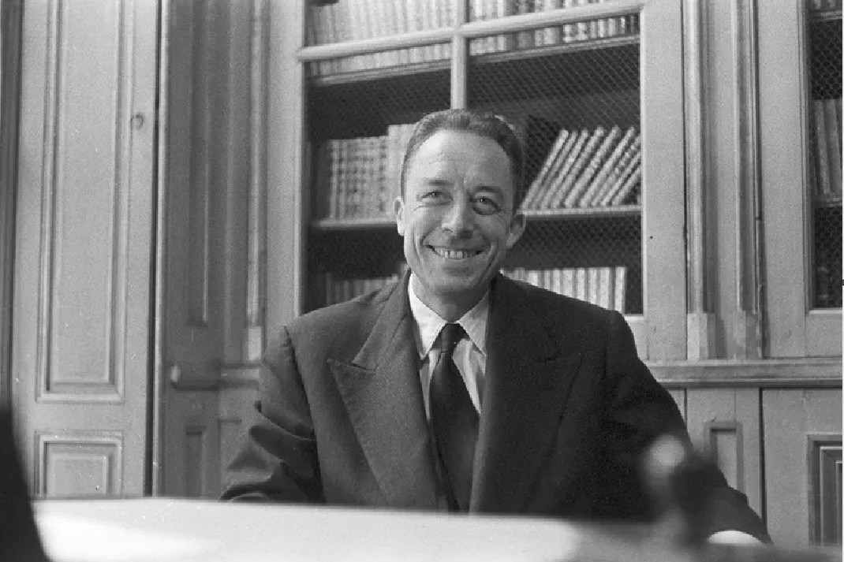

Pessimism and Tyranny, Albert Camus

Contents

Pessimism and Tyranny

Pessimism and Courage

Defense of Intelligence

Pessimism and Tyranny

PESSIMISM AND COURAGE

FOR some time now, articles have been appearing about works that are supposed to be pessimistic and consequently to lead directly to the most cowardly of all forms of subservience. The reasoning is elementary. A pessimistic philosophy is by its essence a philosophy of discouragement, and those who don’t believe that the world is good are therefore said to be willing to serve tyranny. The most effective of those articles, because it was the best, was the one by M. George Adam in Les Lettres Françaises. M. Georges Rabeau in one of the recent issues of L’Aube makes the same accusation under the unacceptable title of “Nazism not dead?”

I see only one way of answering such a campaign, which is to answer openly. Although the problem goes beyond me, although it is aimed at Malraux, Sartre, and a few others more important than I, it would seem to me sheer hypocrisy not to speak in my own name. Yet I shall not insist on the basis of the argument. The idea that a pessimistic philosophy is necessarily one of discouragement is a puerile idea, but one that needs too long a refutation. I shall speak only of the method of thinking that inspired those articles.

Let me say at once that this method is reluctant to take facts into account. The writers who are the butt of the articles have proved, as best as they could, that, though they lacked philosophical optimism, man’s duty, at least, was not alien to them. Hence an objective mind would be willing to say that a negative philosophy was not incompatible, in actual fact, with an ethics of freedom and courage. Such a mind would see here merely an opportunity to learn something about the human heart.

That objective mind would be right. For the coexistence, in certain minds, of a philosophy of negation and a positive morality illustrates, in fact, the great problem that is painfully disturbing the whole epoch. In a word, it is a problem of civilization, and it is essential for us to know whether man, without the help either of the eternal or of rationalistic thought, can unaided create his own values. Such an undertaking goes infinitely beyond all of us. I say this because I believe it: France and Europe must now create a new civilization or else perish.

But civilizations are not built by rapping people on the knuckles. They are built up by the confrontation of ideas, by the blood of the spirit, by suffering and courage. It is not possible that concepts which have belonged to Europe for the past hundred years should be judged in the twinkling of an eye, in L’Aube, by an editorialist who, without hesitation, attributes to Nietzsche a lustful appetite and to Heidegger the idea that existence is useless. I do not have much liking for the too famous existential philosophy, and, to tell the truth, I think its conclusions false.

But at least it represents a great adventure of the mind, and it is hard to see it subjected, by M. Rabeau, to the judgment of the most shortsighted conformism.

In reality, such concepts and such undertakings are not judged at this moment according to the rules of objectivity. They are judged not according to facts but according to a doctrine. Our Communist comrades and our Christian comrades talk to us from the vantage point of doctrines we respect. Their doctrines are not ours, but it has never occurred to us to talk of them in the tone they have just used toward us and with the assurance they show.

Let us pursue then, insofar as we can, our experience and our thought. M. Rabeau blames us for having an audience. I believe that is an exaggeration. But this at least is true: the uneasiness that concerns us belongs to a whole epoch from which we do not want to dissociate ourselves. We want to think and live in our history. We believe that the truth of this age can be found only by living through the drama of it to the very end. If the epoch has suffered from nihilism, we cannot remain ignorant of nihilism and still achieve the moral code we need. No, everything is not summed up in negation and absurdity. We know this. But we must first posit negation and absurdity because they are what our generation has encountered and what we must take into account.

The men who are indicted in these articles are loyally attempting both in their work and in their lives to solve this problem. Is it so hard to realize that one cannot settle in a few lines a question others are not sure of solving when they devote themselves to it altogether? Can’t they be granted the patience that is granted to any sincere undertaking? Isn’t it possible to address them more humbly?

I shall end this protest here. I hope I have been restrained. But I should like my indignation to be felt. Objective criticism is the best of things, in my opinion, and I can’t object when someone says that a work is bad or that a philosophy is not good for man’s fate. It is only fair that writers should answer for their writings. That forces them to reflect, and we all have a dreadful need to reflect. But deriving from such principles judgments as to this or that mind’s disposition toward slavery, especially when you have proof of the contrary, and concluding that this or that line of thought must necessarily lead to Nazism suggests an image of man which I prefer not to qualify and constitutes very paltry proof of the moral advantages of optimistic philosophy.

COMBAT, September 1945

DEFENSE OF INTELLIGENCE

(Speech given at the meeting organized by L’Amitié Française on 15 March 1945)

IF THE kind of French friendship with which we are concerned were to be but an effusion of feeling among people who get along together, I should not count on it. That would be the easiest, but also the least useful, form of friendship. And I suppose that the people who founded this society called L’Amitié Française wanted something else—a more difficult form of friendship that calls for effort. In order to avoid yielding to facility and indulging in self-congratulation, I should like, in the ten minutes allotted me, merely to point out the difficulties of such an undertaking. I could not possibly do this more effectively than by speaking of what always stands in the way of friendship—in other words, falsehood and hatred.

We shall indeed not accomplish anything for French friendship if we cannot get rid of falsehood and hatred. In a way, we have certainly not got rid of them. We have been learning their lessons for too long now. And perhaps the last and most long-lived victory of Hitlerism is to be found in the shameful scars made on the hearts of those who fought Hitlerism most vigorously. How could it be otherwise?

For years now, this world has been subjected to an unparalleled outbreak of hatred. For four years we witnessed here at home the reasoned expression of that hatred. Men like you and me who in the morning patted children on the head would a few hours later become meticulous executioners. Such men became the bureaucrats of hatred and torture. For four years their administration functioned by creating villages of orphans, by shooting men’s faces full of holes so that they would not be recognized, by jamming and stamping children’s bodies into coffins too small for them, by torturing brothers in their sisters’ presence, by shaping cowards as in a mold, and by destroying the proudest of souls.

It seems that such stories are not believed abroad. But for four years, in our anguish, we could not avoid believing them. Every morning for four years each Frenchman received his ration of hatred and his slap in the face—when he opened his newspaper. Necessarily, some of that has remained with us. We were left with hatred. We were left with the impulse that the other day in Dijon made a fourteen-year-old child fall upon a collaborator who had been lynched and disfigure his face. We were left with the rage that consumes our souls at the memory of certain images and certain faces. The executioners’ hatred engendered the victims’ hatred. And once the executioners had gone, the French were left with their hatred only partially spent. They still look at one another with a residue of anger.

Well, this is what we must overcome first of all. Our poisoned hearts must be cured. And the most difficult battle to be won against the enemy in the future must be fought within ourselves, with an exceptional effort that will transform our appetite for hatred into a desire for justice. Not giving in to hatred, not making any concessions to violence, not allowing our passions to become blind—these are the things we can still do for friendship and against Hitlerism. Even today certain newspapers still indulge in violence and insult. But that is simply still giving in to the enemy. Instead, it is essential that we never let criticism descend to insult; we must grant that our opponent may be right and that in any case his reasons, even though bad, may be disinterested. It is essential, in short, that we remake our political mentality.

What does this mean, if we stop to think about it? It means that we must save intelligence. A few years ago, when the Nazis had just seized power, Goering gave a fair idea of their philosophy by declaring: “When anyone talks to me of intelligence, I take out my revolver.” And that philosophy was not limited to Germany. At the same time throughout civilized Europe the excesses of intelligence and the faults of the intellectual were being pointed out.

Intellectuals themselves, by an interesting reaction, were not the last to join the attack. Everywhere philosophies of instinct were dominant and, along with them, the spurious romanticism that prefers feeling to understanding as if the two could be separated. Since then intelligence has regularly been blamed. The war came and then the defeat. Vichy taught us that the chief responsibility lay with the intelligence. Our peasants had read too much Proust. And everyone knows that Paris-Soir, Fernandel, and trade-association banquets are signs of intelligence. It seems that the mediocrity of her leaders which was killing France had its source in books.

Even now intelligence is ill-treated. This proves simply that the enemy is not yet conquered. If you merely make an effort to understand without preconceptions, if you merely talk of objectivity, you will be accused of sophistry and criticized for having pretensions. No, we can’t have that! That is what must be reformed. For I know as well as anyone the excesses of intelligence, and I know as well as anyone that the intellectual is a dangerous animal ever ready to betray.

But that is not the right kind of intelligence. We are speaking of the kind that is backed by courage, the kind that for four years paid whatever was necessary to have the right to respect. When that intelligence is snuffed out, the black night of dictatorship begins. This is why we must maintain it with all its duties and all its rights. At that price, and only at that price, will French friendship have a meaning. For friendship is a knowledge acquired by free men. And there is no freedom without intelligence or without mutual understanding.

In conclusion, I shall speak directly to you students who are gathered here. I am not one to preach virtue to you. Too many Frenchmen confuse virtue with bloodlessness. If I had any right to do so, I should rather preach the passions to you. But I should like those who will represent French intelligence in the future to be resolved at least never to yield on one or two points.

I should like them not to give in when they are told that intelligence is always unwelcome or that it is permissible to lie in order to succeed. I should like them not to give in to guile, to violence, or to inertia. Then perhaps a French friendship will be possible that will be more than idle talk. Then perhaps, in a nation that is free and passionately attached to truth, man will begin again to have that feeling for man, without which the world can never be but a vast solitude.

The End