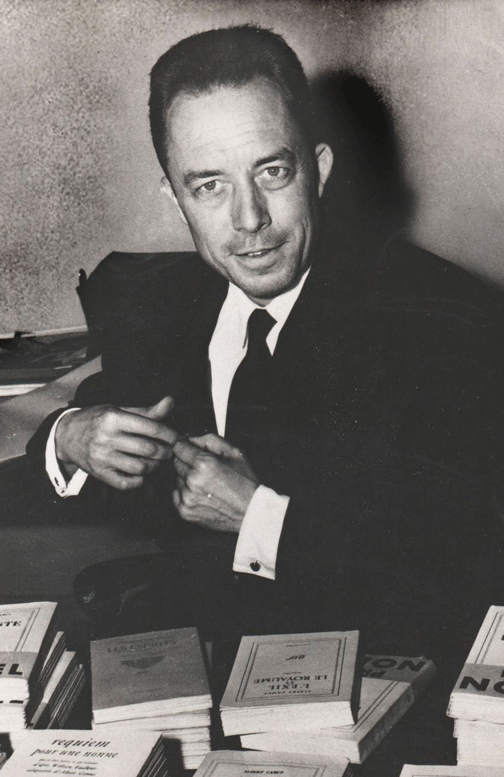

The Flesh, Albert Camus

The Flesh

IT WAS hard for us to speak of René Leynaud yesterday. Those who read in a corner of their newspaper that a Resistance journalist with that name had been shot by the Germans paid but fleeting attention to what for us was a dreadful, an atrocious announcement. And yet we must speak of him. We must speak of him so that the memory of the Resistance will be kept alive, not in a nation that may be forgetful, but at least in a few hearts that pay attention to human quality.

He had entered the Resistance during the first months. Everything that constituted his moral life, Christianity and respect for one’s promise, had urged him to take his place silently in that battle of shadows. He had chosen the pseudonym that corresponded to everything purest in him; to all his comrades on Combat he was known as Clair.

The only private passion he had kept—along with that of personal modesty—was poetry. He had written poems that only two or three of us knew. They had the quality he himself had—transparency. But in the daily struggle he had given up writing, indulging only in buying the most varied books of poetry, which he was saving to read after the war. As for everything else, he shared our conviction that a certain language and insistence on honesty would restore to our country the noble countenance we cherished. For months his place was waiting for him on this newspaper, and with all the blindness of friendship and affection we refused to accept the news of his death. Today that is no longer possible.

He will no longer speak that language it was essential to speak. The absurd tragedy of the Resistance is summed up in this frightful misfortune. For men like Leynaud entered the struggle with the conviction that no one had a right to speak until he had made a personal sacrifice. The trouble is that the unofficial war did not have the dreadful justice of the regular war. At the front, bullets strike at random, killing the best and the worst. But for four years behind the lines, it was the best who volunteered and fell, it was the best who earned the right to speak, and lost the ability to do so.

In any case, the man we loved will never speak again. And yet France needed voices like his. His exceptionally proud heart, protected by his faith and his sense of honor, would have found the words we needed. But he is now forever silent. And some who are not worthy speak of the honor that was identified with him, while others who are not trustworthy speak in the name of the God he had chosen.

It is possible today to criticize the men of the Resistance, to note their shortcomings, and to bring accusations against them. But this is perhaps because the best among them are dead. We say this because we are deeply convinced of it: if we are still here, this is because we did not do enough. Leynaud did enough. And today, having been returned to the soil he enjoyed for so short a time, having been cut off from that passion to which he had sacrificed everything, he may find consolation, we hope, in not hearing the words of bitterness and denigration now being applied to that poor human adventure in which we took part.

Never fear, we shall not make use of him, who never made use of anyone. He left the struggle unknown as he entered it unknown. We shall keep for him what he would have preferred—the silence of our hearts, an attentive memory, and the dreadful sorrow of the irreparable. But he will forgive us if we admit bitterness here where we have always tried to avoid it, and indulge in the thought that perhaps the death of such a man is too high a price to pay for granting others the right to forget in their behavior and their writings what was achieved during four years by the courage and sacrifice of a few Frenchmen.

COMBAT, 27 October 1944

ON THE 16th of May 1944, René Leynaud, bearing secret documents, was arrested by members of the Vichy Militia in Place Bellecour at Lyon. When he tried to flee, a rain of bullets aimed at his legs stopped him. After a short stay in the hospital, he was transferred to Fort Montluc, where he was to remain incarcerated until the 13th of June 1944. That day the Germans who were getting ready to evacuate Lyon picked out nineteen prisoners at Montluc who were considered to have played an important part in the Resistance. We know the names of only eleven of them. Between five and six a.m., Leynaud and eighteen of his fellow prisoners were gathered together in the courtyard. They were served coffee and then handcuffed. One by one, they climbed into a truck, which took them to the Gestapo headquarters in Place Bellecour.

They waited three quarters of an hour in the cellar of that building. When they were finally called, their handcuffs were removed and they were made to climb into the truck again with some German soldiers armed with machine guns. The truck drove out of Lyon in the direction of Villeneuve. At eleven o’clock it crept through Villeneuve and encountered a group of children returning from a walk. The prisoners and the children looked at each other for a time but didn’t exchange a word. Just beyond Villeneuve, opposite a grove of poplars, the truck stopped, the soldiers leaped to the ground and commanded the men to get out and go toward the woods. A first group of six left the truck and started toward the trees.

The machine guns immediately crackled behind them and mowed them down. A second group followed, then a third. Those who were still breathing were put out of their pain by a final shot. One of them, however, though frightfully wounded, managed to drag himself to a peasant’s house. From him we learned the details. Leynaud’s friends simply wonder whether he was in the first group or one of the later groups.

Leynaud was thirty-four. He was born on 24 August 1910 at Lyon-Vaise of parents from the Ardèche. He had begun his education at the public school and gone on to the Lycée Ampère in Lyon. While he was attending law school, he had begun as a journalist on Le Progrès of Lyon. It was probably during the years just before the war that he came to understand his love of poetry and his profound Christianity.

In September 1939 Leynaud is mobilized, fights in Lorraine, then in Belgium, takes part in the Dunkerque retreat, and, being far away from the official evacuation, nevertheless manages by some makeshift means to cross the Channel to Plymouth. He returns to France and at the moment of the armistice he is at Agen, sick and exhausted. I should like to point out, however, that none of his friends ever heard Leynaud talk of the part he had played in the war. We get these details from his wife. Early in 1942 Leynaud made contact with Resistance groups and was eventually to become local leader of the Combat movement in Lyon under the pseudonym of Clair.

For all of us, Leynaud’s death made an example of him. Yet before that we knew, just from the kind of attachment we felt for him, that his life (and we have just told the short, sharp story of that life) was exemplary. Living very quietly, absorbed by the love of his wife and his son, by the needs of the combat, he didn’t have many friends. But I have never known a single person who, loving him, failed to love him without reservation. This is because he inspired confidence. Insofar as it is possible for a man, he gave himself completely to everything he did. He never bargained about anything, and this is why he was assassinated. As solid as the short, stocky oaks of his Ardèche, he was both physically and morally strapping. Nothing could make the slightest dent in him when he had once made up his mind what was fair. It took a burst of bullets to subjugate him.

Up to now, I have spoken of Leynaud dryly and, so to speak, in a general way. But if it is true that I shall probably never again be able to speak freely of the man who was my friend, at least I can try to set down now a few more vivid images that I had already begun to put together.

He was only slightly above average height, with thick, curly hair, a rough-hewn face with gray eyes, a mobile and rather full mouth, a broad nose, and a sharp jaw. He dressed carelessly, but the shape of his body tended to stretch his clothing and give it a certain elegance.

In 1943, on my way through Lyon, I often stayed in his little room in Rue Vieille-Monnaie which his friends knew so well. Leynaud would do the honors rapidly, fussing about the bedside lamp and then, rising, would take cigarettes out of an earthenware pot and share them with me. “I smoke less than you,” he would say, “and, besides, I prefer my pipe.” He would take it out, in fact, and keep in in his mouth for a time. In my memory, those hours have remained as classic examples of friendship. Leynaud, who was going to sleep somewhere else, would stay until the curfew. All around us, the heavy silence of the Occupation nights would settle down.

That big, somber city of conspiracy that Lyon then was would gradually empty. But we would not speak of the conspiracy. As a matter of fact, Leynaud, unless he absolutely had to, never spoke of it. We would exchange news of our friends. Sometimes we spoke of literature. He loved the poets of the sixteenth century and especially the School of Lyon. His library, rare and precious, which surrounded us then, was made up almost exclusively of poetry. But the poems came from all times and all places. I did not have his competence.

Yet I ventured to tell him the impatience I felt when faced with the short poem, the fleeting notation cultivated by so many moderns. We saw eye to eye on that point, and it was then that he told me of his plan for a long poem in which he would try to set down what he had to say. Recovered fragments of that poem figure in his volume of poetry.

But at that time Leynaud was not writing anything. He had decided that he would work afterward. From several indications, I guessed then that he was waiting impatiently for that afterward. This man who had never sidestepped any duty was to be especially congratulated because it so happened that he felt the full weight of duty. Fatigue would seize him at certain moments and give him that set look that would isolate him from the world for a time.

He was too close to all he loved—his wife, his child, a certain way of life—not to dream of a future in which his love would not be endangered and in which he himself could be what he really was. “What will you do when it’s all over?” he would ask me. But then as now I had no imagination and my replies were not clear. For Leynaud, everything was simple; he would resume his life at the point where he had left off, for he found it to his liking. Then, he had a child to raise. And though he rarely became animated, the name of his son was enough to make his eyes shine.

At other times we had less serious conversations. I used to like to see him laugh. He did so rarely, now that I stop to think about it, but then he would do so heartily, leaning back on his chair. The next moment he would be standing in a position in which I see him often, his feet apart, rolling his sleeves high above the elbows, and raising his vigorous arms to try to discipline his always tousled hair. We would talk of boxing, of swimming, and of camping.

He loved the physical life, muscular effort, the fraternal earth, and all that in silence, just as he used to eat, with a lively, uncommunicative appetite. As midnight approached, he would empty his pipe, lay out more cigarettes that he urged me to smoke during the night, and, his coat over his arm, would set forth energetically. I could still hear him on the stairs as I looked around me at what belonged to him.

I also had meetings with him at Saint-Etienne. Between trains, we would spend a few hours in that hopeless town. I recall very vividly the first of those meetings, in September 1943, because everything about it was a disappointment. I had warned Leynaud that nothing could be accomplished at Saint-Etienne, where I used to stop off frequently then—that I was no good for anything in a city where I never felt anything but the most unreasonable torpor.

In my opinion, if hell existed it would have to look like those interminable gray streets where everyone was wearing black. Leynaud assured me that I was exaggerating, and we made an appointment so that he could meet one of my friends whom he wanted to know. The friend was an energetic and irreverent Dominican who claimed to loathe the Christian Democrats and dreamed of a Nietzschean Christianity. Leynaud, who could not feel drawn to the cautious forms of Christianity, felt interested in that soldier-monk. Together with the priest, I was to wait for him at the Saint-Etienne station buffet. Unfortunately the priest, obliged to take a train early in the afternoon, had to lunch very early. Leynaud arrived finally during the dessert, but, suffering from a very obvious chest cold, he was hardly capable of talking coherently.

Five minutes later my white-robed friend had to dash toward the platform. And Leynaud and I, whose trains did not leave until late in the afternoon, began to wander in hell, drugged with heat and boredom, pausing at regular intervals in front of a lemonade sweetened with saccharine in deserted cafés full of flies. Meanwhile he was stuffing himself with aspirin. Around four o’clock we were finally able to talk a little. A bit later I took him to his train, and he was already on the steps of the car when we both broke out laughing. “You see,” I said to him, “it’s impossible to accomplish anything here.” He laughed heartily and, as the train started up, he continued to laugh as he waved in my direction. Of all the images I have of him, this one is especially dear to me.

Another day, in Place Bellecour among playing children and the few pigeons that had escaped the inhabitants’ hunger, Leynaud and I were talking of morality and were of the opinion that, if I dare say so, something should be done about it. That was the occasion when I had a chance to measure what particularly distinguished him, the force and quality of his silence, for we then spent more than half an hour side by side apparently absorbed in watching the passers-by but completely absorbed in pursuing a common thought.

The last time I saw him was in Paris in the spring of 1944. We were never closer to each other than during that last meeting. We had met in a restaurant in Rue Saint-Benoît, and afterward, walking along the quais in beautiful weather, we had spoken at length of the future. We were in such deep agreement that for the first time I felt an absolute confidence in the future of our country. I cannot set down here our conversation although I have it all clearly in mind and several of his letters still remind me that our words were as important to him as they were to me. We had decided then to work together after the liberation.

Leynaud was to settle in Paris and work for the same cause. But now he no longer belongs to anyone, and I shall take care not to give the impression that at present he would naturally be working with me. He left me that day at about four p.m. on the Pont du Carrousel. I am ashamed to say that I don’t recall his last words. And I hadn’t the slightest premonition as to his death. Sunk in stupid human confidence, sure of him and of his future, I merely waved at him from one end of the bridge to the other as he waved at me, with one arm in the air.

A few weeks before, he had written me: “May God grant us this year and a few others, and the joy of serving the same truth. These are my wishes for 1944 that I voice for you and for me because I am eager today not to dissociate you from a certain idea I have of myself, which is not, I hope, the least noble.”

But that year was not granted him.

If I dared paraphrase one of his letters, I should say simply that I often consult in myself an image he put there, or a virtue, that bears his name and his countenance. Truth needs witnesses. Leynaud was one of them, and this is why I miss him today. With him here, I saw more clearly, and his death, far from making me better, as the books of consolation say, made my revolt more blind. The finest thing I can say in his favor is that he would not have followed me in that revolt. But no good is done to men by killing their friends, as I know only too well by now.

And who can ever justify that dreadful death? What are duty, virtue, honors compared to what was irreplaceable in Leynaud? Yes, what are they but the paltry alibis of those who remain alive? We were cheated of a man three years ago, and since then we have had a heavy heart, that is all I can say. For us who loved him and for all those who, without knowing him, deserved to love him, this is a dead loss.

Introduction to POÉSIES POSTHUMES,

by René Leynaud (1947)

The end