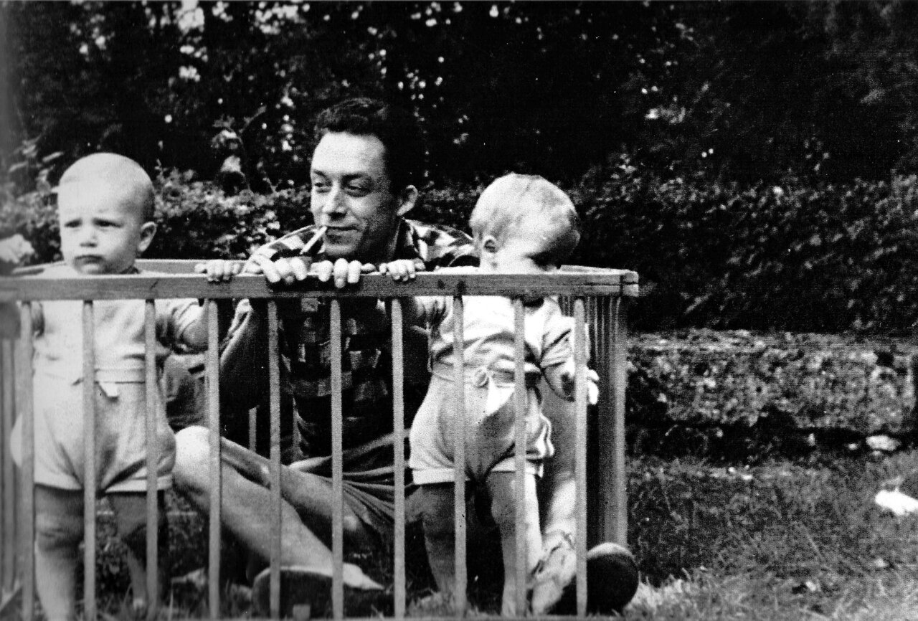

The Liberation of Paris, Albert Camus

The Liberation of Paris

The Blood of Freedom

The Night of Truth

The Liberation of Paris

THE BLOOD OF FREEDOM

PARIS is shooting all her bullets in the August night. In this vast setting of stones and waters, all around this river that has reflected so much history, the barricades of freedom have once more been thrown up. Once more justice must be bought with the blood of men.

We know this fight too well, we are too involved through our flesh and our hearts to accept this dreadful condition without bitterness. But we also know too well what is at stake to refuse the difficult fate that we must endure alone.

Time will bear witness to the fact that the men of France did not want to kill and that their hands were clean when they entered a war they had not chosen. Their reasons must then have been overwhelming for them suddenly to seize their guns and shoot steadily, in the night, at those soldiers who for two years thought the war was easy.

Yes, their reasons are overwhelming. They are as big as hope and as deep as revolt. They are the reasons of the future for a country that others tried so long to limit to the gloomy rumination of her past. Paris is fighting today so that France may speak up tomorrow. The people are under arms tonight because they hope for justice for tomorrow. Some go about saying that it is not worth while and that with a little patience Paris will be liberated without effort. But this is because they vaguely sense that this insurrection threatens many things that would continue to stand if all took place otherwise.

Indeed, this must be increasingly obvious: no one can think that a freedom torn from such convulsions will have the calm, tame aspect that some enjoy imagining. This dreadful travail will give birth to a revolution.

No one can hope that men who have fought in silence for four years and are now fighting all day long in the din of bombs and the crackle of guns will agree to the return of the forces of surrender and injustice under any circumstances. No one can expect that these men—the nation’s best—will again accept doing what the best and purest did for twenty-five years—that is, loving their country in silence and silently despising her leaders. The Paris that is fighting tonight intends to command tomorrow. Not for power, but for justice; not for politics, but for ethics; not for the domination of France, but for her grandeur.

Our conviction is not that this will take place, but that this is taking place today in the suffering and obstinacy of the fight. And this is why, despite men’s suffering, despite the blood and wrath, despite the dead who can never be replaced, the unjust wounds, and the wild bullets, we must utter, not words of regret, but words of hope, of the dreadful hope of men isolated with their fate.

This huge Paris, all black and warm in the summer night, with a storm of bombers overhead and a storm of snipers in the streets, seems to us more brightly lighted than the City of Light the whole world used to envy us. It is bursting with all the fires of hope and suffering, it has the flame of lucid courage and all the glow, not only of liberation, but of tomorrow’s liberty.

COMBAT, 24 August 1944

THE NIGHT OF TRUTH

WHILE the bullets of freedom are still whistling throughout the city, the cannons of the liberation are entering the gates of Paris amid shouts and flowers. In the most beautiful and hottest of August nights, the eternal stars over Paris mingle with the tracer bullets, the smoke of fires, and the colored rockets of a mass celebration. This unparalleled night marks the end of four years of monstrous history and of an unspeakable struggle in which France came to grips with her shame and her wrath.

Those who never despaired of themselves or of their country find their reward under this sky. This night is worth a world; it is the night of truth. Truth under arms and in the fray, truth sustained by force after having so long been empty-handed and unprotected. It is everywhere this night when people and cannons are booming simultaneously. It is the very voice of the people and the cannons; it wears the exhausted face of the street fighters, triumphal under their scars and sweat. Yes, it is indeed the night of truth, of the only truth that matters, the truth that is willing to fight and conquer.

Four years ago men rose up amid ruins and despair and calmly declared that nothing was lost. They said we had to carry on and that the forces of good could always overcome the forces of evil if we were willing to pay the price. They paid the price. And, to be sure, that price was heavy; it had all the weight of blood and the dreadful heaviness of prisons. Many of those men are dead, whereas others have been living for years surrounded by windowless walls. That was the price that had to be paid. But those same men, if they could, would not blame us for this terrible and marvelous joy that sweeps us off our feet like a high tide.

For our joy has not broken faith with them. On the contrary, it justifies them and declares that they were right. United in the same suffering for four years, we still are united in the same intoxication; we have won our solidarity. And we are suddenly astonished to see during this dazzling night that for four years we have never been alone. We have lived the years of fraternity.

Harsh combats still await us. But peace will return to this torn earth and to hearts tortured by hopes and memories. One cannot always live on murders and violence. Happiness and proper affection will have their time. But that peace will not find us forgetful. And for some among us, the faces of our brothers disfigured by bullets, the great virile brotherhood of recent years will never forsake us. May our dead comrades enjoy by themselves the peace that is promised us during this panting night, for they have already won it.

Our fight will be theirs.

Nothing is given to men, and the little they can conquer is paid for with unjust deaths. But man’s greatness lies elsewhere. It lies in his decision to be stronger than his condition. And if his condition is unjust, he has only one way of overcoming it, which is to be just himself. Our truth of this evening, which hovers overhead in this August sky, is just what consoles man. And our hearts are at peace, just as the hearts of our dead comrades are at peace, because we can say as victory returns, without any spirit of revenge or of spite: “We did what was necessary.”

COMBAT, 25 August 1944

The end