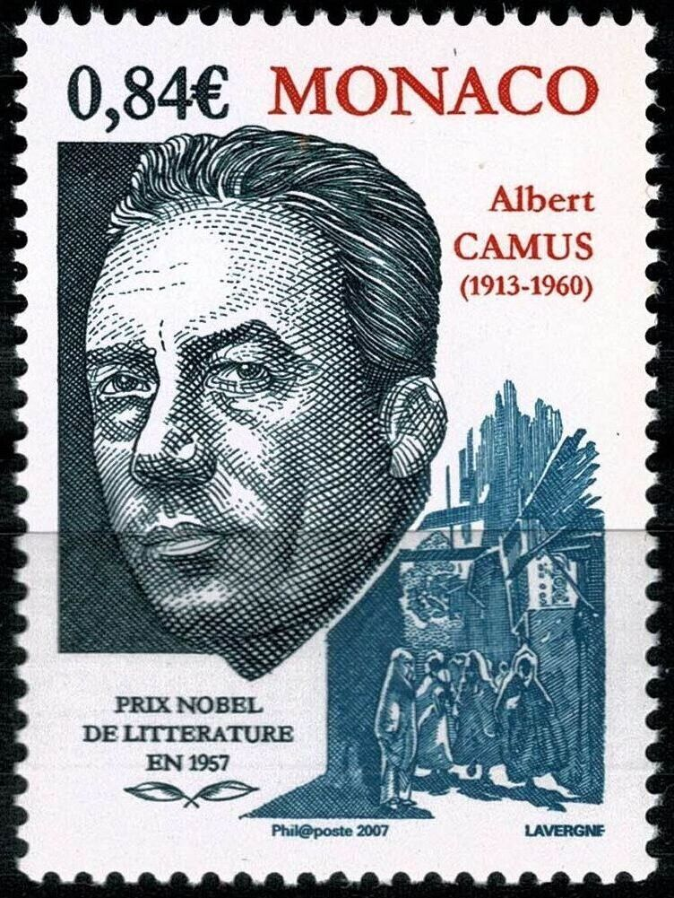

The Unbeliever and Christians, Albert Camus

(Fragments of a statement made at the Dominican Monastery of Latour-Maubourg in 1948)

INASMUCH as you have been so kind as to invite a man who does not share your convictions to come and answer the very general question that you are raising in these conversations, before telling you what I think unbelievers expect of Christians, I should like first to acknowledge your intellectual generosity by stating a few principles.

First, there is a lay pharisaism in which I shall strive not to indulge. To me a lay pharisee is the person who pretends to believe that Christianity is an easy thing and asks of the Christian, on the basis of an external view of Christianity, more than he asks of himself. I believe indeed that the Christian has many obligations but that it is not up to the man who rejects them himself to recall their existence to anyone who has already accepted them.

If there is anyone who can ask anything of the Christian, it is the Christian himself. The conclusion is that if I allowed myself at the end of this statement to demand of you certain duties, these could only be duties that it is essential to ask of any man today, whether he is or is not a Christian.

Secondly, I wish to declare also that, not feeling that I possess any absolute truth or any message, I shall never start from the supposition that Christian truth is illusory, but merely from the fact that I could not accept it. As an illustration of this position, I am willing to confess this: Three years ago a controversy made me argue against one among you, and not the least formidable. The fever of those years, the painful memory of two or three friends assassinated had given me the courage to do so.

Yet I can assure you that, despite some excessive expressions on the part of François Mauriac, I have not ceased meditating on what he said. At the end of this reflection—and in this way I give you my opinion as to the usefulness of the dialogue between believer and unbeliever—I have come to admit to myself, and now to admit publicly here, that for the fundamentals and on the precise point of our controversy François Mauriac got the better of me.

Having said that, it will be easier for me to state my third and last principle. It is simple and obvious. I shall not try to change anything that I think or anything that you think (insofar as I can judge of it) in order to reach a reconciliation that would be agreeable to all. On the contrary, what I feel like telling you today is that the world needs real dialogue, that falsehood is just as much the opposite of dialogue as is silence, and that the only possible dialogue is the kind between people who remain what they are and speak their minds.

This is tantamount to saying that the world of today needs Christians who remain Christians. The other day at the Sorbonne, speaking to a Marxist lecturer, a Catholic priest said in public that he too was anticlerical. Well, I don’t like priests who are anticlerical any more than philosophies that are ashamed of themselves. Hence I shall not, as far as I am concerned, try to pass myself off as a Christian in your presence. I share with you the same revulsion from evil. But I do not share your hope, and I continue to struggle against this universe in which children suffer and die.

And why shouldn’t I say here what I have written elsewhere? For a long time during those frightful years I waited for a great voice to speak up in Rome. I, an unbeliever? Precisely. For I knew that the spirit would be lost if it did not utter a cry of condemnation when faced with force. It seems that that voice did speak up. But I assure you that millions of men like me did not hear it and that at that time believers and unbelievers alike shared a solitude that continued to spread as the days went by and the executioners multiplied.

It has been explained to me since that the condemnation was indeed voiced. But that it was in the style of the encyclicals, which is not at all clear. The condemnation was voiced and it was not understood! Who could fail to feel where the true condemnation lies in this case and to see that this example by itself gives part of the reply, perhaps the whole reply, that you ask of me. What the world expects of Christians is that Christians should speak out, loud and clear, and that they should voice their condemnation in such a way that never a doubt, never the slightest doubt, could rise in the heart of the simplest man.

That they should get away from abstraction and confront the blood-stained face history has taken on today. The grouping we need is a grouping of men resolved to speak out clearly and to pay up personally. When a Spanish bishop blesses political executions, he ceases to be a bishop or a Christian or even a man; he is a dog just like the one who, backed by an ideology, orders that execution without doing the dirty work himself. We are still waiting, and I am waiting, for a grouping of all those who refuse to be dogs and are resolved to pay the price that must be paid so that man can be something more than a dog.

And now, what can Christians do for us?

To begin with, give up the empty quarrels, the first of which is the quarrel about pessimism. I believe, for instance, that M. Gabriel Marcel would be well advised to leave alone certain forms of thought that fascinate him and lead him astray. M. Marcel cannot call himself a democrat and at the same time ask for a prohibition of Sartre’s play. This is a position that is tiresome for everyone. What M. Marcel wants is to defend absolute values, such as modesty and man’s divine truth, when the things that should be defended are the few provisional values that will allow M. Marcel to continue fighting someday, and comfortably, for those absolute values.…

By what right, moreover, could a Christian or a Marxist accuse me, for example, of pessimism? I was not the one to invent the misery of the human being or the terrifying formulas of divine malediction. I was not the one to shout Nemo bonus or the damnation of unbaptized children. I was not the one who said that man was incapable of saving himself by his own means and that in the depths of his degradation his only hope was in the grace of God. And as for the famous Marxist optimism! No one has carried distrust of man further, and ultimately the economic fatalities of this universe seem more terrible than divine whims.

Christians and Communists will tell me that their optimism is based on a longer range, that it is superior to all the rest, and that God or history, according to the individual, is the satisfying end-product of their dialectic. I can indulge in the same reasoning. If Christianity is pessimistic as to man, it is optimistic as to human destiny. Well, I can say that, pessimistic as to human destiny, I am optimistic as to man. And not in the name of a humanism that always seemed to me to fall short, but in the name of an ignorance that tries to negate nothing.

This means that the words “pessimism” and “optimism” need to be clearly defined and that, until we can do so, we must pay attention to what unites us rather than to what separates us.

That, I believe, is all I had to say. We are faced with evil. And, as for me, I feel rather as Augustine did before becoming a Christian when he said: “I tried to find the source of evil and I got nowhere.” But it is also true that I, and a few others, know what must be done, if not to reduce evil, at least not to add to it. Perhaps we cannot prevent this world from being a world in which children are tortured. But we can reduce the number of tortured children. And if you don’t help us, who else in the world can help us do this?

Between the forces of terror and the forces of dialogue, a great unequal battle has begun. I have nothing but reasonable illusions as to the outcome of that battle. But I believe it must be fought, and I know that certain men at least have resolved to do so. I merely fear that they will occasionally feel somewhat alone, that they are in fact alone, and that after an interval of two thousand years we may see the sacrifice of Socrates repeated several times. The program for the future is either a permanent dialogue or the solemn and significant putting to death of any who have experienced dialogue. After having contributed my reply, the question that I ask Christians is this: “Will Socrates still be alone and is there nothing in him and in your doctrine that urges you to join us?”

It may be, I am well aware, that Christianity will answer negatively. Oh, not by your mouths, I am convinced. But it may be, and this is even more probable, that Christianity will insist on maintaining a compromise or else on giving its condemnations the obscure form of the encyclical. Possibly it will insist on losing once and for all the virtue of revolt and indignation that belonged to it long ago. In that case Christians will live and Christianity will die.

In that case the others will in fact pay for the sacrifice. In any case such a future is not within my province to decide, despite all the hope and anguish it awakens in me. I can speak only of what I know. And what I know—which sometimes creates a deep longing in me—is that if Christians made up their minds to it, millions of voices—millions, I say—throughout the world would be added to the appeal of a handful of isolated individuals who, without any sort of affiliation, today intercede almost everywhere and ceaselessly for children and for men.

The End