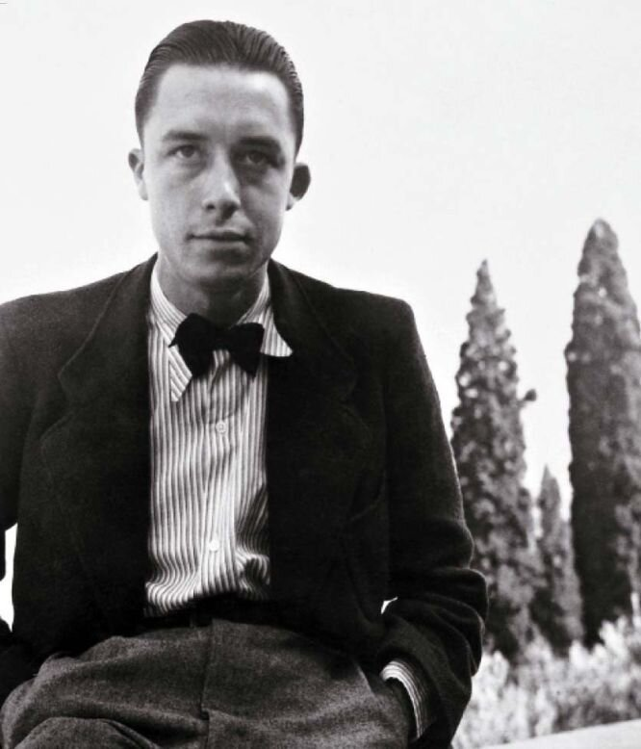

Why Spain? Albert Camus

Why Spain?

(Reply to Gabriel Marcel)

I SHALL reply here to but two passages in your article on my State of Siege in the Nouvelles Littéraires. But I have no intention of replying to the criticisms that you or others made of the play as a dramatic work. When one indulges in publishing a book or staging a play, one has to accept the criticism it evokes. Whatever one may have to say, one must keep silent.

Yet you went beyond the critic’s prerogatives when you expressed surprise that a play about totalitarian tyranny would be laid in Spain, whereas you would have been more inclined to imagine it in Eastern Europe. And when you state that the setting shows a lack of courage and fairness, you are asking for a reply.

To be sure, you are kind enough to think that I am not responsible for the choice (this can be interpreted to mean that everything is the fault of Barrault, already so besmirched with crimes). Unfortunately, the play takes place in Spain because I alone chose, after much thought, that it should take place there. Consequently, I must take upon myself your accusations of opportunism and unfairness. And, under the circumstances, you will not be surprised that I feel obliged to answer you.

It is likely, moreover, that I should not defend myself against even these accusations (to whom can one justify oneself today?) if you had not touched on a subject as serious as that of Spain. For there is certainly no need for me to say that I did not aim to flatter anyone by writing State of Siege.

I wanted to attack a kind of political society that set itself up, or is setting itself up, on a totalitarian model, both on the Right and on the Left. No one in good faith can fail to see that my play defends the individual, the flesh in its noblest aspects—in short, human love—against the abstractions and terrors of the totalitarian state, whether Russian, German, or Spanish. Every day pundits reflect about the decadence of our society and look for its basic causes. Most likely such causes exist.

But for the simpler among us the evil of our times can be defined by its effects rather than by its causes. That evil is the State, whether a police state or a bureaucratic state. Its proliferation in all countries under cover of the most varied ideological pretexts, the revolting security granted it by mechanical and psychological means of repression make of the State a mortal danger for everything that is best in each of us. From this point of view, contemporary political society, in any form, is despicable. This is just what I said, and this is why State of Siege represents a break that aims to spare nothing.

Once this has been stated clearly, why Spain? May I confess that I am somewhat ashamed to ask the question for you? Why Guernica, Gabriel Marcel? Why that event which for the first time, in the face of a world still sunk in its comfort and its wretched morality, gave Hitler, Mussolini, and Franco a chance to show even children the meaning of totalitarian technique? Yes, why that event, which concerned us too? For the first time men of my age came face to face with injustice triumphing in history.

At that time the blood of innocence flowed amid a chatter of pharisees, which, alas, is still going on. Why Spain? Because there are some of us who will never wash their hands of that blood. Anti-communism, whatever reasons there may be for embracing it (and I know some good ones), will never gain acceptance among us if it forgets the injustice that is going on with the complicity of our governments.

I have stated as vigorously as I could what I thought of the Russian concentration camps. But they will not make me forget Dachau, Buchenwald, and the nameless agony of millions, nor the dreadful repression that decimated the Spanish Republic. Yes, despite the commiseration of our political leaders, all this together must be denounced at one and the same time. And I cannot forgive that hideous plague in the West of Europe because it is also ravaging the East on a vaster scale. You write that, for the well-informed, Spain is not now the source of the news most likely to spread despair among men who respect human dignity.

You are not well informed, Gabriel Marcel. Just yesterday five political opponents were condemned to death there. But you did everything you could to be ill informed by developing the art of forgetting. You have forgotten that the first weapons of totalitarian war were bathed in Spanish blood.

You have forgotten that in 1936 a rebellious general, in the name of Christ, raised up an army of Moors, hurled them against the legally constituted government of the Spanish Republic, won victory for an unjust cause after massacres that can never be expiated, and initiated a frightful repression that has lasted ten years and is not yet over. Yes, indeed, why Spain? Because you, like so many others, do not remember.

And also because, together with a small number of fellow Frenchmen, I am still occasionally not proud of my country. I do not know that France ever delivered up to the Russian government any anti-Stalinists who had taken refuge here. This will probably happen, for our leaders are ready for anything. In the case of Spain, however, the deed is already done. By virtue of the most disgraceful clause of the armistice, we handed over to Franco, on Hitler’s orders, many Spanish republicans—among them the great Luis Companys.

And Companys was shot while that frightful deal was going on. By Vichy, to be sure, and not by us. We merely put the poet Antonio Machado, back in 1938, into a concentration camp which he left only to die. But at that time when the French State rounded up victims for the totalitarian executioners, who voiced a protest? No one.

That was probably, Gabriel Marcel, because those who might have protested shared your feeling that all that was a small matter compared to what they most loathed in the Russian system. So, after all, what did they care about one more man being shot by the firing squad? But the face of a man who has been shot by the firing squad is an ugly wound, and eventually gangrene sets in. The gangrene has spread.

Where then are the assassins of Companys? In Moscow or in our country? We must answer: in our country. We must admit that we shot Companys, that we are responsible for what followed. We must declare that we are ashamed, and that our only way of making up for this will be to preserve the memory of a Spain that was free and that we betrayed as best we could, in our own petty way. And it is true that no power failed to betray Spain, except Germany and Italy—and they shot Spaniards in open combat. But this can be no consolation, and free Spain continues, by its very silence, to ask amends of us. I did what I could, within the limits of my power, and this is what shocks you.

If I had had more talent, the amends would have been greater; that is all I can say. But if I had compromised, that would have been cowardice and deceit. I shall not continue with this subject, however, and I shall stifle my feelings out of regard for you. At most let me add that no man of sensitivity should have been astonished that when I wanted to make a people of flesh and pride speak out against the shame and ghosts of dictatorship, I chose the Spanish people. I couldn’t, after all, choose the international public of Reader’s Digest or the readers of Samedi-Soir and France-Dimanche.

But you are doubtless eager for me to explain myself as to the role I gave the Church to play. On this point I shall be brief. You consider that role to be odious whereas it was not so in my novel.1 But in my novel I had to do justice to those of my Christian friends whom I met during the Occupation in a combat that was just. In my play, on the other hand, I had to say what was the role of the Spanish Church. And if I made it odious, I did so because in the eyes of the world the role of the Spanish Church was odious.

However unpleasant this truth may be for you, you can console yourself with the thought that the scene that bothers you lasts but a minute whereas the one that still offends the conscience of Europe has been going on for ten years.

And the entire Church would have been sullied by the unbelievable scandal of Spanish bishops blessing the firing squad’s rifles if during the very first days two great Christians—Bernanos, who is now dead, and José Bergamin, who is now exiled from his country—had not protested. Bernanos would not have written what you have written on this subject. He knew that the line with which my scene ends—“Spanish Christians, you have been abandoned”—does not insult your faith. He knew that if I had said something else or kept silent, I should then have insulted truth.

If I had to rewrite State of Siege, I should still set it in Spain; that is my conclusion. And, now and in the future, it would be obvious to everyone that the judgment pronounced in it transcends Spain and applies to all totalitarian societies. And no shameful complicity would have been involved. This is the way, and absolutely the only way, we can maintain the right to protest against a reign of terror. This is why I cannot share your opinion that we are in complete agreement in matters of politics. For you are willing to keep silent about one reign of terror in order the better to combat another one.

There are some of us who do not want to keep silent about anything. It is our whole political society that nauseates us. Hence there will be no salvation until all those who are still worth while have repudiated it utterly in order to find, somewhere outside insoluble contradictions, the way to a complete renewal. In the meantime we must struggle. But with the knowledge that totalitarian tyranny is not based on the virtues of the totalitarians. It is based on the mistakes of the liberals.

Talleyrand’s remark is contemptible, for a mistake is not worse than a crime. But the mistake eventually justifies the crime and provides its alibi. Then the mistake drives its victims to despair, and that is why it must not be condoned. That is just what I cannot forgive contemporary political society: it is a mechanism for driving men to despair.

It will probably seem to you that I am getting very excited about a small matter. Then let me, for once, speak in my own name. The world I live in is loathsome to me, but I feel one with the men who suffer in it. There are ambitions that are not mine, and I should not feel at ease if I had to make my way by relying on the paltry privileges granted to those who adapt themselves to this world.

But it seems to me that there is another ambition that ought to belong to all writers: to bear witness and shout aloud, every time it is possible, insofar as our talent allows, for those who are enslaved as we are. That is the very ambition you questioned in your article, and I shall consistently refuse you the right to question it so long as the murder of a man angers you only when that man shares your ideas.

COMBAT, December 1948

1 The Plague.

The End