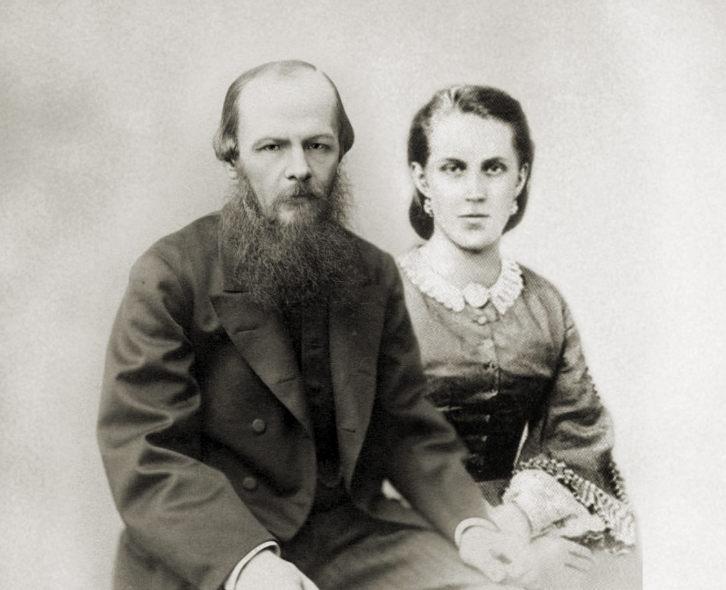

A Few Words about George Sand, Fyodor Dostoevsky

A Few Words about George Sand

George Sand appeared in literature when I was in my early youth, and I am very pleased that it was so long ago because now, more than thirty years later, I can speak almost with complete frankness. I should note that at the time her sort of thing – novels, I mean – was all that was permitted; all the rest, including virtually every new idea, and those coming from France in particular, was strictly suppressed. Oh, of course it often happened that they weren’t able to pick out such ‘ideas,’ and indeed, where could they learn such a skill? Even Metternich lacked it, never mind those here who tried to imitate him.

And so some ‘shocking things’ would slip through (the whole of Belinsky slipped through, for instance). And then, as if to make up for Belinsky (near the end of the period, in particular) and be on the safe side, they began to forbid almost everything so that, as we know, we were left with little more than pages with blank lines on them. But novels were still permitted at the beginning, the middle, and even at the very end of the period. It was here, and specifically with George Sand, that the public’s guardians made a very large blunder. Do you remember the verse:

The tomes of Thiers and of Rabaut

He knows, each line by line;

And he, like furious Mirabeau

Hails Liberty divine.

These are very fine verses, exceptionally so, and they will last forever because they have historic significance; but they are all the more precious because they were written by Denis Davydov, the poet, literary figure, and most honorable Russian. But even if in those days Denis Davydov considered Thiers, of all people (on account of his history of the revolution, of course) as dangerous and put him in a verse along with some Rabaut fellow (such a man also existed, it seems, but I don’t know him), then there surely could not have been much that was permitted officially then. And what was the result?

The whole rush of new ideas that came through the novels of the time served exactly the same ends, and perhaps by the standards of the day in an even more ‘dangerous’ form, since there probably were not too many lovers of Rabaut, but there were thousands who loved George Sand. It should also be noted here that, despite all the Magnitskys and the Liprandis, ever since the eighteenth century people in Russia have at once learned about every intellectual movement in Europe, and these ideas have been at once passed down from the higher levels of our intellectuals to the mass of those taking even a slight interest in things and making some effort to think. This was precisely what happened with the European movement of the 1830s.

Very quickly, right from the beginning of the thirties, we learned of this immense movement of European literatures. The names of the many newly fledged orators, historians, publicists, and professors became known. We even knew, though incompletely and superficially, the direction in which this movement was heading. And this movement manifested itself with particular passion in art – in the novel and above all in George Sand. It is true that Senkovsky and Bulgarin had warned the public about George Sand even before her novels appeared in Russian.

They tried to frighten Russian ladies, in particular, by telling them that she wore trousers; they tried to frighten people by saying she was depraved; they wanted to ridicule her. Senkovsky, who himself had been planning to translate George Sand in his magazine Reader’s Library, began calling her Mrs. Yegor Sand in print and, it seems, was truly pleased with his witticism. Later on, in 1848, Bulgarin wrote in The Northern Bee that she indulged in daily drinking bouts with Pierre Leroux somewhere near the city gates and participated in ‘Athenian evenings’ at the Ministry of the Interior; these evenings were supposedly hosted by the Minister himself, the bandit Ledru-Rollin.

I read this myself and re-member it very clearly. But at that time, in 1848, nearly the whole of our reading public knew George Sand, and no one believed Bulgarin. She appeared in Russian translation for the first time around the middle of the thirties. It’s a pity that I don’t recall when her first work was translated into Russian and which it was; but the impression it made must have been all the more startling. I think that the chaste, sublime purity of her characters and ideals and the modest charm of the severe, restrained tone of her narrative must have struck everyone then as it did me, still a youth – and this was the woman who went about in trousers engaging in debauchery! I was sixteen, I think, when I read her tale L’Uscoque for the first time; it is one of the most charming among her early works.

Afterward, I recall, I had a fever all night long. I think I am right in saying, by my recollection at least, that George Sand for some years held almost the first place in Russia among the whole Pleiad of new writers who had suddenly become famous and created such a stir all over Europe. Even Dickens, who appeared in Russia at virtually the same time, was perhaps not as popular among our readers as she.

I am not including Balzac, who arrived before her but who produced works such as Eugénie Grandet and Père Goriot in the thirties (and to whom Belinsky was so unfair when he completely overlooked Balzac’s significance in French literature). However, I say all this not to make any sort of critical evaluation but purely and simply to recall the tastes of the mass of Russian readers at that time and the direct impression these readers received. What mattered most was that the reader was able to derive, even from her novels, all the things the guardians were trying so hard to keep from them.

At least in the mid-forties the ordinary Russian reader knew, if only incompletely, that George Sand was one of the brightest, most consistent, and most upright representatives of the group of Western ‘new people’ of the time, who, with their arrival on the scene, began to refute directly those ‘positive’ achievements which marked the end of the bloody French (or rather, European) revolution of the preceding century. With the end of the revolution (after Napoleon I) there were fresh attempts to express new aspirations and new ideals.

The most advanced minds understood all too well that this had only been despotism in a new form and that all that had happened was ‘ôte toi de là que je m’y mette’; that the new conquerors of the world, the bourgeoisie, turned out to be perhaps even worse than the previous despots, the nobility; that Liberté, Égalité, Fraternité proved to be only a ringing slogan and nothing more. Moreover, certain doctrines appeared which transformed such ringing slogans into utterly impossible ones.

The conquerors now pronounced or recalled these three sacramental words in a tone of mockery; even science, through its brilliant representatives (economists) came with what seemed to be its new word to support this mocking attitude and to condemn the utopian significance of these three words for which so much blood had been shed. So it was that alongside the triumphant conquerors there began to appear despondent and mournful faces that frightened the victors.

At this very same time a truly new word was pronounced and hope was reborn: people appeared who proclaimed directly that it had been vain and wrong to stop the advancement of the cause; that nothing had been achieved by the change of political conquerors; that the cause must be taken up again; that the renewal of humanity must be radical and social. Oh, of course, along with these solemn exclamations there came a host of views that were most pernicious and distorted, but the most important thing was that hope began to shine forth once more and faith again began to be regenerated.

The history of this movement is well known; it continues even now and, it seems, has no intention of coming to a halt. I have no intention whatever of speaking either for or against it here, but I wanted only to define George Sand’s real place within that movement. We must look for her place at the very beginning of the movement. People who met her in Europe then said that she was propounding a new status for women and foreseeing the ‘rights of the free wife’ (this is what Senkovsky said about her). But that was not quite correct, because she was by no means preaching only about women and never invented any notion of a ‘free wife.’ George Sand belonged to the whole movement and was not merely sermonizing on women’s rights.

It is true that as a woman she naturally preferred portraying heroines to heroes; and of course women all over the world should put on mourning in her memory, because one of the most elevated and beautiful of their representatives has died. She was, besides, a woman of almost unprecedented intelligence and talent – a name that has gone down in history, a name that is destined not to be forgotten and not to disappear from European humanity.

As far as her heroines are concerned, I repeat that from my very first reading at the age of sixteen I was amazed by the strangeness of the contradiction between what was written and said about her and what I myself could see in fact. In actual fact, many, or at least some, of her heroines represented a type of such sublime moral purity as could not be imagined without a most thorough moral scrutiny within the poet’s own soul; without the acceptance of one’s full responsibility; without an understanding and a recognition of the most sublime beauty and mercy, patience, and justice.

It is true that along with mercy, patience, and the recognition of one’s obligations there was also an extraordinary pride in this scrutiny and in protest, but this pride was precious because it stemmed from that higher truth without which humanity could never maintain its high moral ideals. This pride is not a feeling of hostility quand même, based on the fact that I am supposedly better than you and you are worse than I; it is only a sense of the most chaste impossibility of compromise with falsity and vice, although, I repeat, this feeling excludes neither universal forgiveness nor mercy. Moreover, along with the pride came an enormous responsibility, voluntarily assumed.

These heroines of hers sought to make sacrifices and do noble deeds. Several of the girls in her early works particularly appealed to me; these were the ones depicted, for example, in what were called at the time her Venetian tales (including L’Uscoque and Aldini). These were of the type that culminated in her novel Jeanne, a brilliant work which presents a serene and, perhaps, a final solution to the historical question of Joan of Arc.

In a contemporary peasant girl she suddenly resurrects before us the image of the historical Joan of Arc and graphically makes a case for the actual possibility of this majestic and marvellous historical phenomenon, a task quite characteristic of George Sand, for no one but she among contemporary poets, perhaps, bore within her soul such a pure ideal of an innocent girl, an ideal that derives its power from its innocence. In several works in succession we find all these girl characters engaged in the same task and exemplifying the same theme (however, not only girls: this same theme is repeated later in her magnificent novel La Marquise, also one of her early works). We see depicted the upright, honest, but inexperienced character of a young female having that proud chastity, a girl who is unafraid and who cannot be stained by contact with vice, even if she were suddenly to find herself in some den of iniquity.

The need for some magnanimous sacrifice (which supposedly she alone must make) strikes the heart of the young girl, and, without pausing to think or to spare herself, she selflessly, self-sacrificingly, and fearlessly takes a most perilous and fateful step. The things she sees and encounters subsequently do not trouble or frighten her in the least; to the contrary, courage at once rises up in her young heart, which only now becomes fully aware of its power – the power of innocence, honesty, purity. Courage doubles her energy and shows new paths and new horizons to a mind that had not fully known itself but was vigorous and fresh and not yet stained by life’s compromises. In addition to this, there was the irreproachable and charming form of her poem-novels.

At that time George Sand was particularly fond of ending her poems happily, with the triumph of innocence, sincerity, and young, fearless simplicity. Are these images that could trouble society and arouse doubts and fears?

To the contrary, the strictest fathers and mothers began permitting their families to read George Sand and could only wonder, ‘Why is everyone saying these things about her?’ But then voices of warning began to be heard: ‘In this very pride of a woman’s quest, in this irreconcilability of chastity with vice, in this refusal to make any concessions to vice, in this fearlessness with which innocence rises up to struggle and to look straight into the eyes of the offender – in all this there is a poison, the future poison of women’s protest, of women’s emancipation.’ And what of it? Perhaps they were right about the poison; a poison really was being brewed, but what it sought to destroy, what had to perish from that poison and what was to be saved – these were the questions, and they were not answered for a long time.

Now these questions have long been resolved (or so it seems). It should be noted, by the way, that by the middle of the forties the fame of George Sand and the faith in the force of her genius stood so high that we, her contemporaries, all expected something incomparably greater from her in the future, some unprecedented new word, even something final and decisive. These hopes were not realized: it turned out that at that same time, that is, by the end of the forties, she had already said everything that she was destined to say, and now the final word about her can be said over her fresh grave.

George Sand was not a thinker, but she had the gift of most clearly intuiting (if I may be permitted such a fancy word) a happier future awaiting humanity. All her life she believed strongly and magnanimously in the realization of those ideals precisely because she had the capacity to raise up the ideal in her own soul. The preservation of this faith to the end is usually the lot of all elevated souls, all true lovers of humanity.

George Sand died a déiste, firmly believing in God and her own immortal life, but it is not enough to say only that of her: beyond that she was, perhaps, the most Christian of all her contemporaries, the French writers, although she did not formally (as a Catholic) confess Christ. Of course, as a French-woman George Sand, like her compatriots, was unable to confess consciously the idea that ‘in all Creation there is no name other than His by which one may be saved’ – the principal idea of Orthodoxy. Still, despite this apparent and formal contradiction, George Sand was, I repeat, perhaps one of the most thoroughgoing confessors of Christ even while unaware of being so.

She based her socialism, her convictions, her hopes, and her ideals on the human moral sense, on humanity’s spiritual thirst, on its striving toward perfection and purity, and not on the ‘necessity’ of the ant heap. She believed unconditionally in the human personality (even to the point of its immortality), and she elevated and expanded the conception of it throughout her life, in each of her works.

Thus her thoughts and feelings coincided with one of the most basic ideas of Christianity, that is, the acknowledgment of the human personality and its freedom (and accordingly, its responsibility). From here arise her acknowledgment of duty and rigorous moral scrutiny to that end, along with a complete awareness of human responsibility. And there was not a thinker or writer in the France of her time, perhaps, who understood so clearly that ‘man does not live by bread alone.’ As far as the pride in her scrutiny and her protest are concerned, I repeat that this pride never excluded mercy, the forgiveness of an offence and even limitless patience based on compassion toward the one who gave offence.

On the contrary, in her works George Sand was often attracted by the beauty of these truths and often created incarnations of the most sincere forgiveness and love. They write that she died as an admirable mother who worked to the end of her life, a friend to the local peasants, deeply beloved by her friends. It seems she was somewhat inclined to set great store by her aristocratic origins (she was descended on her mother’s side from the royal house of Saxony), but, of course, one can state firmly that if she saw aristocracy as something to be valued in people, it was an aristocracy based only on the level of perfection of the human soul: she could not help but love the great, she could not reconcile herself with the base and compromise her ideas; and here, perhaps, she may have shown an excess of pride. It is true that she also did not like to portray humble people in her novels, to depict the just but pliant, the eccentric and the downtrodden, such as we meet in almost every novel of the great Christian Dickens. On the contrary, she proudly elevated her heroines and placed them as high as queens. This she loved to do, and this trait we should note; it is rather characteristic.

(June 1876)

The End