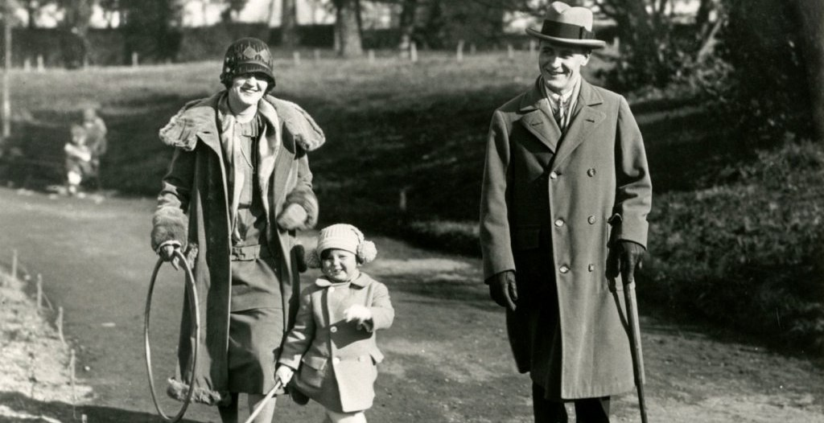

Teamed with Genius, F. Scott Fitzgerald

“I took a chance in sending for you,” said Jack Berners. “But there’s a job that you just MAY be able to help out with.”

Though Pat Hobby was not offended, either as man or writer, a formal protest was called for.

“I been in the industry fifteen years, Jack. I’ve got more screen credits than a dog has got fleas.”

“Maybe I chose the wrong word,” said Jack. “What I mean is, that was a long time ago. About money we’ll pay you just what Republic paid you last month—three-fifty a week. Now—did you ever hear of a writer named René Wilcox?”

The name was unfamiliar. Pat had scarcely opened a book in a decade.

“She’s pretty good,” he ventured.

“It’s a man, an English playwright. He’s only here in L. A. for his health. Well—we’ve had a Russian Ballet picture kicking around for a year—three bad scripts on it.

So last week we signed up Renй Wilcox—he seemed just the person.”

Pat considered.

“You mean he’s—”

“I don’t know and I don’t care,” interrupted Berners sharply. “We think we can borrow Zorina, so we want to hurry things up—do a shooting script instead of just a treatment.

Wilcox is inexperienced and that’s where you come in. You used to be a good man for structure.”

“USED to be!”

“All right, maybe you still are.” Jack beamed with momentary encouragement. “Find yourself an office and get together with Renй Wilcox.”

As Pat started out he called him back and put a bill in his hand. “First of all, get a new hat. You used to be quite a boy around the secretaries in the old days. Don’t give up at forty-nine!”

Over in the Writers’ Building Pat glanced at the directory in the hall and knocked at the door of 216. No answer, but he went in to discover a blond, willowy youth of twenty-five staring moodily out the window.

“Hello, Renй!” Pat said. “I’m your partner.”

Wilcox’s regard questioned even his existence, but Pat continued heartily, “I hear we’re going to lick some stuff into shape. Ever collaborate before?”

“I have never written for the cinema before.”

While this increased Pat’s chance for a screen credit he badly needed, it meant that he might have to do some work. The very thought made him thirsty.

“This is different from playwriting,” he suggested, with suitable gravity.

“Yes—I read a book about it.”

Pat wanted to laugh. In 1928 he and another man had concocted such a sucker-trap, Secrets of Film Writing. It would have made money if pictures hadn’t started to talk.

“It all seems simple enough,” said Wilcox. Suddenly he took his hat from the rack. “I’ll be running along now.”

“Don’t you want to talk about the script?” demanded Pat. “What have you done so far?”

“I’ve not done anything,” said Wilcox deliberately. “That idiot, Berners, gave me some trash and told me to go on from there. But it’s too dismal.” His blue eyes narrowed. “I say, what’s a boom shot?”

“A boom shot? Why, that’s when the camera’s on a crane.”

Pat leaned over the desk and picked up a blue-jacketed “Treatment.” On the cover he read:

BALLET SHOES

A Treatment

by

Consuela Martin

An Original from an idea by Consuela Martin

Pat glanced at the beginning and then at the end.

“I’d like it better if we could get the war in somewhere,” he said frowning. “Have the dancer go as a Red Cross nurse and then she could get regenerated. See what I mean?”

There was no answer. Pat turned and saw the door softly closing.

What is this? he exclaimed. What kind of collaborating can a man do if he walks out? Wilcox had not even given the legitimate excuse—the races at Santa Anita!

The door opened again, a pretty girl’s face, rather frightened, showed itself momentarily, said “Oh,” and disappeared. Then it returned.

“Why it’s Mr. Hobby!” she exclaimed. “I was looking for Mr. Wilcox.”

He fumbled for her name but she supplied it.

“Katherine Hodge. I was your secretary when I worked here three years ago.”

Pat knew she had once worked with him, but for the moment could not remember whether there had been a deeper relation. It did not seem to him that it had been love—but looking at her now, that appeared rather too bad.

“Sit down,” said Pat. “You assigned to Wilcox?”

“I thought so—but he hasn’t given me any work yet.”

“I think he’s nuts,” Pat said gloomily. “He asked me what a boom shot was. Maybe he’s sick—that’s why he’s out here. He’ll probably start throwing up all over the office.”

“He’s well now,” Katherine ventured.

“He doesn’t look like it to me. Come on in my office. You can work for ME this afternoon.”

Pat lay on his couch while Miss Katherine Hodge read the script of Ballet Shoes aloud to him. About midway in the second sequence he fell asleep with his new hat on his chest.

Except for the hat, that was the identical position in which he found Renй next day at eleven. And it was that way for three straight days—one was asleep or else the other—and sometimes both.

On the fourth day they had several conferences in which Pat again put forward his idea about the war as a regenerating force for ballet dancers.

“Couldn’t we NOT talk about the war?” suggested Renй. “I have two brothers in the Guards.”

“You’re lucky to be here in Hollywood.”

“That’s as it may be.”

“Well, what’s your idea of the start of the picture?”

“I do not like the present beginning. It gives me an almost physical nausea.”

“So then, we got to have something in its place. That’s why I want to plant the war—”

“I’m late to luncheon,” said Renй Wilcox. “Good-bye, Mike.”

Pat grumbled to Katherine Hodge:

“He can call me anything he likes, but somebody’s got to write this picture. I’d go to Jack Berners and tell him—but I think we’d both be out on our ears.”

For two days more he camped in Renй’s office, trying to rouse him to action, but with no avail. Desperate on the following day—when the playwright did not even come to the studio—Pat took a benzedrine tablet and attacked the story alone.

Pacing his office with the treatment in his hand he dictated to Katherine—interspersing the dictation with a short, biased history of his life in Hollywood. At the day’s end he had two pages of script.

The ensuing week was the toughest in his life—not even a moment to make a pass at Katherine Hodge. Gradually with many creaks, his battered hulk got in motion.

Benzedrine and great drafts of coffee woke him in the morning, whiskey anesthetized him at night.

Into his feet crept an old neuritis and as his nerves began to crackle he developed a hatred against Renй Wilcox, which served him as a sort of ersatz fuel.

He was going to finish the script by himself and hand it to Berners with the statement that Wilcox had not contributed a single line.

But it was too much—Pat was too far gone. He blew up when he was half through and went on a twenty-four-hour bat—and next morning arrived back at the studio to find a message that Mr.

Berners wanted to see the script at four. Pat was in a sick and confused state when his door opened and Renй Wilcox came in with a typescript in one hand, and a copy of Berners’ note in the other.

“It’s all right,” said Wilcox. “I’ve finished it.”

“WHAT? Have you been WORKING?”

“I always work at night.”

“What’ve you done? A treatment?”

“No, a shooting script. At first I was held back by personal worries, but once I got started it was very simple. You just get behind the camera and dream.”

Pat stood up aghast.

“But we were supposed to collaborate. Jack’ll be wild.”

“I’ve always worked alone,” said Wilcox gently. “I’ll explain to Berners this afternoon.”

Pat sat in a daze. If Wilcox’s script was good—but how could a first script be good? Wilcox should have fed it to him as he wrote; then they might have HAD something.

Fear started his mind working—he was struck by his first original idea since he had been on the job. He phoned to the script department for Katherine Hodge and when she came over told her what he wanted.

Katherine hesitated.

“I just want to READ it,” Pat said hastily. “If Wilcox is there you can’t take it, of course. But he just might be out.”

He waited nervously. In five minutes she was back with the script.

“It isn’t mimeographed or even bound,” she said.

He was at the typewriter, trembling as he picked out a letter with two fingers.

“Can I help?” she asked.

“Find me a plain envelope and a used stamp and some paste.”

Pat sealed the letter himself and then gave directions:

“Listen outside Wilcox’s office. If he’s in, push it under his door. If he’s out get a call boy to deliver it to him, wherever he is.

Say it’s from the mail room. Then you better go off the lot for the afternoon. So he won’t catch on, see?”

As she went out Pat wished he had kept a copy of the note. He was proud of it—there was a ring of factual sincerity in it too often missing from his work.

“Dear Mr. Wilcox:

I am sorry to tell you your two brothers were killed in action today by a long range Tommy-gun. You are wanted at home in England right away.

John Smythe

The British Consulate, New York”

But Pat realized that this was no time for self-applause. He opened Wilcox’s script.

To his vast surprise it was technically proficient—the dissolves, fades, cuts, pans and trucking shots were correctly detailed. This simplified everything. Turning back to the first page he wrote at the top:

BALLET SHOES

First Revise

From Pat Hobby and Rene Wilcox—

presently changing this to read:

From Rene Wilcox and Pat Hobby.

Then, working frantically, he made several dozen small changes. He substituted the word “Scram!” for “Get out of my sight!”, he put “Behind the eight-ball” instead of “in trouble,” and replaced “you’ll be sorry” with the apt coinage “Or else!” Then he phoned the script department.

“This is Pat Hobby. I’ve been working on a script with Renй Wilcox, and Mr. Berners would like to have it mimeographed by half-past three.”

This would give him an hour’s start on his unconscious collaborator.

“Is it an emergency?”

“I’ll say.”

“We’ll have to split it up between several girls.”

Pat continued to improve the script till the call boy arrived. He wanted to put in his war idea but time was short—still, he finally told the call boy to sit down, while he wrote laboriously in pencil on the last page.

CLOSE SHOT: Boris and Rita

Rita: What does anything matter now! I have enlisted as a trained nurse in the war.

Boris: (moved) War purifies and regenerates!

(He puts his arms around her in a wild embrace as the music soars way up and we FADE OUT)

Limp and exhausted by his effort he needed a drink, so he left the lot and slipped cautiously into the bar across from the studio where he ordered gin and water.

With the glow, he thought warm thoughts. He had done ALMOST what he had been hired to do—though his hand had accidentally fallen upon the dialogue rather than the structure.

But how could Berners tell that the structure wasn’t Pat’s? Katherine Hodge would say nothing, for fear of implicating herself.

They were all guilty but guiltiest of all was Renй Wilcox for refusing to play the game. Always, according to his lights, Pat had played the game.

He had another drink, bought breath tablets and for awhile amused himself at the nickel machine in the drugstore. Louie, the studio bookie, asked if he was interested in wagers on a bigger scale.

“Not today, Louie.”

“What are they paying you, Pat?”

“Thousand a week.”

“Not so bad.”

“Oh, a lot of us old-timers are coming back,” Pat prophesied. “In silent days was where you got real training—with directors shooting off the cuff and needing a gag in a split second.

Now it’s a sis job. They got English teachers working in pictures! What do they know?”

“How about a little something on ’Quaker Girl’?”

“No,” said Pat. “This afternoon I got an important angle to work on. I don’t want to worry about horses.”

At three-fifteen he returned to his office to find two copies of his script in bright new covers.

BALLET SHOES

from

Rene Wilcox and Pat Hobby

First Revise

It reassured him to see his name in type. As he waited in Jack Berners’ anteroom he almost wished he had reversed the names.

With the right director this might be another It Happened One Night, and if he got his name on something like that it meant a three or four year gravy ride.

But this time he’d save his money—go to Santa Anita only once a week—get himself a girl along the type of Katherine Hodge, who wouldn’t expect a mansion in Beverly Hills.

Berners’ secretary interrupted his reverie, telling him to go in. As he entered he saw with gratification that a copy of the new script lay on Berners’ desk.

“Did you ever—” asked Berners suddenly “—go to a psychoanalyst?”

“No,” admitted Pat. “But I suppose I could get up on it. Is it a new assignment?”

“Not exactly. It’s just that I think you’ve lost your grip. Even larceny requires a certain cunning. I’ve just talked to Wilcox on the phone.”

“Wilcox must be nuts,” said Pat, aggressively. “I didn’t steal anything from him. His name’s on it, isn’t it?

Two weeks ago I laid out all his structure—every scene. I even wrote one whole scene—at the end about the war.”

“Oh yes, the war,” said Berners as if he was thinking of something else.

“But if you like Wilcox’s ending better—”

“Yes, I like his ending better. I never saw a man pick up this work so fast.” He paused. “Pat, you’ve told the truth just once since you came in this room—that you didn’t steal anything from Wilcox.”

“I certainly did not. I GAVE him stuff.”

But a certain dreariness, a grey malaise, crept over him as Berners continued:

“I told you we had three scripts. You used an old one we discarded a year ago. Wilcox was in when your secretary arrived, and he sent one of them to you. Clever, eh?”

Pat was speechless.

“You see, he and that girl like each other. Seems she typed a play for him this summer.”

“They like each other,” said Pat incredulously. “Why, he—”

“Hold it, Pat. You’ve had trouble enough today.”

“He’s responsible,” Pat cried. “He wouldn’t collaborate—and all the time—”

“—he was writing a swell script. And he can write his own ticket if we can persuade him to stay here and do another.”

Pat could stand no more. He stood up.

“Anyhow thank you, Jack,” he faltered. “Call my agent if anything turns up.” Then he bolted suddenly and surprisingly for the door.

Jack Berners signaled on the Dictograph for the President’s office.

“Get a chance to read it?” he asked in a tone of eagerness.

“It’s swell. Better than you said. Wilcox is with me now.”

“Have you signed him up?”

“I’m going to. Seems he wants to work with Hobby. Here, you talk to him.”

Wilcox’s rather high voice came over the wire.

“Must have Mike Hobby,” he said. “Grateful to him. Had a quarrel with a certain young lady just before he came, but today Hobby brought us together.

Besides I want to write a play about him. So give him to me—you fellows don’t want him any more.”

Berners picked up his secretary’s phone.

“Go after Pat Hobby. He’s probably in the bar across the street. We’re putting him on salary again but we’ll be sorry.” He switched off, switched on again. “Oh! Take him his hat. He forgot his hat.”

Published in Esquire magazine (April 1940).

The end