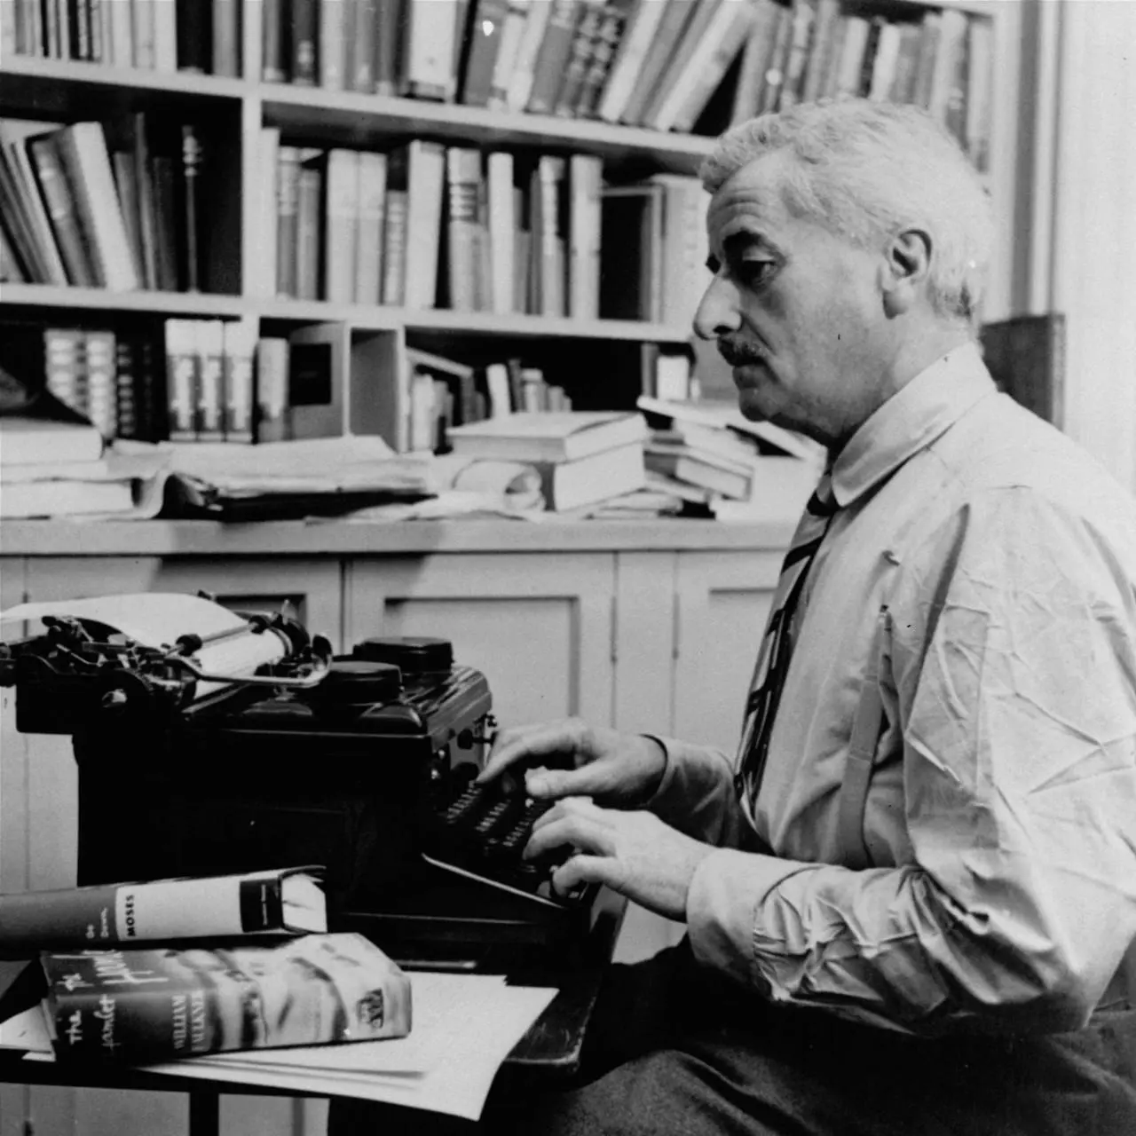

Afternoon of a Cow, William Faulkner

Afternoon of a Cow

Furioso, 1947

MR. FAULKNER AND I were sitting under the mulberry with the afternoon’s first julep while he informed me what to write on the morrow, when Oliver appeared suddenly around the corner of the smokehouse, running and with his eyes looking quite large and white. “Mr. Bill!” he cried. “Day done sot fire to de pasture!”

“ — —” cried Mr. Faulkner, with that promptitude which quite often marks his actions, “ —— those boys to —— !” springing up and referring to his own son, Malcolm, and to his brother’s son, James, and to the cook’s son, Rover or Grover. Grover his name is, though both Malcolm and James (they and Grover are of an age and have, indeed, grown up not only contemporaneously but almost inextricably) have insisted upon calling him Rover since they could speak, so that now all the household, including the child’s own mother and naturally the child itself, call him Rover too, with the exception of myself, whose practice and belief it has never been to call any creature, man, woman, child or beast, out of its rightful name — just as I permit no one to call me out of mine, though I am aware that behind my back both Malcolm and James (and doubtless Rover or Grover) refer to me as Ernest be Toogood — a crass and low form of so-called wit or humor to which children, these two in particular — are only too prone.

I have attempted on more than one occasion (this was years ago; I have long since ceased) to explain to them that my position in the household is in no sense menial, since I have been writing Mr. Faulkner’s novels and short stories for years. But I long ago became convinced (and even reconciled) that neither of them either knew or cared about the meaning of the term.

I do not think that I anticipate myself in saying that we did not know where the three boys would now be. We would not be expected to know, beyond a general feeling or conviction that they would by now be concealed in the loft of the barn or stable — this from previous experience, though experience had never before included or comprised arson. Nor do I feel that I further violate the formal rules of order, unity and emphasis by saying that we would never for one moment have conceived them to be where later evidence indicated that they now were.

But more on this subject anon: we were not thinking of the boys now; as Mr. Faulkner himself might have observed, someone should have been thinking about them ten or fifteen minutes ago; that now it was too late. No, our concern was to reach the pasture, though not with any hope of saving the hay which had been Mr. Faulkner’s pride and even hope — a fine, though small, plantation of this grain or forage fenced lightly away from the pasture proper and the certain inroads of the three stocks whose pleasance the pasture was, which had been intended as an alternative or balancing factor in the winter’s victualing of the three beasts.

We had no hope of saving this, since the month was September following a dry summer, and we knew that this as well as the remainder of the pasture would burn with almost the instantaneous celerity of gunpowder or celluloid. That is, I had no hope of it and doubtless Oliver had no hope of it. I do not know what Mr. Faulkner’s emotion was, since it appears (or so I have read and heard) a fundamental human trait to decline to recognize misfortune with regard to some object which man either desires or already possesses and holds dear, until it has run him down and then over like a Juggernaut itself.

I do not know if this emotion would function in the presence of a field of hay, since I have neither owned nor desired to own one. No, it was not the hay which we were concerned about. It was the three animals, the two horses and the cow, in particular the cow, who, less gifted or equipped for speed than the horses, might be overtaken by the flames and perhaps asphyxiated, or at least so badly scorched as to be rendered temporarily unfit for her natural function; and that the two horses might bolt in terror, and to their detriment, into the further fence of barbed wire or might even turn and rush back into the actual flames, as is one of the more intelligent characteristics of this so-called servant and friend of man.

So, led by Mr. Faulkner and not even waiting to go around to the arched passage, we burst through the hedge itself and, led by Mr. Faulkner who moved at a really astonishing pace for a man of what might be called almost violently sedentary habit by nature, we ran across the yard and through Mrs. Faulkner’s flower beds and then through her rose garden, although I will say that both Oliver and myself made some effort to avoid the plants; and on across the adjacent vegetable garden, where even Mr. Faulkner could accomplish no harm since at this season of the year it was innocent of edible matter; and on to the panel pasture fence over which Mr. Faulkner hurled himself with that same agility and speed and palpable disregard of limb which was actually amazing — not only because of his natural lethargic humor, which I have already indicated, but because of that shape and figure which ordinarily accompanies it (or at least does so in Mr. Faulkner’s case) — and were enveloped immediately in smoke.

But it was at once evident by its odor that this came, not from the hay which must have stood intact even if not green and then vanished in holocaust doubtless during the few seconds while Oliver was crying his news, but, from the cedar grove at the pasture’s foot. Nevertheless, odor or not, its pall covered the entire visible scene, although ahead of us we could see the creeping line of conflagration beyond which the three unfortunate beasts now huddled or rushed in terror of their lives.

Or so we thought until, still led by Mr. Faulkner and hastening now across a stygian and desolate floor which almost at once became quite unpleasant to the soles of the feet and promised to become more so, something monstrous and wild of shape rushed out of the smoke. It was the larger horse, Stonewall — a congenitally vicious brute which no one durst approach save Mr. Faulkner and Oliver, and not even Oliver durst mount (though why either Oliver or Mr. Faulkner should want to is forever beyond me) which rushed down upon us with the evident intent of taking advantage of this opportunity to destroy its owner and attendant both, with myself included for lagniappe or perhaps for pure hatred of the entire human race.

It evidently altered its mind, however, swerving and vanishing again into smoke. Mr. Faulkner and Oliver had paused and given it but a glance. “I reckin dey all right,” Oliver said. “But where you reckin Beulah at?”

“On the other side of that —— fire, backing up in front of it and bellowing,” replied Mr. Faulkner. He was correct, because almost at once we began to hear the poor creature’s lugubrious lamenting. I have often remarked now how both Mr. Faulkner and Oliver apparently possess some curious rapport with horned and hooved beasts and even dogs, which I cheerfully admit that I do not possess myself and do not even understand. That is, I cannot understand it in Mr. Faulkner.

With Oliver, of course, cattle of all kinds might be said to be his avocation, and his dallying (that is the exact word; I have watched him more than once, motionless and apparently pensive and really almost pilgrim-like, with the handle of the mower or hoe or rake for support) with lawn mower and gardening tools his sideline or hobby. But Mr. Faulkner, a member in good standing of the ancient and gentle profession of letters! But then neither can I understand why he should wish to ride a horse, and the notion has occurred to me that Mr. Faulkner acquired his rapport gradually and perhaps over a long period of time from contact of his posterior with the animal he bestrode.

We hastened on toward the sound of the doomed creature’s bellowing. I thought that it came from the flames perhaps and was the final plaint of her agony — a dumb brute’s indictment of heaven itself — but Oliver said not, that it came from beyond the fire. Now there occurred in it a most peculiar alteration. It was not an increase in terror, which scarcely could have been possible. I can describe it best by saying that she now sounded as if she had descended abruptly into the earth.

This we found to be true. I believe however that this time order requires, and the element of suspense and surprise which the Greeks themselves have authorized will permit, that the story progress in the sequence of events as they occurred to the narrator, even though the accomplishment of the actual event recalled to the narrator the fact or circumstance with which he was already familiar and of which the reader should have been previously made acquainted. So I shall proceed.

Imagine us, then, hastening (even if the abysmal terror in the voice of the hapless beast had not been inventive enough, we had another: on the morrow, when I raised one of the shoes which I had worn on this momentous afternoon, the entire sole crumbled into a substance resembling nothing so much as that which might have been scraped from the ink-wells of childhood’s school days at the beginning of the fall term) across that stygian plain, our eyes and lungs smarting with that smoke along whose further edge the border of fire crept. Again a wild and monstrous shape materialized in violent motion before us, again apparently with the avowed and frantic aim of running us down.

For a horrid moment I believed it to be the horse, Stonewall, returned because after passing us for some distance (persons do this; possibly it might likewise occur in an animal, its finer native senses dulled with smoke and terror), remembering having seen myself or recognized me, and had now returned to destroy me alone. I had never liked the horse. It was an emotion even stronger than mere fear; it was that horrified disgust which I imagine one must feel toward a python and doubtless even the horse’s subhuman sensibilities had felt and had come to reciprocate. I was mistaken, however.

It was the other horse, the smaller one which Malcolm and James rode, apparently with enjoyment, as though in miniature of the besotted perversion of their father and uncle — an indiscriminate, round-bodied creature, as gentle as the larger one was vicious, with a drooping sad upper lip and an inarticulate and bemused (though to me still sly and untrustworthy) gaze; it, too, swerved past us and also vanished just before we reached the line of flame which was neither as large nor as fearful as it had looked, though the smoke was thicker, and seemed to be filled with the now loud terrified voice of the cow.

In fact, the poor creature’s voice seemed now to be everywhere: in the air above us and in the earth beneath. With Mr. Faulkner still in the lead we sprang over it, whereupon Mr. Faulkner immediately vanished. Still in the act of running, he simply vanished out of the smoke before the eyes of Oliver and myself as though he too had dropped into the earth.

This is what he had also done. With the voice of Mr. Faulkner and the loud terror of the cow coming out of the earth at our feet and the creeping line of the conflagration just behind us, I now realized what had happened and so solved Mr. Faulkner’s disappearance as well as the previous alteration in the voice of the cow. I now realized that, confused by the smoke and the incandescent sensation about the soles of the feet, I had become disoriented and had failed to be aware that all the while we had been approaching a gully or ravine of whose presence I was quite aware, having looked down into it more than once while strolling in the afternoons while Mr. Faulkner would be riding the large horse, and upon whose brink or verge Oliver and I now stood and into which Mr. Faulkner and the cow had, in turn and in the reverse order, fallen.

“Are you hurt, Mr. Faulkner?” I cried. I shall not attempt to reproduce Mr. Faulkner’s reply, other than to indicate that it was couched in that pure ancient classic Saxon which the best of our literature sanctions and authorizes and which, due to the exigencies of Mr. Faulkner’s style and subject matter, I often employ but which I myself never use although Mr. Faulkner even in his private life is quite addicted to it and which, when he employs it, indicates what might be called a state of the most robust, even though not at all calm, wellbeing. So I knew that he was not hurt. “What shall we now do?” I inquired of Oliver.

“We better git down in dat hole too,” Oliver replied. “Ain’t you feel dat fire right behime us?” I had forgot about the fire in my concern over Mr. Faulkner, but upon glancing behind me I felt instinctively that Oliver was right. So we scrambled or fell down the steep sandy declivity, to the bottom of the ravine where Mr. Faulkner, still speaking, stood and where the cow was now safely ensconced though still in a state of complete hysteria, from which point or sanctuary we watched the conflagration pass over, the flames crumbling and flickering and dying away along the brink of the ravine. Then Mr. Faulkner spoke:

“Go catch Dan, and bring the big rope from the storehouse.”

“Do you mean me?” said I. Mr. Faulkner did not reply, so he and I stood beside the cow who did not yet seem to realize that the danger was past or perhaps whose more occult brute intellect knew that the actual suffering and outrage and despair had yet to occur — and watched Oliver climb or scramble back up the declivity. He was gone for some time, although after a while he returned, leading the smaller and tractable horse who was adorned with a section of harness, and carrying the rope; whereupon commenced the arduous business of extricating the cow. One end of the rope was attached to her horns, she still objecting violently; the other end was attached to the horse. “What shall I do?” I inquired.

“Push,” said Mr. Faulkner.

“Where shall I push?” I asked.

“I don’t give a —— ,” said Mr. Faulkner. “Just push.”

But it appeared that it could not be done. The creature resisted, perhaps to the pull of the rope or perhaps to Oliver’s encouraging shouts and cries from the brink overhead or possibly to the motive power supplied by Mr. Faulkner (he was directly behind, almost beneath her, his shoulder against her buttocks or loins and swearing steadily now) and myself. She made a gallant effort, scrambled quite half way up the declivity, lost her footing and slid back. Once more we tried and failed, and then again. And then a most regrettable accident occurred. This third time the rope either slipped or parted, and Mr. Faulkner and the cow were hurled violently to the foot of the precipice with Mr. Faulkner underneath.

Later — that evening, to be exact — I recalled how, at the moment while we watched Oliver scramble out of the ravine, I seem to have received, as though by telepathy, from the poor creature (a female mind; the lone female among three men) not only her terror but the subject of it: that she knew by woman’s sacred instinct that the future held for her that which is to a female far worse than any fear of bodily injury or suffering: one of those invasions of female privacy where, helpless victim of her own physical body, she seems to see herself as object of some malignant power for irony and outrage; and this none the less bitter for the fact that those who are to witness it, gentlemen though they be, will never be able to forget it but will walk the earth with the remembrance of it so long as she lives; — yes, even the more bitter for the fact that they who are to witness it are gentlemen, people of her own class.

Remember how the poor spent terrified creature had for an entire afternoon been the anguished and blind victim of a circumstance which it could not comprehend, had been sported with by an element which it instinctively feared, and had now been hurled recently and violently down a precipice whose crest it doubtless now believed it would never see again. — I have been told by soldiers (I served in France, in the Y.M.C.A.) how, upon entering battle, there often sets up within them, prematurely as it were, a certain impulse or desire which brings on a result quite logical and quite natural, the fulfillment of which is incontestible and of course irrevocable. — In a word, Mr. Faulkner underneath received the full discharge of the poor creature’s afternoon of anguish and despair.

It has been my fortune or misfortune to lead what is — or might be — called a quiet, even though not retired, life; and I have even preferred to acquire my experience from reading what had happened to others or what other men believe or think might have logically happened to creatures of their invention or even in inventing what Mr. Faulkner conceives might have happened to certain and sundry creatures who compose his novels and stories.

Nevertheless, I would imagine that a man is never too old nor too secure to suffer what might be called experiences of initial and bizarre originality, though of course not always outrage, following which his reaction would be quite almost invariably out of character. Or rather, following which his reaction would reveal that actual character which for years he may have successfully concealed from the public, his intimates, and his wife and family; perhaps even from himself. I would take it to be one of these which Mr. Faulkner had just suffered.

Anyway, his actions during the subsequent few minutes were most peculiar for him. The cow — poor female alone among three men — struggled up almost at once and stood, hysterically still though no longer violent, trembling rather with a kind of aghast abasement not yet become despair. But for a time Mr. Faulkner, prone on the earth, did not stir at all. Then he rose. He said, “Wait,” which naturally we should do until he gave further orders or instructions.

Then — the poor cow and myself, and Oliver looking down from the crest beside the horse — we watched Mr. Faulkner walk quietly a few paces down the ravine and sit down, his elbows on his knees and his chin supported between his hands. It was not the sitting down which was peculiar. Mr. Faulkner did this often — steadily perhaps is a better word — if not in the house, then (in summer) well down in a large chair on the veranda just outside the library window where I would be working, his feet on the railing, reading a detective magazine; in winter in the kitchen, his stocking feet inside the oven to the stove. It was the attitude in which he now sat. As I have indicated, there was a quality almost violent about Mr. Faulkner’s sedentation; it would be immobile without at all being lethargic, if I may put it so.

He now sat in the attitude of M. Rodin’s Penseur increased to his tenth geometric power say, since le penseur’s principal bewilderment appears to be at what has bemused him, while Mr. Faulkner can have had no doubt. We watched him quietly — myself, and the poor cow who now stood with her head lowered and not even trembling in utter and now hopeless female shame; Oliver and the horse on the brink above. I remarked then that Oliver no longer had smoke for his background. The immediate conflagration was now over, though the cedar grove would doubtless smoulder until the equinox.

Then Mr. Faulkner rose. He returned quietly and he spoke as quietly (or even more so) to Oliver as I have ever heard him: “Drop the rope, Jack.” Oliver removed his end of the rope from the horse and dropped it, and Mr. Faulkner took it up and turned and led the cow down the ravine. For a moment I watched him with an amazement of which Oliver doubtless partook; in the next moment doubtless Oliver and I would have looked at one another in that same astonishment.

But we did not; we moved; doubtless we moved at the same moment. Oliver did not even bother to descend into the ravine. He just went around it while I hastened on and overtook Mr. Faulkner and the cow; indeed, the three of us were actually soldiers recovered from the amnesia of battle, the battle with the flames for the life of the cow. It has been often remarked and even insisted upon in literature (novels have been built upon it, though none of them are Mr. Faulkner’s) how, when faced with catastrophe, man does everything but the simple one.

But from the fund of my own experience, though it does consist almost entirely of that afternoon, it is my belief that it is in the face of danger and disaster that he does the simple thing. It is merely simply wrong.

We moved down the ravine to where it turned at right angles and entered the woods which descended to its level. With Mr. Faulkner and the cow in the lead we turned up through the woods and came presently to the black desolation of the pasture in the fence to which Oliver, waiting, had already contrived a gap or orifice through which we passed. Then with Mr. Faulkner again in the lead and with Oliver, leading the horse and the cow, and myself side by side, we retraced across that desolate plain the course of our recent desperate race to offer succor, though bearing somewhat to the left in order to approach the stable — or barnlot.

We had almost reached the late hay plantation when, without warning, we found ourselves faced by three apparitions. They were not ten paces away when we saw them and I believe that neither Mr. Faulkner nor Oliver recognized them at all, though I did. In fact, I had an instantaneous and curious sense, not that I had anticipated this moment so much as that I had been waiting for it over a period which might be computed in years.

Imagine yourself, if you will, set suddenly down in a world in complete ocular or chromatic reversal. Imagine yourself faced with three small ghosts, not of white but of purest and unrelieved black. The mind, the intelligence, simply refuses to believe that they should have taken refuge from their recent crime or misdemeanor in the hay plantation before it took fire, and lived.

Yet there they were. Apparently they had neither brows, lashes nor hair; and clothing epidermis and all, they were of one identical sable, and the only way in which Rover or Grover could be distinguished from the other two was by Malcolm’s and James’ blue eyes. They stood looking at us in complete immobility until Mr. Faulkner said, again with that chastened gentleness and quietude which, granted my theory that the soul, plunged without warning into some unforeseen and outrageous catastrophe, comes out in its true colors, has been Mr. Faulkner’s true and hidden character all these years: “Go to the house.”

They turned and vanished immediately, since it had been only by the eyeballs that we had distinguished them from the stygian surface of the earth at all. They may have preceded us or we may have passed them. I do not know. At least, we did not see them again, because presently we quitted the sable plain which had witnessed our Gethsemane, and presently entered the barnlot where Mr. Faulkner turned and took the halter of the horse while Oliver led the cow into its private and detached domicile, from which there came presently the sound of chewing as, freed now of anguish and shame she ruminated, maiden meditant and — I hope — once more fancy free.

Mr. Faulkner stood in the door of the stable (within which, by and by, I could hear the larger and vicious horse, Stonewall, already at his food, stamp now and then or strike the board wall with his hoof as though even in the act of eating it could not forbear making sounds of threat and derision toward the very man whose food nourished it) and removed his clothing. Then, in full sight of the house and of whoever might care or not care to see, he lathered himself with saddle soap and then stood at the watering trough while Oliver doused or flushed him down with pail after pail of water. “Never mind the clothes just now,” he said to Oliver. “Get me a drink.”

“Make it two,” said I; I felt that the occasion justified, even though it may not have warranted, that temporary aberration into the vernacular of the fleeting moment. So presently, Mr. Faulkner now wearing a light summer horse blanket belonging to Stonewall, we sat again beneath the mulberry with the second julep of the afternoon.

“Well, Mr. Faulkner,” said I after a time, “shall we continue?”

“Continue what?” said Mr. Faulkner.

“Your suggestions for tomorrow,” said I. Mr. Faulkner said nothing at all. He just drank, with that static violence which was his familiar character, and so I knew that he was himself once more and that the real Mr. Faulkner which had appeared momentarily to Oliver and myself in the pasture had already retreated to that inaccessible bourne from which only the cow, Beulah, had ever evoked it, and that doubtless we would never see it again. So after a time I said, “Then, with your permission, tomorrow I shall venture into fact and employ the material which we ourselves have this afternoon created.”

“Do so,” Mr. Faulkner said — shortly, I thought.

“Only,” I continued, “I shall insist upon my prerogative and right to tell this one in my own diction and style, and not yours.”

“By —— !” said Mr. Faulkner. “You better had.”

The End