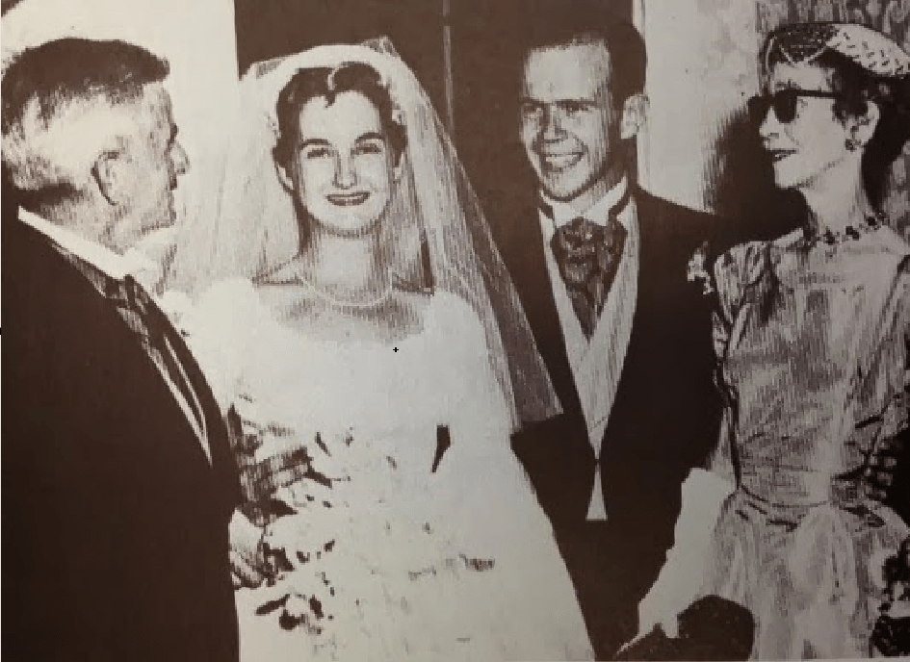

Carcassonne, William Faulkner

Carcassonne

AND ME ON a buckskin pony with eyes like blue electricity and a mane like tangled fire, galloping up the hill and right off into the high heaven of the world

His skeleton lay still. Perhaps it was thinking about this. Anyway, after a time it groaned. But it said nothing. which is certainly not like you he thought you are not like yourself. but I can’t say that a little quiet is not pleasant

He lay beneath an unrolled strip of tarred roofing made of paper. All of him that is, save that part which suffered neither insects nor temperature and which galloped unflagging on the destinationless pony, up a piled silver hill of cumulae where no hoof echoed nor left print, toward the blue precipice never gained. This part was neither flesh nor unflesh and he tingled a little pleasantly with its lackful contemplation as he lay beneath the tarred paper bedclothing.

So were the mechanics of sleeping, of denning up for the night, simplified. Each morning the entire bed rolled back into a spool and stood erect in the corner. It was like those glasses, reading glasses which old ladies used to wear, attached to a cord that rolls onto a spindle in a neat case of unmarked gold; a spindle, a case, attached to the deep bosom of the mother of sleep.

He lay still, savoring this. Beneath him Rincon followed its fatal, secret, nightly pursuits, where upon the rich and inert darkness of the streets lighted windows and doors lay like oily strokes of broad and overladen brushes. From the docks a ship’s siren unsourced itself. For a moment it was sound, then it compassed silence, atmosphere, bringing upon the eardrums a vacuum in which nothing, not even silence, was. Then it ceased, ebbed; the silence breathed again with a clashing of palm fronds like sand hissing across a sheet of metal.

Still his skeleton lay motionless. Perhaps it was thinking about this and he thought of his tarred paper bed as a pair of spectacles through which he nightly perused the fabric of dreams:

Across the twin transparencies of the spectacles the horse still gallops with its tangled welter of tossing flames. Forward and back against the taut roundness of its belly its legs swing, rhythmically reaching and overreaching, each spurning overreach punctuated by a flicking limberness of shod hooves.

He can see the saddlegirth and the soles of the rider’s feet in the stirrups. The girth cuts the horse in two just back of the withers, yet it still gallops with rhythmic and unflagging fury and without progression, and he thinks of that riderless Norman steed which galloped against the Saracen Emir, who, so keen of eye, so delicate and strong the wrist which swung the blade, severed the galloping beast at a single blow, the several halves thundering on in the sacred dust where him of Bouillon and Tancred too clashed in sullen retreat; thundering on through the assembled foes of our meek Lord, wrapped still in the fury and the pride of the charge, not knowing that it was dead.

The ceiling of the garret slanted in a ruined pitch to the low eaves. It was dark, and the body consciousness, assuming the office of vision, shaped in his mind’s eye his motionless body grown phosphorescent with that steady decay which had set up within his body on the day of his birth. the flesh is dead living on itself subsisting consuming itself thriftily in its own renewal will never die for I am the Resurrection and the Life Of a man, the worm should be lusty, lean, hairedover.

Of women, of delicate girls briefly like heard music in tune, it should be suavely shaped, falling feeding into prettinesses, feeding. what though to Me but as a seething of new milk Who am the Resurrection and the Life

It was dark. The agony of wood was soothed by these latitudes; empty rooms did not creak and crack. Perhaps wood was like any other skeleton though, after a time, once reflexes of old compulsions had spent themselves.

Bones might lie under seas, in the caverns of the sea, knocked together by the dying echoes of waves. Like bones of horses cursing the inferior riders who bestrode them, bragging to one another about what they would have done with a first-rate rider up. But somebody always crucified the first-rate riders. And then it’s better to be bones knocking together to the spent motion of falling tides in the caverns and the grottoes of the sea.

where him of Bouillon and Tancred too

His skeleton groaned again. Across the twin transparencies of the glassy floor the horse still galloped, unflagging and without progress, its destination the barn where sleep was stabled. It was dark. Luis, who ran the cantina downstairs, allowed him to sleep in the garret. But the Standard Oil Company, who owned the garret and the roofing paper, owned the darkness too; it was Mrs Widdrington’s, the Standard Oil Company’s wife’s, darkness he was using to sleep in.

She’d make a poet of you too, if you did not work anywhere. She believed that, if a reason for breathing were not acceptable to her, it was no reason. With her, if you were white and did not work, you were either a tramp or a poet. Maybe you were. Women are so wise. They have learned how to live unconfused by reality, impervious to it. It was dark.

and knock my bones together and together It was dark, a darkness filled with a fairy pattering of small feet, stealthy and intent. Sometimes the cold patter of them on his face waked him in the night, and at his movement they scurried invisibly like an abrupt disintegration of dead leaves in a wind, in whispering arpeggios of minute sound, leaving a thin but definite effluvium of furtiveness and voracity.

At times, lying so while daylight slanted grayly along the ruined pitch of the eaves, he watched their shadowy flickings from obscurity to obscurity, shadowy and huge as cats, leaving along the stagnant silences those whisperings gusts of fairy feet.

Mrs Widdrington owned the rats too. But wealthy people have to own so many things. Only she didn’t expect the rats to pay for using her darkness and silence by writing poetry. Not that they could not have, and pretty fair verse probably. Something of the rat about Byron: allocutions of stealthful voracity; a fairy pattering of little feet behind a bloody arras where fell where fell where I was King of Kings but the woman with the woman with the dog’s eyes to knock my bones together and together

“I would like to perform something,” he said, shaping his lips soundlessly in the darkness, and the galloping horse filled his mind again with soundless thunder. He could see the saddlegirth and the soles of the rider’s stirruped feet, and he thought of that Norman steed, bred of many fathers to bear iron mail in the slow, damp, green valleys of England, maddened with heat and thirst and hopeless horizons filled with shimmering nothingness, thundering along in two halves and not knowing it, fused still in the rhythm of accrued momentum. Its head was mailed so that it could not see forward at all, and from the center of the plates projected a — projected a —

“Chamfron,” his skeleton said.

“Chamfron.” He mused for a time, while the beast that did not know that it was dead thundered on as the ranks of the Lamb’s foes opened in the sacred dust and let it through. “Chamfron,” he repeated. Living, as it did, a retired life, his skeleton could know next to nothing of the world. Yet it had an astonishing and exasperating way of supplying him with bits of trivial information that had temporarily escaped his mind. “All you know is what I tell you,” he said.

“Not always,” the skeleton said. “I know that the end of life is lying still. You haven’t learned that yet. Or you haven’t mentioned it to me, anyway.”

“Oh, I’ve learned it,” he said. “I’ve had it dinned into me enough. It isn’t that. It’s that I don’t believe it’s true.”

The skeleton groaned.

“I don’t believe it, I say,” he repeated.

“All right, all right,” the skeleton said testily. “I shan’t dispute you. I never do. I only give you advice.”

“Somebody has to, I guess,” he agreed sourly. “At least, it looks like it.” He lay still beneath the tarred paper, in a silence filled with fairy patterings. Again his body slanted and slanted downward through opaline corridors groined with ribs of dying sunlight upward dissolving dimly, and came to rest at last in the windless gardens of the sea. About him the swaying caverns and the grottoes, and his body lay on the rippled floor, tumbling peacefully to the wavering echoes of the tides.

I want to perform something bold and tragical and austere he repeated, shaping the soundless words in the pattering silence me on a buckskin pony with eyes like blue electricity and a mane like tangled fire, galloping up the hill and right off into the high heaven of the world Still galloping, the horse soars outward; still galloping, it thunders up the long blue hill of heaven, its tossing mane in golden swirls like fire. Steed and rider thunder on, thunder punily diminishing: a dying star upon the immensity of darkness and of silence within which, steadfast, fading, deepbreasted and grave of flank, muses the dark and tragic figure of the Earth, his mother.

The End