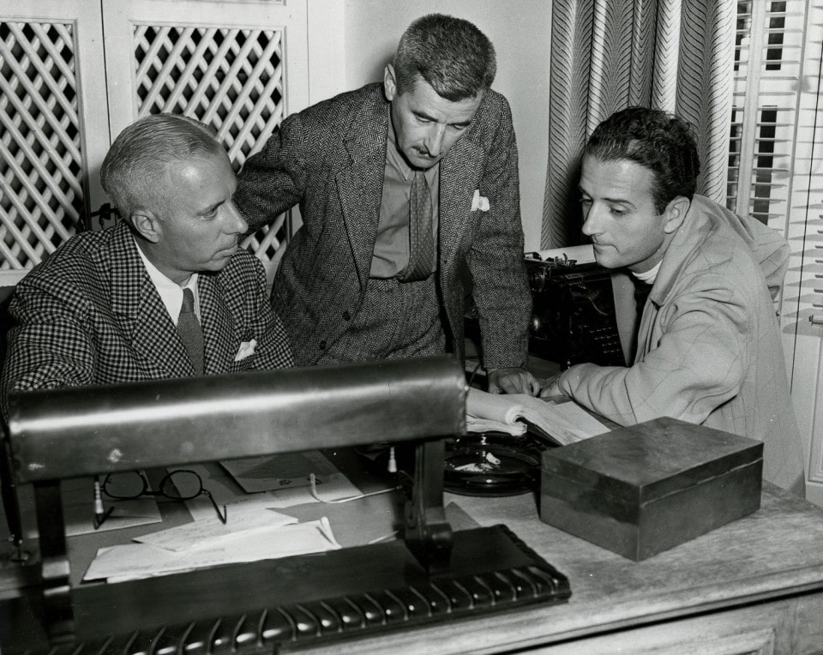

Honor, William Faulkner

Honor

I

WALKED RIGHT through the anteroom without stopping. Miss West says, “He’s in conference now,” but I didn’t stop. I didn’t knock, either. They were talking and he quit and looked up across the desk at me.

“How much notice do you want to write me off?” I said.

“Write you off?” he said.

“I’m quitting,” I said. “Will one day be notice enough?”

He looked at me, frog-eyed. “Isn’t our car good enough for you to demonstrate?” he said. His hand lay on the desk, holding the cigar. He’s got a ruby ring the size of a tail-light. “You’ve been with us three weeks,” he says. “Not long enough to learn what that word on the door means.”

He don’t know it, but three weeks is pretty good; it’s within two days of the record. And if three weeks is a record with him, he could have shaken hands with the new champion without moving.

The trouble is, I had never learned to do anything. You know how it was in those days, with even the college campuses full of British and French uniforms, and us all scared to death it would be over before we could get in and swank a pair of pilot’s wings ourselves. And then to get in and find something that suited you right down to the ground, you see.

So after the Armistice I stayed in for a couple of years as a test pilot. That was when I took up wing-walking, to relieve the monotony. A fellow named Waldrip and I used to hide out at about three thousand on a Nine while I muscled around on top of it.

Because Army life is pretty dull in peace-time: nothing to do but lay around and lie your head off all day and play poker all night. And isolation is bad for poker. You lose on tick, and on tick you always plunge.

There was a fellow named White lost a thousand one night. He kept on losing and I wanted to quit but I was winner and he wanted to play on, plunging and losing every pot. He gave me a check and I told him it wasn’t any rush, to forget it, because he had a wife out in California. Then the next night he wanted to play again. I tried to talk him out of it, but he got mad. Called me yellow. So he lost fifteen hundred more that night.

Then I said I’d cut him, double or quit, one time. He cut a queen. So I said, “Well, that beats me. I won’t even cut.” And I flipped his cut over and riffled them and we saw a gob of face cards and three of the aces. But he insisted, and I said, “What’s the use? The percentage would be against me, even with a full deck.” But he insisted. I cut the case ace.

I would have paid to lose. I offered again to tear up the checks, but he sat there and cursed me. I left him sitting at the table, in his shirt sleeves and his collar open, looking at the ace.

The next day we had the job, the speed ship. I had done everything I could. I couldn’t offer him the checks again. I will let a man who is worked up curse me once. But I won’t let him twice. So we had the job, the speed ship. I wouldn’t touch it. He took it up five thousand feet and dived the wings off at two thousand with a full gun.

So I was out again after four years, a civ again. And while I was still drifting around — that was when I first tried selling automobiles — I met Jack, and he told me about a bird that wanted a wing-walker for his barn-storming circus. And that was how I met her.

II

Jack — he gave me a note to Rogers — told me about what a good pilot Rogers was, and about her, how they said she was unhappy with him.

“So is your old man,” I said.

“That’s what they say,” Jack said. So when I saw Rogers and handed him the note — he was one of these lean, quiet-looking birds — I said to myself he was just the kind that would marry one of these flighty, passionate, good-looking women they used to catch during the war with a set of wings, and have her run out on him the first chance. So I felt safe. I knew she’d not have had to wait any three years for one like me.

So I expected to find one of these long, dark, snake-like women surrounded by ostrich plumes and Woolworth incense, smoking cigarettes on the divan while Rogers ran out to the corner delicatessen for sliced ham and potato salad on paper plates. But I was wrong. She came in with an apron on over one of these little pale squashy dresses, with flour or something on her arms, without apologizing or flurrying around or anything.

She said Howard — that was Rogers — had told her about me and I said, “What did he tell you?” But she just said:

“I expect you’ll find this pretty dull for spending the evening, having to help cook your own dinner. I imagine you’d rather go out to dance with a couple of bottles of gin.”

“Why do you think that?” I said. “Don’t I look like I could do anything else?”

“Oh, don’t you?” she said.

We had washed the dishes then and we were sitting in the firelight, with the lights off, with her on a cushion on the floor, her back against Rogers’ knees, smoking and talking, and she said, “I know you had a dull time. Howard suggested that we go out for dinner and to dance somewhere. But I told him you’d just have to take us as we are, first as well as later. Are you sorry?”

She could look about sixteen, especially in the apron. By that time she had bought one for me to wear, and the three of us would all go back to the kitchen and cook dinner. “We don’t expect you to enjoy doing this any more than we do,” she said. “It’s because we are so poor. We’re just an aviator.”

“Well, Howard can fly well enough for two people,” I said. “So that’s all right, too.”

“When he told me you were just a flyer too, I said, ‘My Lord, a wing-walker? When you were choosing a family friend,’ I said, ‘why didn’t you choose a man we could invite to dinner a week ahead and not only count on his being there, but on his taking us out and spending his money on us?’

But he had to choose one that is as poor as we are.” And once she said to Rogers: “We’ll have to find Buck a girl, too. He’s going to get tired of just us some day.” You know how they say things like that: things that sound like they meant something until you look at them and find their eyes perfectly blank, until you wonder if they were even thinking about you, let alone talking about you.

Or maybe I’d have them out to dinner and a show. “Only I didn’t mean that like it sounded,” she said. “That wasn’t a hint to take us out.”

“Did you mean that about getting me a girl too?” I said.

Then she looked at me with that wide, blank, innocent look. That was when I would take them by my place for a cocktail — Rogers didn’t drink, himself — and when I would come in that night I’d find traces of powder on my dresser or maybe her handkerchief or something, and I’d go to bed with the room smelling like she was still there.

She said: “Do you want us to find you one?” But nothing more was ever said about it, and after a while, when there was a high step or any of those little things which men do for women that means touching them, she’d turn to me like it was me was her husband and not him; and one night a storm caught us downtown and we went to my place and she and Rogers slept in my bed and I slept in a chair in the sitting-room.

One evening I was dressing to go out there when the ‘phone rang. It was Rogers. “I am—” he said, then something cut him off. It was like somebody had put a hand on his mouth, and I could hear them talking, murmuring: her, rather. “Well, what—” Rogers says. Then I could hear her breathing into the mouth-piece, and she said my name.

“Don’t forget you’re to come out to-night,” she said.

“I hadn’t,” I said. “Or did I get the date wrong? If this is not the night—”

“You come on out,” she said. “Goodbye.”

When I got there he met me. His face looked like it always did, but I didn’t go in. “Come on in,” he said.

“Maybe I got the date wrong,” I said. “So if you’ll just—”

He swung the door back. “Come on in,” he said.

She was lying on the divan, crying. I don’t know what; something about money. “I just can’t stick it,” she said. “I’ve tried and I’ve tried, but I just can’t stand it.”

“You know what my insurance rates are,” he said. “If something happened, where would you be?”

“Where am I, anyway? What tenement woman hasn’t got more than I have?” She hadn’t looked up, lying there on her face, with the apron twisted under her. “Why don’t you quit and do something that you can get a decent insurance rate, like other men?”

“I must be getting along,” I said. I didn’t belong there. I just got out. He came down to the door with me, and then we were both looking back up the stairs toward the door where she was lying on her face on the couch.

“I’ve got a little stake,” I said. “I guess because I’ve eaten so much of your grub I haven’t had time to spend it. So if it’s anything urgent. . . .” We stood there, he holding the door open. “Of course, I wouldn’t try to muscle in where I don’t . . .”

“I wouldn’t, if I were you,” he said. He opened the door. “See you at the field tomorrow.”

“Sure,” I said. “See you at the field.”

I didn’t see her for almost a week, didn’t hear from her. I saw him every day, and at last I said, “How’s Mildred these days?”

“She’s on a visit,” he said. “At her mother’s.”

For the next two weeks I was with him every day. When I was out on top I’d look back at his face behind the goggles. But we never mentioned her name, until one day he told me she was home again and that I was invited out to dinner that night.

It was in the afternoon. He was busy all that day hopping passengers, so I was doing nothing, just killing time waiting for evening and thinking about her, wondering some, but mostly just thinking about her being home again, breathing the same smoke and soot I was breathing, when all of a sudden I decided to go out there.

It was plain as a voice saying, “Go out there. Now, at once.” So I went. I didn’t even wait to change. She was alone, reading before the fire. It was like gasoline from a broken line blazing up around you.

III

It was funny. When I’d be out on top I’d look back at his face behind the windscreen, wondering what he knew. He must have known almost at once. Why, say, she didn’t have any discretion at all. She’d say and do things, you know: insist on sitting close to me; touching me in that different way from when you hold an umbrella or a raincoat over them, and such that any man can tell at one look, when she thought he might not see: not when she knew he couldn’t, but when she thought maybe he wouldn’t. And when I’d unfasten my belt and crawl out I’d look back at his face and wonder what he was thinking, how much he knew or suspected.

I’d go out there in the afternoon when he was busy. I’d stall around until I saw that he would be lined up for the rest of the day, then I’d give some excuse and beat it. One afternoon I was all ready to go, waiting for him to take off, when he cut the gun and leaned out and beckoned me. “Don’t go off,” he said. “I want to see you.”

So I knew he knew then, and I waited until he made the last hop and was taking off his monkey suit in the office. He looked at me and I looked at him. “Come out to dinner,” he said.

When I came in they were waiting. She had on one of those little squashy dresses and she came and put her arms around me and kissed me with him watching.

“I’m going with you,” she said. “We’ve talked it over and have both agreed that we couldn’t love one another any more after this and that this is the only sensible thing to do. Then he can find a woman he can love, a woman that’s not bad like I am.”

He was looking at me, and she running her hands over my face and making a little moaning sound against my neck, and me like a stone or something. Do you know what I was thinking? I wasn’t thinking about her at all.

I was thinking that he and I were upstairs and me out on top and I had just found that he had thrown the stick away and was flying her on the rudder alone and that he knew that I knew the stick was gone and so it was all right now, whatever happened. So it was like a piece of wood with another piece of wood leaning against it, and she held back and looked at my face.

“Don’t you love me any more?” she said, watching my face. “If you love me, say so. I have told him everything.”

I wanted to be out of there. I wanted to run. I wasn’t scared. It was because it was all kind of hot and dirty. I wanted to be away from her a little while, for Rogers and me to be out where it was cold and hard and quiet, to settle things.

“What do you want to do?” I said. “Will you give her a divorce?”

She was watching my face very closely. Then she let me go and she ran to the mantel and put her face into the bend of her arm, crying.

“You were lying to me,” she said. “You didn’t mean what you said. Oh God, what have I done?”

You know how it is. Like there is a right time for everything. Like nobody is anything in himself: like a woman, even when you love her, is a woman to you just a part of the time and the rest of the time she is just a person that don’t look at things the same way a man has learned to.

Don’t have the same ideas about what is decent and what is not. So I went over and stood with my arms about her, thinking, “God damn it, if you’ll just keep out of this for a little while! We’re both trying our best to take care of you, so it won’t hurt you.”

Because I loved her, you see. Nothing can marry two people closer than a mutual sin in the world’s eyes. And he had had his chance. If it had been me that knew her first and married her and he had been me, I would have had my chance. But it was him that had had it, so when she said, “Then say what you tell me when we are alone. I tell you I have told him everything,” I said.

“Everything? Have you told him everything?” He was watching us. “Has she told you everything?” I said.

“It doesn’t matter,” he said. “Do you want her?” Then before I could speak, he said: “Do you love her? Will you be good to her?”

His face was gray-looking, like when you see a man again after a long time and you say, “Good God, is that Rogers?” When I finally got away the divorce was all settled.

IV

So the next morning when I reached the field, Harris, the man who owned the flying circus, told me about the special job; I had forgotten it, I suppose. Anyway, he said he had told me about it. Finally I said I wouldn’t fly with Rogers.

“Why not?” Harris said.

“Ask him,” I said.

“If he agrees to fly you, will you go up?”

So I said yes. And then Rogers came out; he said that he would fly me. And so I believed that he had known about the job all the time and had laid for me, sucked me in. We waited until Harris went out. “So this is why you were so mealy-mouthed last night,” I said. I cursed him. “You’ve got me now, haven’t you?”

“Take the stick yourself,” he said. “I’ll do your trick.”

“Have you ever done any work like this before?”

“No. But I can, as long as you fly her properly.”

I cursed him. “You feel good,” I said. “You’ve got me. Come on; grin on the outside of your face. Come on!”

He turned and went to the crate and began to get into the front seat. I went and caught his shoulder and jerked him back. We looked at one another.

“I won’t hit you now,” he said, “if that’s what you want. Wait till we get down again.”

“No,” I said. “Because I want to hit back once.”

We looked at one another; Harris was watching us from the office.

“All right,” Rogers said. “Let me have your shoes, will you? I haven’t got any rubber soles out here.”

“Take your seat,” I said. “What the hell does it matter? I guess I’d do the same thing in your place.”

The job was over an amusement park, a carnival. There must have been twenty-five thousand of them down there, like colored ants. I took chances that day that I had never taken, chances you can’t see from the ground. But every time the ship was right under me, balancing me against side pressure and all, like he and I were using the same mind. I thought he was playing with me, you see. I’d look back at his face, yelling at him: “Come on; now you’ve got me. Where are your guts?”

I was a little crazy, I guess. Anyway, when I think of the two of us up there, yelling back and forth at one another, and all the little bugs watching and waiting for the big show, the loop. He could hear me, but I couldn’t hear him; I could just see his lips moving. “Come on,” I’d yell; “shake the wing a little; I’ll go off easy, see?”

I was a little crazy. You know how it is, how you want to rush into something you know is going to happen, no matter what it is. I guess lovers and suicides both know that feeling. I’d yell back at him: “You want it to look all right, eh? And to lose me off the level ship wouldn’t look so good, would it?

All right,” I yelled, “let’s go.” I went back to the center section and cast the rope loose where it loops around the forward jury struts and I got set against it and looked back at him and gave him the signal. I was a little crazy. I was still yelling at him; I don’t know what I was yelling. I thought maybe I had already fallen off and was dead and didn’t know it.

The wires began to whine and I was looking straight down at the ground and the little colored dots. Then the wires were whistling proper and he gunned her and the ground began to slide back under the nose. I waited until it was gone and the horizon had slid back under too and I couldn’t see anything but sky. Then I let go one end of the rope and jerked it out and threw it back at his head and held my arms out as she zoomed into the loop.

I wasn’t trying to kill myself. I wasn’t thinking about myself. I was thinking about him. Trying to show him up like he had shown me up. Give him something he must fail at like he had given me something I failed at. I was trying to break him.

We were over the loop before he lost me. The ground had come back, with the little colored dots, and then the pressure went off my soles and I was falling. I made a half somersault and was just going into the first turn of a flat spin, with my face to the sky, when something banged me in the back.

It knocked the wind out of me, and for a second I must have been completely out. Then I opened my eyes and I was lying on my back on the top wing, with my head hanging over the back edge.

I was too far down the slope of the camber to bend my knees over the leading edge, and I could feel the wing creeping under me. I didn’t dare move. I knew that if I tried to sit up against the slip stream, I would go off backward.

I could see by the tail and the horizon that we were upside now, in a shallow dive, and I could see Rogers standing up in his cockpit, unfastening his belt, and I could turn my head a little more and see that when I went off I would miss the fuselage altogether, or maybe hit it with my shoulder.

So I lay there with the wing creeping under me, feeling my shoulders beginning to hang over space, counting my backbones as they crept over the edge, watching Rogers crawl forward along the fuselage toward the front seat. I watched him for a long time, inching himself along against the pressure, his trouser-legs whipping. After a while I saw his legs slide into the front cockpit and then I felt his hands on me.

There was a fellow in my squadron. I didn’t like him and he hated my guts. All right. One day he got me out of a tight jam when I was caught ten miles over the lines with a blowing valve. When we were down he said, “Don’t think I was just digging you out. I was getting a Hun, and I got him.” He cursed me, with his goggles cocked up and his hands on his hips, cursing me like he was smiling. But that’s all right.

You’re each on a Camel; if you go out, that’s too bad; if he goes out, it’s just too bad. Not like when you’re on the center section and he’s at the stick, and just by stalling her for a second or ruddering her a little at the top of the loop.

But I was young, then. Good Lord, I used to be young! I remember Armistice night in ‘18, and me chasing all over Amiens with a lousy prisoner we had brought down that morning on an Albatross, trying to keep the frog M.P.’s from getting him. He was a good guy, and those damned infantrymen wanting to stick him in a pen full of S. O. S. and ginned-up cooks and such. I felt sorry for the bastard, being so far from home and licked and all. I was sure young.

We were all young. I remember an Indian, a prince, an Oxford man, with his turban and his trick major’s pips, that said we were all dead that fought in the war. “You will not know it,” he said, “but you are all dead. With this difference: those out there” — jerking his arm toward where the front was— “do not care, and you do not know it.”

And something else he said, about breathing for a long time yet, some kind of walking funerals; catafalques and tombs and epitaphs of men that died on the fourth of August, 1914, without knowing that they had died, he said. He was a card, queer. A good little guy, too.

But I wasn’t quite dead while I was lying on the top wing of that Standard and counting my backbones as they crawled over the edge like a string of ants, until Rogers grabbed me. And when he came to the station that night to say goodbye, he brought me a letter from her, the first I ever had.

The handwriting looked exactly like her; I could almost smell the scent she used and feel her hands touching me. I tore it in two without opening it and threw the pieces down. But he picked them up and gave them back to me. “Don’t be a fool,” he said.

And that’s all. They’ve got a kid now, a boy of six. Rogers wrote me; about six months afterward the letter caught up with me. I’m his godfather. Funny to have a godfather that’s never seen you and that you’ll never see, isn’t it?

V

So I said to Reinhardt: “Will one day be enough notice?”

“One minute will be enough,” he said. He pressed the buzzer. Miss West came in. She is a good kid. Now and then, when I’d just have to blow off some steam, she and I would have lunch at the dairy place across the street, and I could tell her about them, about the women. They are the worst.

You know; you get a call for a demonstration, and there’ll be a whole car full of them waiting on the porch and we’d pile in and all go shopping. Me dodging around in the traffic, hunting a place to park, and her saying, “John insisted that I try this car. But what I tell him, it’s foolish to buy a car that is as difficult to find parking space for as this one appears to be.”

And them watching the back of my head with that bright, hard, suspicious way. God knows what they thought we had; maybe one that would fold up like a deck chair and lean against a fire plug. But hell, I couldn’t sell hair straightener to the widow of a nigger railroad accident.

So Miss West comes in; she is a good kid, only somebody told her I had had three or four other jobs in a year without sticking, and that I used to be a war pilot, and she’d keep on after me about why I quit flying and why I didn’t go back to it, now that crates were more general, since I wasn’t much good at selling automobiles or at anything else, like women will.

You know: urgent and sympathetic, and you can’t shut them up like you could a man; she came in and Reinhardt says, “We are letting Mr. Monaghan go. Send him to the cashier.”

“Don’t bother,” I said. “Keep it to buy yourself a hoop with.”

The End