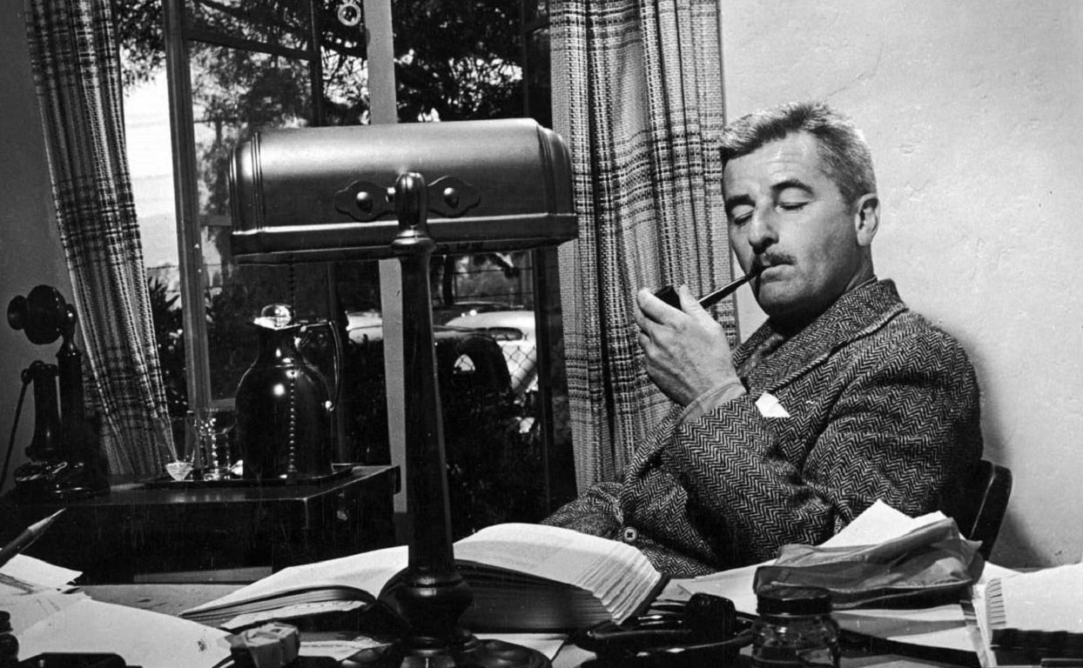

Once Aboard the Lugger, William Faulkner

Once Aboard the Lugger

Contempo, February 1932

IN THE MIDDLE of the afternoon we made a landfall. Ever since we left the mouth of the river at dawn and felt the first lift of the sea, Pete’s face had been getting yellower and yellower, until by midday and twenty four hours out of New Orleans, when we spoke to him he’d glare at us with his yellow cat’s eyes, and curse Joe. Joe was his older brother. He was about thirty-five. He had some yellow diamonds big as gravel. Pete was about nineteen, in a silk shirt of gold and lavender stripes, and a stiff straw hat, and all day long he squatted in the bows, holding his hat and saying Jesus Christ to himself.

He wouldn’t even drink any of the whiskey he had hooked from Joe. Joe wouldn’t let us take any with us, and the Captain wouldn’t have let us fetch it aboard, if he had. The Captain was a teetotaller. He had been in the outside trade before Joe hired him, where they took on cargoes of green alcohol in the West Indies and had it all flavored and aged and bottled and labeled and cased before they raised Tortugas. He said he never had been a drinking man, but if he ever had, he’d be cured now. He was a real prohibitionist: he believed that nobody should be allowed to drink. He was a New Englander, with a face like a worn doormat.

So Pete had to hook a couple of bottles from Joe, and we brought them aboard inside our pants leg and the nigger hid them in the galley, and between wheel tricks I’d go forward where Pete was squatting, holding his hat, and have a nip. Now and then the nigger’s disembodied face ducked into the port, without any expression at all, like a mask in carnival, and he passed up a cup of coffee which Pete drank and like as not threw the cup at the nigger’s head just as it ducked away.

“He done busted two of them,” the nigger told me. “We ain’t got but four left, now. I gwine give it to him in a bakingpowder can next time.”

Pete hadn’t eaten any breakfast, and he flung his dinner overside and turned his back while I ate mine, his face getting yellower and yellower, and when we fetched the island — a scar of sand with surf creaming along its windward flank and tufted with gnawed purple pines on a darkling twilit sea — his face and his eyes were the same color.

The Captain held inside. We passed into the island’s lee. The motion ceased and we pounded along in slack water of the clearest green. To starboard the island stretched on, bastioned and sombre, without sign of any life at all. Across the Sound a low smudge of mainland lay like a violet cloud. From beyond the island we could hear the boom and hiss of surf, but inside here the water was like a mill-pond, with sunlight slanting into it in green corridors. And then Pete got really sick, leaning overside and holding his hat on.

Twilight came swiftly. The clear green of the water, losing the sun, darkened. We beat on across a pulseless surface fading slowly to the hue of violet ink. Against the sky the tall pines stood in shabby and gaunt parade. The smudge of mainland had dissolved. Low on the water where it had been, a beacon was like a cigarette coal. Pete was still being sick.

The engine slowed. “Forrard there,” the Captain said at the wheel. I manned the anchor.

“Come on, Pete,” I said, “Give me a hand with it. You’ll feel better.”

“Hell with it,” Pete said. “Leave the bastard sink.”

So the nigger came topside and we cleared the hawser. The engine stopped and our momentum died into a violet silence floored with whispering water.

“Let go,” the Captain said. We tumbled the anchor over, the hawser rattling and hissing about our feet.

Just before dark came completely down a pale wing of rigid water and a green navigating light stood abruptly in the dusk two miles away and as abruptly faded.

“There her,” the nigger said. “Gwine, too.”

“What is it?”

“Rum chaser. Gwine to Mobile.”

“Hope she stays there,” I said. In the twilight my shirt felt warmer than I, drily so, like a garment of sand.

Pete wouldn’t eat his supper, either. He sat humped in the bows, a filthy quilt about his shoulders, looking like a big disgruntled bird. He sat there while the nigger and I warped the dinghy alongside and until the Captain emerged with three spades and a flashlight. Then he refused unconditionally to get into the dinghy, and he and the Captain cursed each other at point-blank range in the darkness, in ferocious whispers.

But move he would not. So we left him there, humped in his quilt, his hat slanted in savage silhouette above the shapeless blob of the vessel lurking neither wholly hidden nor wholly revealed against the perspective of the Sound and the ghostly and sourceless echo of starlight and the new moon.

The dinghy moved in darkness, in silence save for small gurgling clucks of water as the nigger wielded the oars. At each invisible stroke I could feel the steady and fading surge of the thwart under my thighs. Milky serpentines seethed alongside, mooned with bubbled fire, in the nothingness which bore us and which slapped now and then beneath the keel with whispering, caressing shocks, as of soft and secret palms. Soon a lesser darkness smoldered laterally across the bows, the Captain humped in vague relief against it, and the nigger’s rhythmic blobbing. It thickened still more. The dinghy lifted with a faint grating jar, and stopped. The new moon hung in the crests of the pines overhead.

We hauled the dinghy up. The Captain stood squinting at the skyline. The sand was white, faintly luminous in the starlight. Staring at it, it seemed to be within a hand’s breadth of the face. Then as you stared it seemed to shrink dizzily away until equilibrium itself was lost, fading at last without demarcation into the spangled sky that seemed to take of the sand something of its quality of dizzy and faint incandescence and against which the pines reared their tall and ragged crests, forlorn and gallant and a little austere.

The nigger had lifted the shovels out of the dinghy and the Captain, having oriented himself, took up one of them. The nigger and I took up the other two and followed the dark blob of him across the beach and into the trees. The sand was grown over with a harsh undergrowth of some sort, tough and possessing that pointless perversity of random rusty wire. We struggled through it, the sand shifting beneath us, also with a sort of derisive perversity.

The surge and hiss of surf came steadily out of the darkness upon our faces, with the cool, strong breath of the sea itself, and immediately before us the treacherous darkness burst into mad shapes and a tense, soundless uproar. For a moment it seemed that I could taste my very heart in my mouth and the nigger prodded heavily into me from behind, and in the yellow tunnel of the Captain’s flashlight wildeyed and anonymous horned beasts glared at us on braced forelegs, then whirled and rushed soundlessly away with mad overreaching of gaunt flanks and tossing tails. It was like a nightmare through which, pursued by demons, you run forever on a shifting surface that gives no purchase for the feet.

My shirt felt colder than I, now, and damp, and in the dizzy darkness that followed the flash my heart consented to beat again. The nigger handed me my shovel and I found that the Captain had gone on.

“What in God’s name was that?” I said.

“Wild cattle,” the nigger said. “Island full of them. They’ll run you in the daytime.”

“Oh,” I said. We slogged on and overtook the Captain halted beside a dune grown harshly over with the wirelike undergrowth. He bade us halt here while he prowled slowly about the dune, prodding at it with his shovel. The nigger and I squatted, our shovels beside us. My shirt was wet, cold to my body. The steady breathing of the sea came across the sand, among the pines.

“What are cattle doing on this island?” I whispered. “I thought it was uninhabited.”

“I don’t know,” the nigger said. “I don’t know what anything want here, walking around night and day in this sand, listening to that wind in them trees.” He squatted beside me, naked to the waist, the starlight glinting faintly upon him, reflected by the sand. “Be wild, too.” he said.

I killed a mosquito on the back of my hand. It left a huge, warm splash, like a raindrop. I wiped my hands on my flanks.

“Skeeter bad here,” the nigger said.

I killed another on my forearm, and two bit me on the ankles at the same time, and one on the neck, and I rolled my sleeves down and buttoned my collar.

“They’ll eat you up, without any shirt on,” I said.

“No, sir,” he said. “Skeeter dont bother me. Cant nothing off the land bother me. I got medicine.”

“You have? On you?”

In the darkness somewhere the cattle moved, in dry crackling surges in the undergrowth. The nigger tugged at his middle and drew something from his waist — a cloth tobacco sack in which I could feel three small, hard objects, slung on a cord about his hips.

“Nothing from the land, eh? How about the water?”

“They aint no water charm,” he said. I sat on my feet, covering my ankles, wishing I had worn socks. The nigger stowed his charm away.

“What do you go to sea for, then?”

“I dont know. Man got to die someday.”

“But do you like going to sea? Cant you make as much ashore?”

The cattle moved now and then in the darkness, among the undergrowth. The breath of the sea came steadily out of the darkness, among the pines.

“Man got to die someday,” the nigger said.

The Captain returned and spoke to us, and we rose and took up our shovels. He showed us where to dig, and he fell to with his own implement and we spaded the dry sand behind us, digging into the dune. As fast as we dug the sand obliterated the shovelmarks, shaling in secret, whispering sighs from above, and my shirt was soon wet and warm again, and where it clung to my shoulders the mosquitoes needled my flesh as though it were naked.

We made progress however, the three rhythmic blobs of us like three figures in a ritualistic and illtimed dance against that background of ghostly incandescence and the deep breath of the sea stirring the unceasing pinetops overhead, for at last the nigger’s shovel rang on metal — a single half thump, half clang which the breath of the sea took up and swept on with it among the pines and so away.

We uncovered the metal slowly, a broad, limber sheet of iron roofing, and presently the nigger and I were able to get our hands beneath the edge of it. We bent our backs and straightened our legs and heaved. The sand shifted, hissing drily. We heaved again. “Hah!” the nigger grunted beside me, and the metal sheet buckled and broke free with a single clashing report like that of a pistol fired inside a tin bucket, and it too drifted away on the breath of the sea and sand sifted down across the buckled metal and into the pit beneath it in fading whispers. Shhhhhhhhhhhhh. Shhhhhhhhhhhhhhhhhh.

The nigger and I leaned on our shovels, panting a little and sweating a good deal, while the sea went Hush Hush through the pines. The Captain propped the corner of the metal up on his shovel and delved beneath it with his hands. I killed three more mosquitoes on my ankles and wished again that I had worn socks.

The Captain was half into the pit now, and he spoke to us again from the dry whispering of that tomb and we laid our shovels aside and helped him haul the sacks out. They were faintly damp, and sand clung to them, and we dragged them out onto the sand and the nigger and I took up one under each arm and he led the way back to the beach.

The vessel was faintly visible against the starlight on the sound, a shadow among treacherous shades, motionless as an island or a rock. We stowed the sacks carefully in the dinghy and retraced our steps.

Back and forth we went, carrying those endless awkward sacks. They were difficult to hold, at best, would have been heartbreaking labor on good footing, but in shifting sand that bartered each step for the price of four, surrounded always by a soundless and vicious needling which I could not brush even temporarily off, that sense of nightmare returned ten fold — a sense of hopeless enslavement to an obscure compulsion, in which the very necessity for striving was its own derision.

We loaded the dinghy and the nigger pulled off in the darkness toward the vessel. Then I was making the trips alone, and still the sacks came out of the black gullet into which the Captain had wholly disappeared.

I could hear the cattle moving about in the darkness, but they paid me no attention. With every return to the beach I tried to mark the stars, if they had moved any. But even they seemed to be fixed overhead, among the ragged crests of the pines and the constant breath of the sea in their sighing tops.

Pete returned in the dinghy with the nigger, with his hat on. He was sullen and uncommunicative, but he had stopped saying Jesus Christ. The Captain came out of his hole and looked at him, but said nothing, and with another hand the sacks moved faster, and when the nigger made his second trip out to the vessel, I had Pete for company.

He worked well enough, as though his meditation on board after we left had imbued him with the necessity of getting the job done, but he spoke only once. That was when he and I got a little off the track and blundered into the cattle again.

“What the hell’s that?” he said, and I knew there was a gun in his hand.

“Just some wild cattle,” I said.

“Jesus Christ,” Pete said, and then he paraphrased the nigger unawares: “No wonder they’re wild.”

Back and forth we went between the sibilant and ceaseless cavern and the beach, until at last Pete and the Captain and I stood again together on the beach waiting for the dinghy to return. Though I had not seen him moving, Orion was down beyond the high pines and the moon was gone.

The dinghy came back and we went on board, and in the dark hold stinking of bilge and of fish and of what other nameless avatars through which the vessel had passed, we hauled and shifted cargo until it was stacked and battened down to the Captain’s notion. He flicked the torch upon his watch.

“Three oclock,” he said, the first word he had spoken since he quit cursing Pete yesterday. “We’ll sleep till sunup.”

Pete and I went forward and lay again on the mattress. I heard Pete go to sleep, but for a long while I was too tired to sleep, although I could hear the nigger snoring in the galley, where he had made his bed after that infatuated conviction of his race that fresh air may be slept in only at the gravest peril.

My back and arms and loins ached, and whenever I closed my eyes it seemed immediately that I was struggling through sand that shifted and shifted under me with patient derision, and that I still heard the dark high breath of the sea in the pines.

Out of this sound another sound grew, mounted swiftly, and I raised my head and watched a red navigating light and that pale wing of water that seemed to have a quality of luminousness of its own, stand up and pass and fade, and I thought of Conrad’s centaur, the half man, half tugboat, charging up and down river in the same higheared, myopic haste, purposeful but without destination, oblivious to all save what was immediately in its path, and to that a dire and violent menace. Then it was gone, the sound too died away, and I lay back again while my muscles jerked and twitched to the fading echo of the old striving and the Hush Hush of the sea in my ears.

The End