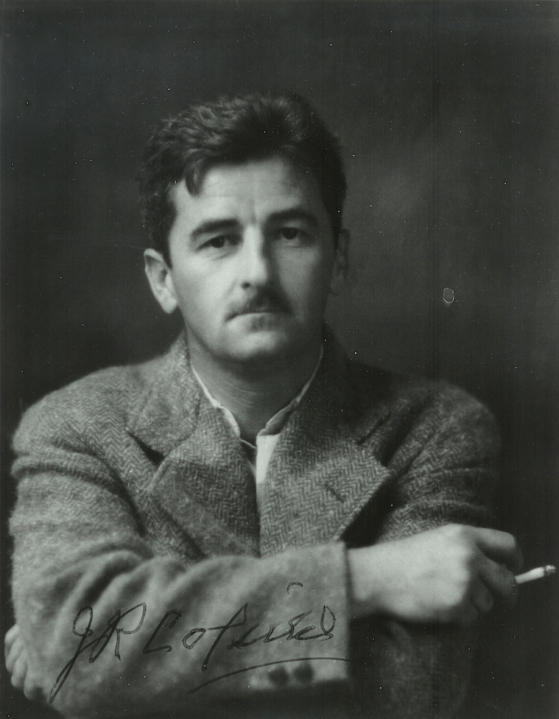

Two Dollar Wife, William Faulkner

Two Dollar Wife

College Life, Volume XVIII, 1936

“AIN’T SHE NEVER going to be ready!” Maxwell Johns stared at himself in the mirror. He watched himself light a cigarette and snap the match backward over his shoulder. It struck the hearth and bounced, still burning, toward the rug.

“What the hell do I care if it burns the damn dump down!” he snarled, striding up and down the garish parlor of the Houston home. He stared at his reflection again — slim young body in evening clothes, smooth dark hair, smooth white face. He could hear, in the room overhead, Doris Houston and her mother shrieking at each other.

“Listen at ’em squall!” he grunted. “You’d think it was a knock-down-and-drag-out going on instead of a flounce getting into her duds. Oh, hell! Their brains are fuzzy as the cotton we grow!”

A colored maid entered the room and puttered about a moment, her vast backside billowing like a high wave under oil. She glanced at Maxwell and sniffed her way out of the room.

The screams above reached a crescendo. Then he heard rushing feet, eager and swift — a bright eager clatter, young and evanescent.

A final screech from above seemed to shoot Doris Houston into the room like a pip squeezed from an orange. She was thin as a dragonfly, honey-haired, with long coltish legs. Her small face was alternate patches of dead white and savage red.

She carried a fur coat over her arm and held onto one shoulder of her dress with the other hand. The other shoulder, with a dangling strap, had slipped far down.

Doris shrugged the gown back into place and mumbled between her red lips. A needle glinted between her white teeth, the gossamer thread floating out as she flung the coat down and whirled her back to Maxwell. “Here, Unconscious, sew me up!” he interpreted her mumbled words.

“Good God, I just sewed you into it night before last!” Maxwell growled. “And I sewed you into it Christmas Eve, and I sewed—”

“Aw, dry up!” said Doris. “You did your share of tearing it off of me! Sew it good this time, and let it stay sewed!”

He sewed it, muttering to himself, with long, savage stitches like a boy sewing the ripped cover of a baseball. He snapped the thread, juggled the needle from one hand to the other for a moment and then thrust it carelessly into the seat cover of a chair.

Doris shrugged the strap into place with a wriggle and reached for her coat. Outside a motor horn brayed, “Here they are!” she snapped. “Come on!”

Again feet sounded on the stairs — like lumps of half-baked dough slopping off a table. Mrs. Houston thrust her frizzled hair and her diamonds into the room.

“Doris!” she shrieked. “Where are you going tonight? Maxwell, don’t you dare let Doris stay out till all hours again like she did Christmas Eve! I don’t care if it is New Year’s! Do you hear? Doris, you come home—”

“All right! All right!” squawked Doris without looking back. “Come on, Unconscious!”

“Get in!” barked Walter Mitchell, driver of the car. “Get in back, Doris, damn it! Lucille, get your legs outa my lap! How the hell you expect me to drive?”

As the car ripped through the outer fringe of the town, a second car, also containing two couples, turned in from a side road. The drivers blatted horns at each other in salute. Side by side they swerved into the straight road that led past the Country Club. They raced, roaring, rocking — sixty — seventy — seventy-five, hub brushing hub, outer wheels on the rims of the road. Behind the steering wheels glowered two almost identical faces — barbered, young, grim.

Far ahead gleamed the white gates of the Country Club. “You better slow down!” shrieked Doris.

“Slow down, hell!” growled Mitchell, foot and accelerator both flat on the floorboards.

The other car drew ahead, horn blatting derisively, voices squalling meaningless gibberish. Mitchell swore under his breath.

Scre-e-e-e-each!

The lead car took the turn on two wheels, leaped, bucked, careened wildly and shot up the drive. Mitchell slammed his throttle shut and drifted on down the dark road. A mile from the Country Club he ground the car to a stop, switched off engine and lights and pulled a flask from his pocket.

“Let’s have a drink!” he grunted, proffering the flask.

“I don’t want to stop here,” Doris said. “I want to go to the Club.”

“Don’t you want a drink?” asked Mitchell.

“No. I don’t want a drink, either. I want to go to the Club.”

“Don’t pay any attention to her,” said Maxwell. “If anybody comes along I’ll show ’em the license.”

A month before, just after Maxwell had been suspended from Sewanee, Mitchell had dared Doris and him to get married. Maxwell had borrowed two dollars from the Negro janitor at the Cotton Exchange, where Max “worked” in his father’s office, and they had driven a hundred miles and bought a license. Then Doris changed her mind. Maxwell still carried the license in his pocket, now a little smeary from moisture and friction.

Lucille shrieked with laughter.

“Max, you behave yourself!” squawked Doris. “Take your hands away!”

“Here, give me the license,” said Walter, “I’ll tie it on the radiator. Then they won’t even have to get out of the car to look at it.”

“No you won’t!” Doris cried.

“What you got to say about it?” demanded Walter. “Max was the one that paid two dollars for it — not you.”

“I don’t care! It’s got my name on it!”

“Gimme my two dollars back and you can have it,” said Maxwell.

“I haven’t got two dollars. You take me back to the Club, Walter Mitchell!”

“I’ll give you two bucks for it, Max,” said Walter.

“Okay,” agreed Maxwell, putting his hand to his coat. Doris flung herself at him.

“No you don’t!” she cried. “I’m going to tell daddy on you!”

“What do you care?” protested Walter. “I’m going to scratch out yours and Max’s names and put mine and Lucille’s in. We’re liable to need it!”

“I don’t care! Mine will still be on it and it will be bigamy.”

“You mean incest, honey,” Lucille said.

“I don’t care what I mean. I’m going back to the Club!”

“Are you?” Walter said. “Tell them we’ll be there after while.” He handed Maxwell the flask.

Doris banged the door open and jumped out.

“Hey, wait!” Walter cried. “I didn’t—”

Already they could hear Doris’ spike heels hitting the road hard. Walter turned the car.

“You better get out and walk behind her,” he told Maxwell. “You left home with her. Get her to the Club, anyway. It ain’t far — not even a mile, hardly.”

“Watch where you’re going!” yelped Maxwell. “Here comes a car behind us!”

Walter drew aside and flashed his spot on the other car as it passed.

“It’s Hap White!” shrieked Lucille, craning her neck. “He’s got that Princeton man, Jornstadt, with him — the handsome one all the girls are crazy about. He’s from Minnesota and is visiting his aunt in town.”

The other car ground to a halt beside Doris. The door opened. She got in.

“The little snake!” shrilled Lucille. “I bet she knew Jornstadt was in that car. I bet she made a date with Hap White to pick her up.”

Walter Mitchell chuckled maliciously. “ ‘There goes my girl—’ “ he hummed.

Maxwell swore savagely under his breath.

There were already five in the other car. Doris sat on Jornstadt’s lap. He could feel the warmth and the rounded softness of her legs. He held her steady drawing her back against him. Doris wriggled slightly and his arm tightened.

Jornstadt drew a deep breath freighted with the perfume of the honey-colored hair. His arm tightened still more.

A moment later Mitchell’s car roared past.

Lurking between two parked cars, Walter and Maxwell watched the six from Hap White’s car enter the club house. The group [passed] the girls in a bee-like clot around the tall Princeton man, whose beautifully ridged head towered over them. The blaring music seemed to be a triumphant carpet spread for him, derisive and salutant.

Walter handed his almost empty flask to Maxwell. Max tilted it up.

“I know a good place for that Princeton guy,” he said, wiping his lips.

“Huh?”

“The morgue,” said Max.

“Gonna dance?” asked Walter.

“Hell, no! Let’s go to the cloak room. Oughta be a crap game in there.”

There was. Above the kneeling ring of tense heads and shoulders, they saw the Princeton man, Jornstadt, and Hap White, a fat youth with a cherubic face and a fawning manner. They were drinking, turn about, from a thick tumbler in which a darky poured corn from a Coca-Cola bottle. Hap waved a greeting. “Hi-yi, boy,” he addressed Max. “Little family trouble?”

“Nope,” said Maxwell evenly. “Gimme a drink.”

Max and Walter watched the crap game. Hap and Jornstadt strolled out, the music squalling briefly through the opening and closing door. Around the kneeling ring droned monotonous voices.

“E-eleven! Shoot four bits.”

“You’re faded! Snake eyes! Let the eight bits ride?”

“C’mon, Little Joe!”

“Ninety days in the calaboose! Let it ride!”

The bottle went around. The door began banging open and shut. The cloak room became crowded, murky with cigarette smoke. The music had stopped.

Suddenly pandemonium broke loose: the rising wail of a fire siren, the shrieks of whistles from the cotton gins scattered about the countryside, the crack of pistols and rifles and the duller boom of shotguns. On the veranda girls shrieked and giggled.

“Happy New Year!” said Walter viciously. Max glared at him, shucked off his coat and ripped his collar open.

“Lemme in that game!” he snarled.

A tall man with beautifully ridged hair had just sauntered past the open door. On his arm hung a lithe girl with honey-colored hair.

By three o’clock, Maxwell had won a hundred and forty dollars and broken the game. One by one the gamblers arose, stiffly, like people who have been asleep. The music was still droning along but the cloak room was full of flapping overcoat sleeves. Youths adjusted their ties, smoothed their already patent-leather-smooth hair.

“Is it over?” asked Maxwell.

“Damn near it!” grunted Walter.

Fat Hap White sidled in through the door. Behind him was Jornstadt, his face flushed, hesitant.

“That Princeton guy sure can put away the likker,” grunted a voice behind Max. “He’s still got a quart flask of prime stuff, too.”

Hap White eased up beside Maxwell, speaking in a low voice.

“That license you got, Max,” he hesitated.

Maxwell gave him a cold look. “What license?’

Hap dabbed at his forehead with a handkerchief. “You know, that marriage license for you and Doris. We — we want to buy it, since you won’t be needing it yourself.”

“I ain’t selling, and it wouldn’t do you any good if you did have it. It’s got the names already written in it.”

“We can fix that,” wheedled Hap. “It’s easy, Max. Johns — Jornstadt. See? They look alike on paper and there wouldn’t anybody expect a county clerk to be able to write so you could read it. See?”

“Yes, I see,” said Maxwell quietly, very quietly.

“It’s all right with Doris,” urged Hap. “Look, here’s a note she sent.”

Max read the unsigned scrawl in Doris’ childish hand: “You leave me be, you old bigamist!” He scowled blackly.

“What say, Max?” persisted Hap.

Maxwell’s lean jaw set grimly.

“No, I won’t sell it; but I’ll shoot Jornstadt for it — the license against his flask.”

“Aw, come on, Max,” protested Hap, “Jornstadt ain’t no crap shooter. He’s a Northerner. He don’t even know how to handle the dice.”

“Best two out of three, high dice,” said Max. “Take it or leave it.”

Hap pattered over to Jornstadt, muttered a few words. The Princeton man protested, then agreed.

“All right,” said Hap. “Here’s the flask. Put the license beside it on the floor.”

“Where’s the dice?” asked Maxwell. “Who’s got some dice? Peter, gimme that set of yours.”

The darky rolled the whites of his eyes. “My dice — they ain’t — they—”

“Shut up and give them here!” blazed Maxwell. “We won’t hurt ’em. C’mon!”

Peter fished them from his pocket.

“Here, lemme show you, Jornstadt,” exclaimed Hap White.

Jornstadt handled the dice awkwardly. He fumbled them onto the floor. A five and a four showed.

“Nine!” chortled Hap. “That’s a good roll!”

It was plenty good. The best Max could get was three and four — seven. The first round went to Jornstadt.

Max won the next one, however, nine against five. He clicked the dice together.

“Shall I go on shootin’?” he asked Jornstadt.

The Princeton man looked inquiringly at Hap White.

“Sure, it’s all right,” said Hap. “Let him shoot first.”

Clickety-click! The dice tumbled from Maxwell’s hand, rolled over and over and stopped.

“Whoopeee!” cheered Walter Mitchell under his breath. “Two fives! That’s a winner!”

“Any use for me to shoot?” asked Jornstadt.

“Sure, take your roll,” said Hap gloomily, “but you ain’t got no more chance than a female in a frat house.”

Jornstadt fumbled the dice awkwardly from hand to hand. He tossed them out. A five showed. The other cube spun dizzily on a corner for a spine-crawling moment and settled. Maxwell stared at the six black dots winking at him like spotty-eyed devils.

“Osky-wow-wow!” shrilled Hap White. “A natural!”

Jornstadt picked up the dice and glanced inquiringly about.

“Do I win?” he asked.

“Yes, you win,” replied Maxwell evenly. He began putting on his collar. Jornstadt handed the dice to the pop-eyed Peter. “Thank you,” he said. He sauntered from the room with the gleeful Hap White, stuffing flask and license into his pocket.

The room was very still as Maxwell walked to the mirror and began adjusting his tie. One by one the youths slipped out. Maxwell was left alone. He glared into the mirror.

He heard somebody muttering to himself in the little wash room back of the partition. He recognized Peter’s voice.

“Lawdy! Lawdy!” sounded the darky’s querulous tones. “He jest nacherly couldn’ta made no ‘leben wiff dem bones, kase dey ain’t no sixes on ’em! Dem’s special bones. He jest couldn’t! But he did! I wish I knowed how to shoot crap like he don’t know!”

Maxwell stared into the mirror, his lips slowly whitening. He reached to his hip pocket. The dull blue-black of an automatic pistol winked back at him from the mirror. He hesitated, returned the gun to his pocket.

“I don’t want to get myself hung!” he muttered.

For long minutes he stood staring, the smoothness of his forehead wrinkled with the unaccustomed labor of intense thought. Peter still puttered around in the washroom.

Maxwell strode around the partition. He gripped the darky by the arm.

“Pete, I want you to get me something, and get it darned quick,” he snarled. “Listen—”

“But, Mistuh Max, that stuff’s blue lightnin’!” protested the darky. “That ain’t no drinkin’s for white gemmuns! All right, I’s a-gwin’! I’s a-gwin’!”

He was back in five minutes, with a fruit jar full of something that looked like water. Maxwell took it and shoved it into his coat pocket. A minute later Walter Mitchell came in with Jornstadt and Hap White. They had the flask.

Maxwell pulled out his fruit jar, unscrewed the cap and tilted it up.

“This is a man’s drink,” he said. “It ain’t colored water like that stuff!”

Jornstadt sneered. “I never saw anything I couldn’t drink,” he declared. “Gimme a swig!”

“Better leave it alone,” cautioned Maxwell. “I tell you it’s for men.”

Jornstadt flushed darkly. “Gimme that jar!”

Max handed it to him. Hap White caught a whiff and his mouth gaped open.

“That’s cawn likker!” he squeaked.

“Jornstadt, don’t you—”

Maxwell’s elbow caught him viciously in the throat. Jornstadt, the jar already tilted, did not notice. Hap gagged, gulped and subsided, shivering slightly under Maxwell’s baleful glare. Jornstadt gasped.

“Thought so,” nodded Max. “Can’t take it!”

“Who the hell says I can’t!” snarled Jornstadt, and the jar tilted again.

The orchestra was playing “Goodnight, Sweetheart,” when they left the coat room. Jornstadt’s eyes were slightly glazed and he held onto Hap White’s arm. Maxwell walked behind them, a thin smile on his lips. The smile was still there when he saw Jornstadt wobble to Hap White’s car, his arm around Doris.

“We’re headin’ for Marley,” he heard Hap White say. Lucille, already in the car, giggled.

“Follow them!” Maxwell snarled at Walter Mitchell. Marley was twenty-two miles away. There was a justice of the peace at Marley.

Jornstadt was sagging limply, his head on his breast. His once immaculate shirt bosom had burst open. His collar was up around his ears. Doris and Lucille supported him in the careening car. Doris was whimpering:

“I don’t want to marry anybody. I want to go home. Old drunken bigamist!”

“You’ve got to go through with it now,” said Lucille. “Both your names are on it now. If you don’t it’ll be forgery!”

“It says Maxwell Jornstadt!” wailed Doris. “I’ll be married to both of them! It’ll be bigamy!”

“Bigamy isn’t as bad as forgery. We’ll all be in trouble!”

“I don’t wanna!”

The car slammed to a stop in front of a boxcar that had apparently got lost from its railroad. There were windows cut in it, and a door over which was a sign reading, “Justice of the Peace.”

“I don’t wanna be married in a boxcar!” whimpered Doris.

“It’s just like a church,” urged Lucille, “only there ain’t no organ. A J. P. isn’t a D. D., so he can’t marry you in a church.”

The boxcar door opened and a paunchy, oldish man carrying a flash light looked out. His nightshirt was thrust into his trousers. His braces were dangling.

“Come in! Come in!” he grumbled.

Walter Mitchell’s car slid up. Maxwell got out and strolled to Hap’s car.

Hap was pawing at Jornstadt; trying to rouse him.

“Let him be,” grunted Maxwell. “Get the license and give it to me. I’ll stand up for him.”

“I don’t wanna!” whimpered Doris.

They went into the boxcar. The J. P. stood with a large book in his hand. The light of an oil lamp yellowed their wan faces. The J. P. looked at Doris.

“How old are you, sister?” he asked.

Doris stared woodenly. Lucille spoke up quickly:

“She’s just eighteen.”

“She looks about fourteen and like she ought to be home in bed,” grunted the J. P.

“She’s been sitting up with a sick friend,” said Lucille.

The J. P. looked at the license. Lucille gulped in her throat.

“These names—” he began. Lucille found her voice.

“Doris Houston and Maxwell Johnstadt,” she said.

“Good God, don’t they even know their own names!” exclaimed the J. P. “This one looks like—”

Something suddenly nuzzled into the palm of his hand. Maxwell was standing beside him, very close. The thing that nuzzled the J. P.’s hand was the hundred and forty dollars Max had won in the crap game. The J. P.’s hands closed over the roll of bills like a tomcat’s claw over a mouse. He opened the big book.

“Come on,” Max told Doris three minutes later. “From now on you’re taking orders from me — Mrs. Johns!”

Lucille wailed. Hap White yammered. Jornstadt snored loudly in the tonneau of Hap’s car.

“Oh!” said Doris.

The cold light of a January morning was breaking as they reached the big, garish Houston house. There was already a car standing in front of it.

“That’s Doc Carberry’s Chrysler!” exclaimed Maxwell. “Do you reckon somebody—”

Doris was out and running before the car stopped. “If it is it’s your fault!” she wailed thinly over her shoulder: “Go away from me, you old bigamist.”

Maxwell followed her into the house. He heard Dr. Carberry say:

“He’ll be all right now, Mrs. Houston. I got it out; but it was a narrow escape.”

Doris was screaming at her mother:

“Mamma! I’m married, Mamma! Mamma! I’m married!”

“Married!” shrieked Mrs. Houston. “My God, ain’t we had enough trouble here tonight! Married! Who—”

She caught sight of Maxwell. “You!” she screeched, rushing at him, waving her pudgy hands. The diamonds on her fingers sent dazzling glints of light into his eyes. “You get out of here! Get out, I say! Get out!”

“We’re mar—” began Max. “I tell you—”

Mrs. Houston rushed him into the hall, screeched a final, “Get out!” and dived back into the parlor. The billowing form of the Negro maid suddenly appeared before Max. He gave back a step.

“De front door’s open,” said the Negress pointedly.

“What you talking about?” demanded Max. “I tell you we’re married, all right. We—”

“Ain’t you kicked up enough bobbery ‘round heah for one night?” demanded the Negress. “You get out now. Mebbe you telefoam t’morrow.”

“Telephone!” sputtered Max. “I tell you she’s my—”

“You to blame for it all!” glowered the Negress. “Leavin’ the needle stickin’ in de chair wheah anybody’d knowed de baby would get hold of it!”

She billowed forward. Max suddenly found himself on the front porch.

“Needle — baby—” he gurgled dazedly. “What — what—”

“You no ‘count good-fo’ nothin’! De baby he swallered it!”

The door closed in his face.

He started the car. It moved slowly away. “Telephone, hell,” he said suddenly. “She’s my—”

But he did not say it. An approaching car swung wide of him. He did not see it. He was fumbling in his pocket. At last he drew out a crumpled cigarette. Another car swerved wildly and barely missed Maxwell’s car.

The cruising driver saw only a big car moving with erratic slowness on the wrong side of the street driven by a young man in evening clothes at nine o’clock in the morning.

The End