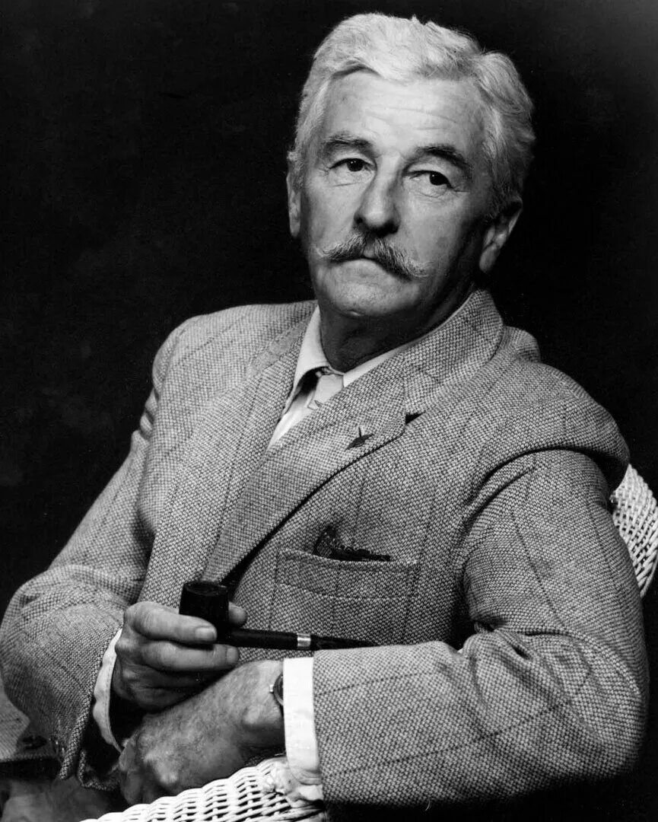

Percy Grimm, William Faulkner

Percy Grimm

IN THE TOWN ON THAT DAY LIVED A YOUNG MAN NAMED PERCY Grimm. He was about twentyfive and a captain in the State national guard. He had been born in the town and had lived there all his life save for the periods of the summer encampments.

He was too young to have been in the European War, though it was not until 1921 or ’22 that he realised that he would never forgive his parents for that fact. His father, a hardware merchant, did not understand this. He thought that the boy was just lazy and in a fair way to become perfectly worthless, when in reality the boy was suffering the terrible tragedy of having been born not alone too late but not late enough to have escaped first hand knowledge of the lost time when he should have been a man instead of a child.

And now, with the hysteria passed away and the ones who had been loudest in the hysteria and even the ones, the heroes who had suffered and served, beginning to look at one another a little askance, he had no one to tell it, to open his heart to. In fact, his first serious fight was with an exsoldier who made some remark to the effect that if he had to do it again, he would fight this time on the German side and against France. At once Grimm took him up. “Against America too?” he said.

“If America’s fool enough to help France out again,” the soldier said. Grimm struck him at once; he was smaller than the soldier, still in his teens. The result was foregone; even Grimm doubtless knew that. But he took his punishment until even the soldier begged the bystanders to hold the boy back. And he wore the scars of that battle as proudly as he was later to wear the uniform itself for which he had blindly fought.

It was the new civilian-military act which saved him. He was like a man who had been for a long time in a swamp, in the dark. It was as though he not only could see no path ahead of him, he knew that there was none. Then suddenly his life opened definite and clear. The wasted years in which he had shown no ability in school, in which he had been known as lazy, recalcitrant, without ambition, were behind him, forgotten.

He could now see his life opening before him, uncomplex and inescapable as a barren corridor, completely freed now of ever again having to think or decide, the burden which he now assumed and carried as bright and weightless and martial as his insignatory brass: a sublime and implicit faith in physical courage and blind obedience, and a belief that the white race is superior to any and all other races and that the American is superior to all other white races and that the American uniform is superior to all men, and that all that would ever be required of him in payment for this belief, this privilege, would be his own life.

On each national holiday that had any martial flavor whatever he dressed in his captain’s uniform and came downtown. And those who saw him remembered him again on the day of the fight with the exsoldier as, glittering, with his marksman’s badge (he was a fine shot) and his bars, grave, erect, he walked among the civilians with about him an air half belligerent and half the self conscious pride of a boy.

He was not a member of the American Legion, but that was his parents’ fault and not his. But when Christmas was fetched back from Mottstown on that Saturday afternoon, he had already been to the commander of the local Post. His idea, his words, were quite simple and direct. “We got to preserve order,” he said. “We must let the law take its course. The law, the nation. It is the right of no civilian to sentence a man to death. And we, the soldiers in Jefferson, are the ones to see to that.”

“How do you know that anybody is planning anything different?” the legion commander said. “Have you heard any talk?”

“I dont know. I haven’t listened.” He didn’t lie. It was as though he did not attach enough importance to what might or might not have been said by the civilian citizens to lie about it. “That’s not the question. It’s whether or not we, as soldiers, that have worn the uniform, are going to be the first to state where we stand. To show these people right off just where the government of the country stands on such things. That there wont be any need for them even to talk.”

His plan was quite simple. It was to form the legion Post into a platoon, with himself in command vide his active commission. “But if they dont want me to command, that’s all right too. I’ll be second, if they say. Or a sergeant or a corporal.” And he meant it. It was not vainglory that he wanted. He was too sincere. So sincere, so humorless, that the legion commander withheld the flippant refusal he was about to make.

“I still dont think that there is any need of it. And if there was, we would all have to act as civilians. I couldn’t use the Post like that. After all, we are not soldiers now. I dont think I would, if I could.”

Grimm looked at him, without anger, but rather as if he were some kind of bug. “Yet you wore the uniform once,” he said, with a kind of patience. He said: “I suppose you wont use your authority to keep me from talking to them, will you? As individuals?”

“No. I haven’t any authority to do that, anyway. But just as individuals, mind. You mustn’t use my name at all.”

Then Grimm gave him a shot on his own account. “I am not likely to do that,” he said. Then he was gone. That was Saturday, about four o’clock. For the rest of that afternoon he circulated about the stores and offices where the legion members worked, so that by nightfall he had enough of them also worked up to his own pitch to compose a fair platoon. He was indefatigable, restrained yet forceful; there was something about him irresistible and prophetlike.

Yet the recruits were with the commander in one thing: the official designation of the legion must be kept out of it—whereupon and without deliberate intent, he had gained his original end: he was now in command. He got them all together just before suppertime and divided them into squads and appointed officers and a staff; the younger ones, the ones who had not gone to France, taking proper fire by now.

He addressed them, briefly, coldly: “… order … course of justice … let the people see that we have worn the uniform of the United States … And one thing more.” For the moment now he had descended to familiarity: the regimental commander who knows his men by their first names. “I’ll leave this to you fellows. I’ll do what you say. I thought it might be a good thing if I wear my uniform until this business is settled. So they can see that Uncle Sam is present in more than spirit.”

“But he’s not,” one said quickly, immediately; he was of the same cut as the commander, who by the way was not present. “This is not government trouble yet. Kennedy might not like it. This is Jefferson’s trouble, not Washington’s.”

“Make him like it,” Grimm said. “What does your legion stand for, if not for the protection of America and Americans?”

“No,” the other said. “I reckon we better not make a parade out of this. We can do what we want without that. Better. Aint that right, boys?”

“All right,” Grimm said. “I’ll do as you say. But every man will want a pistol. We’ll have a small arms’ inspection here in one hour. Every man will report here.”

“What’s Kennedy going to say about pistols?” one said.

“I’ll see to that,” Grimm said. “Report here in one hour exactly, with side arms.” He dismissed them. He crossed the quiet square to the sheriff’s office. The sheriff was at home, they told him. “At home?” he repeated. “Now? What’s he doing at home now?”

“Eating, I reckon. A man as big as him has got to eat several times a day.”

“At home,” Grimm repeated. He did not glare; it was again that cold and detached expression with which he had looked at the legion commander. “Eating,” he said. He went out, already walking fast. He recrossed the empty square, the quiet square empty of people peacefully at suppertables about that peaceful town and that peaceful country. He went to the sheriff’s home. The sheriff said No at once.

“Fifteen or twenty folks milling around the square with pistols in their pants? No, no. That wont do. I cant have that. That wont do. You let me run this.”

For a moment longer Grimm looked at the sheriff. Then he turned, already walking fast again. “All right,” he said. “If that’s the way you want it. I dont interfere with you and you dont interfere with me, then.” It didn’t sound like a threat. It was too flat, too final, too without heat. He went on, rapidly. The sheriff watched him; then he called. Grimm turned.

“You leave yours at home, too,” the sheriff said. “You hear me?” Grimm didn’t answer. He went on. The sheriff watched him out of sight, frowning.

That evening after supper the sheriff went back downtown—something he had not done for years save when urgent and inescapable business called. He found a picket of Grimm’s men at the jail, and another in the courthouse, and a third patrolling the square and the adjacent streets.

The others, the relief, they told the sheriff, were in the cotton office where Grimm was employed, which they were using for an orderly room, a P.C. The sheriff met Grimm on the street, making a round of inspection. “Come here, boy,” the sheriff said. Grimm halted. He did not approach; the sheriff went to him.

He patted Grimm’s hip with a fat hand. “I told you to leave that at home,” he said. Grimm said nothing. He watched the sheriff levelly. The sheriff sighed. “Well, if you wont, I reckon I’ll have to make you a special deputy. But you aint to even show that gun unless I tell you to. You hear me?”

“Certainly not,” Grimm said. “You certainly wouldn’t want me to draw it if I didn’t see any need to.”

“I mean, not till I tell you to.”

“Certainly,” Grimm said, without heat, patiently, immediately. “That’s what we both said. Dont you worry. I’ll be there.”

Later, as the town quieted for the night, as the picture show emptied and the drug stores closed one by one, Grimm’s platoon began to drop off too. He did not protest, watching them coldly; they became a little sheepish, defensive. Again without knowing it he had played a trump card. Because of the fact that they felt sheepish, feeling that somehow they had fallen short of his own cold ardor, they would return tomorrow if just to show him.

A few remained; it was Saturday night anyhow, and someone got more chairs from somewhere and they started a poker game. It ran all night, though from time to time Grimm (he was not in the game; neither would he permit his second in command, the only other there who held the equivalent of commissioned rank, to engage) sent a squad out to make a patrol of the square. By this time the night marshal was one of them, though he too did not take a hand in the game.

Sunday was quiet. The poker game ran quietly through that day, broken by the periodical patrols, while the quiet church bells rang and the congregations gathered in decorous clumps of summer colors. About the square it was already known that the special Grand Jury would meet tomorrow. Somehow the very sound of the two words with their evocation secret and irrevocable and something of a hidden and unsleeping and omnipotent eye watching the doings of men, began to reassure Grimm’s men in their own makebelieve.

So quickly is man unwittingly and unpredictably moved that without knowing that they were thinking it, the town had suddenly accepted Grimm with respect and perhaps a little awe and a deal of actual faith and confidence, as though somehow his vision and patriotism and pride in the town, the occasion, had been quicker and truer than theirs.

His men anyway assumed and accepted this; after the sleepless night, the tenseness, the holiday, the suttee of volition’s surrender, they were almost at the pitch where they might die for him, if occasion rose. They now moved in a grave and slightly aweinspiring reflected light which was almost as palpable as the khaki would have been which Grimm wished them to wear, wished that they wore, as though each time they returned to the orderly room they dressed themselves anew in suave and austerely splendid scraps of his dream.

This lasted through Sunday night. The poker game ran. The caution, the surreptitiousness, which had clothed it was now gone. There was something about it too assured and serenely confident to the braggadocio; tonight when they heard the marshal’s feet on the stairs, one said, “Ware M.P.’s,” and for an instant they glanced at one another with hard, bright, daredevil eyes; then one said, quite loud: “Throw the son of a bitch out,” and another through pursed lips made the immemorial sound. And so the next morning, Monday, when the first country cars and wagons began to gather, the platoon was again intact. And they now wore uniforms.

It was their faces. Most of them were of an age, a generation, an experience. But it was more than that. They now had a profound and bleak gravity as they stood where crowds milled, grave, austere, detached, looking with blank, bleak eyes at the slow throngs who, feeling, sensing without knowing, drifted before them, slowing, staring, so that they would be ringed with faces rapt and empty and immobile as the faces of cows, approaching and drifting on, to be replaced. And all morning the voices came and went, in quiet question and answer: “There he goes. That young fellow with the automatic pistol. He’s the captain of them. Special officer sent by the governor. He’s the head of the whole thing. Sheriff aint got no say in it today.”

Later, when it was too late, Grimm told the sheriff: “If you had just listened to me. Let me bring him out of that cell in a squad of men, instead of sending him across the square with one deputy and not even handcuffed to him, in all that crowd where that damned Buford didn’t dare shoot, even if he could hit a barn door.”

“How did I know he aimed to break, would think of trying it right then and there?” the sheriff said. “When Stevens had done told me he would plead guilty and take a life sentence.”

But it was too late then. It was all over then. It happened in the middle of the square, halfway between the sidewalk and the courthouse, house, in the midst of a throng of people thick as on Fair Day, though the first that Grimm knew of it was when he heard the deputy’s pistol twice, fired into the air. He knew at once what had happened, though he was at the time inside the courthouse. His reaction was definite and immediate. He was already running toward the shots when he shouted back over his shoulder at the man who had tagged him now for almost fortyeight hours as half aide and half orderly: “Turn in the fire alarm!”

“The fire alarm?” the aide said. “What—”

“Turn in the fire alarm!” Grimm shouted back. “It dont matter what folks think, just so they know that something …” He did not finish; he was gone.

He ran among running people, overtaking and passing them, since he had an objective and they did not; they were just running, the black, blunt, huge automatic opening a way for him like a plow. They looked at his tense, hard, young face with faces blanched and gaped, with round, toothed orifices; they made one long sound like a murmuring sigh: “There … went that way …” But already Grimm had seen the deputy, running, his pistol aloft in his hand.

Grimm glanced once about and sprang forward again; in the throng which had evidently been pacing the deputy and the prisoner across the square was the inevitable hulking youth in the uniform of the Western Union, leading his bicycle by the horns like a docile cow. Grimm rammed the pistol back into the holster and flung the boy aside and sprang onto the bicycle, with never a break in motion.

The bicycle possessed neither horn nor bell. Yet they sensed him somehow and made way; in this too he seemed to be served by certitude, the blind and untroubled faith in the rightness and infallibility of his actions. When he overtook the running deputy he slowed the bicycle. The deputy turned upon him a face sweating, gaped with shouting and running. “He turned,” the deputy screamed. “Into that alley by—”

“I know,” Grimm said. “Was he handcuffed?”

“Yes!” the deputy said. The bicycle leaped on.

‘Then he cant run very fast,’ Grimm thought. ‘He’ll have to hole up soon. Get out of the open, anyway.’ He turned into the alley, fast. It ran back between two houses, with a board fence on one side. At that moment the fire siren sounded for the first time, beginning and mounting to a slow and sustained scream that seemed at last to pass beyond the realm of hearing, into that of sense, like soundless vibration. Grimm wheeled on, thinking swiftly, logically, with a kind of fierce and constrained joy. ‘The first thing he will want is to get out of sight,’ he thought, looking about. On one hand the lane was open, on the other stood the board fence six feet high.

At the end it was cut short off by a wooden gate, beyond which was a pasture and then a deep ditch which was a town landmark. The tops of tall trees which grew in it just showed above the rim; a regiment could hide and deploy in it. “Ah,” he said, aloud. Without stopping or slowing he swept the bicycle around and pedalled back down the lane toward the street which he had just quitted. The wail of the siren was dying now, descending back into hearing again, and as he slewed the bicycle into the street he saw briefly the running people and a car bearing down upon him.

For all his pedalling the car overtook him; its occupants leaned shouting toward his set, forwardlooking face. “Get in here!” they shouted. “In here!” He did not answer. He did not look at them. The car had overshot him, slowing; now he passed it at his swift, silent, steady pace; again the car speeded up and passed him, the men leaning out and looking ahead. He was going fast too, silent, with the delicate swiftness of an apparition, the implacable undeviation of Juggernaut or Fate. Behind him the siren began again its rising wail. When next the men in the car looked back for him, he had vanished completely.

He had turned full speed into another lane. His face was rocklike, calm, still bright with that expression of fulfillment, of grave and reckless joy. This lane was more rutted than the other, and deeper. It came out at last upon a barren knoll where, springing to earth while the bicycle shot on, falling, he could see the full span of the ravine along the edge of town, his view of it broken by two or three Negro cabins which lined the edge of it. He was quite motionless, still, alone, fateful, like a landmark almost. Again from the town behind him the scream of the siren began to fall.

Then he saw Christmas. He saw the man, small with distance, appear up out of the ditch, his hands close together. As Grimm watched he saw the fugitive’s hands glint once like the flash of a heliograph as the sun struck the handcuffs, and it seemed to him that even from here he could hear the panting and desperate breath of the man who even now was not free. Then the tiny figure ran again and vanished beyond the nearest Negro cabin.

Grimm ran too now. He ran swiftly, yet there was no haste about him, no effort. There was nothing vengeful about him either, no fury, no outrage. Christmas saw that, himself. Because for an instant they looked at one another almost face to face. That was when Grimm, running, was in the act of passing beyond the corner of the cabin.

At that instant Christmas leaped from the rear window of it, with an effect as of magic, his manacled hands high and now glinting as if they were on fire. For an instant they glared at one another, the one stopped in the act of crouching from the leap, the other in midstride of running, before Grimm’s momentum carried him past the corner. In that instant he saw that Christmas now carried a heavy nickelplated pistol. Grimm whirled and turned and sprang back past the corner, drawing the automatic.

He was thinking swiftly, calmly, with that quiet joy: ‘He can do two things. He can try for the ditch again, or he can dodge around the house until one of us gets a shot. And the ditch is on his side of the house.’ He reacted immediately. He ran at full speed around the corner which he had just turned. He did it as though under the protection of a magic or a providence, or as if he knew that Christmas would not be waiting there with the pistol. He ran on past the next corner without pausing.

He was beside the ditch now. He stopped, motionless in mid-stride. Above the blunt, cold rake of the automatic his face had that serene, unearthly luminousness of angels in church windows. He was moving again almost before he had stopped, with that lean, swift, blind obedience to whatever Player moved him on the Board. He ran to the ditch.

But in the beginning of his plunge downward into the brush that choked the steep descent he turned, clawing. He saw now that the cabin sat some two feet above the earth. He had not noticed it before, in his haste. He knew now that he had lost a point. That Christmas had been watching his legs all the time beneath the house. He said, “Good man.”

His plunge carried him some distance before he could stop himself and climb back out. He seemed indefatigable, not flesh and blood, as if the Player who moved him for pawn likewise found him breath. Without a pause, in the same surge that carried him up out of the ditch again, he was running again. He ran around the cabin in time to see Christmas fling himself over a fence three hundred yards away. He did not fire, because Christmas was now running through a small garden and straight toward a house. Running, he saw Christmas leap up the back steps and enter the house. “Hah,” Grimm said. “The preacher’s house. Hightower’s house.”

He did not slow, though he swerved and ran around the house and to the street. The car which had passed him and lost him and then returned was just where it should have been, just where the Player had desired it to be. It stopped without signal from him and three men got out. Without a word Grimm turned and ran across the yard and into the house where the old disgraced minister lived alone, and the three men followed, rushing into the hall, pausing, bringing with them into its stale and cloistral dimness something of the savage summer sunlight which they had just left.

It was upon them, of them: its shameless savageness. Out of it their faces seemed to glare with bodiless suspension as though from haloes as they stooped and raised Hightower, his face bleeding, from the floor where Christmas, running up the hall, his raised and armed and manacled hands full of glare and glitter like lightning bolts, so that he resembled a vengeful and furious god pronouncing a doom, had struck him down. They held the old man on his feet.

“Which room?” Grimm said, shaking him. “Which room, old man?”

“Gentlemen!” Hightower said. Then he said: “Men! Men!”

“Which room, old man?” Grimm shouted.

They held Hightower on his feet; in the gloomy hall, after the sunlight, he too with his bald head and his big pale face streaked with blood, was terrible. “Men!” he cried. “Listen to me. He was here that night. He was with me the night of the murder. I swear to God—”

“Jesus Christ!” Grimm cried, his young voice clear and outraged like that of a young priest. “Has every preacher and old maid in Jefferson taken their pants down to the yellowbellied son of a bitch?” He flung the old man aside and ran on.

It was as though he had been merely waiting for the Player to move him again, because with that unfailing certitude he ran straight to the kitchen and into the doorway, already firing, almost before he could have seen the table overturned and standing on its edge across the corner of the room, and the bright and glittering hands of the man who crouched behind it, resting upon the upper edge. Grimm emptied the automatic’s magazine into the table; later someone covered all five shots with a folded handkerchief.

But the Player was not done yet. When the others reached the kitchen they saw the table flung aside now and Grimm stooping over the body. When they approached to see what he was about, they saw that the man was not dead yet, and when they saw what Grimm was doing one of the men gave a choked cry and stumbled back into the wall and began to vomit.

Then Grimm too sprang back, flinging behind him the bloody butcher knife. “Now you’ll let white women alone, even in hell,” he said. But the man on the floor had not moved. He just lay there, with his eyes open and empty of everything save consciousness, and with something, a shadow, about his mouth. For a long moment he looked up at them with peaceful and unfathomable and unbearable eyes.

Then his face, body, all, seemed to collapse, to fall in upon itself, and from out the slashed garments about his hips and loins the pent black blood seemed to rush like a released breath. It seemed to rush out of his pale body like the rush of sparks from a rising rocket; upon that black blast the man seemed to rise soaring into their memories forever and ever.

They are not to lose it, in whatever peaceful valleys, beside whatever placid and reassuring streams of old age, in the mirroring faces of whatever children they will contemplate old disasters and newer hopes. It will be there, musing, quiet, steadfast, not fading and not particularly threatful, but of itself alone serene, of itself alone triumphant. Again from the town, deadened a little by the walls, the scream of the siren mounted toward its unbelievable crescendo, passing out of the realm of hearing.

The End