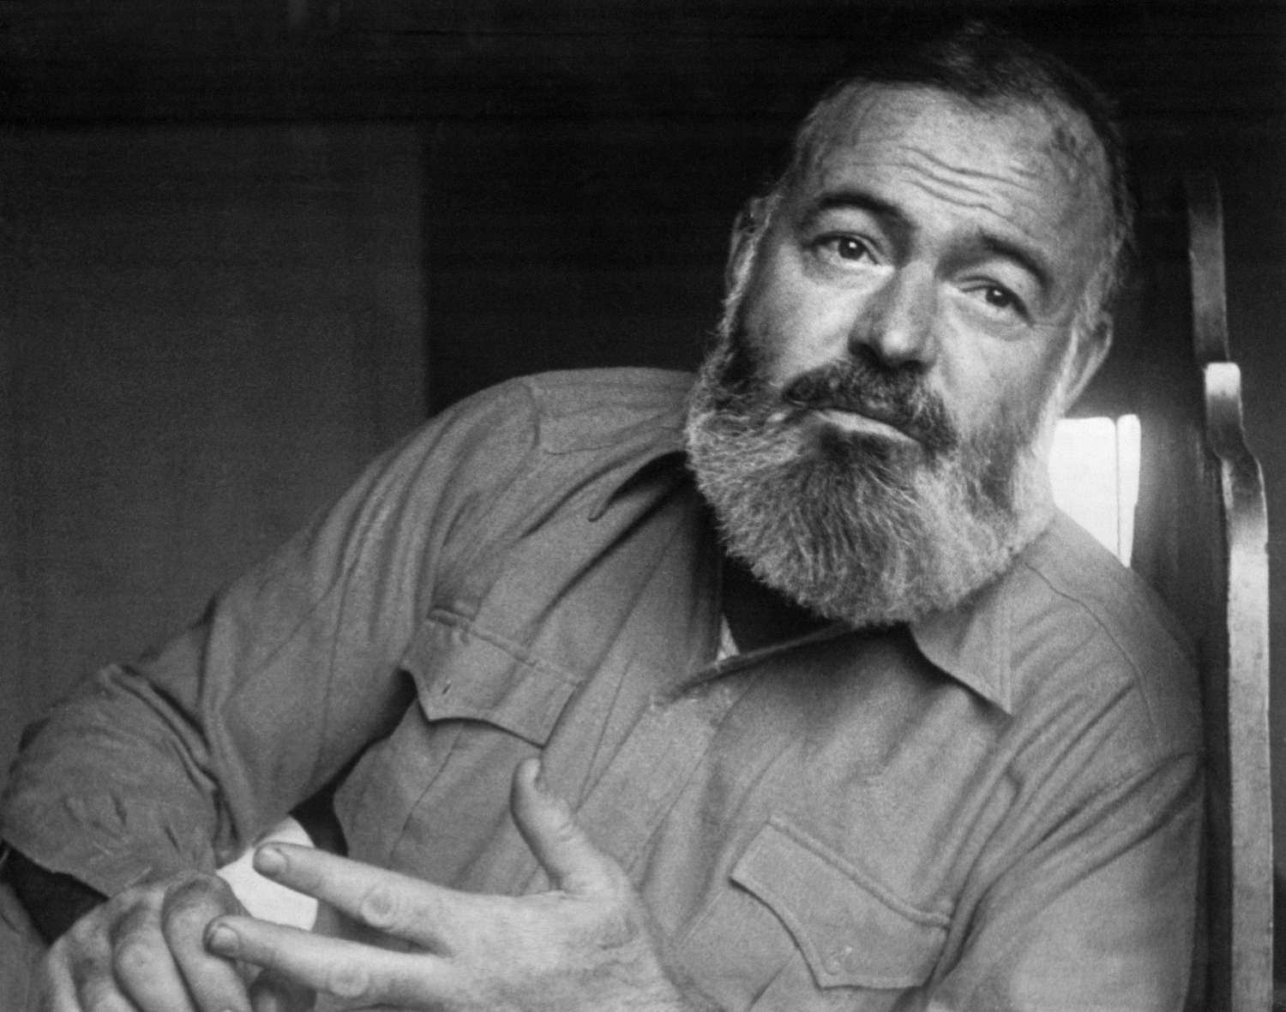

A Man of the World, Ernest Hemingway

A Man of the World

THE BLIND MAN KNEW THE SOUNDS OF all the different machines in the Saloon. I don’t know how long it took him to learn the sounds of the machines but it must have taken him quite a time because he only worked one saloon at a time. He worked two towns though and he would start out of The Flats along after it was good and dark on his way up to Jessup. He’d stop by the side of the road when he heard a car coming and their lights would pick him up and either they would stop and give him a ride or they wouldn’t and would go on by on the icy road. It would depend on how they were loaded and whether there were women in the car because the blind man smelled plenty strong and especially in winter. But someone would always stop for him because he was a blind man.

Everybody knew him and they called him Blindy which is a good name for a blind man in that part of the country, and the name of the saloon that he threw his trade to was The Pilot. Right next to it was another saloon, also with gambling and a dining room, that was called The Index.

Both of these were the names of mountains and they were both good saloons with old-days bars and the gambling was about the same in one as in the other except you ate better in The Pilot probably, although you got a better sizzling steak at The Index. Then The Index was open all night long and got the early morning trade and from daylight until ten o’clock in the morning the drinks were on the house. They were the only saloons in Jessup and they did not have to do that kind of thing. But that was the way they were.

Blindy probably preferred The Pilot because the machines were right along the left-hand wall as you came in and faced the bar. This gave him better control over them than he would have had at The Index where they were scattered on account it was a bigger place with more room.

On this night it was really cold outside and he came in with icicles on his mustache and small pus icicles out of both eyes and he didn’t look really very good. Even his smell was froze but that wasn’t for very long and he started to put out almost as soon as the door was shut. It was always hard for me to look at him but I was looking at him carefully because I knew he always rode and I didn’t see how he would be frozen up so bad. Finally I asked him.

“Where you walk from, Blindy?”

“Willie Sawyer put me out of his car down below the railway bridge. There weren’t no more cars come and I walked in.”

“What did he put you afoot for?” somebody asked.

“Said I smelled too bad.”

Someone had pulled the handle on a machine and Blindy started listening to the whirr. It came up nothing. “Any dudes playing?” he asked me.

“Can’t you hear?”

“Not yet.”

“No dudes, Blindy, and it’s a Wednesday.”

“I know what night it is. Don’t start telling me what night it is.”

Blindy went down the line of machines feeling in all of them to see if anything had been left in the cups by mistake. Naturally there wasn’t anything, but that was the first part of his pitch. He came back to the bar where we were and Al Chaney asked him to have a drink.

“No,” Blindy said. “I got to be careful on those roads.”

“What you mean those roads?” somebody asked him. “You only go on one road. Between here and The Flats.”

“I been on lots of roads,” Blindy said. “And any time I may have to take off and go on more.”

Somebody hit on a machine but it wasn’t any heavy hit. Blindy moved on it just the same. It was a quarter machine and the young fellow who was playing it gave him a quarter sort of reluctantly. Blindy felt it before he put it in his pocket.

“Thank you,” he said. “You’ll never miss it.”

The young fellow said, “Nice to know that,” and put a quarter back in the machine and pulled down again.

He hit again but this time pretty good and he scooped in the quarters and gave a quarter to Blindy.”

“Thanks,” Blindy said. “You’re doing fine.”

“Tonight’s my night,” the young fellow who was playing said.

“Your night is my night,” Blindy said and the young fellow went on playing but he wasn’t doing any good any more and Blindy was so strong standing by him and he looked so awful and finally the fellow quit playing and came over to the bar. Blindy had run him out but he had no way of noticing it because the fellow didn’t say anything, so Blindy just checked the machines again with his hand and stood there waiting for someone else to come in and make a play.

There wasn’t any play at the wheel nor at the crap table and at the poker game there were just gamblers sitting there and cutting each other up. It was a quiet evening on a week night in town and there wasn’t any excitement. The place was not making a nickel except at the bar. But at the bar it was pleasant and the place had been nice until Blindy had come in. Now everybody was figuring they might as well go next door to The Index or else cut out and go home.

“What will yours be, Tom?” Frank the bartender asked me. “This is on the house.”

“I was figuring on shoving.”

“Have one first then.”

“The same with ditch,” I said. Frank asked the young fellow, who was wearing heavy Oregon Cities and a black hat and was shaved clean and had a snow-burned face, what he would drink and the young fellow took the same. The whisky was Old Forester.

I nodded to him and raised my drink and we both sipped at the drinks. Blindy was down at the far end of the machines. I think he figured maybe no one would come in if they saw him at the door. Not that he was self-conscious.

“How did that man lose his sight?” the young fellow asked me.

“In a fight,” Frank told him.

“I wouldn’t know,” I told him.

“Him fight?” the stranger said. He shook his head.

“Yeah,” Frank said. “He got that high voice out of the same fight. Tell him, Tom.”

“I never heard of it.”

“No. You wouldn’t of,” Frank said. “Of course not. You wasn’t here, I suppose. Mister, it was a night about as cold as tonight. Maybe colder. It was a quick fight too. I didn’t see the start of it. Then they come fighting out of the door of The Index. Blackie, him that’s Blindy now, and this other boy Willie Sawyer, and they were slugging and kneeing and gouging and biting and I see one of Blackie’s eyes hanging down on his cheek.

They were fighting on the ice of the road with the snow all banked up and the light from this door and The Index door, and Hollis Sands was right behind Willie Sawyer who was gouging for the eye and Hollis kept hollering, ‘Bite it off! Bite it off just like it was a grape!” Blackie was biting onto Willie Sawyer’s face and he had a good holt and it give way with a jerk and then he had another good holt and they were down on the ice now and Willie Sawyer was gouging him to make him let go and then Blackie gave a yell like you’ve never heard. Worse than when they cut a boar.”

Blindy had come up opposite us and we smelled him and turned around.

“‘Bite it off just like it was a grape,’” he said in his high-pitched voice and looked at us, moving his head up and down. “That was the left eye. He got the other one without no advice. Then he stomped me when I couldn’t see. That was the bad part.” He patted himself.

“I could fight good then,” he said. “But he got the eye before I knew even what was happening. He got it with a lucky gouge. Well,” Blindy said without any rancor, “that put a stop to my fighting days.”

“Give Blackie a drink,” I said to Frank.

“Blindy’s the name, Tom. I earned that name. You seen me earn it. That’s the same fellow who put me adrift down the road tonight. Fellow bit the eye. We ain’t never made friends.”

“What did you do to him?” the stranger asked.

“Oh, you’ll see him around,” Blindy said. “You’ll recognize him any time you see him. I’ll let it come as a surprise.”

“You don’t want to see him,” I told the stranger.

“You know that’s one of the reasons I’d like to see sometimes,” Blindy said. “I’d like to just have one good look at him.”

“You know what he looks like,” Frank told him. “You went up and put your hands on his face once.”

“Did it again tonight too,” Blindy said happily. “That’s why he put me out of the car. He ain’t got no sense of humor at all. I told him on a cold night like this he’d ought to bundle up so the whole inside of his face wouldn’t catch cold. He didn’t even think that was funny. You know that Willie Sawyer he’ll never be a man of the world.”

“Blackie, you have one on the house,” Frank said. “I can’t drive you home because I only live just down the road. But you can sleep in the back of the place.”

“That’s mighty good of you, Frank. Only just don’t call me Blackie. I’m not Blackie any more. Blindy’s my name.”

“Have a drink, Blindy.”

“Yes, sir,” Blindy said. His hand reached out and found the glass and he raised it accurately to the three of us.

“That Willis Sawyer,” he said. “Probably alone home by himself. That Willie Sawyer he don’t know how to have any fun at all.”

The End