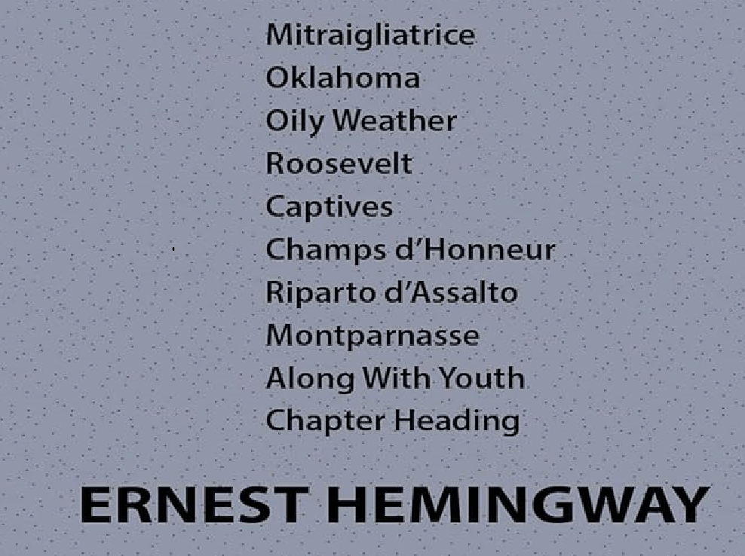

Ten Poems, Ernest Hemingway

Mitraigliatrice

Oklahoma

Oily Weather

Roosevelt

Captives

Champs d'Honneur

Riparto d'Assalto

Montparnasse

Along With Youth

Chapter Heading

Mitraigliatrice

The mills of the gods grind slowly;

But this mill

Chatters in mechanical staccato.

Ugly short infantry of the mind,

Advancing over difficult terrain,

Make this Corona

Their mitrailleuse.

Oklahoma

All of the Indians are dead

(a good Indian is a dead Indian)

Or riding in motor cars—

(the oil lands, you know, they’re all rich)

Smoke smarts my eyes,

Cottonwood twigs and buffalo dung

Smoke grey in the teepee—

(or is it myopic trachoma)

The prairies are long,

The moon rises,

Ponies

Drag at their pickets.

The grass has gone brown in the summer—

(or is it the hay crop failing)

Pull an arrow out:

If you break it

The wound closes.

Salt is good too

And wood ashes.

Pounding it throbs in the night—

(or is it the gonorrhea)

Oily Weather

The sea desires deep hulls—

It swells and rolls.

The screw churns a throb—

Driving, throbbing, progressing.

The sea rolls with love

Surging, caressing,

Undulating its great loving belly.

The sea is big and old—

Throbbing ships scorn it.

Roosevelt

Workingmen believed

He busted trusts,

And put his picture in their windows.

“What he’d have done in France!”

They said.

Perhaps he would—

He could have died

Perhaps,

Though generals rarely die except in bed,

As he did finally.

And all the legends that he started in his life

Live on and prosper,

Unhampered now by his existence.

Captives

Some came in chains

Unrepentent but tired.

Too tired but to stumble.

Thinking and hating were finished

Thinking and fighting were finished

Retreating and hoping were finished.

Cures thus a long campaign,

Making death easy.

Champs d'Honneur

Soldiers never do die well;

Crosses mark the places—

Wooden crosses where they fell,

Stuck above their faces.

Soldiers pitch and cough and twitch—

All the world roars red and black;

Soldiers smother in a ditch,

Choking through the whole attack.

Riparto d'Assalto

Drummed their boots on the camion floor,

Hob-nailed boots on the camion floor.

Sergeants stiff,

Corporals sore.

Lieutenant thought of a Mestre whore—

Warm and soft and sleepy whore,

Cozy, warm and lovely whore;

Damned cold, bitter, rotten ride,

Winding road up the Grappa side.

Arditi on benches stiff and cold,

Pride of their country stiff and cold,

Bristly faces, dirty hides—

Infantry marches, Arditi rides.

Grey, cold, bitter, sullen ride—

To splintered pines on the Grappa side

At Asalone, where the truck-load died.

Montparnasse

There are never any suicides in the quarter among people one knows

No successful suicides.

A Chinese boy kills himself and is dead.

(they continue to place his mail in the letter rack at the Dome)

A Norwegian boy kills himself and is dead.

(no one knows where the other Norwegian boy has gone)

They find a model dead

alone in bed and very dead.

(it made almost unbearable trouble for the concierge)

Sweet oil, the white of eggs, mustard and water, soap suds

and stomach pumps rescue the people one knows.

Every afternoon the people one knows can be found at the café.

Along With Youth

A porcupine skin,

Stiff with bad tanning,

It must have ended somewhere.

Stuffed horned owl

Pompous

Yellow eyed;

Chuck-wills-widow on a biassed twig

Sooted with dust.

Piles of old magazines,

Drawers of boy’s letters

And the line of love

They must have ended somewhere.

Yesterday’s Tribune is gone

Along with youth

And the canoe that went to pieces on the beach

The year of the big storm

When the hotel burned down

At Seney, Michigan.

Chapter Heading

For we have thought the longer thoughts

And gone the shorter way.

And we have danced to devils’ tunes,

Shivering home to pray;

To serve one master in the night,

Another in the day.