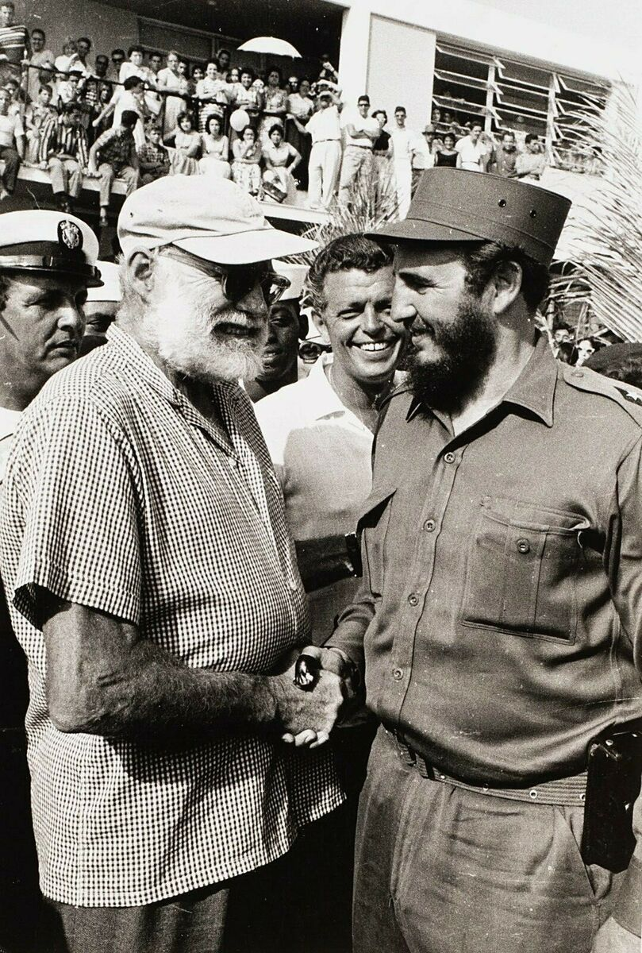

The Butterfly and the Tank

Ernest Hemingway

The Butterfly and the Tank

ON THIS EVENING I WAS WALKING HOME from the censorship office to the Florida Hotel and it was raining. So about halfway home I got sick of the rain and stopped into Chicote’s for a quick one. It was the second winter of shelling in the siege of Madrid and everything was short including tobacco and people’s tempers and you were a little hungry all the time and would become suddenly and unreasonably irritated at things you could do nothing about such as the weather. I should have gone on home. It was only five blocks more, but when I saw Chicote’s doorway I thought I would get a quick one and then do those six blocks up the Gran Via through the mud and rubble of the streets broken by the bombardment.

The place was crowded. You couldn’t get near the bar and all the tables were full. It was full of smoke, singing, men in uniform, and the smell of wet leather coats, and they were handing drinks over a crowd that was three deep at the bar.

A waiter I knew found a chair from another table and I sat down with a thin, white-faced, Adam’s-appled German I knew who was working at the censorship and two other people I did not know. The table was in the middle of the room a little on your right as you go in.

You couldn’t hear yourself talk for the singing and I ordered a gin and Angostura and put it down against the rain. The place was really packed and everybody was very jolly; maybe getting just a little bit too jolly from the newly made Catalan liquor most of them were drinking. A couple of people I did not know slapped me on the back and when the girl at our table said something to me, I couldn’t hear it and said, “Sure.”

She was pretty terrible looking now I had stopped looking around and was looking at our table; really pretty terrible. But it turned out, when the waiter came, that what she had asked me was to have a drink. The fellow with her was not very forceful looking but she was forceful enough for both of them. She had one of those strong, semi-classical faces and was built like a lion tamer; and the boy with her looked as though he ought to be wearing an old school tie. He wasn’t though. He was wearing a leather coat just like all the rest of us. Only it wasn’t wet because they had been there since before the rain started. She had on a leather coat too and it was becoming to the sort of face she had.

By this time I was wishing I had not stopped into Chicote’s but had gone straight on home where you could change your clothes and be dry and have a drink in comfort on the bed with your feet up, and I was tired of looking at both of these young people. Life is very short and ugly women are very long and sitting there at the table I decided that even though I was a writer and supposed to have an insatiable curiosity about all sorts of people, I did not really care to know whether these two were married, or what they saw in each other, or what their politics were, or whether he had a little money, or she had a little money, or anything about them. I decided they must be in the radio. Any time you saw really strange looking civilians in Madrid they were always in the radio. So to say something I raised my voice above the noise and asked, “You in the radio?”

“We are,” the girl said. So that was that. They were in the radio.

“How are you comrade?” I said to the German.

“Fine. And you?”

“Wet,” I said, and he laughed with his head on one side.

“You haven’t got a cigarette?” he asked. I handed him my next to the last pack of cigarettes and he took two. The forceful girl took two and the young man with the old school tie face took one.

“Take another,” I shouted.

“No thanks,” he answered and the German took it instead.

“Do you mind?” he smiled.

“Of course not,” I said. I really minded and he knew it. But he wanted the cigarettes so badly that it did not matter. The singing had died down momentarily, or there was a break in it as there is sometimes in a storm, and we could all hear what we said.

“You been here long?” the forceful girl asked me. She pronounced it bean as in bean soup.

“Off and on,” I said.

“We must have a serious talk,” the German said. “I want to have a talk with you. When can we have it?”

“I’ll call you up,” I said. This German was a very strange German indeed and none of the good Germans liked him. He lived under the delusion that he could play the piano, but if you kept him away from pianos he was all right unless he was exposed to liquor, or the opportunity to gossip, and nobody had even been able to keep him away from those two things yet.

Gossip was the best thing he did and he always knew something new and highly discreditable about anyone you could mention in Madrid, Valencia, Barcelona, and other political centers.

Just then the singing really started in again, and you cannot gossip very well shouting, so it looked like a dull afternoon at Chicote’s and I decided to leave as soon as I should have bought a round myself.

Just then it started. A civilian in a brown suit, a white shirt, black tie, his hair brushed straight back from a rather high forehead, who had been clowning around from table to table, squirted one of the waiters with a flit gun. Everybody laughed except the waiter who was carrying a tray full of drinks at the time. He was indignant.

“No hay derecho,” the waiter said. This means, “You have no right to do that,” and is the simplest and the strongest protest in Spain.

The flit gun man, delighted with his success, and not seeming to give any importance to the fact that it was well into the second year of the war, that he was in a city under siege where everyone was under a strain, and that he was one of only four men in civilian clothes in the place, now squirted another waiter.

I looked around for a place to duck to. This waiter, also, was indignant and the flit gun man squirted him twice more, lightheartedly. Some people still thought it was funny, including the forceful girl. But the waiter stood, shaking his head. His lips were trembling. He was an old man and he had worked in Chicote’s for ten years that I knew of.

“No hay derecho, ” he said with dignity.

People had laughed, however, and the flit gun man, not noticing how the singing had fallen off, squirted his flit gun at the back of a waiter’s neck. The waiter turned, holding his tray.

“No hay derecho,” he said.

This time it was no protest. It was an indictment and I saw three men in uniform start from a table for the flit gun man and the next thing all four of them were going out the revolving door in a rush and you heard a smack when someone hit the flit gun man on the mouth. Somebody else picked up the flit gun and threw it out the door after him.

The three men came back in looking serious, tough and very righteous. Then the door revolved and in came the flit gun man. His hair was down in his eyes, there was blood on his face, his necktie was pulled to one side and his shirt was torn open. He had the flit gun again and as he pushed, wild-eyed and white-faced, into the room he made one general, unaimed, challenging squirt with it, holding it toward the whole company.

I saw one of the three men start for him and I saw this man’s face. There were more men with him now and they forced the flit gun man back between two tables on the left of the room as you go in, the flit gun man struggling wildly now, and when the shot went off I grabbed the forceful girl by the arm and dove for the kitchen door.

The kitchen door was shut and when I put my shoulder against it it did not give.

“Get down here behind the angle of the bar,” I said. She knelt there.

“Flat,” I said and pushed her down. She was furious.

Every man in the room except the German, who lay behind a table, and the public-school-looking boy who stood in a corner drawn up against the wall, had a gun up. On a bench along the wall three over-blonde girls, their hair dark at the roots, were standing on tiptoe to see and screaming steadily.

“I’m not afraid,” the forceful one said. “This is ridiculous.”

“You don’t want to get shot in a café brawl,” I said. “If that flit king has any friends here this can be very bad.”

But he had no friends, evidently, because people began putting their pistols away and somebody lifted down the blonde screamers and everyone who had started over there when the shot came drew back away from the flit man who lay, quietly, on his back on the floor.

“No one is to leave until the police come,” someone shouted from the door.

Two policemen with rifles, who had come in off the street patrol, were standing by the door and at this announcement I saw six men form up just like the line-up of a football team coming out of a huddle and head out through the door.

Three of them were the men who had first thrown the flit king out. One of them was the man who shot him. They went right through the policemen with the rifles like good interference taking out an end and a tackle. And as they went out one of the policemen got his rifle across the door and shouted, “No one can leave. Absolutely no one.”

“Why did those men go? Why hold us if anyone’s gone?”

“They were mechanics who had to return to their air field,” someone said.

“But if anyone’s gone it’s silly to old the others.”

“Everyone must wait for the Seguridad. Things must be done legally and in order.”

“But don’t you see that if any person has gone it is silly to hold the others?”

“No one can leave. Everyone must wait.”

“It’s comic,” I said to the forceful girl.

“No it’s not. It’s simply horrible.”

We were standing up now and she was staring indignantly at where the flit king was lying. His arms were spread wide and he had one leg drawn up.

“I’m going over to help that poor wounded man. Why has no one helped him or done anything for him?”

“I’d leave him alone,” I said. “You want to keep out of this.”

“But it’s simply inhuman. I’ve nurse’s training and I’m going to give him first aid.”

“I wouldn’t,” I said. “Don’t go near him.”

“Why not?” She was very upset and almost hysterical.

“Because he’s dead,” I said.

When the police came they held everybody there for three hours. They commenced by smelling of all the pistols. In this manner they would detect one which had been fired recently. After about forty pistols they seemed to get bored with this and anyway all you could smell was wet leather coats. Then they sat at a table placed directly behind the late flit king, who lay on the floor looking like a grey wax caricature of himself, with grey wax hands and a grey wax face, and examined people’s papers.

With his shirt ripped open you could see the flit king had no undershirt and the soles of his shoes were worn through. He looked very small and pitiful lying there on the floor. You had to step over him to get to the table where two plain clothes policemen sat and examined everyone’s identification papers. The husband lost and found his papers several times with nervousness.

He had a safe conduct pass somewhere but he had mislaid it in a pocket and he kept on searching and perspiring until he found it. Then he would put it in a different pocket and have to go searching again. He perspired heavily while doing this and it made his hair very curly and his face red. He now looked as though he should have not only an old school tie but one of those little caps boys in the lower forms wear. You have heard how events age people. Well, this shooting had made him look about ten years younger.

While we were waiting around I told the forceful girl I thought the whole thing was a pretty good story and that I would write it sometime. The way the six had lined up in single file and rushed that door was very impressive. She was shocked and said that I could not write it because it would be prejudicial to the cause of the Spanish Republic.

I said that I had been in Spain for a long time and that they used to have a phenomenal number of shootings in the old days around Valencia under the monarchy, and that for hundreds of years before the Republic people had been cutting each other with large knives called navajas in Andalucia, and that if I saw a comic shooting in Chicote’s during the war I could write about it just as though it had been in New York, Chicago, Key West or Marseilles. It did not have anything to do with politics.

She said I shouldn’t. Probably a lot of other people will say I shouldn’t too. The German seemed to think it was a pretty good story, however, and I gave him the last of the Camels. Well, anyway, finally, after about three hours the police said we could go.

They were sort of worried about me at the Florida because in those days, with the shelling, if you started for home on foot and didn’t get there after the bars were closed at seven-thirty, people worried. I was glad to get home and I told the story while we were cooking supper on an electric stove and it had quite a success.

Well, it stopped raining during the night, and the next morning it was a fine, bright, cold early winter day and at twelve forty-five I pushed open the revolving doors at Chicote’s to try a little gin and tonic before lunch. There were very few people there at that hour and two waiters and the manager came over to the table. They were all smiling.

“Did they catch the murderer?” I asked.

“Don’t make jokes so early in the day,” the manager said. “Did you see him shot?”

“Yes,” I told him.

“Me too,” he said. “I was just here when it happened.” He pointed to a comer table. “He placed the pistol right against the man’s chest when he fired.”

“How late did they hold people?”

“Oh, until past two this morning.”

“They only came for the fiambre,” using the Spanish slang word for corpse, the same used on menus for cold meat, “at eleven o’clock this morning.”

“But you don’t know about it yet,” the manager said.

“No. He doesn’t know,” a waiter said.

“It is a very rare thing,” another waiter said. “Muy raro.”

“And sad too,” the manager said. He shook his head.

“Yes. Sad and curious,” the waiter said. “Very sad.”

“Tell me.”

“It is a very rare thing,” the manager said.

“Tell me. Come on, tell me.”

The manager leaned over the table in great confidence.

“In the flit gun, you know,” he said. “He had eau de cologne. Poor fellow.”

“It was not a joke in such bad taste, you see?” the waiter said.

“It was really just gaiety. No one should have taken offense,” the manager said. “Poor fellow.”

“I see,” I said. “He just wanted everyone to have a good time.”

“Yes,” said the manager. “It was really just an unfortunate misunderstanding.”

“And what about the flit gun?”

“The police took it. They have sent it around to his family.”

“I imagine they will be glad to have it,” I said.

“Yes,” said the manager. “Certainly. A flit gun is always useful.”

“Who was he?”

“A cabinet maker.”

“Married?”

“Yes, the wife was here with the police this morning.”

“What did she say?”

“She dropped down by him and said, ‘Pedro, what have they done to thee, Pedro? Who has done this to thee? Oh, Pedro.’ ”

“Then the police had to take her away because she could not control herself,” the waiter said.

“It seems he was feeble of the chest,” the manager said. “He fought in the first days of the movement. They said he fought in the Sierra but he was too weak in the chest to continue.”

“And yesterday afternoon he just went out on the town to cheer things up,” I suggested.

“No,” said the manager. “You see it is very rare. Everything is muy raro. This I learn from the police who are very efficient if given time. They have interrogated comrades from the shop where he worked. This they located from the card of his syndicate which was in his pocket.

Yesterday he bought the flit gun and agua de colonia to use for a joke at a wedding. He had announced this intention. He bought them across the street. There was a label on the cologne bottle with the address. The bottle was in the washroom. It was there he filled the flit gun. After buying them he must have come in here when the rain started.”

“I remember when he came in,” a waiter said.

“In the gaiety, with the singing, he became gay too.”

“He was gay all right,” I said. “He was practically floating around.”

The manager kept on with the relentless Spanish logic.

“That is the gaiety of drinking with a weakness of the chest,” he said.

“I don’t like this story very well,” I said.

“Listen,” said the manager. “How rare it is. His gaiety comes in contact with the seriousness of the war like a butterfly—”

“Oh, very like a butterfly,” I said. “Too much like a butterfly.”

“I am not joking,” said the manager. “You see it? Like a butterfly and a tank.”

This pleased him enormously. He was getting into the real Spanish metaphysics.

“Have a drink on the house,” he said. “You must write a story about this.”

I remembered the flit gun man with his grey wax hands and his grey wax face, his arms spread wide and his legs drawn up and he did look a little like a butterfly; not too much, you know. But he did not look very human either. He reminded me more of a dead sparrow.

“I’ll take gin and Schweppes quinine tonic water,” I said.

“You must write a story about it,” the manager said. “Here. Here’s luck.”

“Luck,” I said. “Look, an English girl last night told me I shouldn’t write about it. That it would be very bad for the cause.”

“What nonsense,” the manager said. “It is very interesting and important, the misunderstood gaiety coming in contact with the deadly seriousness that is here always. To me it is the rarest and most interesting thing which I have seen for some time. You must write it.”

“All right,” I said. “Sure. Has he any children?”

“No,” he said. “I asked the police. But you must write it and you must call it ‘The Butterfly and the Tank.’ ”

“All right,” I said. “Sure. But I don’t like the title much.”

“The title is very elegant,” the manager said. “It is pure literature.”

“All right,” I said. “Sure. That’s what we’ll call it. ‘The Butterfly and the Tank.’ ”

And I sat there on that bright cheerful morning, the place smelling clean and newly aired and swept, with the manager who was an old friend and who was now very pleased with the literature we were making together and I took a sip of the gin and tonic water and looked out the sandbagged window and thought of the wife kneeling there and saying, “Pedro. Pedro, who has done this to thee, Pedro?” And I thought that the police would never be able to tell her that even if they had the name of the man who pulled the trigger.

The End