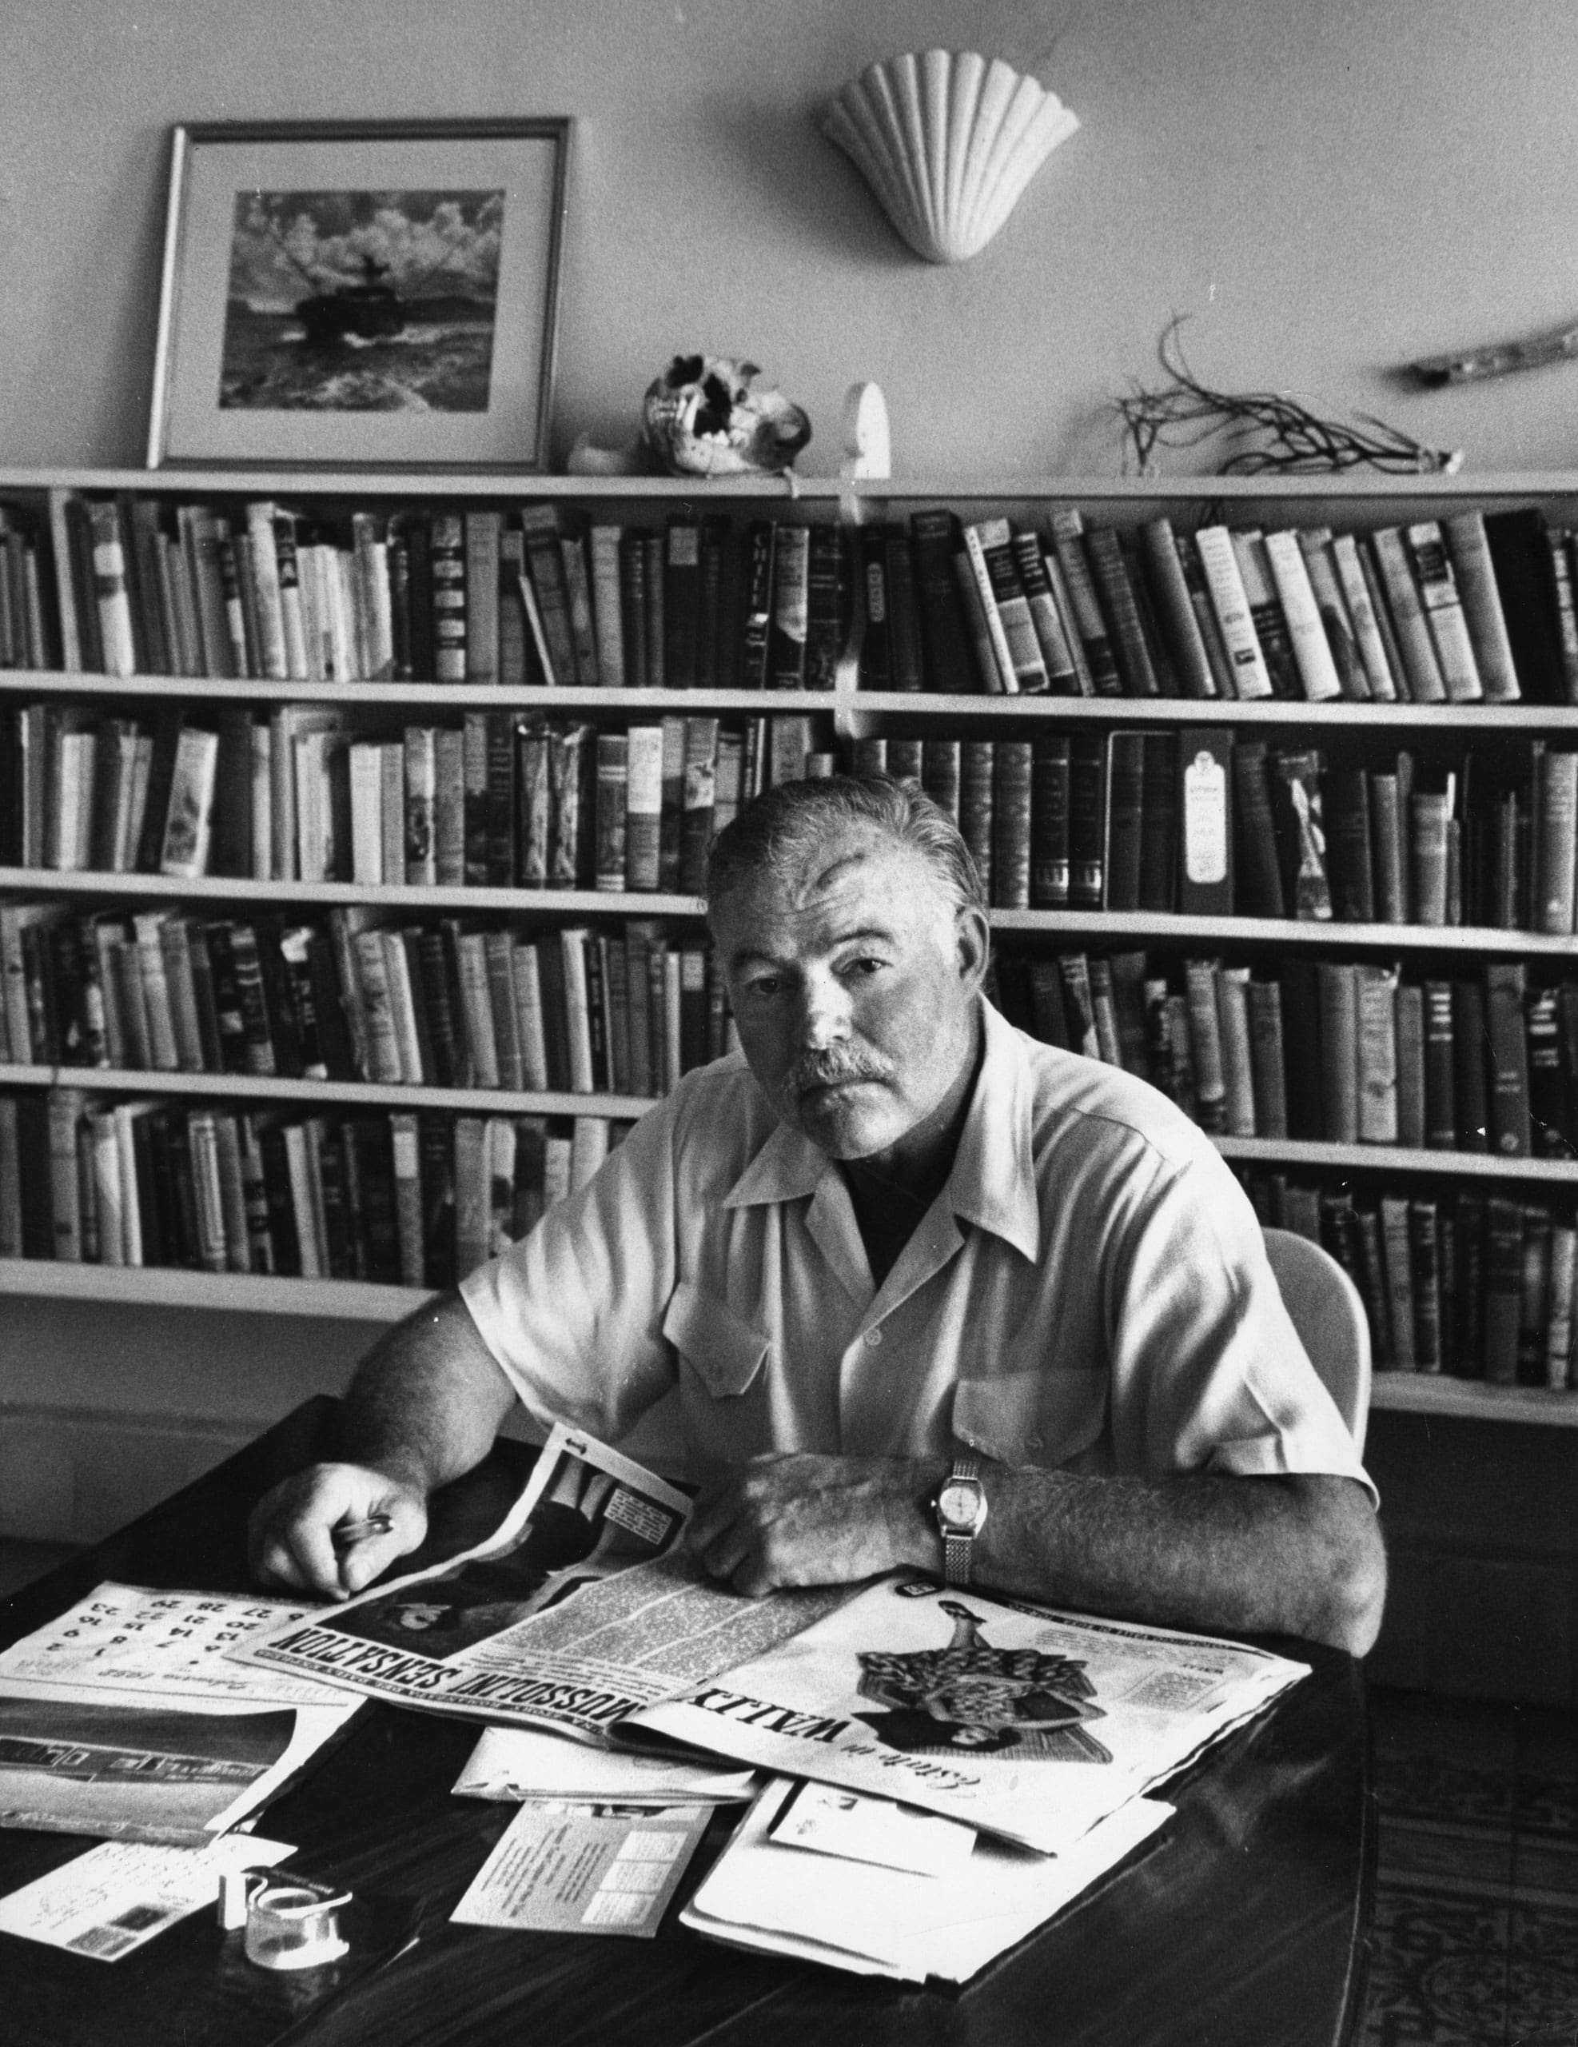

The Denunciation, Ernest Hemingway

The Denunciation

CHICOTE’S IN THE OLD DAYS IN MADRID was a place sort of like The Stork, without the music and the debutantes, or the Waldorfs men’s bar if they let girls in. You know, they came in, but it was a man’s place and they didn’t have any status. Pedro Chicote was the proprietor and he had one of those personalities that make a place. He was a great bartender and he was always pleasant, always cheerful, and he had a lot of zest. Now zest is a rare enough thing and few people have it for long. It should not be confused with showmanship either.

Chicote had it and it was not faked or put on. He was also modest, simple and friendly. He really was as nice and pleasant and still as marvelously efficient as George, the chasseur at the Ritz bar in Paris, which is about the strongest comparison you can make to anyone who has been around, and he ran a fine bar.

In those days the snobs among the rich young men of Madrid hung out at something called the Nuevo Club and the good guys went to Chicote’s. A lot of people went there that I did not like, the same as at The Stork, say, but I was never in Chicote’s that it wasn’t pleasant. One reason was that you did not talk politics there. There were cafés where you went for politics and nothing else but you didn’t talk politics at Chicote’s. You talked plenty of the other five subjects though and in the evening the best looking girls in the town showed up there and it was the place to start an evening from, all right, and we had all started some fine ones from there.

Then it was the place where you dropped in to find out who was in town, or where they had gone to if they were out of town. And if it was summer, and there was no one in town, you could always sit and enjoy a drink because the waiters were all pleasant.

It was a club only you didn’t have to pay any dues and you could pick a girl up there. It was the best bar in Spain, certainly, and I think one of the best bars in the world, and all of us that used to hang out there had a great affection for it.

Another thing was that the drinks were wonderful. If you ordered a martini it was made with the best gin that money could buy, and Chicote had a barrel whisky that came from Scotland that was so much better than the advertised brands that it was pitiful to compare it with ordinary Scotch. Well, when the revolt started, Chicote was up at San Sebastian running the summer place he had there. He is still running it and they say it is the best bar in Franco’s Spain. The waiters took over the Madrid place and they are still running it, but the good liquor is all gone now.

Most of Chicote’s old customers are on Franco’s side; but some of them are on the Government side. Because it was a very cheerful place, and because really cheerful people are usually the bravest, and the bravest get killed quickest, a big part of Chicote’s old customers are now dead. The barrel whisky had all been gone for many months now and we finished the last of the yellow gin in May of 1938.

There’s not much there to go for now so I suppose Luis Delgado, if he had come to Madrid a little later, might have stayed away from there and not gotten into that trouble. But when he came to Madrid in the month of November of 1937 they still had the yellow gin and they still had Indian quinine water. They do not seem worth risking your life for, so maybe he just wanted to have a drink in the old place. Knowing him, and knowing the place in the old days, it would be perfectly understandable.

They had butchered a cow at the Embassy that day and the porter had called up at the Hotel Florida to tell us that they had saved us ten pounds of fresh meat. I walked over to get it through the early dusk of a Madrid winter. Two assault guards with rifles sat on chairs outside the Embassy gate and the meat was waiting at the porter’s lodge.

The porter said it was a very good cut but that the cow was lean. I offered him some roasted sunflower seeds and some acorns from the pocket of my mackinaw jacket and we joked a little standing outside the lodge on the gravel of the Embassy driveway.

I walked home across the town with the meat heavy under my arm. They were shelling up the Gran Via and I went into Chicote’s to wait it out. It was noisy and crowded and I sat at a little table in one corner against the sandbagged window with the meat on the bench beside me and drank a gin and tonic water. It was that week that we discovered they still had tonic water.

No one had ordered any since the war started and it was still the same price as before the revolt. The evening papers were not yet out so I bought three party tracts from an old woman. They were ten centavos apiece and I told her to keep the change from a peseta. She said God would bless me. I doubted this but read the three leaflets and drank the gin and tonic.

A waiter I had known in the old days came over to the table and said something to me.

“No,” I said. “I don’t believe it.”

“Yes,” he insisted, slanting his tray and his head in the same direction. “Don’t look now. There he is.”

“It’s not my business,” I told him.

“Nor mine either.”

He went away and I bought the evening papers which had just come in from another old woman and read them. There was no doubt about the man the waiter had pointed out. We both knew him very well. All I could think was: the fool. The utter bloody fool.

Just then a Greek comrade came over and sat down at the table. He was a company commander in the Fifteenth Brigade who had been buried by an airplane bomb which had killed four other men and he had been sent in to be under observation for a while and then sent to a rest home or something of the sort.

“How are you, John?” I asked him. “Try one of these.”

“What you call that drink, Mr. Emmunds?”

“Gin and tonic.”

“What is that kind of tonic?”

“Quinine. Try one.”

“Listen, I don’t drink very much but is a quinine very good for fever. I try little one.”

“What did the doctor say about you, John?”

“Is a no necessity see doctor. I am all right. Only I have like buzzing noises all the time in the head.”

“You have to go to see him, John.”

“I go all right. But he not understand. He says I have no papers to admit.”

“I’ll call up about it,” I said. “I know the people there. Is the doctor a German?”

“That’s right,” said John. “Is a German. No talk English very good.”

Just then the waiter came over. He was an old man with a bald head and very old-fashioned manners which the war had not changed. He was very worried.

“I have a son at the front,” he said. “I have another son killed. Now about this.”

“It is thy problem.”

“And you? Already I have told you.”

“I came in here to have a drink before eating.”

“And I work here. But tell me.”

“It is thy problem,” I said. “I am not a politician.”

“Do you understand Spanish, John?” I asked the Greek comrade.

“No, I understand few words but I speak Greek, English, Arabic. One time I speak good Arabic. Listen, you know how I get buried?”

“No. I knew you were buried. That’s all.”

He had a dark good-looking face and very dark hands that he moved about when he talked. He came from one of the islands and he spoke with great intensity.

“Well, I tell you now. You see I have very much experience in war. Before I am captain in Greek army too. I am good soldier. So when I see plane come over there when we are in trenches there at Fuentes del Ebro I look at him close. I look at plane come over, bank, turn like this” (he turned and banked with his hands), “look down on us and I say, ‘Ah ha. Is for the General Staff. Is made the observation. Pretty soon come others.’

“So just like I say come others. So I am stand there and watch. I watch close. I look up and I point out to company what happens. Is come three and three. One first and two behind. Is pass one group of three and I say to company, ‘See? Now is pass one formation.’

“Is pass the other three and I say to company, ‘Now is hokay. Now is all right. Now is nothing more to worry.’ That the last thing I remember for two weeks.”

“When did it happen?”

“About one month ago. You see is my helmet forced down over my face when am buried by bomb so I have the air in that helmet to breathe until they dig me out but I know nothing about that. But in that air I breathe is the smoke from the explosion and that make me sick for long time. Now am I hokay, only with the ringing in the head. What you call this drink?”

“Gin and tonic. Schweppes Indian tonic water. This was a very fancy café before the war and this used to cost five pesetas when there were only seven pesetas to the dollar. We just found out they still have the tonic water and they’re charging the same price for it. There’s only a case left.”

“Is a good drink all right. Tell me, how was this city before the war?”

“Fine. Like now only lots to eat.”

The waiter came over and leaned toward the table.

“And if I don’t?” he said. “It is my responsibility.”

“If you wish to, go to the telephone and call this number. Write it down.”

He wrote it down. “Ask for Pepé,” I said.

“I have nothing against him,” the waiter said. “But it is the Causa. Certainly such a man is dangerous to our cause.”

“Don’t the other waiters recognize him?”

“I think so. But no one has said anything. He is an old client.”

“I am an old client, too.”

“Perhaps then he is on our side now, too.”

“No,” I said. “I know he is not.”

“I have never denounced anyone.”

“It is your problem. Maybe one of the other waiters will denounce him.”

“No. Only the old waiters know him and the old waiters do not denounce.”

“Bring another of the yellow gins and some bitters,” I said. “There is tonic water still in the bottle.”

“What’s he talk about?” asked John. “I only understand little bit.”

“There is a man here that we both knew in the old days. He used to be a marvelous pigeon shot and I used to see him at shoots. He is a fascist and for him to come here now, no matter what his reasons, is very foolish. But he was always very brave and very foolish.”

“Show him to me.”

“There at that table with the flyers.”

“Which one?”

“With the very brown face; the cap over one eye. Who is laughing now.”

“He is fascist?”

“Yes.”

“That’s a closest I see fascist since Fuentes del Ebro. Is a many fascist here?”

“Quite a few from time to time.”

“Is drink the same drink as you,” said John. “We drink that other people think we fascists, eh? Listen you ever been South America, West Coast, Magallanes?”

“No.”

“Is all right. Only too many oc-toe-pus.”

“Too many what?”

“Oc-toe-pus.” He pronounced it with the accent on the toe as oc-toepus. “You know with the eight arms.”

“Oh,” I said. “Octopus.”

“Oc-toe-pus,” said John. “You see I am diver too. Is a good place to work all right make plenty money only too many oc-toe-pus.”

“Did they bother you?”

“I don’t know about that. First time I go down in Magallanes harbor I see oc-toe-pus. He is stand on his feet like this.” John pointed his fingers on the table and brought his hands up, at the same time bringing up his shoulders and raising his eyebrows. “He is stand up taller than I am and he is look me right in the eye. I jerk cord for them to bring me up.”

“How big was he, John?”

“I cannot say absolutely because the glass in the helmet make distort a little. But the head was big around more than four feet anyway. And he was stand on his feet like on tip-toes and look at me like this.” (He peered in my face.) “So when I get up out of water they take off the helmet and so I say I don’t go down there any more. Then the man of the job says, ‘What a matter with you, John? The oc-toe-pus is more afraid of you than you afraid of oc-toe-pus.’ So I say to him ‘Impossible!’ What you say we drink some more this fascist drink?”

“All right,” I said.

I was watching the man at the table. His name was Luis Delgado and the last time I had seen him had been in 1933 shooting pigeons at Saint Sebastian and I remembered standing with him up on top of the stand watching the final of the big shoot. We had a bet, more than I could afford to bet, and I believed a good deal more than he could afford to lose that year, and when he paid coming down the stairs, I remembered how pleasant he was and how he made it seem a great privilege to pay. Then I remembered our standing at the bar having a martini, and I had that wonderful feeling of relief that comes when you have bet yourself out of a bad hole and I was wondering how badly the bet had hit him. I had shot rottenly all week and he had shot beautifully but drawn almost impossible birds and he had bet on himself steadily.

“Should we match a duro?” he asked.

“You really want to?”

“Yes, if you like.”

“For how much?”

He took out a notecase and looked in it and laughed.

“I’d say for anything you like,” he said. “But suppose we say for eight thousand pesetas. That’s what seems to be there.”

That was close to a thousand dollars then.

“Good,” I said, all the fine inner quiet gone now and the hollow that gambling makes come back again. “Who’s matching who?”

“I’ll match you.”

We shook the heavy five-peseta pieces in our cupped hands; then each man laid his coin on the back of his left hand, each coin covered with the right hand.

“What’s yours?” he asked.

I uncovered the big silver piece with the profile of Alfonso XIII as a baby showing.

“Heads,” I said.

“Take these damned things and be a good man and buy me a drink.” He emptied out the notecase. “You wouldn’t like to buy a good Purdey gun would you?”

“No,” I said. “But look, Luis, if you need some money—”

I was holding the stiffly folded, shiny-heavy-paper, green thousandpeseta notes toward him.

“Don’t be silly, Enrique,” he said. “We’ve been gambling, haven’t we?”

“Yes. But we know each other quite well.”

“Not that well.”

“Right,” I said. “You’re the judge of that. Then what will you drink?”

“What about a gin and tonic? That’s a marvelous drink you know.”

So we had a gin and tonic and I felt very badly to have broken him and I felt awfully good to have won the money, and a gin and tonic never tasted better to me in all my life. There is no use to lie about these things or pretend you do not enjoy winning; but this boy Luis Delgado was a very pretty gambler.

“I don’t think if people gambled for what they could afford it would be very interesting. Do you, Enrique?”

“I don’t know. I’ve never been able to afford it.”

“Don’t be silly. You have lots of money.”

“No I haven’t,” I said. “Really.”

“Oh, everyone has money,” he said. “It’s just a question of selling something or other to get hold of it.”

“I don’t have much. Really.”

“Oh, don’t be silly. I’ve never known an American who wasn’t rich.”

I guess that was the truth all right. He wouldn’t have met them at the Ritz bar or at Chicote’s either in those days. And now he was back in Chicote’s and all the Americans he would meet there now were the kind he would never have met; except me, and I was a mistake. But I would have given plenty not to have seen him in there.

Still, if he wanted to do an absolutely damn fool thing like that it was his own business. But as I looked at the table and remembered the old days I felt badly about him and I felt very badly too that I had given the waiter the number of the counterespionage bureau in Seguridad headquarters. He could have had Seguridad by simply asking on the telephone. But I had given him the shortest cut to having Delgado arrested in one of those excesses of impartiality, righteousness and Pontius Pilatry, and the always-dirty desire to see how people act under an emotional conflict, that makes writers such attractive friends.

The waiter came over.

“What do you think?” he asked.

“I would never denounce him myself,” I said, now trying to undo for myself what I had done with the number. “But I am a foreigner and it is your war and your problem.”

“But you are with us.”

“Absolutely and always. But it does not include denouncing old friends.”

“But for me?”

“For you it is different.”

I knew this was true and there was nothing else to say, only I wished I had never heard of any of it.

My curiosity as to how people would act in this case had been long ago, and shamefully, satisfied. I turned to John and did not look at the table where Luis Delgado was sitting. I knew he had been flying with the fascists for over a year, and here he was, in a loyalist uniform, talking to three young loyalist flyers of the last crop that had been trained in France.

None of those new kids would know him and I wondered whether he had come to try to steal a plane or for what. Whatever he was there for, he was a fool to come to Chicote’s now.

“How do you feel, John?” I asked.

“Feel good,” said John. “Is a good drink hokay. Makes me feel little bit drunk maybe. Is a good for the buzzing in the head.”

The waiter came over. He was very excited.

“I have denounced him,” he said.

“Well then,” I said, “now you haven’t any problem.”

“No,” he said proudly. “I have denounced him. They are on their way now to get him.”

“Let’s go,” I said to John. “There is going to be some trouble here.”

“Is best go then,” said John. “Is a plenty trouble always come, even if you do best to avoid. How much we owe?”

“You aren’t going to stay?” the waiter asked.

“No.”

“But you gave me the telephone number.”

“I know it. You get to know too many telephone numbers if you stay around in this town.”

“But it was my duty.”

“Yes. Why not? Duty is a very strong thing.”

“But now?”

“Well, you felt good about it just now, didn’t you? Maybe you will feel good about it again. Maybe you will get to like it.”

“You have forgotten the package,” the waiter said. He handed me the meat which was wrapped in two envelopes which had brought copies of the Spur to the piles of magazines which accumulated in one of the office rooms of the Embassy.

“I understand,” I said to the waiter. “Truly.”

“He was an old client and a good client. Also I have never denounced anyone before. I did not denounce for pleasure.”

“Also I should not speak cynically or brutally. Tell him that I denounced him. He hates me anyway by now for differences in politics. He’d feel badly if he knew it was you.”

“No. Each man must take his responsibility. But you understand?”

“Yes,” I said. Then lied. “I understand and I approve.” You have to lie very often in a war and when you have to lie you should do it quickly and as well as you can.

We shook hands and I went out the door with John. I looked back at the table where Luis Delgado sat as I went out. He had another gin and tonic in front of him and everyone at the table was laughing at something he had said. He had a very gay, brown face, and shooter’s eyes, and I wondered what he was passing himself off as.

He was a fool to go to Chicote’s. But that was exactly the sort of thing that he would do in order to be able to boast of it when he was back with his own people.

As we went out of the door and turned to walk up the street, a big Seguridad car drew up in front of Chicote’s and eight men got out of it. Six with submachine guns took up positions outside the door. Two in plain clothes went inside. A man asked us for our papers and when I said, “Foreigners,” he said to go along; that it was all right.

In the dark going up the Gran Via there was much new broken glass on the sidewalk and much rubble under foot from the shelling. The air was still smoky and all up the street it smelled of high explosive and blasted granite.

“Where you go eat?” asked John.

“I have some meat for all of us, and we can cook it in the room.”

“I cook it,” said John. “I cook good. I remember one time when I cook on ship—”

“It will be pretty tough,” I said. “It’s just been freshly butchered.”

“Oh no,” said John. “Is a no such thing as a touch meat in a war.”

People were hurrying by in the dark on their way home from the cinemas where they had stayed until the shelling was over.

“What’s a matter that fascist he come to that café where they know him?”

“He was crazy to do it.”

“Is a trouble with a war,” John said. “Is a too many people crazy.”

“John,” I said, “I think you’ve got something there.”

Back at the hotel we went in the door past the sandbags piled to protect the porter’s desk and I asked for the key, but the porter said there were two comrades upstairs in the room taking a bath. He had given them the keys.

“Go on up, John,” I said. “I want to telephone.”

I went over to the booth and called the same number I had given the waiter.

“Hello? Pepé?”

A thin-lipped voice came over the phone. “¿Qué tal Enrique?”

“Listen, Pepé, did you pick up a certain Luis Delgado at Chicote’s?”

“Sí, hombre, sí. Sin novedad. Without trouble.”

“He doesn’t know anything about the waiter?”

“No, hombre, no.”

“Then don’t tell him. Tell him I denounced him then, will you? Nothing about the waiter.”

“Why when it will make no difference? He is a spy. He will be shot. There is no choice in the matter.”

“I know,” I said. “But it makes a difference.”

“As you want, hombre. As you want. When shall I see thee?”

“Lunch tomorrow. We have some meat.”

“And whisky before. Good, hombre, good.”

“Salud, Pepé, and thank you.”

“Salud, Enrique. It is nothing. Salud.”

It was a strange and very deadly voice and I never got used to hearing it, but as I walked up the stairs now, I felt much better.

All we old clients of Chicote’s had a sort of feeling about the place. I knew that was why Luis Delgado had been such a fool as to go back there. He could have done his business some place else. But if he was in Madrid he had to go there. He had been a good client as the waiter had said and we had been friends.

Certainly any small acts of kindness you can do in life are worth doing. So I was glad I had called my friend Pepé at Seguridad headquarters because Luis Delgado was an old client of Chicote’s and I did not wish him to be disillusioned or bitter about the waiters there before he died.

The End