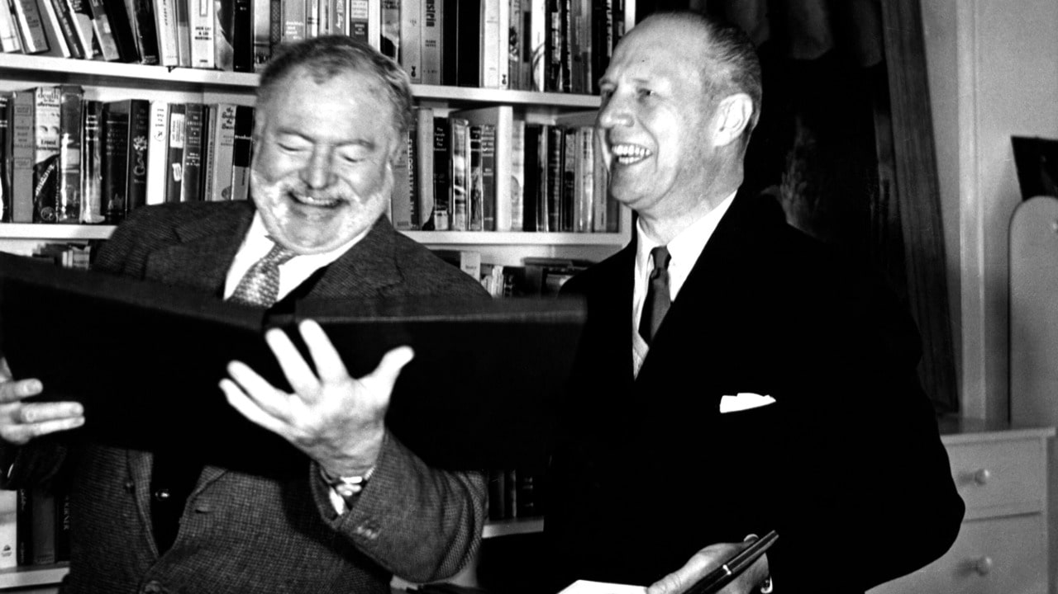

Ernest Hemingway Speech of Acceptance upon the award of the Nobel Prize December 10, 1954

As the Laureate was unable to be present at the Nobel Banquet at the City Hall in Stockholm, December 10, 1954, the speech was read by John M. Cabot, United States Ambassador to Sweden\*

«Having no facility for speech-making and no command of oratory nor any domination of rhetoric, I wish to thank the administrators of the generosity of Alfred Nobel for this Prize.

No writer who knows the great writers who did not receive the Prize can accept it other than with humility. There is no need to list these writers. Everyone here may make his own list according to his knowledge and his conscience.

It would be impossible for me to ask the Ambassador of my country to read a speech in which a writer said all of the things which are in his heart. Things may not be immediately discernible in what a man writes, and in this sometimes he is fortunate; but eventually they are quite clear and by these and the degree of alchemy that he possesses he will endure or be forgotten.

Writing, at its best, is a lonely life. Organizations for writers palliate the writer’s loneliness but I doubt if they improve his writing. He grows in public stature as he sheds his loneliness and often his work deteriorates. For he does his work alone and if he is a good enough writer he must face eternity, or the lack of it, each day.

For a true writer each book should be a new beginning where he tries again for something that is beyond attainment. He should always try for something that has never been done or that others have tried and failed. Then sometimes, with great luck, he will succeed.

How simple the writing of literature would be if it were only necessary to write in another way what has been well written. It is because we have had such great writers in the past that a writer is driven far out past where he can go, out to where no one can help him.

I have spoken too long for a writer. A writer should write what he has to say and not speak it. Again I thank you.»

Prior to the speech, H.S. Nyberg, Member of the Swedish Academy, made the following comment: «Another deep regret is that the winner of this year’s Nobel Prize in Literature, Mr. Ernest Hemingway, on account of ill health has to be absent from our celebration. We wish to express our admiration for the eagle eye with which he has observed, and for the accuracy with which he has interpreted the human existence of our turbulent times; also for the admirable restraint with which he has described their naked struggle. The human problems which he has treated are relevant to all of us, living as we do in the confused conditions of modern life; and few authors have exercised such a wide influence on contemporary literature in all countries. It is our sincere hope that he will soon recover health and strength in pursuit of his life-work.»

\* Ernest Hemingway read and recorded his speech on a later date.

December 10, 1954

The End