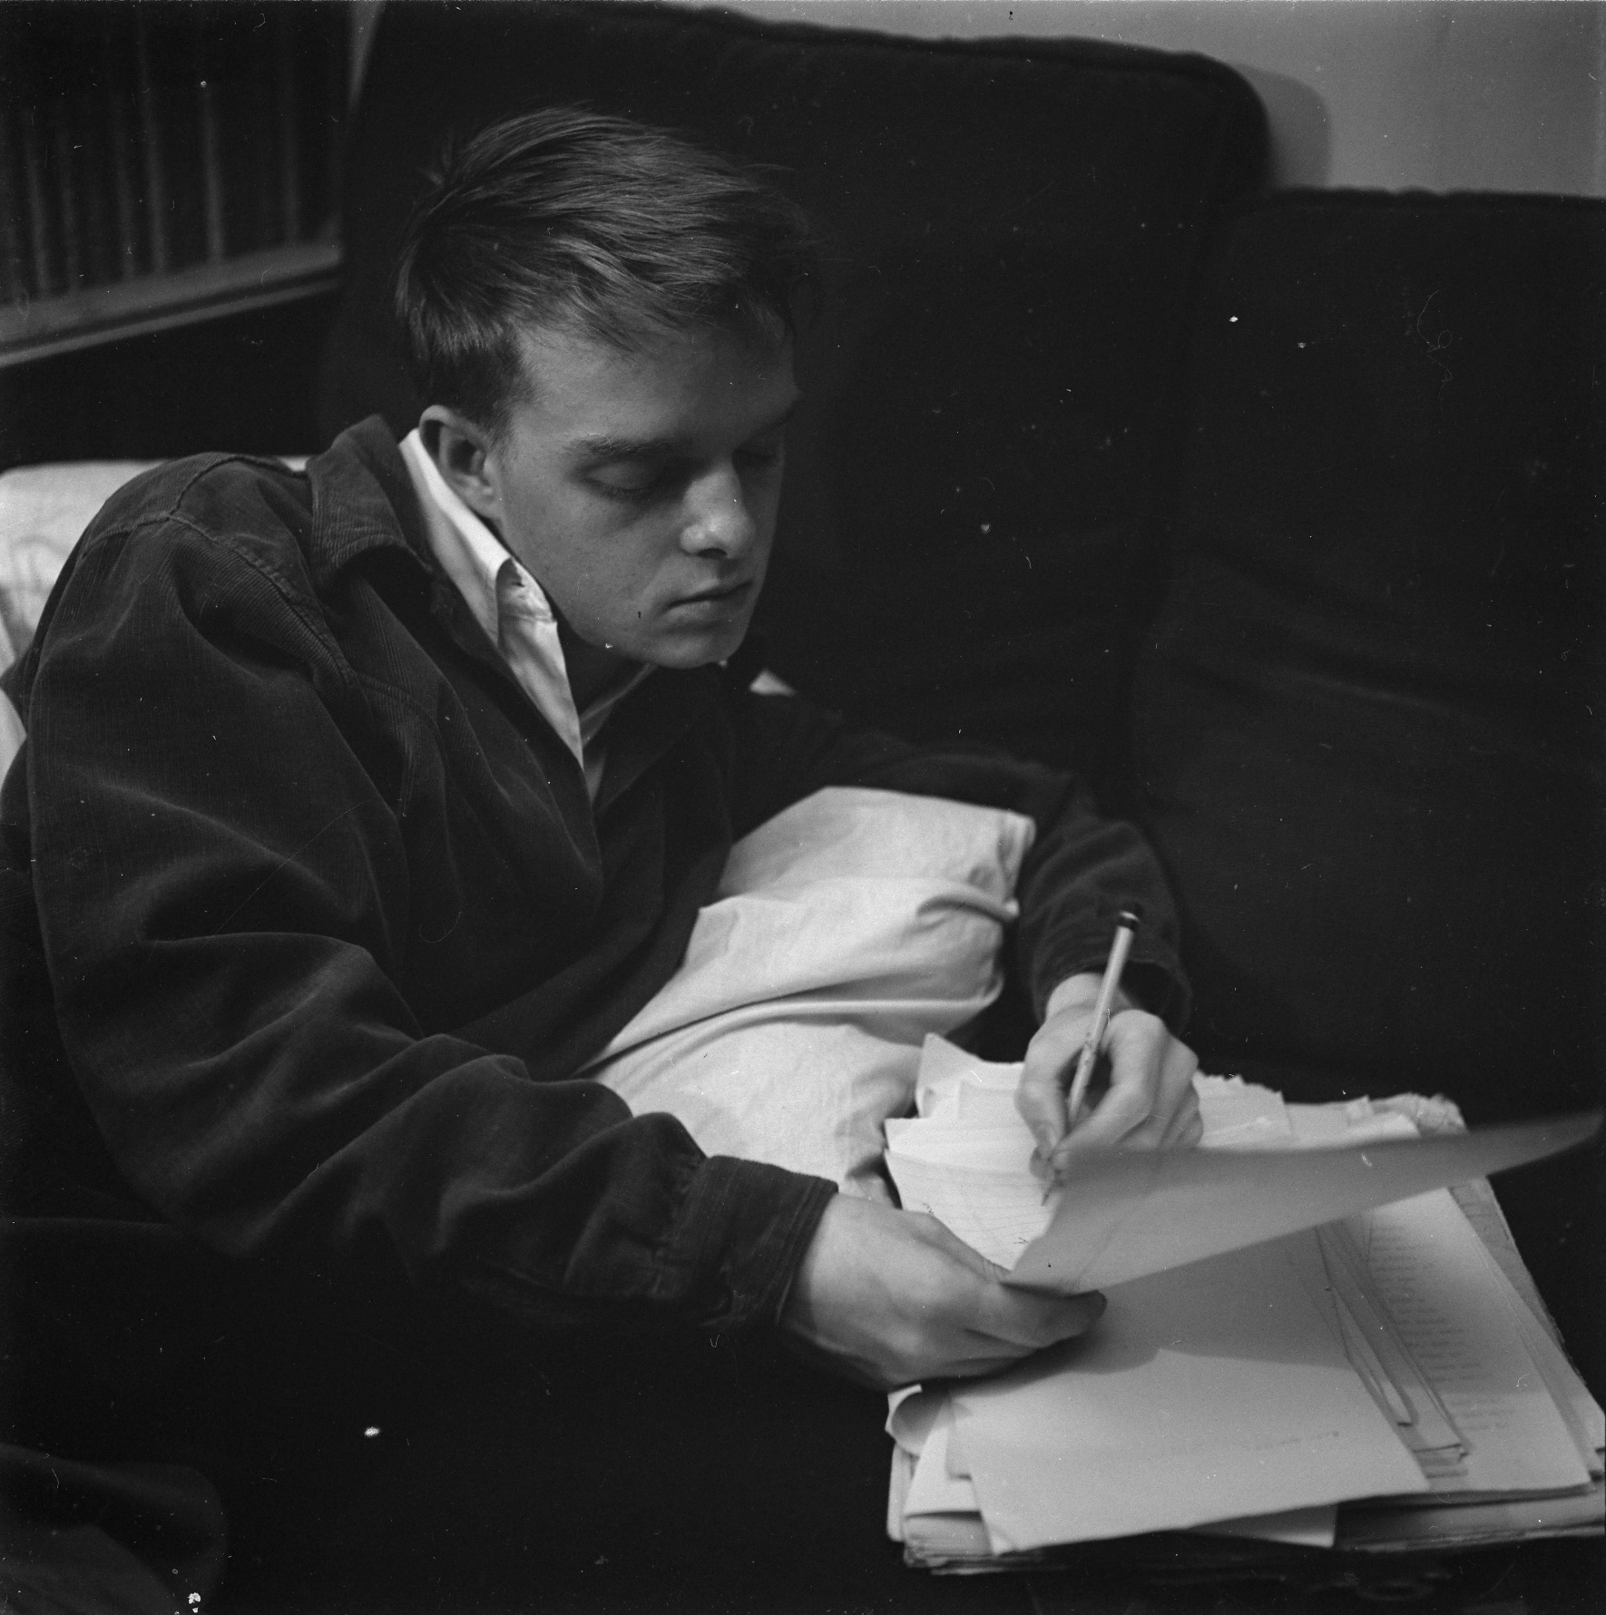

A Mink of One’s Own, Truman Capote

A Mink of One’s Own

Mrs. Munson finished twisting a linen rose in her auburn hair and stepped back from her mirror to judge the effect. Then she ran her hands down her hips … the dress was just too tight and that’s all there was to it. “Alteration won’t save it again,” she thought angrily. With one last disparaging glance at her reflection she turned and went into the livingroom.

The windows were open and the room was filled with loud, unearthly shrieks. Mrs. Munson lived on the third floor, and across the street was a public school playground. In the late afternoon the noise was almost unbearable. God, if she’d only known about this before she signed the lease! With a little grunt she closed both windows and as far as she was concerned they could stay that way for the next two years.

But Mrs. Munson was far too excited to be really annoyed. Vini Rondo was coming to see her, imagine, Vini Rondo … and this very afternoon! When she thought about it she felt fluttering wings in her stomach. It had been almost five years, and Vini had been in Europe all this time. Whenever Mrs. Munson found herself in a group discussing the war she invariably announced, “Well, you know I have a very dear friend in Paris this very minute, Vini Rondo, she was right there when the Germans marched in! I have positive nightmares when I think what she must be going through!” Mrs. Munson said it as if it were she whose fate lay in the balance.

If there was anyone in the party who hadn’t heard the story before she would hasten to explain about her friend. “You see,” she would begin, “Vini was just the most talented girl, interested in art and all that sort of thing. Well, she had quite a bit of money, so she went to Europe at least once a year. Finally, when her father died she packed up her things and went for good. My, but she had a fling, and then she married some Count or Baron or something. Maybe you’ve heard of her … Vini Rondo … Cholly Knickerbocker used to mention her all the time.” And it went on and on, like some historical lecture.

“Vini, back in America,” she thought, never ceasing to revel in the wonder of it. She puffed up the small green pillows on the couch and sat down. With piercing eyes she examined her room. Funny you never really see your surroundings until a visitor is expected. Well, Mrs. Munson sighed contentedly, that new girl had, for a rarity, restored pre-war standards.

The door-bell rang abruptly. It buzzed twice before Mrs. Munson could move, she was that excited. Finally she composed herself and went to answer.

At first Mrs. Munson didn’t recognize her. The woman who confronted her had no chic up-swept coiffure … indeed her hair hung rather limply and had an uncombed look. A print dress in January? Mrs. Munson tried to keep the disappointment out of her voice when she said, “Vini, darling, I should have known you anywhere.”

The woman still stood in the threshold. Under her arm she carried a large pink box and her gray eyes looked out at Mrs. Munson curiously.

“Would you, Bertha?” Her voice was a queer whisper. “That’s nice, very nice. I should have recognized you, too, although you’ve gotten rather fat, haven’t you?” Then she accepted Mrs. Munson’s extended hand and came in.

Mrs. Munson was embarrassed and she didn’t know quite what to say. Arm-in-arm they went into the livingroom and sat down.

“How about some sherry?”

Vini shook her dark little head, “No, thank you.”

“Well, how about a scotch or something?” Mrs. Munson asked desperately. The figurine clock on the sham mantelpiece chimed softly. Mrs. Munson had never noticed how loud it could sound.

“No,” said Vini firmly, “nothing, thank you.”

Resignedly Mrs. Munson settled back on the couch. “Now, darling, tell me all about it. When did you get back in the States?” She liked the sound of that. “The States.”

Vini placed the big pink box down between her legs and folded her hands. “I’ve been here for almost a year,” she paused, then hurried on, realizing the startled expression of her hostess, “but I haven’t been in New York. Naturally I would have gotten in touch with you sooner, but I was out in California.”

“Oh, California, I love California!” Mrs. Munson exclaimed, though in point of fact, she had never been further west than Chicago.

Vini smiled and Mrs. Munson noticed how irregular her teeth were and decided they could do with a good brushing.

“So,” Vini continued, “when I got back in New York last week I thought of you at once. I had an awful time trying to find you because I couldn’t remember your husband’s first name.…”

“Albert,” Mrs. Munson put in unnecessarily.

“… but I finally did and here I am. You know, Bertha, I really started thinking about you when I decided to get rid of my mink coat.”

Mrs. Munson saw a sudden blush on Vini’s face.

“Your mink coat?”

“Yes,” Vini said, lifting up the pink box. “You remember my mink coat. You always admired it so. You always said it was the loveliest coat you’d ever seen.” She started to undo the frayed silk ribbon that held the box together.

“Of course, yes of course,” Mrs. Munson said, letting the “course” trill down softly.

“I said to myself, ‘Vini Rondo, what on earth do you need that coat for? Why not let Bertha have it?’ You see, Bertha, I bought the most gorgeous sable in Paris and you can understand that I really don’t need two fur coats. Besides I have my silver-fox jacket.”

Mrs. Munson watched her parting the tissue paper in the box, saw the chipped enamel on her nails, saw that her fingers were jewel-less, and suddenly realized a great many other things.

“So I thought of you and unless you want it I’ll just keep it because I couldn’t bear to think of anyone else having it.”

She held the coat and stood turning it this way and that. It was a beautiful coat; the fur shone rich and very smooth. Mrs. Munson reached out and ran her fingers across it, ruffling the tiny hairs the wrong way. Without thinking she said: “How much?”

Mrs. Munson brought back her hand quickly, as though she had touched fire, and then she heard Vini’s voice, small and tired.

“I paid almost a thousand for it. Is a thousand too much?”

Down in the street Mrs. Munson could hear the deafening roar of the playground and for once she was grateful. It gave her something else to concentrate on, something to lessen the intensity of her own feelings.

“I’m afraid that’s too much. I really can’t afford it,” Mrs. Munson said distractedly, still staring at the coat, afraid to lift her eyes and see the other woman’s face.

Vini tossed the coat on the couch. “Well, I want you to have it. It’s not so much the money, but I feel I should get something back on my investment.… How much could you afford?”

Mrs. Munson closed her eyes. Oh, God, this was awful! Just plain damned awful!

“Maybe four hundred,” she answered weakly.

Vini picked up the coat again and said brightly, “Let’s see how it fits then.”

They went into the bedroom and Mrs. Munson tried on the coat in front of her full-length closet mirror. Just a few alterations, the sleeves shortened, and maybe she would have it re-glazed. Yes, it certainly did things for her.

“Oh, I think it’s beautiful, Vini. It was so sweet of you to think of me.”

Vini leaned against the wall, her pale face looking hard in the magnified sunlight of the big bedroom windows.

“You can make out the check to me,” she said disinterestedly.

“Yes, of course,” Mrs. Munson said, suddenly coming back to earth. Imagine Bertha Munson with a mink of her own!

They went back into the livingroom and she wrote the check for Vini. Carefully folding it, Vini deposited it in her small beaded purse.

Mrs. Munson tried hard to make conversation but she came up against a cold wall at each new channel. Once she asked, “Where is your husband, Vini? You must bring him around for Albert to talk to.” And Vini answered, “Oh, him! I haven’t seen him for aeons. He’s still in Lisbon for all I know.” And so that was that.

Finally, after promising to phone the next day, Vini left. When she had gone Mrs. Munson thought, “Why, poor Vini, she’s nothing but a refugee!” Then she took her new coat and went into the bedroom. She couldn’t tell Albert how she got it, that was definite. My, but he would be mad about the money! She decided to hide it in the furthest reaches of her closet and then one day she’d bring it out and say, “Albert, look at the divine mink I bought at an auction. I got it for next to nothing.”

Groping in the darkness of her closet she caught the coat on a hook. She gave a little yank and was terrified to hear the sound of ripping. Quickly she snapped on the light and saw that the sleeve was torn. She held the tear apart and pulled slightly. It ripped more and then some more. With a sick emptiness she knew the whole thing was rotten. “Oh, my God,” she said, clutching at the linen rose in her hair. “Oh, my God, I’ve been taken and taken good, and there’s nothing in the world I can do about it, nothing in the world!” For suddenly Mrs. Munson realized Vini wouldn’t phone tomorrow or ever again.

1944

The End