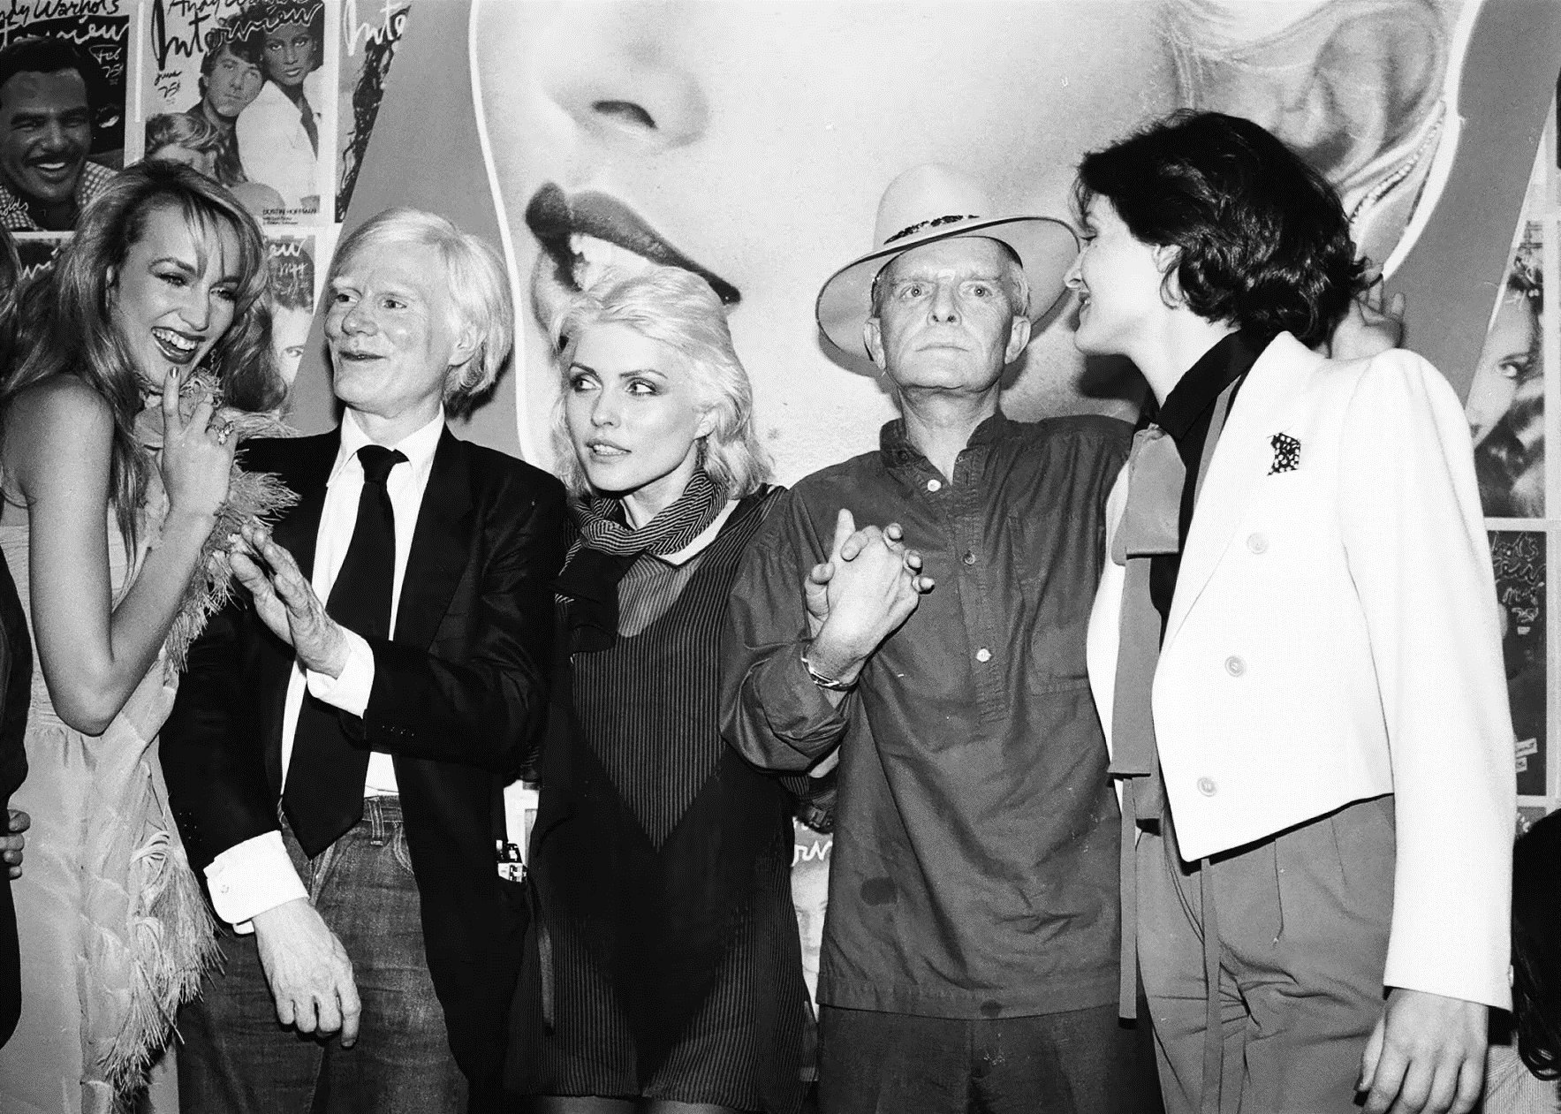

A Ride Through Spain, Truman Capote

A RIDE THROUGH SPAIN

Certainly the train was old. The seats sagged like the jowls of a bulldog, windows were out and strips of adhesive held together those that were left; in the corridor a prowling cat appeared to be hunting mice, and it was not unreasonable to assume his search would be rewarded.

Slowly, as though the engine were harnessed to elderly coolies, we crept out of Granada. The southern sky was as white and burning as a desert; there was one cloud, and it drifted like a traveling oasis.

We were going to Algeciras, a Spanish seaport facing the coast of Africa. In our compartment there was a middle-aged Australian wearing a soiled linen suit; he had tobacco-colored teeth and his fingernails were unsanitary. Presently he informed us that he was a ship’s doctor. It seemed curious, there on the dry, dour plains of Spain, to meet someone connected with the sea. Seated next to him there were two women, a mother and daughter. The mother was an overstuffed, dusty woman with sluggish, disapproving eyes and a faint mustache.

The focus for her disapproval fluctuated; first, she eyed me rather strongly because as the sunlight fanned brighter, waves of heat blew through the broken windows and I had removed my jacket—which she considered, perhaps rightly, discourteous. Later on, she took a dislike to the young soldier who also occupied our compartment.

The soldier and the woman’s not very discreet daughter, a buxom girl with the scrappy features of a prizefighter, seemed to have agreed to flirt. Whenever the wandering cat appeared at our door, the daughter pretended to be frightened, and the soldier would gallantly shoo the cat into the corridor: this byplay gave them frequent opportunity to touch each other.

The young soldier was one of many on the train. With their tasseled caps set at snappy angles, they hung about in the corridors smoking sweet black cigarettes and laughing confidentially. They seemed to be enjoying themselves, which apparently was wrong of them, for whenever an officer appeared the soldiers would stare fixedly out the windows, as though enraptured by the landslides of red rock, the olive fields and stern stone mountains.

Their officers were dressed for a parade, many ribbons, much brass; and some wore gleaming, improbable swords strapped to their sides. They did not mix with the soldiers, but sat together in a first-class compartment, looking bored and rather like unemployed actors. It was a blessing, I suppose, that something finally happened to give them a chance at rattling their swords.

The compartment directly ahead was taken over by one family: a delicate, attenuated, exceptionally elegant man with a mourning ribbon sewn around his sleeve, and traveling with him, six thin, summery girls, presumably his daughters. They were beautiful, the father and his children, all of them, and in the same way: hair that had a dark shine, lips the color of pimientos, eyes like sherry. The soldiers would glance into their compartment, then look away. It was as if they had seen straight into the sun.

Whenever the train stopped, the man’s two youngest daughters would descend from the carriage and stroll under the shade of parasols. They enjoyed many lengthy promenades, for the train spent the greatest part of our journey standing still. No one appeared to be exasperated by this except myself.

Several passengers seemed to have friends at every station with whom they could sit around a fountain and gossip long and lazily. One old woman was met by different little groups in a dozen-odd towns—between these encounters she wept with such abandon that the Australian doctor became alarmed: why no, she said, there was nothing he could do, it was just that seeing all her relatives made her so happy.

At each stop cyclones of barefooted women and somewhat naked children ran beside the train sloshing earthen jars of water and furrily squalling Agua! Agua! For two pesetas you could buy a whole basket of dark runny figs, and there were trays of curious white-coated candy doughnuts that looked as though they should be eaten by young girls wearing Communion dresses. Toward noon, having collected a bottle of wine, a loaf of bread, a sausage and a cheese, we were prepared for lunch.

Our companions in the compartment were hungry, too. Packages were produced, wine uncorked, and for a while there was a pleasant, almost graceful festiveness. The soldier shared a pomegranate with the girl, the Australian told an amusing story, the witch-eyed mother pulled a paper-wrapped fish from between her bosoms and ate it with a glum relish.

Afterward everyone was sleepy; the doctor went so solidly to sleep that a fly meandered undisturbed over his open-mouthed face. Stillness etherized the whole train; in the next compartment the lovely girls leaned loosely, like six exhausted geraniums; even the cat had ceased to prowl, and lay dreaming in the corridor. We had climbed higher, the train moseyed across a plateau of rough yellow wheat, then between the granite walls of deep ravines where wind, moving down from the mountains, quivered in strange, thorny trees. Once, at a parting in the trees, there was something I’d wanted to see, a castle on a hill, and it sat there like a crown.

It was a landscape for bandits. Earlier in the summer, a young Englishman I know (rather, know of) had been motoring through this part of Spain when, on the lonely side of a mountain, his car was surrounded by swarthy scoundrels. They robbed him, then tied him to a tree and tickled his throat with the blade of a knife. I was thinking of this when without preface a spatter of bullet fire strafed the dozy silence.

It was a machine gun. Bullets rained in the trees like the rattle of castanets, and the train, with a wounded creak, slowed to a halt. For a moment there was no sound except the machine gun’s cough. Then, “Bandits!” I said in a loud, dreadful voice.

“Bandidos!” screamed the daughter.

“Bandidos!” echoed her mother, and the terrible word swept through the train like something drummed on a tom-tom. The result was slapstick in a grim key. We collapsed on the floor, one cringing heap of arms and legs. Only the mother seemed to keep her head; standing up, she began systematically to stash away her treasures.

She stuck a ring into the buns of her hair and without shame hiked up her skirts and dropped a pearl-studded comb into her bloomers. Like the cryings of birds at twilight, airy twitterings of distress came from the charming girls in the next compartment. In the corridor the officers bumped about yapping orders and knocking into each other.

Suddenly, silence. Outside, there was the murmur of wind in leaves, of voices. Just as the weight of the doctor’s body was becoming too much for me, the outer door of our compartment swung open, and a young man stood there. He did not look clever enough to be a bandit.

“Hay un médico en el tren?” he said, smiling.

The Australian, removing the pressure of his elbow from my stomach, climbed to his feet. “I’m a doctor,” he admitted, dusting himself. “Has someone been wounded?”

“Si, Señor. An old man. He is hurt in the head,” said the Spaniard, who was not a bandit: alas, merely another passenger. Settling back in our seats, we listened, expressionless with embarrassment, to what had happened. It seemed that for the last several hours an old man had been stealing a ride by clinging to the rear of the train. Just now he’d lost his hold, and a soldier, seeing him fall, had started firing a machine gun as a signal for the engineer to stop the train.

My only hope was that no one remembered who had first mentioned bandits. They did not seem to. After acquiring a clean shirt of mine which he intended to use as a bandage, the doctor went off to his patient, and the mother, turning her back with sour prudery, reclaimed her pearl comb. Her daughter and the soldier followed after us as we got out of the carriage and strolled under the trees, where many passengers had gathered to discuss the incident.

Two soldiers appeared carrying the old man. My shirt was wrapped around his head. They propped him under a tree and all the women clustered about vying with each other to lend him their rosary; someone brought a bottle of wine, which pleased him more. He seemed quite happy, and moaned a great deal. The children who had been on the train circled around him, giggling.

We were in a small wood that smelled of oranges.

There was a path, and it led to a shaded promontory; from here, one looked across a valley where sweeping stretches of scorched golden grass shivered as though the earth were trembling. Admiring the valley, and the shadowy changes of light on the hills beyond, the six sisters, escorted by their elegant father, sat with their parasols raised above them like guests at a fête champêtre.

The soldiers moved around them in a vague, ambitious manner; they did not quite dare to approach, though one brash, sassy fellow went to the edge of the promontory and called, “Yo te quiero mucho.” The words returned with the hollow sub-music of a perfect echo, and the sisters, blushing, looked more deeply into the valley.

A cloud, somber as the rocky hills, had massed in the sky, and the grass below stirred like the sea before a storm. Someone said he thought it would rain. But no one wanted to go: not the injured man, who was well on his way through a second bottle of wine, nor the children, who, having discovered the echo, stood happily caroling into the valley. It was like a party, and we all drifted back to the train as though each of us wished to be the last to leave. The old man, with my shirt like a grand turban on his head, was put into a first-class carriage and several eager ladies were left to attend him.

In our compartment, the dark, dusty mother sat just as we had left her. She had not seen fit to join the party. She gave me a long, glittering look. “Bandidos,” she said with a surly, unnecessary vigor.

The train moved away so slowly butterflies blew in and out the windows.

1950

The End