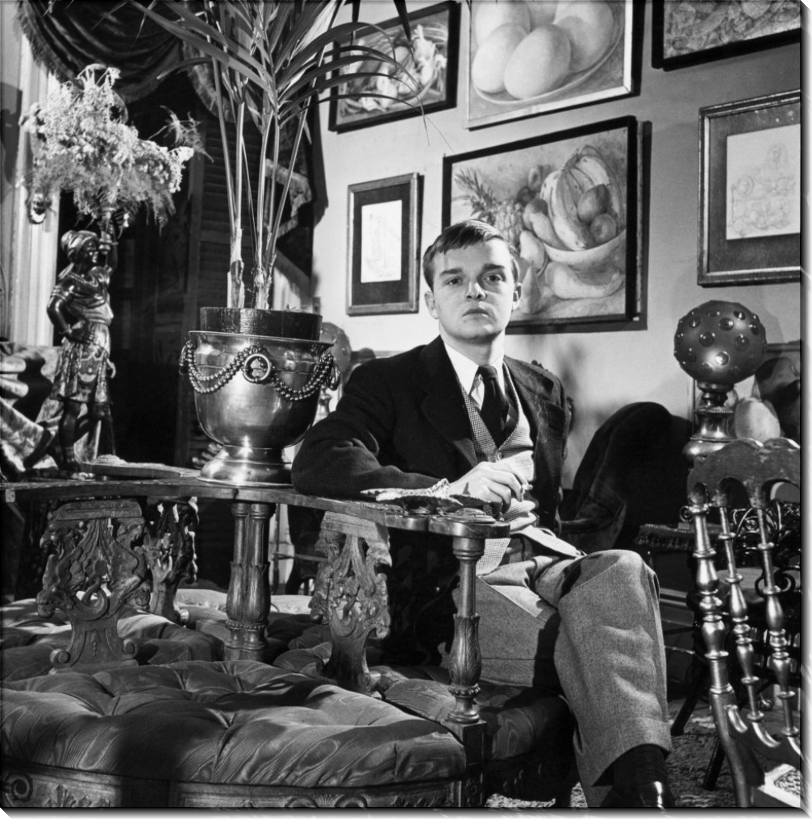

A Voice From A Cloud, Truman Capote

A VOICE FROM A CLOUD

Other Voices, Other Rooms (my own title: it is not a quotation) was published in January, 1948. It took two years to write and was not my first novel, but the second. The first, a manuscript never submitted and now lost, was called Summer Crossing—a spare, objective story with a New York setting.

Not bad, as I remember: technically accomplished, an interesting enough tale, but without intensity or pain, without the qualities of a private vision, the anxieties that then had control of my emotions and imagination. Other Voices, Other Rooms was an attempt to exorcise demons: an unconscious, altogether intuitive attempt, for I was not aware, except for a few incidents and descriptions, of its being in any serious degree autobiographical. Rereading it now, I find such self-deception unpardonable.

Surely there were reasons for this adamant ignorance, no doubt protective ones: a fire curtain between the writer and the true source of his material. As I have lost contact with the troubled youth who wrote this book, since only a faded shadow of him is any longer contained inside myself, it is difficult to reconstruct his state of mind. However, I shall try.

At the time of the appearance of Other Voices, Other Rooms, critics, ranging from the warmest to the most hostile, remarked that obviously I was much influenced by such Southern literary artists as Faulkner and Welty and McCullers, three writers whose work I knew well and admired. Nevertheless, the gentlemen were mistaken, though understandably.

The American writers who had been most valuable to me were, in no particular order, James, Twain, Poe, Cather, Hawthorne, Sarah Orne Jewett; and, overseas, Flaubert, Jane Austen, Dickens, Proust, Chekhov, Katherine Mansfield, E. M. Forster, Turgenev, De Maupassant and Emily Brontë. A collection more or less irrelevant to Other Voices, Other Rooms; for clearly not one of these writers, with the conceivable exception of Poe (who was by then a blurred childhood enthusiasm, like Dickens and Twain), was a necessary antecedent to this particular work.

Rather, they all were, in the sense that each of them had contributed to my literary intelligence, such as it was. But the real progenitor was my difficult, subterranean self. The result was both a revelation and an escape: the book set me free, and, as in its prophetic final sentence, I stood there and looked back at the boy I had left behind.

I was born in New Orleans, an only child; my parents were divorced when I was four years old. It was a complicated divorce with much bitterness on either side, which is the main reason why I spent most of my childhood wandering among the homes of relatives in Louisiana, Mississippi and rural Alabama (off and on, I attended schools in New York City and Connecticut).

The reading I did on my own was of greater importance than my official education, which was a waste and ended when I was seventeen, the age at which I applied for and received a job at The New Yorker magazine. Not a very grand job, for all it really involved was sorting cartoons and clipping newspapers.

Still, I was fortunate to have it, especially since I was determined never to set a studious foot inside a college classroom. I felt that either one was or wasn’t a writer, and no combination of professors could influence the outcome. I still think I was correct, at least in my own case; however, I now realize that most young writers have more to gain than not by attending college, if only because their teachers and classroom comrades provide a captive audience for their work; nothing is lonelier than to be an aspiring artist without some semblance of a sounding board.

I stayed two years at The New Yorker, and during this period published a number of short stories in small literary magazines. (Several of them were submitted to my employers, and none accepted, though once one was returned with the following comment: “Very good. But romantic in a way this magazine is not.”) Also, I wrote Summer Crossing.

Actually, it was in order to complete the book that I took courage, quit my job, left New York and settled with relatives, a cotton-growing family who lived in a remote part of Alabama: cotton fields, cattle pastures, pinewoods, dirt roads, creeks and slow little rivers, jaybirds, owls, buzzards circling in empty skies, distant train whistles—and, five miles away, a small country town: the Noon City of the present volume.

It was early winter when I arrived there, and the atmosphere of the roomy farmhouse, entirely heated by stoves and fireplaces, was well suited to a fledgling novelist wanting quiet isolation. The household rose at four-thirty, breakfasted by electric light, and was off about its business as the sun ascended—leaving me alone and, increasingly, in a panic. For, more and more, Summer Crossing seemed to me thin, clever, unfelt. Another language, a secret spiritual geography, was burgeoning inside me, taking hold of my night-dream hours as well as my wakeful daydreams.

One frosty December afternoon I was far from home, walking in a forest along the bank of a mysterious, deep, very clear creek, a route that led eventually to a place called Hatter’s Mill. The mill, which straddled the creek, had been abandoned long ago; it was a place where farmers had brought their corn to be ground into cornmeal. As a child, I’d often gone there with cousins to fish and swim; it was while exploring under the mill that I’d been bitten in the knee by a cottonmouth moccasin—precisely as happens to Joel Knox.

And now as I came upon the forlorn mill with its sagging silver-gray timbers, the remembered shock of the snakebite returned; and other memories too—of Idabel, or rather the girl who was the counterpart of Idabel, and how we used to wade and swim in the pure waters, where fat speckled fish lolled in sunlit pools; Idabel was always trying to reach out and grab one.

Excitement—a variety of creative coma—overcame me. Walking home, I lost my way and moved in circles round the woods, for my mind was reeling with the whole book. Usually when a story comes to me, it arrives, or seems to, in toto: a long sustained streak of lightning that darkens the tangible, so-called real world, and leaves illuminated only this suddenly seen pseudo-imaginary landscape, a terrain alive with figures, voices, rooms, atmospheres, weather. And all of it, at birth, is like an angry, wrathful tiger cub; one must soothe and tame it. Which, of course, is an artist’s principal task: to tame and shape the raw creative vision.

It was dark when I got home, and cold, but I didn’t feel the cold because of the fire inside me. My Aunt Lucille said she had been worried about me, and was disappointed because I didn’t want any supper. She wanted to know if I was sick; I said no. She said, “Well, you look sick.

You’re white as a ghost.” I said good night, locked myself in my room, tossed the manuscript of Summer Crossing into a bottom bureau drawer, collected several sharp pencils and a fresh pad of yellow lined paper, got into bed fully clothed, and with pathetic optimism, wrote: “Other Voices, Other Rooms—a novel by Truman Capote.” Then: “Now a traveller must make his way to Noon City by the best means he can …”

It is unusual, but occasionally it happens to almost every writer that the writing of some particular story seems outer-willed and effortless; it is as though one were a secretary transcribing the words of a voice from a cloud. The difficulty is maintaining contact with this spectral dictator. Eventually it developed that communication ran highest at night, as fevers are known to do after dusk.

So I took to working all night and sleeping all day, a routine that distressed the household and caused constant disapproving comment: “But you’ve got everything turned upside down. You’re ruining your health.” That is why, in the spring of the year, I thanked my exasperated relatives for their generosity, their burdened patience, and bought a ticket on a Greyhound bus to New Orleans.

There I rented a bedroom in the crowded apartment of a Creole family who lived in the French Quarter on Royal Street. It was a small hot bedroom almost entirely occupied by a brass bed, and it was noisy as a steel mill. Streetcars racketed under the window, and the carousings of sightseers touring the Quarter, the boisterous whiskey brawlings of soldiers and sailors made for continuous pandemonium. Still, sticking to my night schedule, I progressed; by late autumn the book was half finished.

I need not have been as lonely as I was. New Orleans was my hometown and I had many friends there, but because I did not desire that familiar world and preferred to remain sealed off in the self-created universe of Zoo and Jesus Fever and the Cloud Hotel, I called none of my acquaintances.

My only company was the Creole family, who were kindly working-class people (the father was a dock hand and his wife a seamstress), or encounters with drugstore clerks and café folk. Curiously, for New Orleans is not that sizable a town, I never saw a soul I knew. Except, by accident, my father. Which was ironic, considering that though I was unaware of it at the time, the central theme of Other Voices, Other Rooms was my search for the existence of this essentially imaginary person.

I seldom ate more than once a day, usually when I finished work. At that dawn hour I would walk through the humid, balconied streets, past St. Louis Cathedral and on to the French Market, a square crammed in the murky early morning with the trucks of vegetable farmers, Gulf Coast fishermen, meat vendors and flower growers. It smelled of earth, of herbs and exotic, gingery scents, and it rang, clanged, clogged the ears with the sounds of vivacious trading. I loved it.

The market’s chief gathering place was a café that served only bitter-black chicory coffee and the crustiest, most delicious fresh-fried doughnuts. I had discovered the place when I was fifteen, and had become addicted. The proprietor of the café gave all its habitués a nickname; he called me the Jockey, a reference to my height and build. Every morning as I plowed into the coffee and the doughnuts, he would warn me with a sinister chuckle, “Better watch it, Jockey. You’ll never make your weight.”

It was in this café that five years earlier I’d met the prototype of Cousin Randolph. Actually, Cousin Randolph was suggested by two people. Once, when I was a very young child, I had spent a few summer weeks in an old house in Pass Christian, Mississippi. I don’t remember much about it, except that there was an elderly man who lived there, an asthmatic invalid who smoked medicinal cigarettes and made remarkable scrap-quilts.

He had been the captain of a fishing trawler, but illness had forced him to retire to a darkened room. His sister had taught him to sew; in consequence, he had found in himself a beautiful gift for designing cloth pictures. I often used to visit his room, where he would spread his tapestry-like quilts on the floor for me to admire: rose bouquets, ships in full sail, a bowl of apples.

The other Randolph, the character’s spiritual ancestor, was the man I met in the café, a plump blond fellow who was said to be dying of leukemia. The proprietor called him the Sketcher, for he always sat alone in a corner drawing pictures of the clientele, the truckers and cattlemen, in a large looseleaf notebook. One night it was obvious that I was his subject; after sketching for a while, he moseyed over to the counter where I was sitting and said, “You’re a Wunderkind, aren’t you?

I can tell by your hands.” I didn’t know what it meant—Wunderkind; I thought that either he was joking or making a dubious overture. But then he defined the word, and I was pleased: it coincided with my own private opinion. We became friends; afterward I saw him not only at the café, but we also took lazy strolls along the levee. We did not have much conversation, for he was a monologist obsessed with death, betrayed passions and unfulfilled talent.

All this transpired during one summer. That autumn I went to school in the East, and when I returned in June and asked the proprietor about the Sketcher, he said, “Oh, he died. Saw it in the Picayune. Did you know he was rich? Uh-huh. Said so in the paper. Turned out his family owned half the land around Lake Pontchartrain. Imagine that. Well, you never know.”

The book was completed in a setting far removed from the one in which it was begun. I wandered and worked in North Carolina, Saratoga Springs, New York City and, ultimately, in a rented cottage on Nantucket. It was there at a desk by a window with a view of sky and sand and arriving surf that I wrote the last pages, finishing them with disbelief that the moment had come, a wonder simultaneously regretful and exhilarated.

I am not a keen rereader of my own books: what’s done is done. Moreover, I am always afraid of finding that my harsher detractors are correct and that the work is not as good as I choose to think it. Until the subject of the present reissue arose, I never again really examined Other Voices, Other Rooms. Last week I read it straight through.

And? And, as I have already indicated, I was startled by its symbolic subterfuges. Also, while there are passages that seem to me accomplishments, others arouse uneasiness. On the whole, though, it was as if I were reading the fresh-minted manuscript of a total stranger.

I was impressed by him. For what he had done has the enigmatic shine of a strangely colored prism held to the light—that, and a certain anguished, pleading intensity like the message of a shipwrecked sailor stuffed into a bottle and thrown into the sea.

1969

The End