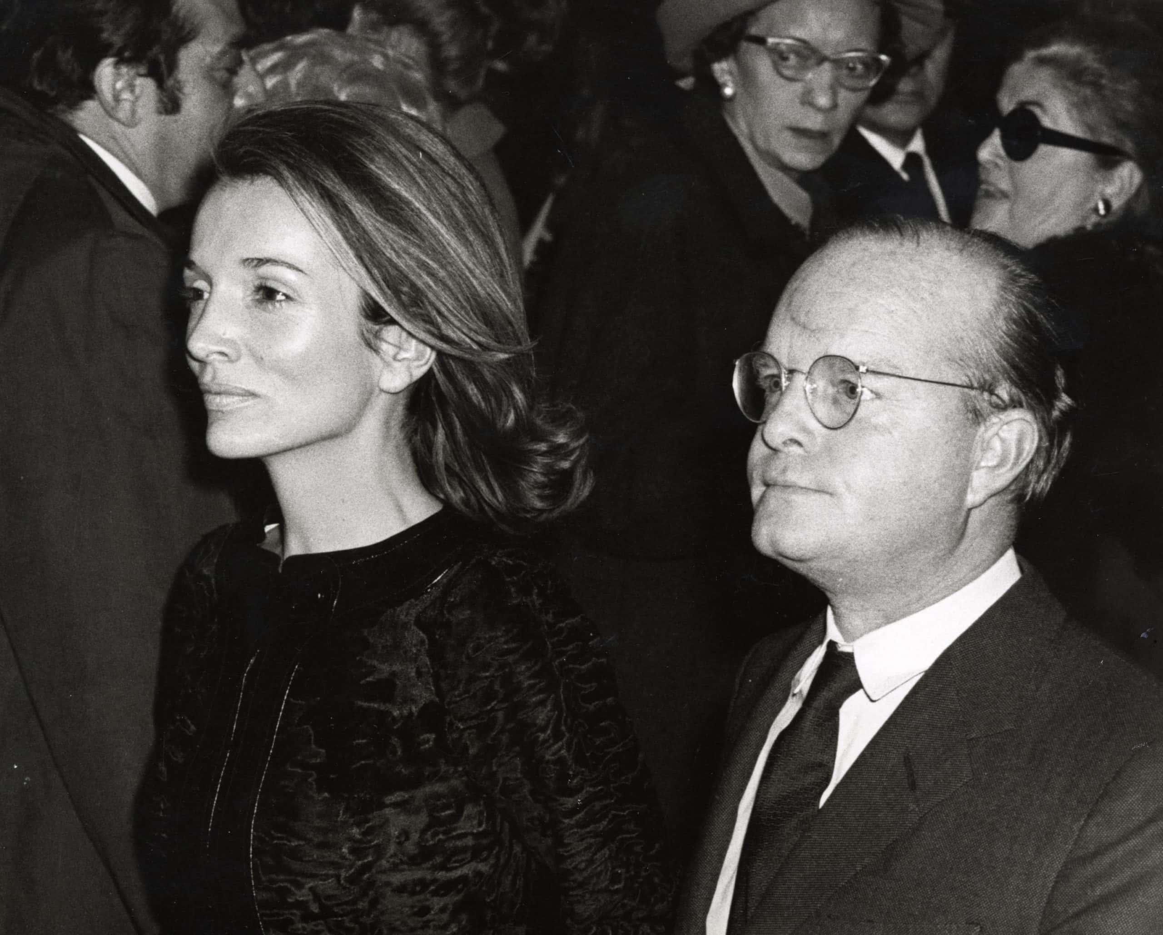

Elizabeth Taylor, Truman Capote

ELIZABETH TAYLOR

Some years ago, rather more than fifteen, a friend and I decided to install, among the New York social curriculum, a series of surprise-guest lunch parties; the idea seemed amusing enough for February, the dreariest month in New York, so my friend and I invited four other friends to join us for lunch at a private apartment. The idea was that the six of us would, individually, supply an additional guest, a “mystery” guest—preferably someone interesting and well-known and yet not known personally to any or at least all of us. My choice was Dr. J. Robert Oppenheimer, but he wasn’t available that day; now I can’t remember who I brought.

But I do remember the selection made by Lady Keith, who was then Mrs. Leland Hayward. Lady Keith, whom her friends call Slim, is a tall, coltish, California-bred aristocrat (northern California, need one add) with the most beautiful legs, ankles and feet extant. Her “surprise,” Elizabeth Taylor, was rather a runt by comparison—like Mrs. Onassis, her legs are too short for the torso, the head too bulky for the figure in toto; but the face, with those lilac eyes, is a prisoner’s dream, a secretary’s self-fantasy: unreal, nonobtainable, at the same time shy, overly vulnerable, very human, with the flicker of suspicion constantly flaring behind the lilac eyes.

We had met once before—one summer afternoon on the farm of a mutual friend in Connecticut. At the time, her third husband, the tough and short and sexy Mike Todd, still had his plane crash ahead of him, was still alive and married to this beautiful child who seemed besotted by him.

Often, when couples make oozing displays of themselves, always kissing, gripping, groping—well, often one imagines their romance must be in serious difficulties. Not so with these two. I remember them, that afternoon, sprawled in the sun in a field of grass and daisies holding hands and kissing while a litter of six or eight fat Newfoundland puppies tumbled over their stomachs, tangled in their hair.

But it was not until I encountered her as Slim Hayward’s guest that Elizabeth Taylor made an impression on me, at least as a person; as an actress I’d always liked her—from National Velvet straight on, but especially as the rich girl in A Place in the Sun.

In the years since our first meeting, much had happened to her, but the two worst things were that Mike Todd had died and that she had married the “singer” Eddie Fisher—an event almost as unsuitable as Mrs. Kennedy’s Grecian nuptials. Still, neither of these occurrences had dimmed the hectic allure Taylor radiates like a rather quivery light.

The lunch was long, we talked a lot. My first discovery about her was that despite an amusing abundance of four-lettered profanity, she was in various areas a moralist, quite a strict one, almost Calvinistic. For instance, she was agitated at the thought of playing the ill-starred, hedonistic heroine of John O’Hara’s Butterfield 8; she had an unbreakable legal obligation to do the role (for which she later won an Academy Award), but she wished she could get out of it because “I don’t like that girl. I don’t like what she stands for. The sleazy emptiness of her. The men. The sleeping around.”

At this point I recalled a conversation I’d once had with Marilyn Monroe (not that I’m making a comparison between Taylor and Monroe; they were different birds, the first being a take-or-leave-it professional, the other a morbidly uncertain, naturally gifted primitive). But Monroe’s moral attitude was similar: “I don’t believe in casual sex. Right or wrong, if I go for a guy, I feel I ought to marry him.

I don’t know why. Stupid, maybe. But that’s just the way I feel. Or if not that, then it should have meaning. Other than something only physical. Funny, when you think of the reputation I have. And maybe deserve. Only I don’t think so. Deserve it, I mean. People just don’t understand what can happen to you. Without your real consent at all. Inside consent.”

The second surprise was how well-read Taylor seemed to be—not that she made anything of it, or posed as an intellectual, but clearly she cared about books and, in haphazard style, had absorbed a large number of them. And she discussed them with considerable understanding of the literary process; all in all, it made one wonder about the men in her life—with the exception of Mike Todd, who had had a certain flashbulb-brightness, a certain neon-savvy, her husbands thus far had not been a whiplash lot: Nicky Hilton, Michael Wilding, Mr. Fisher—what on earth did this very alert and swift-minded young woman find to talk to them about? “Well, one doesn’t always fry the fish one wants to fry. Some of the men I’ve really liked really didn’t like women.”

And so we began to discuss a mutual friend, Montgomery Clift, the young actor with whom she had starred in A Place in the Sun, and toward whom she felt an affectionate protectiveness. She said, “You know, it happened at my house. Or rather, just after he’d left my house. He’d had a lot to drink, and he lost control of his car.

He was really all right before that—before the accident. Well, he always drank too much—but it was after the accident, getting hooked on all those pills and pain-killers. Nobody beats that rap forever. I haven’t seen him for over a year. Have you?”

And I said yes, I had. He called a few days before Christmas, and he sounded fine. He wanted to know what I was doing for lunch, and I wasn’t doing anything, I was going Christmas shopping, so he said he’d buy me lunch at Le Pavillon if I’d take him shopping. He had a couple of martinis at lunch, but he was rational, very amusing; but on the way he stopped in the gents, and while he was in there he must have taken something, because about twenty minutes later he was flying.

We were in Gucci, and he had picked out and piled on the counter perhaps two dozen very expensive sweaters. Suddenly, he grabbed up all the sweaters and sauntered outside, where it was pouring rain. He threw the sweaters into the street and began kicking them around.

The Gucci personnel took it calmly. One of the attendants produced a pen and sales pad and asked me, “To whom shall I charge these sweaters?” The thing was he really didn’t know. He said he wanted some identification. So I went out into the street, where Monty was still kicking the sweaters around (observed by amassing voyeurs), and asked him if he had a charge card. He looked at me with the most manic, far-gone hauteur, and said, “My face is my charge card!”

Taylor, her eyes always so liquid with life, acquired an additional mistiness. “He can’t go on like that. It will kill him.” She was right; it did. But not before, greatly because of her sympathy and insistence at a time when producers were reluctant to use Clift, they worked together in Suddenly, Last Summer—which contained Clift’s last worthy performance, and one of Taylor’s best—except, many years later, the subtlety and shrewish, constrained hysteria with which she pigmented the role of the alcoholic wife in Albee’s Who’s Afraid of Virginia Woolf?

Some years went by before we met again, on this occasion in London, where she was biding time before heading for Rome and the start of the doomed Cleopatra production. She and “The Busboy,” as Mr. Fisher was called by many of Mrs. Fisher’s friends, were living in a penthouse at the Dorchester.

I’d visited that same penthouse often, as another friend had once lived there. Oliver Messel had tarted it up, and it was rather pretty, or had been: during the Taylor residency, the rooms were so crowded with shedding cats and unhousebroken dogs and a general atmosphere of disorderly paraphernalia that one could not easily espy the Messel touch.

On the first evening I saw Taylor in this particular surrounding, she tried her best to give me a charming calico cat she had gathered up off some street. “No? That’s really very mean of you. I can’t cart all this …” she extended her arms, indicating the vastness of her burdens—enough animals to stock a pet shop, a male secretary serving drinks, a maid whisking in and out of the room displaying newly arrived dresses (“All from Paris. But I’ll have to send most of them back. I can’t afford it. I really haven’t any money. He doesn’t have any either. Debbie Reynolds—if you’ll pardon the expression—got it all”), not to mention “The Busboy,” who sat on the couch rubbing his eyes as if trying to rouse himself from a nap.

She said to him, “What’s the matter? Why do you keep rubbing your eyes?”

“It’s all that reading!” he complained.

“All what reading?”

“That thing you tell me I gotta read. I’ve tried. I can’t get through it somehow.”

Her gaze disdainfully glided away from him. “He means To Kill a Mockingbird. Have you read it? It just came out. I think it’s a really lovely book.”

Yes, I’d read it; as a matter of fact, I told her, the author, Harper Lee, was a childhood friend. We’d grown up together in a small Alabama town, and her book was more or less autobiographical, a roman à clef; indeed, Dill, one of the principal characters, was supposed to be me.

“You see,” she told her husband, “I may not have had a particular education, but somehow I knew that book was true. I like the truth.”

“The Busboy” regarded her oddly. “Oh, yeah?”

A few mornings later I rang her up, and was informed by her secretary that she was in the hospital, a circumstance the London evening press confirmed: LIZ CRITICAL.

When I got Mr. Fisher on the phone, he was already balanced on the precipice of mourning: “It looks like I’m going to lose my girl.” He was so destined, though not in the style he presumed.

Then I heard she hadn’t died after all, so I stopped by the hospital to leave her some books, and to my surprise, was ushered straightaway to her room. I was so impressed by the smallness of it; at least she wasn’t in a ward, but this claustrophobic closet, entirely stuffed by one narrow iron bed and one wooden chair, did not seem an appropriate arena for the life-death struggles of a Flick Queen.

She was very lively, though one could see she had undergone a massive ordeal. She was whiter by far than the hospital’s bedsheets; her eyes, without make-up, seemed bruised and swollen, like a weeping child’s. What she was recovering from was a form of pneumonia. “My chest and lungs were filled with a sort of thick black fire. They had to cut a hole in my throat to drain out the fire. You see,” she said, pointing at a wound in her throat that was stopped with a small rubber plug. “If I pull this out my voice disappears,” and she pulled it out, and indeed her voice did disappear, an effect which made me nervous, which made her merry.

She was laughing, but I didn’t hear her laughter until she had reinserted the plug. “This is the second time in my life that I felt—that I knew—I was dying. Or maybe the third. But this was the most real. It was like riding on a rough ocean. Then slipping over the edge of the horizon. With the roar of the ocean in my head. Which I suppose was really the noise of my trying to breathe. No,” she said, answering a question, “I wasn’t afraid. I didn’t have time to be. I was too busy fighting. I didn’t want to go over that horizon. And I never will. I’m not the type.”

Perhaps not; not like Marilyn Monroe and Judy Garland, both of whom had yearned to go over the horizon, some darker rainbow, and before succeeding, had attempted the voyage innumerable times. And yet there was some common thread between these three, Taylor, Monroe, Garland—I knew the last two fairly well, and yes, there was something. An emotional extremism, a dangerously greater need to be loved than to love, the hotheaded willingness of an incompetent gambler to throw good money after bad.

“Would you like some champagne?” she said, indicating a bottle of Dom Perignon cooling in a bucket beside the bed. “I’m not supposed to have any. But—that. I mean when you’ve been through what I’ve been through.…” She laughed, and once more uncorked the throat incision, sending her laughter into soundless oblivion.

I opened the champagne, and filled two ugly white plastic hospital glasses.

She sighed. “Hmm, that’s good. I really like only champagne. The trouble is, it gives you permanently bad breath. Tell me, have you ever thought you were dying?”

“Yes. Once I had a burst appendix. And another time, when I was wading in a creek, I was bitten by a cottonmouth moccasin.”

“And were you afraid?”

“Well, I was only a child. Of course I was afraid. I don’t know whether I would be now.”

She pondered, then, “My problem is I can’t afford to die. Not that I have any great artistic commitments (before Mike, before what happened to him, I’d been planning to get the hell out of movies; I thought I’d had enough of the whole damn thing). Just financial commitments, emotional: what would become of my children? Or my dogs, for that matter?” She’d finished her champagne, I poured her another glass, and when she spoke again she seemed, essentially, to be addressing herself. “Everyone wants to live. Even when they don’t want to, think they don’t. But what I really believe is: Something is going to happen to me. That will change everything. What do you suppose it might be?”

“Love?”

“But what kind of love?”

“Well. Ah. The usual.”

“This can’t be anything usual.”

“Then perhaps a religious vision?”

“Bull!” She bit her lip, concerned. But after a while she laughed and said, “How about love combined with a religious vision?”

It was years before we met again, and then it seemed to me that I was the one undergoing a religious vision. This was one winter night in New York, and I was in a limousine together with Taylor and Richard Burton, the gifted coal-miner’s son who had replaced “The Busboy.”

The Burtons’ chauffeur was driving away from, or attempting to drive away from, a Broadway theater where Burton was appearing in a play. But the car couldn’t move because of the thousands, really thousands, of people carousing the streets, cheering and shouting and insisting on a glimpse of the most celebrated lovers since Mrs. Simpson deigned to accept the King.

Damp, ghostly faces were flattened against the car’s windows; hefty girls, in exalted conditions of libidinous excitement, pounded the roof of the car; hundreds of ordinary folk, exiting from other theaters, found themselves engorged among the laughing, weeping Burton-Taylor freaks. The whole scene was like a stilled avalanche nothing could budge, not even a squad of mounted policemen badgering the mob, in a rather good-natured way, with their clubs.

Burton, a light-eyed man with a lilting, Welsh-valley voice and an acne-rough complexion you could scratch a match on, visibly relished the carrying-on. “It’s just a phenomenon,” he said, grinning a good grin full of expensive teeth. “Every night Elizabeth comes to pick me up after the show, and there are always these … these … these …”

“Sex-maniacs,” his wife interposed coolly.

“These enthusiastic crowds,” he corrected her a little scoldingly, “waiting … waiting …”

“To see a pair of sinful freaks. For God’s sake, Richard, don’t you realize the only reason all this is happening is because they think we’re sinners and freaks.”

An old man who had climbed onto the hood of the car shouted obscenities as the car suddenly started an abrupt escape, and he slid off the hood under the hooves of prancing horses.

Taylor was upset. “That’s the thing that always bothers me. That someone is going to get hurt.”

But Burton seemed unconcerned. “Sinatra was with us the other night. He couldn’t get over it. He said he’d never seen anything like it. He was really impressed.”

Well, it was impressive. And depressing. Taylor was depressed by it, and as soon as we eventually arrived at the hotel where they were staying, and where there was another group to greet their arrival, she fixed herself a sort of triple vodka. So did Burton.

Champagne followed vodka, and from room service appeared a not very exciting after-midnight buffet. Burton and Taylor wolfed it down: I’ve noticed that actors and dancers always seem to have uncontrollable hungers—yet their weight stays at some strange, ethereal level (even Taylor, who never, off-camera, appears as plumpish as she occasionally does in photographs: the camera has a habit of adding thirty pounds—even Audrey Hepburn is no exception).

Gradually, one became aware of an excessive tension between the two: constant contradictions in dialogue, a repartee reminiscent of the husband and wife in Who’s Afraid of Virginia Woolf? Yet it was the tension of romance, of two people who had made a physical, psychological commitment to one another. Jane Austen once said that all literature revolved around two themes: love and money. Burton, an exceptional conversationalist, encompassed the first theme (“I love this woman. She is the most interesting and exciting woman I’ve ever known”), and the second (“I care about money. I’ve never had any, and now I do, and I want—well, I don’t know what you consider rich, but that’s what I want to be”). Those two subjects, and literature—not acting, writing: “I never wanted to be an actor. I always wanted to be a writer. And that’s what I will be if this circus ever stops. A writer.”

When he said this, Taylor’s eyes had a particularly prideful glow. Her enthusiasm for the man illuminated the room like a mass of Japanese lanterns.

He left the room to uncork another bottle of champagne.

She said, “Oh, we quarrel. But at least he’s worth quarreling with. He’s really brilliant. He’s read everything and I can talk to him—there’s nothing I can’t talk to him about. All his friends … Emlyn Williams told him he was a fool to marry me. He was a great actor. Could be a great actor. And I was nothing. A movie star. But the most important thing is what happens between a man and a woman who love each other. Or any two people who love each other.”

She walked to the window and pushed back the curtain. It had started to rain and the rain was puttering against the window. “Rain makes me sleepy. I really don’t want any more champagne. No. No. Don’t go. We’ll drink it anyway. And then either everything will be wonderful or we’ll have a real fight. He thinks I drink too much. And I know he does. I’m just trying to stay in the mood. Keep up. I always want to be where he is. Remember, a long time ago, I told you there was something I wanted to live for?”

She closed the curtains against the rain, and looked at me sightlessly—Galatea surveying some ultimate horizon.

“Well, what do you think?” But it was a question with an answer already prepared. “What do you suppose will become of us? I guess, when you find what you’ve always wanted, that’s not where the beginning begins, that’s where the end starts.”

1974

The End