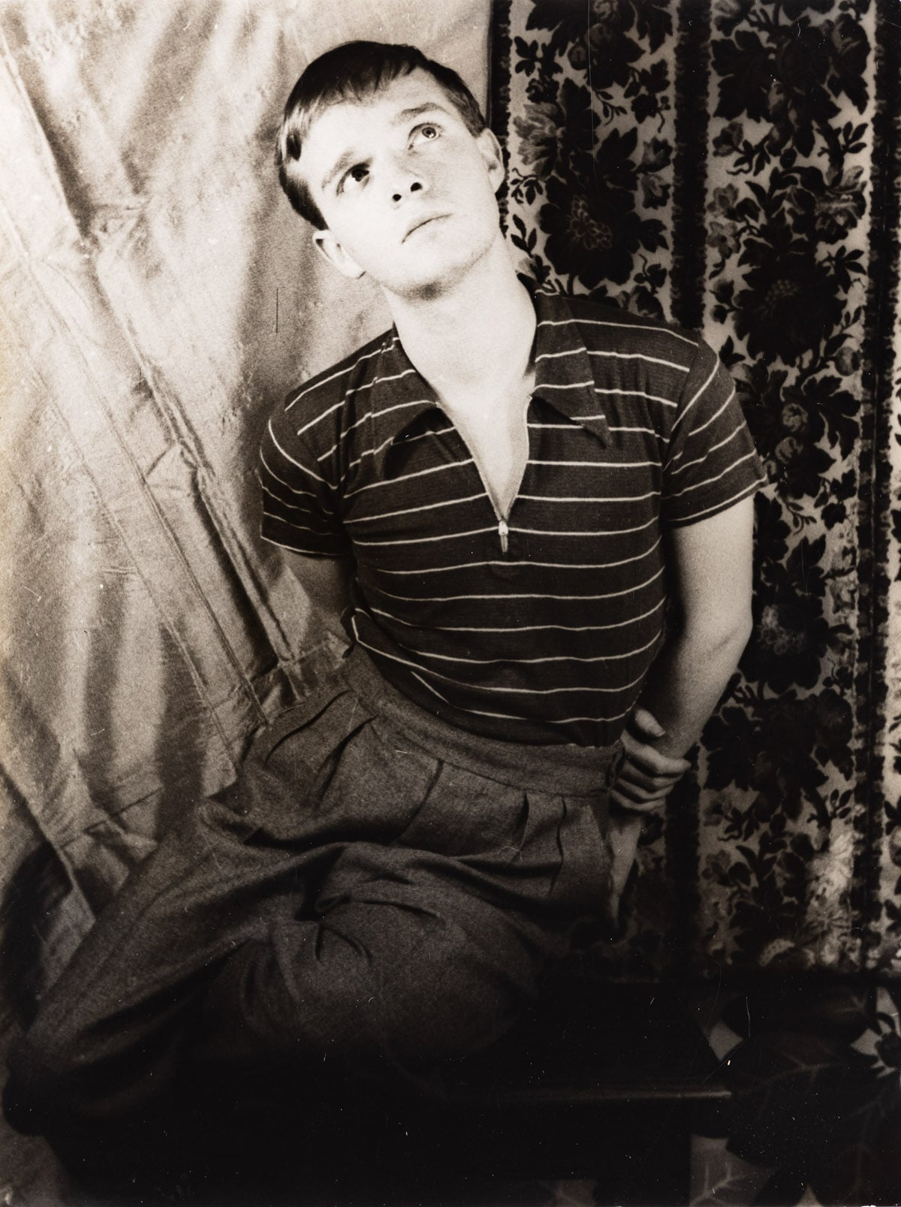Extreme Magic, Truman Capote

EXTREME MAGIC

August, 1966! Aboard the Tritona. Others aboard: Gianni and Marella Agnelli (hosts), Stash and Lee Radziwill, Luciana Pignatelli, Eric Nielsen, Sandro Durso, Adolfo Caracciolo, his daughter Allegra and his nephew Carlo. Seven Italians, one Dane, one Pole, and two of us (Lee et moi). Hmm.

Point of departure: Brindisi, a rather sexy seaport on the Italian Adriatic. Destination: the islands and coast of Yugoslavia, a twenty-day cruise ending in Venice.

It is now eleven P.M., and we had hoped to sail at midnight, but the captain, a no-nonsense gentleman from Germany, complains of a rising wind and thinks it unsafe to risk the sea before sunrise. Never mind!—the quay alongside the yacht is awash with café lights and piano sounds and Negro and Norwegian sailors browsing among brigades of pretty little purse-swinging tarts (one a really speedy baby with pimiento-colored hair).

Groan. Moan. Oh oh oh hold on to the wall. And crawl, Jesus, please. Please, Jesus. Slowly, slowly, one at a time: Yes, I am crawling up the stairs from my cabin (where green waves are smashing against the portholes), crawling toward the presumed safety of the salon.

The Tritona is a luxurious craft constructed on a wide-bottomed principle of a Grecian caïque. The property of Conte Theo Rossi, who lent it to the Agnellis for their cruise, it is furnished throughout like the apartment of an elegantly humorous art collector: The salon is a greenhouse of flowering plants—a huge Rubens dominates the wall above an arrangement of brown velvet couches.

But on this particular morning, the first day of the voyage, as we crossed the swelling seas between Italy and Yugoslavia, the salon, when at last I’ve crawled my way to it, is a rocking wreck. A television set is overturned. Bottles from the bar are rolling on the floor. Bodies are strewn all over like the aftermath of an Indian massacre. One of the choicest belongs to Lee (Radziwill). As I crawl past her, she opens a seasick eye and, in a hospital whisper, says: “Oh, it’s you. What time is it?”

“Nine. Thereabouts.”

Moan. “Only nine? And this is going to last the whole day. Oh I wish I’d listened to Stash. He said we shouldn’t have come. How do you feel?”

“Maybe I’ll live.”

“You look incredible. Yellow. Have you taken a pill? They help. A little.”

Eric Nielsen, lying face-down and somewhat askew, as though he’d been felled from behind by an ax murderer, says: “Shut up. I’m worse off than either of you.”

“The trouble,” says Lee, “the trouble with the pills is they make you so thirsty. And then you’re dying for water. But if you drink water, that only makes you sicker.”

How true—as I learned after swallowing two pills. Thirst is not the word; it was as if one had been a prisoner in the Sahara half a year or more.

A steward had arranged a buffet breakfast, but no one has gone near it—until presently Luciana (Pignatelli) appears. Luciana, looking impossibly serene and lovely—her slacks immaculate, every strand of golden hair just so, and her face, the eyes particularly, a triumph of precise maquillage.

“Oh, Luciana,” says Lee in a grieving, drowning tone, “how ever did you do it?”

And Luciana, buttering a slice of toast and spreading it with apricot jam, says: “Do what, darling?”

“Put on your face. I’m trembling so—I can’t hold a lipstick. If I’d tried to do what you’ve done to your eyes—all those Egyptian lines—I would have blinded myself.”

“Trembling?” says Luciana, crunching her toast. “Oh I see. You are troubled by the motion of the boat. But really it is not so bad, no?”

Eric says: “Shut up, girl. I’ve been on hundreds of boats, and I’ve never been seasick before.”

Luciana shrugs. “As you like.” Then she calls for the steward, who arrives careening to and fro. “May I have an egg, please?”

Lee says: “Oh, Luciana. How can you?”

At dusk this day the sea calmed as the Tritona approached the stony Montenegro coast. Everyone, feeling vastly better, is on deck staring down at the green-crystal depths skidding below. Suddenly a trio of sailors, standing in the ship’s prow, start to shout and gesture: An immense porpoise is racing along beside us.

The porpoise leaps, arcs, gleefully descends out of sight, leaps like laughter materialized, plunges again, and this time disappears. Then the sailors, leaning over the rail, begin to whistle a curious intense whistle-chant, and the whistling is some Ondine melody the seamen know will lure the creature back. Back it comes!—soaring heavenward wreathed in water-spark.

The porpoise guides us along the coast as far as a cave, then turns and seeks the deeper, now darkening outer sea.

Village lamps light the distance; but only Gianni (Agnelli), ever the questing spirit, wants to go ashore. The rest of us have more sense. And anyway, it’s my policy to leave heavy sightseeing to others—I’ve never cared to burden myself with churches and such relics. I like people, cafés and the stuff in shop windows. Unfortunately Yugoslavia, much as it happily differs from most socialist states, nonetheless is afflicted by that same tristesse, that same atmosphere of empty vistas, of nowhere to go and nothing to do when you get there, that starts just the other side of the Berlin Wall.

As usual in these countries, the store shelves are crammed with merchandise, but none of it is anything you would care to buy, not even as a gift for a cruel stepmother. Occasionally one encounters a street peddler selling pretty-enough native rugs; and if you like liqueurs, the best Maraschino in the world, a masterpiece of the distilling art, is a Yugoslavian creation. Otherwise zero, a shopper’s hell.

Nor can we praise the restaurants; as in Russia, the service is very Stepin Fetchit, every meal an endurance test. Dinner at the best restaurant in Dubrovnik is an only so-so affair. And the queer thing is, the quality of produce available in the marketplace is excellent. In the larger coastal cities, say Split, the markets sprawl like immense crazy quilts, a pattern composed of tomatoes and peaches and roses and soap and pickles and pigs’ feet and severed carcasses strung upside down.

And over it all, over everything, hovers a buzzy, prickly cloud of wasps. These wasps are like a political emblem, a subtly evoked threat—they seldom sting, but one cannot escape them, for they are a constant factor in the Yugoslavian landscape: a part of the air, unavoidable even aboard the Tritona, where, when we lunch on deck, the wasps dance in a yellow haze above the wines and melon.

Some quite unusual melons were served at lunch yesterday—cantaloupe-colored, yet spongy and sweet as honeydews. Marella said: “Absolutely divino! I wonder where the melons come from.” And pretty Princess Pignatelli, who has spent much of the voyage raptly reading a book called The Big Spenders (by Lucius Beebe), snaps to attention: “The Mellons?” says she. “The Mellons? They come from Pittsburgh.”

“A week is enough. Ten days is the absolute maximum,” so remarked Stash (Radziwill), referring to the amount of time he considered it possible to spend within the confines of a yacht cruise; and apparently most people in a position to judge second his opinion—that ten days is the limit, regardless of the charm of the company or the fascination of the scenery. But I do not agree with this. To my mind, the longer a cruise lasts the more intoxicating it becomes—a strange drifting awake-dream, a drug compounded of sun and motion and floating-by views that both lifts and lowers the spirit into a condition of alert slumber.

Also, I like boat routine. Tritona mornings are spent ashore in city-ports or island villages; around noon the cast, separated in twos and threes, wanders back aboard, then departs again by various speedboats to isolated coves and beaches for an hour’s swim. When everyone has once more reassembled, we gather on the sun-exposed upper deck for drinks and, for the athletes, a session of exercises conducted by Luciana (“my figure has improved seventy percent since I started weight-lifting”).

Then lunch (Italian chef, lots of great pasta concoctions, am gaining about a half-pound a day, oh what the hell). And as we start lunch, the yacht sets sail; we cruise all afternoon to our next destination, usually arriving at sunset.

Yesterday, abandoning the languors of a Norwegian-like fjord, we went all together in two speedboats to explore the beautiful waters surrounding a rocky little island. That was where we encountered the unpleasant fisherman.

He was a husky, handsome man, brown and naked except for denim trousers rolled up to his knees; not young—but a youthful fifty. His sturdy little boat was anchored in the cove where we had stopped to swim. He and his crew, three men much smaller than their captain, were ashore building a fire under a big iron kettle. The captain, a cleaver in his hand, was chopping up great hunks of fish and tossing them into the pot.

It was Eric who said why not buy fish from them, so we all swam to the beach, and Eric and I went over to discuss the matter with the fishermen. None of them acknowledged our approach. They just, in a rather eerie way, pretended we weren’t there. Finally Eric, speaking Italian, which most Yugoslavian seamen speak or understand, complimented them on their fine haul and, pointing out a particular loup, asked its price. The sullen captain, with a mirthless grunt, replied: “Three hundred dollars.” And he said it in English!

At this juncture Marella arrived, and she said to us: “He thinks we are all Americans. That’s why he is being so rude.” Then, turning to the captain, still unconcernedly preparing his stew, she announced: “I am an Italian.”

And in Italian the captain said: “Italians are no good either. Why,” he shouted, pointing at the delicious-looking mess simmering in his kettle, “why do you people come here and stare at our food? Do we stare at your food?” He gestured toward the yacht riding at a distance on the ultra-clear sea. “Do we go aboard your fine ship and watch you while you eat your food?”

“Well,” said Marella, as we walked away, “the old boy has a point, you know.”

“Personally,” said Eric, “I think he ought to be reported to the Tourist Bureau.”

What new can one say about Dubrovnik anyway? It is like some section of Venice drained of its canals and stripped of color: gray, medieval, Italian without Italian brio. In autumn and winter it must, in its emptiness, be most impressive; but in summer it is so crowded with excursion-fare vacationers, one can scarcely keep to the pavement. And for those holiday-makers the government has arranged a quite startling night life, altogether unlike any this diarist has seen in other so-called Communist countries (which, excepting Albania and China, includes the lot).

Above the city, nightclubs with sea-panorama vistas throb through the night; one in particular, an al fresco affair attached to a full-scale gambling casino, puts on a floor show reminiscent of those erotic hoedowns in pre-Castro Havana. And in fact the star of the show turned out to be that old-time Cuban legend: Superman!

All those who remember Superman from Havana will be interested to hear that his act, which formerly consisted of vigorous sexual intercourse on a brightly lighted stage, has changed: He is now the male section of a dance team. He and his partner writhe around to the banging of bongo drums, gradually removing one another’s attire until such nakedness appears that Superman seems ready to go into the routine that once made him so famous—but there it stops. The whole thing is fairly humorous, though God knows the audience doesn’t think so: Their response is a kind of stupor, the dazed attention of pimply boys at an Ann Corio exhibit.

Now, leaving the warm moist southern climate, we steam steadily northward into spheres where the air, though it is only late August, trembles already with a beyond-September chill. It is as if a cold crystal ball had descended, enclosing and stilling the green sea, sky, the growing-greener coast bobbing by: gone is the harsh and stony Montenegrin grayness, the subtropic pallor, for now each northward-going day the scene is more fruitful, there are trees and fields of wild flowers and grape vineyards and shepherds munching close to the Adriatic’s edge.

I feel touched by some extreme magic, an expectant happiness—as I always do when that sense of autumn arrives, for autumn never seems to me an end but a start, the true beginning of all our new years.

And so our voyage stopped in the mists of a Venetian evening. With sea mists blurring the lights of San Marco, and sea buoys mournfully tolling watery warnings, the Tritona entered the saddest and loveliest of cities and anchored alla Salute.

The mood aboard is not all sad; the sailors, many of them Venetians, whistle and amiably shout as they swing ropes and lower launches. In the salon, Eric and Allegra are dancing to the phonograph. And I, huddled in the dark, on the upper deck, am very pleased myself—pleased with the air’s promising chill, and the oily flickering lights, and the thought of an imminent visit to Harry’s Bar.

I’ve starved myself all day because … Oh, what joy to step out of the night into the chattering warmth of Harry’s Bar and wash down those little shrimp sandwiches with an icy martini or three!

1967

The End