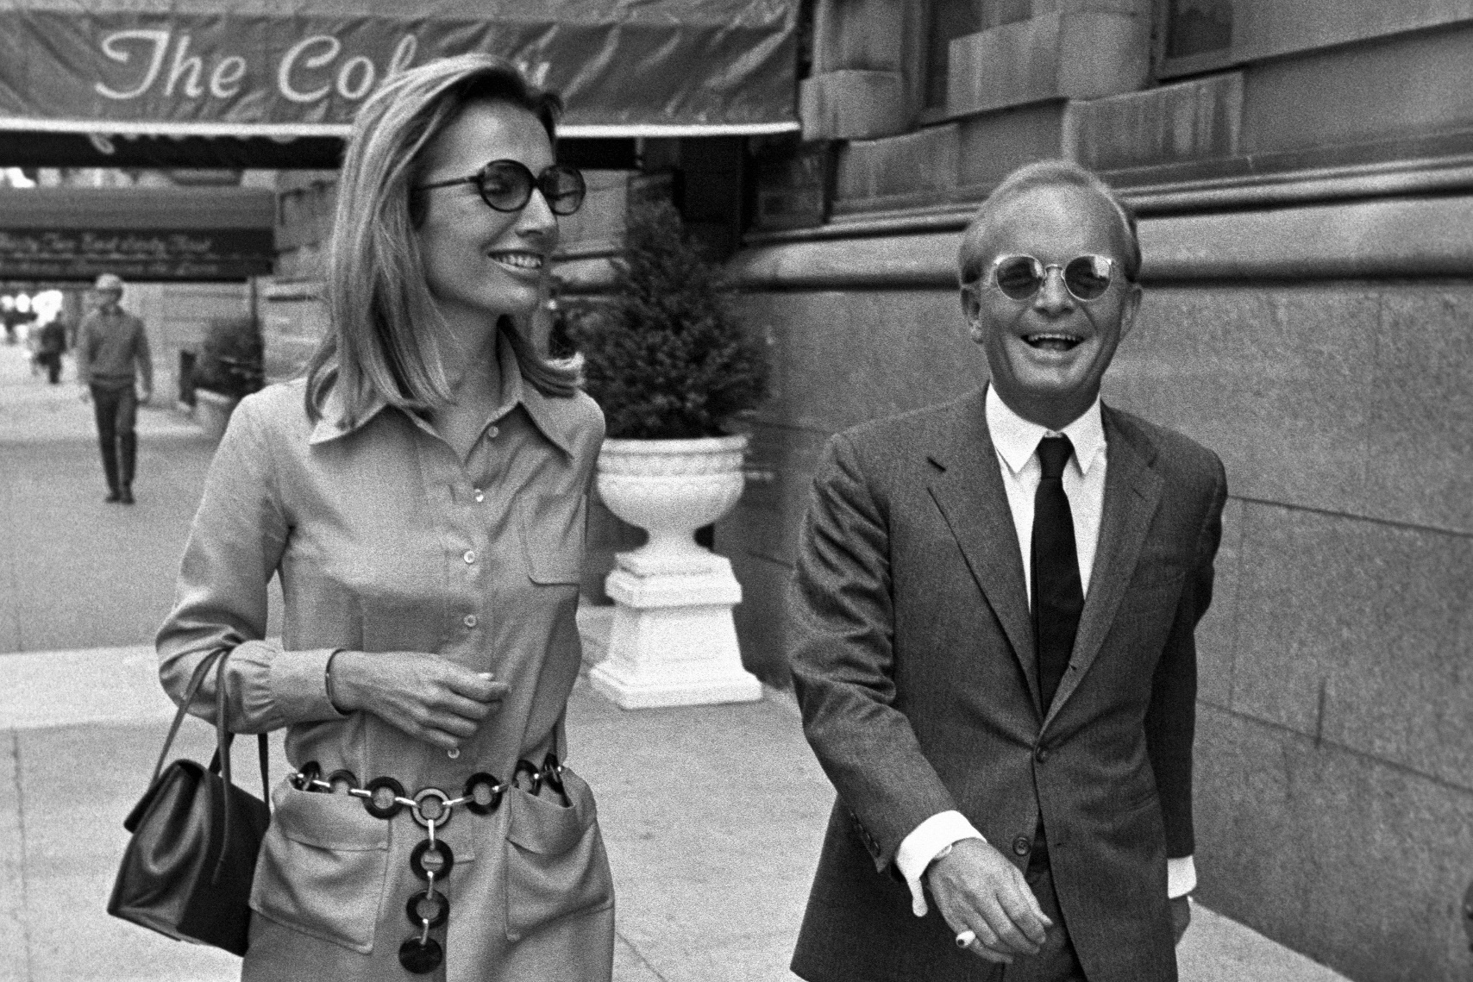

Fontana Vecchia, Truman Capote

FONTANA VECCHIA

Fontana Vecchia, old fountain. So the house is called. Pace, peace: this word is carved into the stone doorstep. There is no fountain; there has been, I think, something rather like peace. It is a rose-colored house dominating a valley of almond and olive trees that sinks into the sea. Across the water there is a view on clear days of Italy’s tip end, the peninsula of Calabria. Back of us, a stony, wavering path, traveled mostly by farming peasants, their donkeys and goats, leads along the side of the mountain into the town of Taormina.

It is very like living in an airplane, or a ship trembling on the peak of a tidal wave: there is a momentous feeling each time one looks from the windows, steps onto the terrace, a feeling of being suspended, like the white reeling doves, between the mountains and above the sea. This vastness reduces to an intimate size particulars of the landscape—the cypress trees are small as green pen quills; each passing ship could be held in the palm of your hand.

Before dawn, when drooping stars drift at the bedroom window fat as owls, a racket begins along the steep, at moments perilous, path that descends from the mountains. It is the farm families on their way to the marketplace in Taormina. Loose rocks scatter under the stumbling hoofs of overloaded donkeys; there are swells of laughter, a sway of lanterns: it is as though the lanterns were signaling to the far-below night fishermen, who just then are hauling in their nets. Later, in the market, the farmers and the fishermen meet: a small people, not unlike the Japanese, but brawny; indeed there is something almost lush about their lean walnut-hardness. If you question the freshness of a fish, the ripeness of a fig, they are great showmen.

Si, buono: your head is pushed down to smell the fish; you are told, with an ecstatic and threatening roll of eyes, how delicious it is. I am always intimidated; not so the villagers, who poke stonily among the tiny jewel tomatoes and never hesitate to sniff a fish or bruise a melon. Shopping, and the arranging of meals, is universally a problem, I know; but after a few months in Sicily even the most skilled householder might consider the noose—no, I exaggerate: the fruit, at least when first it comes into season, is more than excellent; the fish is always good, the pasta, too.

I’m told you can find edible meat; I’ve never been so fortunate. Also, there is not much choice of vegetables; in winter, eggs are rare. But of course the real trouble is we can’t cook; neither, I’m afraid, can our cook. She is a spirited girl, very charming, a little superstitious: our gas bill, for instance, is sometimes astronomical, as she is fond of melting immense pots of lead on the stove, then twisting the lead into carven images. As long as she keeps to simple Sicilian dishes, really simple and really Sicilian, they are, well, something to eat.

But let me tell about the chicken. Not long ago Cecil Beaton, in Sicily on a holiday, came to stay with us. After a few days he was beginning to look a bit peaked: we saw that a more proper effort toward feeding him would have to be made. We sent for a chicken; it appeared, quite alive, and accompanied by the cagey peasant woman who lives slightly higher on the mountain. It was a great black bird—I said it must be very old. No, said the woman, not old, just large. Its neck was wrung and G., the cook, put it to boil. Around twelve she came to say the chicken was still troppo duro—in other words, hard as nails.

We advised her to keep trying, and settling on the terrace with glasses of wine, prepared to wait. Several hours, several wine liters later, I went out to the kitchen to find G. in a critical condition: after boiling the chicken, she had roasted it, then fried it, and now, in desperation, was giving it another boil.

Though there was nothing else to eat, it should never have been brought to the table, for when it was set before us we had to avert our eyes: crowning this steaming heap was the poor bird’s severed head, its withered eyes gazing at us, its blackened cockscomb still attached. That evening Cecil, who previously had been staying with other friends on the island, informed us, quite suddenly, that he must return to them.

When first we leased Fontana Vecchia—this was in the spring, April—the valley was high with wheat green as the lizards racing among its stalks. It begins in January, the Sicilian spring, and accumulates into a kingly bouquet, a wizard’s garden where all things have bloomed: the creek sprouts mint; dead trees are wreathed in wild clamber roses; even the brutal cactus shoots tender blossoms.

April, Eliot writes, is the cruelest month: not here. It is bright as the snows on Etna’s summit. Children climb along the mountainside filling sacks of petals in preparation for a Saint’s Day, and fishermen, passing with their baskets of pearl-colored pesce, have geraniums tucked behind their ears.

May, and the spring is in its twilight: the sun enlarges; you remember that Africa is only eighty miles away; like a bronze shadow autumn color falls across the land. By June the wheat was ready to harvest. We listened with a certain melancholy to the scythes swinging in the golden field. When the work was over, our landlord, to whom the crop belonged, gave a party for the harvesters. There were only two women—a young girl who sat nursing a baby, and an old woman, the girl’s grandmother.

The old woman loved to dance; barefooted, she whirled with all the men—no one could make her take a rest, she would spring up in the middle of a tune to grab herself a partner. The men, who took turns playing the accordion, all danced together, which is a rural custom in Sicily. It was the best kind of party: too much dancing, far too much wine. Later, as I went exhaustedly to bed, I thought of the old woman. After working all day in the field and dancing all evening, she had now to start on a five-mile upward climb to her house in the mountains.

It is a walk to the beach, or beaches; there are several, all of them pebbly, and only one of them, Mazzaro, especially inhabited. The most attractive, Isola Bella, a guarded cove with water clear as barrel rain, is a mile and a half straight down; getting up again is the trick. A few times we have walked into Taormina and taken the bus, or a taxi. But mostly we go on foot.

You can swim from March until Christmas (so the hearty souls say), but I confess I was not too enthusiastic until we bought the water mask. The mask had a round glass viewing plate, and a breathing tube that closes when you dive. Swimming silently among the rocks, it is as though one had discovered a new visual dimension: in the underwater dusk a red phosphorescent fish looms at alarming proximity; your shadow drifts over a field of ermine-colored grass; blue, silver bubbles rise from some long-legged sleeping thing lying in a field of blowing sea flowers, and it is as if a wind of music were moving them; the sea flowers, the Javanese tendrils of purple jelly. Coming to shore, how static, gross, the upper world seems.

If we do not go to the beach, then there is only one other reason for leaving the house: to shop in Taormina, and have an apéritif in the piazza. Taormina, really an extension of Naxos, the earliest Greek city in Sicily, has had a continuous existence since 396 B.C. Goethe explored here in 1787; he describes it thus: “Now sitting at the spot where formerly sat the uppermost spectators, you confess at once that never did any audience, in any theater, have before it such a spectacle as you there behold.

On the right, and on high rocks at the side, castles tower in the air; farther on, the city lies below you, and although all of its buildings are of a modern date, still similar ones, no doubt, stood of old on the same site.

After this the eye falls on the whole of the long range of Aetna, then on the left it catches a view of the seashore as far as Catania, and even Syracuse, and then the wide and extensive view is closed by the immense smoking volcano, but not horribly, for the atmosphere, with its softening effect, makes it look more distant and milder than it really is.” Goethe’s vantage point was, I gather, the Greek theater, a superb cliff-top ruin where even today plays and concerts are occasionally given.

Taormina is as scenically extravagant as Goethe claims; but it is a curious town. During the war it was the headquarters of Kessel-ring, the German general; consequently, it came in for a share of Allied bombing. The damage was slight. Nevertheless, the war has been the town’s undoing. Up until 1940 it was, with the exception of Capri, the most successful Mediterranean resort south of the French Riviera.

Though Americans have never come here, at least in any quantity, it had considerable reputation among English and Germans. (A guidebook to Sicily, written by an Englishman, and published in 1905, remarks: “Taormina is flooded with Germans. At some hotels they have separate tables for them, because the other nations do not like sitting with Germans.”) Now, of course, the Germans are in no position to travel; due to currency restrictions, neither are the English. Last year the San Domenico, an old convent that late in the nineteenth century was converted into a most luxurious hotel, was never more than a quarter filled; before the war it was necessary to have your reservations a year in advance.

This winter, as perhaps a frantic last measure, the town, in the hope that it will attract the international audience, is opening a gambling casino. I wish them luck: it is imperative that someone come along and buy all those hand-woven hats, handbags, that junk in the shops along the Corso. For myself, Taormina suits me the way it is; it has the comforts of a tourist center (running water, a shop with foreign newspapers, a bar where you can buy a good martini) without the tourists.

The town, not large, is contained between two gates; near the first of these, the Porto Messina, there is a small tree-shaded square with a fountain and a stone wall along which village idlers are arranged like birds on a telephone wire. Taking one of my first walks through Taormina, I was startled to see perched upon this wall an old man wearing velvet trousers and wrapped in a black cape; his hat, an olive fedora, had been dented into a peaked tricorne crown, and the brim threw a shadow over his broad, yellowed, somewhat Mongolian face.

It was a surprisingly theatrical appearance, merely that, until looking closely I realized it was André Gide. Through the spring and early summer I often saw him there, either sitting unnoticed on the wall, apparently only another of the old men, or browsing about the fountain, where, with his cape drawn about him in a Shakespearean manner, he seemed to be observing in the water his own reflection: si jeunesse savait, si vieillesse pouvait.

Beneath the excess trappings Taormina is an ordinary town, and its people have ordinary ambitions, occupations. However, many of them, the young men in particular, possess what I think of as the mentality of hotel-children, children who have spent their lives in hotels, and who know that all things are transient, that the heart must never be involved, for friendship is a matter of days.

These young men live, as it were, “outside” the town; they are interested in foreigners, not so much for gainful reasons as the distinction they believe it bestows upon them to have English and American acquaintances, and as most of them have a primitive way with several languages, they spend their days at piazza cafés courteously, artificially, chattering with travelers.

It is a beautiful piazza centering around a promontory with a view of Etna and the sea. Toy Sardinian donkeys, attached to delicately carved carts, go prancing past, their bells jangling, their carts filled with bananas and oranges.

On Sunday afternoons, while the town band plays an eccentric but catchy concert, there is a grand promenade, and if I am there, I always look out for the butcher’s daughter, a stout, beefy girl who all week swings a meat ax with the ferocity of any two men; but on Sunday, coiffed and scented, careening on two-inch heels, and accompanied by her fiancé, a slender boy rising not quite to her shoulder, there is about her a romance, an atmosphere of triumph that stalls the satiric tongue: hers is the haughtiness, the belief in oneself, that should be the spirit of a promenade.

Occasionally traveling entertainers appear in the piazza: goatlike mountain boys who play on hair-covered bagpipes haunting, yodelerlike tunes; or, as in the spring, a singer, a child whose family supported themselves by each year touring him around the island: his stage was the limb of a tree, and there, his head thrown back and his throat trembling with heart-bursts of soprano song, he sang until his voice tired to the saddest whisper.

When shopping, the tabacchi is my last stop before starting out into the country. In Sicily all tobacconists are irritable fellows. Their places are usually crowded, but few of the customers buy more than three or four loose cigarettes: with a pinched solemnity the weathered men put down their ragged lire, then minutely examine the cigarettes, the poky cigars that have been doled out to them—it seems the most important moment of their day, this visit to the tabacchi; perhaps that is why they are so reluctant to give up their place in line.

There are possibly twenty different Sicilian newspapers; great garlands of them are strung in front of the tobacconist shop. One afternoon as I walked into town it started to rain. It was not a serious rainfall; still, the streets were deserted, not a soul about until I came alongside the tabacchi—a crowd was gathered where the newspapers, shriekingly headlined, fluttered in the rain.

Young boys, bareheaded, unmindful, stood with their heads leaning together, while an older boy, his finger pointing to an enormous photograph of a man stretched in a pool of blood, read aloud to them: Giuliano, dead, shot in Castelvetrano. Triste, triste, a shame, a pity, the older people said; the young ones said nothing, but two girls went into the shop and came out with copies of La Sicilia, a paper whose front page was taken up by a giant portrait of the slain bandit; protecting their papers against the rain, the girls ran hand in hand skidding along the shining street.

Then it was August; we felt the sun before it had risen. Strangely, here on the open mountain, the days were cooler than the nights, for more often than not a booming breeze blew off the water; at sunset the wind turned, plowed seaward, south, toward Greece, Africa. It was a month of silent leaves, shooting stars, red moons, a season of gorgeous moths, sleeping lizards.

Figs split, plums swelled, the almonds hardened. One morning I woke to hear in the almond trees the rattle of bamboo canes. In the valley, off on the hills, hundreds of peasants, working in family groups, were knocking down the almonds, then gathering them off the ground; and they sang to each other, one voice leading the rest, Moorish, flamencolike voices whose songs began nowhere, ended nowhere, and yet contained the marrow of work, heat, a harvest. They were a week bringing in the almonds, and each day the singing reached a not quite sane intensity.

I could not think for it; there was in me such an overriding sense of extra-life. At the end, during the mad last days, the fierce fine voices seemed to rise from the sea, the almond roots; it was as if one were lost in a cave of echoes, and when darkness came, and stillness, even so I could hear, at the edge of sleep, the sound of singing, and it seemed, though one tried to push it back, about to tell a pitiful, painful story, about to impart some terrible knowledge.

We do not have many visitors at Fontana Vecchia; it is too far a walk for casual callers, and days go by when no one knocks at the door except the ice boy. Blond, witty, the ice boy is a scholarly-looking child of eleven. He has a beautiful young aunt, surely one of the most attractive girls I’ve ever known, and I often talk to him about her. Why, I wanted to know, does A., the aunt, have no beau?

Why is she always alone, never at the dances or the Sunday promenade? The ice boy says it is because his aunt has no use for the local men, that she is very unhappy and longs only to go to America. Perhaps. But it is my own theory that the men in her family are so jealous of her that no one dares come too near.

Sicilian males have quite a lot to say about what their women do or don’t; heaven knows, the women seem to like it. For instance our cook, G., who is nineteen, has a somewhat older brother. One morning she appeared with a split lip, blackened eyes, a knife gash in her arm, and bruised yellow-green top to toe. It was astonishing; she should have been in a hospital. Smiling lopsidedly, G. said, Well, her brother had beat her up; they’d quarreled because he felt she went too often to the beach. Of course, we thought that an odd objection; when did she go to the beach—at night?

I told her to pay no attention to her brother, that he was brute, ugly. Her reply, in effect, was that I should mind my own business; she said her brother was a fine man. “He is good-looking and has many friends—only to me is he brute.” Nevertheless, I went to our landlord and complained that G.’s brother must be warned that we would not tolerate his sister’s coming to work in this kind of condition. He seemed mystified: why should I blame the brother?

After all, a brother is entitled to reprimand his sister. When I spoke of it to the ice boy he agreed with the landlord, and stated firmly that if he had a sister who didn’t do what he said, he would beat her up too. One evening in August, when the moons were so preposterous, the ice boy and I had a small but chilling exchange. He asked, What do you think of the werewolf? Are you afraid to go out after dark?

As it happened, I’d just that day heard of the werewolf scare: a boy walking home late at night claimed to have been set upon by a howling animal, a human on all fours. But I laughed. You don’t believe in werewolves, do you? Oh yes. “There used to be many werewolves in Taormina,” he said, his gray eyes regarding me steadily; then, with a disdainful shrug, “Now there are only two or three.”

And so autumn came, is here at this moment, a tambourine wind, a ghost of smoke moving between the yellow trees. It has been a good year for grapes; sweet in the air is the smell of fallen grapes in the mold of leaves, new wine. The stars are out at six; still, it is not too chilly to have a cocktail on the terrace and watch, in the bright starlight, the sheep with their Buster Keaton faces coming down from pasture, and the goats, whose herd-movement makes a sound like the dragging of dry branches. Yesterday men brought us a wagonload of wood. So I am not afraid of winter’s coming: what better prospect than to sit by a fire and wait for spring?

1951

The End