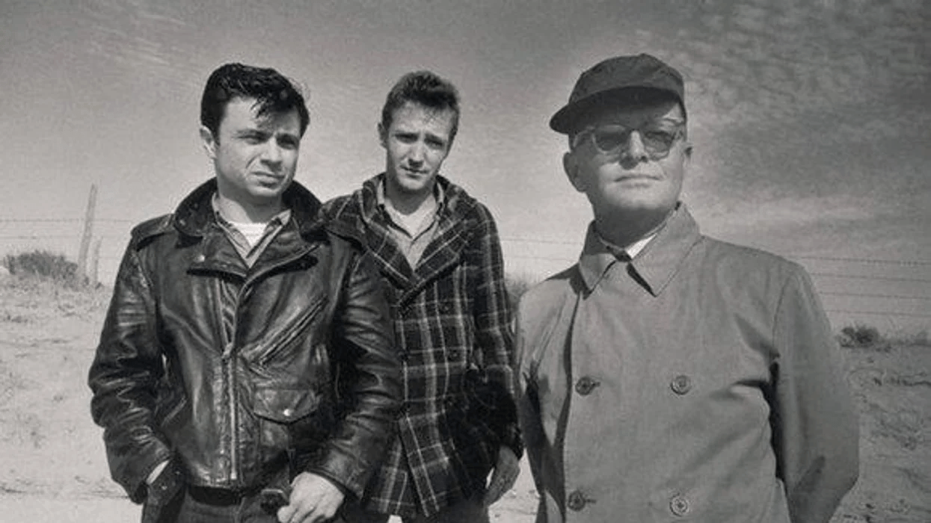

Ghosts In Sunlight. The Filming Of In Cold Blood

Truman Capote

GHOSTS IN SUNLIGHT. THE FILMING OF IN COLD BLOOD

One hot afternoon last March in a courthouse on the high wheat plains of western Kansas, Richard Brooks turned to me, between takes of the movie he was directing, and rather reproachfully asked, “What are you laughing at?”

“Oh, nothing,” I said, but the truth was that I’d remembered a long-ago question by Perry Smith, one of the two murderers whose trial was being reenacted here. He had been captured a few days before, and his question was, “Were there any representatives of the cinema there?”

I wondered what he would have thought of the present scene: the huge arc lights arranged inside the courtroom where he and Richard Hickock had been tried, the jury box filled with the very same men who had convicted them, the purring generators, whirring cameras, the whispering technicians dancing in and out among thick coils of electric cable.

The first conversation I ever had with Perry Smith was at the beginning of January, 1960. It was a cold day, glittery as an icicle; Smith and I talked together at the sheriff’s office in a room where prairie winds pressed against the windows, sucked the glass, rattled it.

I was fairly rattled myself, for I had been working for more than a month on a book about the murder of Herbert Clutter and his family, In Cold Blood, and unless I could establish close contact with this half-Irish, half-Indian young man, I would have to abandon the project. His court-appointed attorney had persuaded him to speak to me; but it was soon obvious that Smith regretted having granted the interview. He was remote, suspicious, sullenly sleepy-eyed: It took years, hundreds of letters and conversations, before I slipped all the way past this façade.

At the moment, nothing I said interested him. He rather arrogantly began to question my credentials. What kind of writer was I, and what had I written? Well, he said, after I’d provided a dossier, he’d never heard of me or any of my books; but—had I written any movies? Yes, one: Beat the Devil. Now the sleepy eyes somewhat wakened. “Uh-huh. I remember. Only saw it because Humphrey Bogart was in it. Did you, uh, uh, know Bogart? Personally?”

When I answered that Bogart had been a close friend of mine, he smiled in the flustered, fragile way I came to know very well. “Bogart,” he said, his voice so soft one could scarcely hear it above the wind. “I’ve always had this thing about him. He was my favorite actor. I saw Treasure of the Sierra Madre—oh, over and over. One of the reasons I liked that picture so much was—the old man in it, Walter Huston? that played the crazy gold prospector?—he was just like my father. Tex Smith. Just like him. I couldn’t get over it. It really hit me.” Then he said, “Were you there last night? When they brought us in?”

He was referring to the previous evening when the two handcuffed murderers, escorted by a regiment of state troopers, had arrived by car from Las Vegas, where they were arrested, to be arraigned at the Finney County courthouse in Garden City, Kansas. Hundreds of people had waited for hours in the dark and zero-cold to glimpse them; the crowd, orderly, almost awesomely hushed, had filled the square. The press, too, had been heavily represented by newsmen from all over the West and Midwest; there were also several television crews.

I told him yes, I’d been present—and had minor pneumonia to prove it. Well, he said, he was sorry about that: “Pneumonia is nothing to fool around with. But tell me—I was so scared I couldn’t see what was happening. When I saw that crowd, I thought, Jesus, these people are going to tear us limb from limb.

To hell with the public hangman. They were going to hang us on the spot. Which maybe wouldn’t have been the worst idea. I mean, what’s the use of going through this whole ordeal? Trial and everything. It’s such a farce. These prairie-billies, they’ll hang us in the long run.” He chewed his lip; something shy and bashful happened to his face—the aw-gee expression of a kid digging his toe into the ground. “What I wanted to know is—were there any representatives of the cinema there?”

This was typical of Perry—of his pathetic linguistic pretensions (the careful insertion of words like “cinema”), and of the kind of vanity that made him welcome “recognition” regardless of its nature. He tried to disguise it, shrug it off, but nevertheless he was undeniably gratified when I informed him that indeed the event had been recorded by motion-picture cameras.

Now, seven years later, I laughed to myself at the recollection, but I avoided answering Brooks’s query because the young men who were playing Perry and Dick were standing nearby, and I felt extremely uneasy in their presence. Self-conscious. I had seen photographs of Robert Blake (Perry) and Scott Wilson (Dick) before they were selected for the roles.

But it wasn’t until I went to Kansas to follow the progress of the film that I met them. And meeting them, having to be around them, was not an experience I care to repeat. This has nothing to do with my reaction to them as private individuals: they both are sensitive, seriously gifted men. It’s simply that despite the clear physical resemblance to the original pair, their photographs had not prepared me for the mesmerizing reality.

Particularly Robert Blake. The first time I saw him I thought a ghost had sauntered in out of the sunshine, slippery-haired and sleepy-eyed. I couldn’t accept the idea that this was someone pretending to be Perry, he was Perry—and the sensation I felt was like a free fall down an elevator shaft. Here were the familiar eyes, placed in a familiar face, examining me with the detachment of a stranger.

It was as though Perry had been resurrected but was suffering from amnesia and remembered me not at all. Shock, frustration, helplessness—these emotions, combined with impending flu, sent me home to a motel on the outskirts of Garden City. The Wheat Lands Motel, a place I had often stayed during the years I worked on In Cold Blood. An accumulated remembrance of those years, the loneliness of the endless wintry nights with forlorn salesmen coughing next door, seized me like a sudden Kansas cyclone and threw me on the bed.

To quote from my day-to-day journal: “Presently passed out, having drunk a pint of Scotch in less than thirty minutes. Woke in the morning with fever, television still going and total lack of knowledge of where I was or why. All unreal because too real, as reality’s reflections tend to be. Called Dr. Maxfield, who gave me an injection and several prescriptions. But the trouble is in my mind (?).”

That phrase “reality’s reflections” is self-explanatory, but perhaps I ought to clarify my own interpretation of it. Reflected reality is the essence of reality, the truer truth. When I was a child I played a pictorial game. I would, for example, observe a landscape: trees and clouds and horses wandering in grass; then select a detail from the overall vision—say, grass bending in the breeze—and frame it with my hands.

Now this detail became the essence of the landscape and caught, in prismatic miniature, the true atmosphere of a panorama too sizable to encompass otherwise. Or if I was in a strange room, and wanted to understand the room and the nature of its inhabitants, I let my eye wander selectively until it discovered something—a shaft of light, a decrepit piano, a pattern in the rug—that seemed of itself to contain the secret. All art is composed of selected detail, either imaginary or, as in In Cold Blood, a distillation of reality. As with the book, so with the film—except that I had chosen my details from life, while Brooks had distilled his from my book: reality twice transposed, and all the truer for it.

As soon as the book was published, many producers and directors expressed a desire to make a film of it. Actually, I had already decided that if a film was to be made, I wanted the writer-director Richard Brooks to act as intermediary between book and screen. Aside from my long-standing respect for his imaginative professionalism, he was the only director who agreed with—and was willing to risk—my own concept of how the book should be transferred to film. He was the one person who entirely accepted two important points: I wanted the film made in black and white, and I wanted it played by a cast of unknowns—that is, actors without “public” faces.

Although Brooks and I have different sensibilities, we both wanted the film to duplicate reality, to have the actors resemble their prototypes as much as possible, and to have every scene filmed in its real locale: the house of the murdered Clutter family; the same Kansas variety store where Perry and Dick bought the rope and tape used to bind their four victims; and certain courthouses, prisons, filling stations, hotel rooms and highways and city streets—all those places that they had seen in the course of their crime and its aftermath. A complicated procedure, but the only possible one by which almost all elements of fantasy could be removed and reality thereby achieve its proper reflection.

I felt this particularly strongly when Brooks and I went into the Clutter house while Brooks was preparing to film the murder sequence. To quote from my journal again: “Spent the afternoon at the Clutter farm. A curious experience to find myself once more in this house where I have so often been, and heretofore under such silent circumstances: the silent house, the plain rooms, the hardwood floors that echo every footstep, the windows that look out on solemn prairies and fields tawny with wheat stubble. No one has really lived there since the murders.

The property was bought by a Texan who farms the land, and who has a son who occasionally stays there. Certainly it has not gone to ruin; nevertheless it seems abandoned, a scarecrow without crows to frighten. The present owner gave Brooks permission to film there; a considerable amount of the original furniture was still on hand, and Brooks’s chief assistant, Tom Shaw, has done an extraordinary job of tracking down and retrieving the departed pieces. The rooms looked precisely the same as they had when I examined them in December, 1959—that is, soon after the crime was discovered. Mr. Clutter’s Stetson hanging on a wall hat rack. Nancy’s sheet music open at the piano. Her brother’s spectacles resting on a bureau, the lenses shimmering in sunlight.

“But it was the Venetian blinds that I noticed—that I, as it were, ‘framed.’ The blinds cover the windows of Mr. Clutter’s office, the room by which the murderers entered the house. Upon entering, Dick had parted the Venetian slats and peered through them to see if any witnesses were lurking in the moonlit night; again, on departing, and after the immense noise of the shootings, Dick’s eyes had explored the landscape through the slats, his heart pounding for fear that the crash of four shotgun blasts might have roused the countryside.

And now the actor who is impersonating Dick, and who is so uncannily like Dick, is on the verge of repeating these actions. Yet eight years have passed, the Clutter family are gone and Dick is dead, but the Venetian blinds still exist, still hang at the same windows. Thus reality, via an object, extends itself into art; and that is what is original and disturbing about this film: reality and art are intertwined to the point that there is no identifiable area of demarcation.

“Almost the whole of the murder sequence is being photographed in total darkness—except for the use of flashlights. This has never been done before, because ordinarily a flashlight is incapable of producing light sufficiently powerful to register a scene without the aid of extra illumination. In the present case, however, the production’s technicians have invented flashlights fixed with special batteries that generate solid shafts of white blaze—extremely effective as the beams wander in the darkness, crossing and crisscrossing.

“Brooks’s attention to detail can occasionally be comic. Today he noticed that between takes inside the Clutter house several of the crew were smoking cigarettes. Suddenly he clapped his hands and shouted, ‘All right! Cut that out! Mr. Clutter never allowed anyone to smoke in this house, so I’m not going to allow it either.’ ”

Presently undermined by flu and the strain of reliving painful events, I left Brooks and his company to get on with their work free of my critical surveillance. No director can abide an author staring over his shoulder; and, agreeable as our relationship was, I sensed that Brooks felt my presence made everyone edgy, himself included. He was not unhappy to see me go.

Returning to New York, I was surprised to find that few people asked me how the film was progressing. Rather, they were curious to know what the reaction of the townspeople was to the fact of the film’s being made in their midst: Was the atmosphere antagonistic? Cooperative? What? To answer the question, I have to refer to my own experiences during the years I spent roaming around Finney County, accumulating material.

When I arrived there in 1959 I knew no one, and no one, except the local librarian and several schoolteachers, had ever heard of me. As it happened, the first person I interviewed turned out to be the only genuine enemy I made there—at least the only one both openly and covertly hostile (a contradiction in terms, but nevertheless accurate). This fellow was, and is, the editor of the local daily paper, the Garden City Telegram, and therefore in a position to constantly publicize his belligerent attitude toward me and the work I was attempting to do. His columns are signed Bill Brown, and he is as plain as his name: a thin, rumpled man with mud-colored eyes and a beige complexion.

Of course, I understood his resentment, and at first sympathized with it: here was this “New York” writer, as he often drawlingly described me, invading his terrain and presuming to write a book about a “sordid” subject that was best swept away and forgotten. His continuous theme was: “We want to forget our tragedy, but this New York writer isn’t going to let us.” Therefore, it came as no surprise when Brown started a campaign to prevent Brooks from filming the Kansas scenes in Garden City and Holcomb.

Now his theme was that the advent of these “Hollywood people” would attract “undesirable elements,” and everything in Finney County would go to hell. Huffed and puffed, did Mr. Brown, but his efforts failed. For the simple reason that most of the people I met in western Kansas are reasonable and helpful; I couldn’t have survived if it hadn’t been for their consistent kindness, and I made friends among them that will last a lifetime.

That was in March of last year. In September, I traveled to California to see a rough cut of the finished film. On arrival, I had a meeting with Brooks, who was screening the picture for me the following day. Brooks is a very secretive man; he hoards his scripts, locks them up at night and never lets anyone read a complete version. Shooting on In Cold Blood had ended in June, and since that time Brooks had worked only with a cutter and a projectionist, not allowing anyone else to view a foot of the film. As we talked he seemed under the kind of whitened strain one does not associate with so assertive and vigorous a man. “Of course I’m nervous,” he said. “Why shouldn’t I be? It’s your book—and suppose you don’t like it?”

And suppose you don’t like it? Excellent question; and, strangely, one I’d never asked myself, principally because I had chosen the ingredients, and I always have faith in my own judgment.

The next day, when I arrived at Columbia studios around noon, Brooks was even more nervous. My God, he was glum! He said, “I’ve had some rough moments with this picture. But today’s the roughest.” On that note we walked into the screening room, and the sensation was not unlike entering a death cell.

Brooks picked up a telephone connected with the projectionist’s booth. “All right. Let’s go.”

The lights dimmed. The white screen turned into a highway at twilight: Route 50 winding under draining skies through a countryside empty as a cornhusk, woebegone as wet leaves. In the far horizon a silvery Greyhound bus appears, enlarges as it hummingly approaches, streaks by. Music: solitary guitar. Now the credits start as the image changes, dissolves into the Greyhound’s interior. Slumber hangs heavily. Only a weary little girl roams the aisle, gradually wandering toward the darkened rear, lured there by the lonely, disconnected plunk-plunk-plunk of a guitar. She finds the player, but we do not see him; she says something to him, but we cannot quite hear what it is.

The guitarist strikes a match to light a cigarette, and the flame partially illuminates his face—Perry’s face, Perry’s eyes, sleepy, remote. Dissolve to Dick, then to Dick and Perry in Kansas City, then to Holcomb, and Herbert Clutter breakfasting on the final day of his life, then back to his future executioners: the contrapuntal technique I used in writing the book.

The scenes move with striking fluidity, but I am increasingly gripped by a sense of loss; and a ring forms around my heart, like the frosty haze around a harvest moon. Not because of what is on the screen, which is fine, but because of what isn’t. Why has such-and-such been omitted? Where is Bobby Rupp? Susan Kidwell? The postmistress and her mother?

In the midst of my dilemma of not being able to concentrate appreciatively on what was there because of what wasn’t, the film caught fire—literally. One could see the tiny fire burning on the screen, a zipper of flame that separated the images and crisped them. In the silence following the abrupt halt, Brooks said, “Nothing serious. Just an accident. It’s happened before. We’ll have it fixed in a minute.”

A lucky accident, for during the time it took the projectionist to repair the damage and resume the screening, I managed to resolve the quarrel I was having with myself. Look, an inner voice said, you’re being unrealistic, unfair. This picture is two hours long, and that is as long as it can reasonably be. If Brooks included everything you would like to have shown, every nuance you’re grieving over, it would last nine hours! So stop worrying. Watch it for what it is: judge from that.

I did, and it was like swimming into a familiar sea only to be surprised by a muscular wave of sinister height, trapped in a hurtling current that carried me downward to ocean-floor depths, escorted me, pummeled raw and groggy, onto a beach uniquely desolate—not, unfortunately, the victim of a bad dream, or of “just a movie,” but of reality.

The screen returned to its pristine state; overhead lighting resumed. But again, as in the motel room in Garden City, I seemed to wake up not knowing where I was. A man was sitting near me. Who was he, and why did he look at me so intently, as if expecting me to say something? Ah, Brooks. Finally I said, “By the way, thank you.”

1967

The End