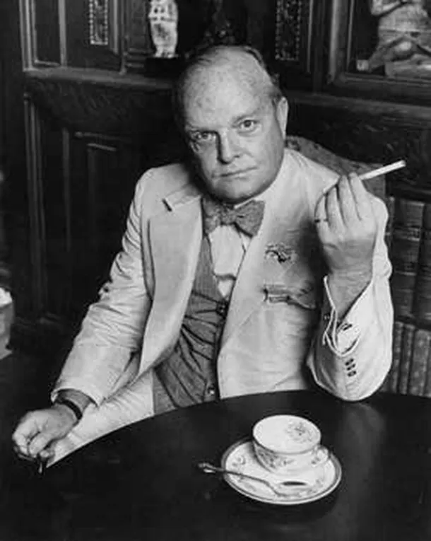

Greek Paragraphs, Truman Capote

GREEK PARAGRAPHS

A few summers ago Italian friends invited me on a cruise through the Greek Islands aboard an especially graceful sailing yacht. We were to depart from Piraeus on a morning in July. The sea was calm, the ship sparkled, the captain and his crew awaited us in uniforms as white as the churches of Mykonos; and I was there, oh yes. Unfortunately, a sudden tragedy, a death in the family, had detained my hosts; but, though unable to meet me, they insisted I should proceed with the cruise.

Just imagine!—a whole yacht at the disposal of one passenger. Only the nuttiest, richest, most selfish person could deliberately conceive such an adventure. However, as it happened by accident, I felt neither guilt nor hesitation. Avanti.

Herewith, some notes from the voyage.

PEACHES

I dislike Greek wines; however, there is one unresinated white wine that is as dry and light as the best Italian soaves. It’s called King Minos, and just now, sitting under the starlight on the afterdeck, I drank a half bottle of it while eating two enormous peaches. Peaches the size of cantaloupes and the color of cantaloupe meat. Peaches of a deliciously yielding texture and a juicy liqueurlike sweetness.

And to think they are the product of a Greek island, these mountainous bits of sea-surrounded desert. One would not have thought they could grow such peaches in the greenest Persian garden, much less here on these sun-seared rocks. Yet it is true, for the cook bought them at Santorin, where we are harbored for the night.

The crew have gone ashore: up Up UP to Santorin village. Quite a climb, a matter of several thousand steps and dizzying views. I made it there this afternoon astride one of these fragile and courageous little fly-pestered donkeys, bless its put-upon heart. Felt very ashamed of myself, also was rump-sore, so returned afoot.

The sky, a bonfire of stars—as ablaze as the skies above the Sahara. The sway of caiques. The sway of moored caiques. Music from a harbor café. An ouzo-scented old man dancing in front of the café. The cool King Minos warming my veins, the taste of peaches lingering, the perfume of peach skins saturating the soft, salt-tart air.

MELTEMI

That cursed wind, the Meltemi. Yesterday we were caught in one, an inevitable event on the summer seas of Greece, for the damn thing blasts about the whole of July and August. Some years ago I spent a summer in the Cyclades on the island of Paros, which is surely the meltemi’s favored haunt: indeed, it seldom departs, but hurls around the island howling like the spectral voices of drowned sailors, centuries of sailors smashed against its shores.

It is an evil wind, scratchy, nerve-twisting. And look what it does to the economy, the diet of the islanders: when fishermen can’t fish, as they can’t when the meltemi roars, an islander’s already sufficiently meager menu is reduced by half.

April is the finest month to visit here: fields of wild flowers, wild anemones, white violets, and the water, green as spring buds, is just warm enough for a brisk swim. April … or late September, when the water is still warm enough (if you don’t object to sharing it with migrating geese who abruptly plunge from the heavens and swim along beside you), and the meltemi has stopped prowling.

But until yesterday I had never experienced one at sea. I was below when it arrived; even so, I could hear it approaching across the water—a dark rippling feathery noise. The ship lurched, spun, fish peered into the portholes; it seemed the mast must crack: how close we all come to joining that complaining choir of drowned mariners! At dusk it died and we hurried to hide in a cove.

A TERRIBLE TALE

There are Yugoslavs in the crew, Greeks, mostly Italians. the captain is Italian. He doesn’t much like the yacht because he doesn’t like sailing yachts, not even that black pearl of the Aegean, Niarchos’s Creole. He says they are romantic but too much work for the crew. He speaks English, speaks it well, and is a rather youngish man with dramatic eyes and a dark-toned voice; he might easily have been an actor, and all actors are liars, I’ve never met one that wasn’t.

But perhaps the captain is not a liar. Anyway, this morning we passed Delos, not stopping because I’d been there twice before, and a glimpse of the marble ruins drifting by in a shimmering lavender haze reminded him of a story. At lunch he told it to me. He swore it was true.

“This happened when I was a boy of seventeen, and in the crew of a yacht owned by an Englishman, Lord Sickle. Now, Lord Sickle often chartered his yacht, and in August of that year he chartered it to a beautiful Englishwoman: a widow, I would say forty, very tall, a tiny waist, so elegant. She had a son, a lad sixteen or so and also very beautiful and elegant. Crippled, however: a withered leg in a brace, and he walked with two canes. But a genius, this boy. A scholar. It was for his sake that the mother undertook a Greek cruise; he wanted to see the places he knew so well from his studies.

“They came aboard accompanied by a maid and a manservant; otherwise they were alone, and I’ve often thought what a pity that was. Perhaps it wouldn’t have happened if they had had friends with them.

“There was a strange island the boy wanted to visit. North of Delos. Yes, north. I can’t remember precisely. It was an island of only a few acres and all but unknown; still, he knew of it and spoke of a well-preserved temple there.

“We arrived après midi, and because of the shallows, had to anchor more than a mile offshore. The boy was very excited. He had made up his mind to pack a supper and spend the night alone with his mother on the island; he wanted to see the temple by moonlight and sleep on the shore. The mother loved him very much. Too much. She laughed and ordered a picnic.

“It was I who rowed them there, set them ashore; and it was I who returned at dawn to collect them. The boy was dead, stripped to a skeleton; and the mother, whom I found wading in the water, was unrecognizable—fearfully mutilated, half mad.

“Only months later, months spent in an Athens hospital, was she able to tell a court of inquiry what had happened. She said, ‘At first it was very peaceful and lovely. We wandered around the temple until twilight, then spread our supper on a flight of steps; my son Eric said oh, look, it’s going to be a full moon. We could see the lights of the yacht riding far out—I wished we had kept the sailor with us.

Because, as the moon thickened, brightened, somehow I mistrusted the landscape. And gradually I became aware of a sound. Claws. An icy scuttling. And a huge brown rat, another and another, leapt with tearing teeth into our picnic.

A horde of rats pouring out of the temple, hundreds flailing in the moonlight. Eric screamed; he tried to run and fell, and I had to drag him by the arms, but the rats were at us, all over us, they even swam after us into the water, pulled Eric back onto the beach, and no one heard me the whole night I bled and screamed and cried there in the sea.’ ”

The captain lit a cigar. “This woman is still alive. She lives in Nice. I’ve seen her—sitting in a chaise on the promenade. She wears a full veil. I’m told she never speaks to anyone.”

OBSERVATIONS

(1) Numerous educated Greek men share a snobbish affectation—obsessed by their fingernails, they pamper them ceaselessly, letting the nails on either little finger grow to Dragon Lady length. This is to let the lesser folk know that they work with their heads, not their hands.

(2) Greek businessmen also share an eccentric hobby: playing with ropes of amber or ivory beads, their nervous fingers twitching from bead to bead, rubbing, counting. This conduct is said to relieve the pressure of affairs and prevent ulcers.

(3) And what most Greeks, male or female, have in common are medical superstitions. The humblest village has a vendor who sells small replicas, stamped from sheets of polished tin, of hands, hearts, feet, ears, eyes. If, say, you are recovering from a coronary, why, you simply acquire a tin heart, carry it on your person, and presently the actual ailing organ will have magically healed itself. The True Believers are not limited to peasants and middle-class housewives, but include many intellectuals. Once, when I was living on Paros, I mentioned to a Professor Calliope, a linguist of great renown, that my father was virtually blind and that I myself had a considerable fear of failing eyesight.

He bought me a pair of tin eyes, and insisted we walk, through curtains of quivering August heat, to a nunnery in the mountains where there resided a remarkable abbess endowed with witch-powers: once she had blessed my medals, my worries were over. At the monastery I was made to feel like a missionary captive in some perilous Hottentot village: the nuns, very unused to visitors, gathered around me, all giggling and poking and pinching—really pinching, as if to judge how juicy I’d be when put to boil. But soon the professor had them calmed down and we were served cool water and a crystal candy that smelled of roses and contained inside each piece a roseleaf. As for the abbess—we were too late: she had died the week before.

A BLUE COVE

The only scenery that bores me is any that I can’t imagine purchasing a part of: usually, if a place provides the slightest uplift, I instantly consider buying or building a house. The hundreds of properties I’ve constructed mentally! But now something serious has occurred. For the past few days we’ve been cruising around Rhodes, lingering a lot at the perfect little bay of Lindos. An American acquaintance who has a house above Lindos took me to see something he thinks I should own.

I think so too. It is a small stone farmhouse situated inside a horseshoe-shaped cove; the beach is a sandy confection, and the water, being entirely protected, tranquil as a sapphire winking in a jeweler’s window. It could be mine for three thousand dollars: an investment of another five or six would put the house in delicious order. It is a prospect that sizzles the imagination.

At night I think, Yes I will, but in the morning I recall—politics, old mortality, inconvenient emotional commitments, the impossibilities of the Greek tongue, a trillion difficulties. Still, I ought to have the courage; I’ll never again find anything quite as ideal as that.

AT A CAFE

I left the yacht at Rhodes, and this morning flew to Athens. Now at not quite midnight am sitting alone in an outdoor café on Constitution Square. There are not many patrons, though I recognize one of them as someone I’d seen years ago in Tangier, where she was quite the Queen of the Casbah (Southern Belle Version): Eugenia Bank-head, Tallulah’s even more voluble sister. She is arguing with a Negro companion.

Come to consider, many of the world-trampers who used to hang around Tangier now frequent Athens. Across the street from where I sit I see every conceivable breed of hustler, from muscled dock-hands to plump Egyptian lovelies wearing wavy platinum wigs.

It is very hot, and the ubiquitous white dust of Athens mists the air, coats the street and my tabletop like the pale rough crust on a bilious tongue. I am remembering the stone house in the blue cove. But that is all I will ever do. Remember it.

1968

The End