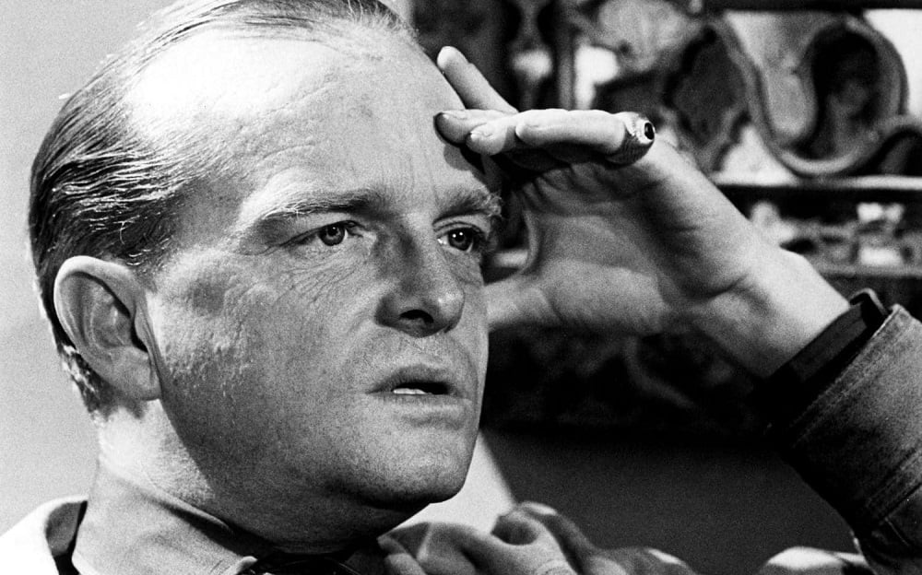

Haiti, Truman Capote

HAITI

To look at, Hyppolite is perhaps an ugly man: monkey-thin, gaunt-faced, quite dark, he looks (through silver schoolmarm spectacles), listens with the steadiest, most gracious precision, his eyes echoing a subtle and basic understanding. One feels with him a certain safety; there is created between you that too uncommon circumstance, no sense of isolation.

This morning I heard that during the night his daughter died, a daughter eight months old; there are other children, he has been married many times, five or six; even so, how hard it must be, for he is not young.

No one has told me, I wonder if there is a wake. In Haiti they are extravagant, these wakes, and excessively stylized: the mourners, strangers in large part, claw air, drum their heads on the ground, in unison moan a low doglike grief. Heard at night, or seen suddenly on a country road, it seems so alien the heart shivers, and then one realizes that in essence these are mimes.

Because he is the most popular of Haiti’s primitive painters, Hyppolite could afford a running-water house, real beds, electricity; as it is, he lives by lamp, by candle, and all the neighbors, old withered coconut-headed ladies and handsome sailor boys and hunched sandal makers, can see into his affairs as he can see into theirs.

Once, some while back, a friend took it upon himself to rent Hyppolite another house, a sturdy sort of place with concrete floors and walls behind which one could hide, but of course he was not happy there, he has no need for secrecy or comfort. It is for this reason that I find Hyppolite admirable, for there is nothing in his art that has been slyly transposed, he is using what lives within himself, and that is his country’s spiritual history, its singings and worships.

Displayed prominently in the room where he paints is an enormous trumpet-shaped shell; pink and elaborately curled, it is like some ocean flower, an underwater rose, and if you blow through it, there comes forth a howl hoarse and lonesome, a windlike sound: it is for sailors a magic horn that calls the wind, and Hyppolite, who plans an around-the-world voyage aboard his own red-sailed ship, practices upon it regularly. Most of his energy and all his money go into the building of this ship; there is about his dedication the quality frequently seen in those who supervise the plotting of their own funerals, the building of their own tombs.

Once he sets sail and is out of land’s sight, I wonder if again anyone will ever see him.

From the terrace where in the mornings I sit reading or writing, I can see the mountains sliding blue and bluer down to the harbor bay. Below there is the whole of Port-au-Prince, a town whose colors are paled into peeling historical pastels by centuries of sun: sky-gray cathedral, hyacinth fountain, green-rust fence. To the left, and like a city within this other, there is a great chalk garden of baroque stone; here is the cemetery, this is where, amid flat metal light and monuments like birdcages, they will bring his daughter: they will bring her up the hill, a dozen of them dressed in straw hats and black, sweet peas heavy on the air.

1. Tell me, why are there so many dogs? to whom do they belong, and for what purpose? Mangy, hurt-eyed, they pad along the streets in little herds like persecuted Christians, all innocuous enough by day, but come night how their vanity and their voices exaggerate! First one, another, then all, through the hours you can hear their enraged, embittered, moon-imploring tirades. S. says it is like a reversed alarm clock, for as soon as the dogs commence, and that indeed is early, it is time to go to bed. You might as well; the town has drawn shutters by ten, except, that is, on rahrah weekends, when drums and drunks drown out the dogs. But I like hearing a morning multitude of cock-crows; they set blowing a windfall of reverberations. On the other hand, what is more irritating than the racket of car horns? Haitians who own cars seem so to adore honking their horns; one begins to suspect this activity of political and/or sexual significance.

2. If it were possible, I should like to make a film here; except for incidental music it would be soundless, nothing but a camera brilliantly framing architecture, objects. There is a flying kite, on the kite there is a crayon eye, now the eye is loose and blowing in the wind, it snags on a fence and we, the eye, the camera, see a house (like M. Rigaud’s).

This is a tall, brittle, somewhat absurd structure representing no particular period, but seeming rather to be of an infinitely bastard lineage: the French influence, and England in somber Victorian garb; there is an Oriental quality, too, touches that suggest a lantern of frilled paper.

It is a carved house, its turrets, towers, porticoes are laced with angel heads, snowflake shapes, valentine hearts: as the camera traces each of these we hear a tantalizing sub-musical tap-rap of bamboo rods. A window, very sudden; a sugar-white meringue of curtains, and a lumplike eye, and then a face, a woman like an old pressed flower, jet at her throat and jet combs in her hair; we pass through her, and into the room, two green chameleons race over the chifforobe mirror where her image shines. Like dissonant piano notes, the camera shifts with swift sharp jabs, and we are aware of the happenings our eyes never notice: a rose leaf falling, a picture tilting crooked. Now we have begun.

3. Comparatively few tourists come to Haiti, and a fair number of those who do, especially the average American couple, sit around in their hotels in a superior sulk. It is unfortunate, for of all the West Indies, Haiti is quite the most interesting; still, when one considers the objectives of these vacationers their attitude is not without reason: the nearest beach is a three-hour drive, night life is unimpressive, there is no restaurant whose menu is very distinguished. Aside from the hotels, there are only a few public places where late of an evening one can go for a rum soda; among the pleasanter of these are the whorehouses set back among the foliage along the Bizonton Road.

All the houses have names, rather egotistical ones: the Paradise, for example. And they are uncompromisingly respectable, perfect parlor decorum is observed: the girls, most of whom are from the Dominican Republic, sit on the front porch rocking in rocking chairs, fanning themselves with cardboard pictures of Jesus and conversing in a gentle, gossipy, laughing way; it is like any American summer scene. Beer, not whiskey or even champagne, is considered de rigueur, and if one wants to make an impression, it is the drink to order.

One girl I know can down thirty bottles; she is older than the others, wears lavender lipstick, is rumba-hipped and viper-tongued, all of which makes her a popular lady indeed, though she herself says she will never feel like a success until she can afford to have every tooth in her head converted into solid gold.

4. The Estimé government has passed a law which forbids promenading in the streets sans shoes: this is a hard, uneconomical ruling, and an uncomfortable one as well, especially for those peasants who must bring their produce to market afoot. But the government, now anxious to make the country more of a tourist attraction, feels that shoeless Haitians might depress his potential trade, that the poorness of the people should not be overt. By and large, however, Haitians are poor, but about this poverty there is none of that vicious, mean atmosphere which surrounds the poverty that demands a keeping-up of appearances.

It always makes me rather wretched when some popular platitude proves true; still, it is a fact, I suppose, that the most generous of us are those that have the least to be generous with. Almost any Haitian who comes to call will conclude his visit by presenting you with a small, usually odd gift: a can of sardines, a spool of thread; but these gifts are given with such dignity and tenderness that, ah! the sardines have swallowed pearls, the thread is purest silver.

5. This is R.’s story. A few days ago he went out into the country to sketch; suddenly, coming to the bottom of a hill, he saw a tall, slant-eyed, ragged girl. She was tied to the trunk of a tree, wire and rope binding her there. At first, because she laughed at him, he thought it was a joke, but when he tried to let her loose several children appeared and began to poke at him with sticks; he asked them why the girl was tied to the tree, but they giggled and shouted and would not give an answer.

Presently an old man joined them; he was carrying a gourd filled with water. When R. asked again about the girl, the old man, tears misting his eyes, said, “She is bad, monsieur, there is no use she is so bad,” and shook his head. R. started back up the hill; then, turning, he saw the man was letting her drink from the gourd, and as she took a last swallow she spat into his face; with a gentle patience the old man wiped himself and walked away.

6. I like Estelle, and I must say I have come to care less for S. because he doesn’t: there is no brand of intolerance so tiresome as that which results in condemning characteristics you yourself possess: in the opinion of S., Estelle is lusty, vulgar, a fraud; S., to be sure, and except for the first mentioned, is not without these qualities himself.

In any event, it shows a finer nature to be unconsciously vulgar than to be consciously virtuous. But of course S. is very much “in” with the American colony here, and their views, with a few isolated exceptions, are often gray and always severe. Estelle isn’t cherished by any group. “Who gives a damn?” says she. “Listen, egghead, there’s nothing wrong with me but the fact that I’m so almighty good-looking, and when a girl’s as good-looking as me and she won’t let a lot of crumbs crawl all over, well, thumbs down, get it?”

Estelle is one of the tallest girls I’ve ever seen, an easy six feet; her face is strong and bony, in the Swedish manner, her hair rosy, her eyes cat-green: somehow there is always an aura about her which suggests that she has just been tossed about in a hurricane. She is several Estelles, actually. One of them is the heroine of a not-too-good novel: here today—gone tomorrow, hello, you heartache of a world, that school of antics. Another Estelle is a big puppy of a girl dizzy for love: she is always quite sure the most improbable people have the most honorable intentions.

A third Estelle is not so much shady as she is shadowy: who is Estelle? what is she doing here? how long does she intend to stay? what is it that makes her get up in the morning? Now and then this third element of the multiple Miss E. will refer to her “work.” But the nature of her work is never labeled.

Most of the time she sits in a café on the Champ de Mars and, at a cost of ten cents a round, drinks rum punches. The bartender is always asleep, and whenever she wants anything she swaggers over and thumps his head as though it were a ripe watermelon. There is a crazy little lop-eared dog that follows her everywhere, and usually she has some human crony with her, too. Her favorite is a pale, prim man who might be a Bible salesman; as it happens, he is a traveling entertainer who hops from island to island with a suitcase full of puppets and a head full of nonsense.

On clear evenings Estelle sets up headquarters at a table on the sidewalk outside the café; many of the young native girls bring their love problems here to this table: about other people’s love she is serious and sad. Once she herself was married, when or to whom I do not know, she is so altogether vague, but, and even though she is only twenty-five, it must have been a very long time ago. Last night I passed by the café, and as usual she was sitting at her sidewalk table. But there was a difference.

She was wearing make-up, which she seldom does, and a neat, conventional dress; there were two pink carnations burning in her hair, the sort of decoration of which I’d thought her incapable. Also, I’d never seen her really drunk before. “Egghead, hello, is it you? Yesyesyes,” she said, tapping me on the chest, “listen, kid, I’m going to give you proof positive, I’m going to show you it’s a fact, it’s a fact that when you love somebody that somebody can make you eat any goddamn thing. Look now”—and she yanked a carnation from her hair—“he’s nuts about me,” she said, thrusting the flower at the little dog crouched at her feet, “he’ll eat it just because I say to, damn if he won’t.”

But the dog merely sniffed.

The last few weekends here have been devoted to the rahrahs preceding carnival, and carnival, which began yesterday, continues for three days. Rahrahs are miniature previews of carnival itself; Saturday, sometime past noon, the drums commence, separately at first, one high in the hills, another nearer town, back and forth these signals run, insinuating, insistent, until there is established a pervasive vibration which shimmers the surface of silence, ripples like heat waves, and here where I am, alone in this arsenic-colored room, all action seems to stem from their sound: doom die doom, over there, look: light quivers in the water jar, a crystal bubble, set in motion, rolls across a table, shatters on the floor, wind, catching curtains, curling Bible leaves, tells doom die doom.

By dusk the island takes the expanding shape of a sound of drums. Small bands carouse the streets; these are made of family groups, or secret societies, all singing different songs which sound the same; the leader of each band wears feathers in his hair, a spangled crazy-quilt suit, and each has a pair of cheap dark glasses; while the others sing and stamp their feet he spins around, grinds his hips, cocks his head from side to side like an evil parrot: everybody laughs, and some couples join together, dancing with their heads thrown back, their lips ajar, doom die doom, the rhythm rotates their haunches, their eyes are rich moons, doom die doom.

Last night R. took me into the midst of the carnival. We were going to see the ceremony of a young boungan, that is to say, Voodou priest, this one an extraordinary boy whose name I never heard.

It was held at a distance from the city, and so we had to take an autobus, a small wagon which can inconveniently carry ten passengers; but there were almost double that number, some of them in costume, including a dwarf wearing a cap of bells and an old man with a mask like raven wings; R. sat next to the old man, who at one point said, “Do you understand the sky? Yes, I thought you would, but it was I who made it.”

To which R. answered, “I suppose you made the moon, too?”

The man nodded. “And the stars, they are my grandchildren.”

A rowdy woman clapped her hands and announced that the old man was crazy. “But, dear lady,” he replied, “if I am crazy, then how could I have done these beautiful things?”

It was a slow trip; the autobus stalled, crowds surged around, faces concealed behind masks dangled in the dark, archaic light of candle torches showering them like some eccentric yellow rain.

When we reached the boungan’s, which is above the town, a quiet place shrill only with the night noises of insects, the ceremony had already begun, although the boungan himself had not yet appeared. Surrounding the temple, a long thatch-roofed shed with altar rooms at either end (the doors to these rooms were closed, for beyond one the boungan awaited his entrance), were perhaps a hundred silent, solemn Haitians.

In the open clearing between the rooms seven or eight barefoot girls, all dressed in white with white bandannas wrapped around their heads, moved in a snaking circle, smacking their sides and singing a chant that two drummers echoed. A kerosene lamp cast smoky, horizontal shadows of the dancers, and the drummers, both intent, both froglike, wavered on the walls.

Suddenly the drums stopped, the girls made an aisle leading to an altar door. It was so quiet one could almost identify the various species of serenading insects. R. asked for a cigarette, but I would not give it to him: who smokes in church? and Voodou after all is a real, very complex religion, one which is nevertheless frowned on by the Haitian bourgeoisie, who, when they are anything, are Catholics, and that is why, as a compromise you might think, so much Catholicism has seeped into Voodou: a picture of the Virgin Mary, for example, and an image of the Infant Jesus, who is represented sometimes by a homemade doll, will be found adorning the altar of almost any boungan.

And the primary functions of Voodou do not seem to me basically different from those of other religions: appeals to certain gods, symbols, appease the pressures of evil, man is weak but God protects him, there is magic abroad, the gods own it, they can provide a man’s wife with child or allow the sun to burn his crops, steal the breath from his body but reward him with a soul. In Voodou, however, there is no boundary between the countries of the living and the dead; the dead rise and walk among the living.

Now again the drums began, the voices of the girls spacing every slow, dramatic beat, and then the door to the altar opened: three boys came out, each carrying a plate filled with a different substance—ashes, cornmeal, black powder—and candles, like those for a birthday cake, burned in the center of these materials; balancing the plates on a rounded stone, the boys knelt facing the door.

The drums grew softer, there began a nervous rhythmical rattling, this made by a gourd encasing snake vertebrae, and swiftly, like a spirit that has unexpectedly solidified, the boungan glided airy as a bird through the column of girls and around the room, his feet, the ankles tinkling with silver bracelets, seeming not at all to touch the floor, and his loose silk scarlet robes rustling winglike.

There was a caul of red velvet draped around his head, a pearl gleamed in his ear. Here and there he paused, like a hummingbird, and clasped the hands of a worshiper: he took mine, and I looked into his face, an amazing, androgynous face, beautiful, really, a troubling combination of blue-black skin and Caucasian features; he could not have been more than twenty, still, there was something about him unaccountably old, asleep, transfixed.

At last, taking a handful of cornmeal and ashes, he started drawing on the ground a verver; there are in Voodou hundreds of ververs, which are intricate, somewhat surrealist designs whose every detail has implications, and to execute them demands not only the sort of academic memory required of a pianist who would, say, play an entire program of Bach, but also unusually deft technique, artistry.

While the drums grew explosively fast he stooped about, deep in his art, like a red spider that, instead of silk, spills forth an ashy, ferocious web of crowns, crisscrosses, snakes, phallic shapes, eyes, fishtails. Then, the verver completed, he went back to the altar room, and reappeared wearing green, in his hands a great iron ball; as he stood there the ball caught fire, holy blue wrapping it like the atmospheres of earth; still carrying it, he fell to his knees, crawled, chants and shouts applauding him, and when the flames cooled he arose, stretching his unburned palms upward.

A tremor swept his body, as if an unknown wind passed through him, his eyes rolled into his skull, the spirit (god and demon) opened like a seed and flowered in his flesh: unsexed, unidentifiable, he gathered in his arms man and woman. Whoever his partner, they whirled over the snakes and eyes of the verver, mysteriously never quite disturbing them, and when he changed to another, the castoff partner flung himself, as it were, into infinity, tore his breast, screamed.

And the young boungan, shining with sweat, his pearl earring loosened, ran smash into the farthest, unopened door: singing, crying, he beat his hands upon it until they left blood prints. It was as if he were a moth, the door the bright enormity of an electric bulb, for beyond this obstacle, immediately beyond it, there was magic: truth’s secret, pure peace. And if the door had opened, as it never will, would he have found it, this unobtainable? That he believed so is all that matters.

1948

The End