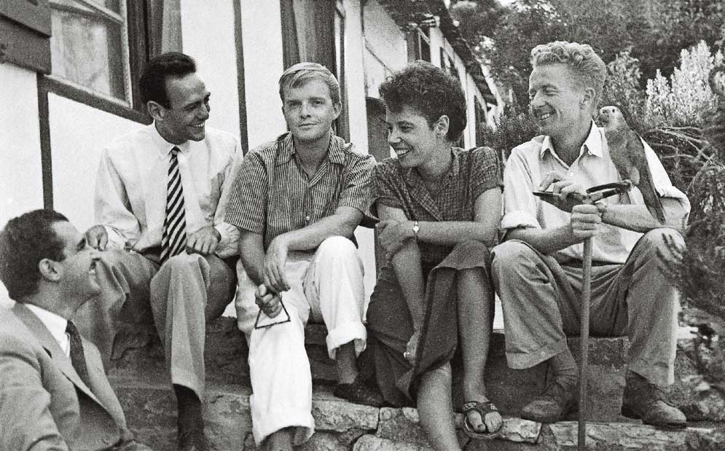

Jane Bowles, Truman Capote

JANE BOWLES

It must be seven or eight years since I last saw the modern legend named Jane Bowles; nor have I heard from her, at least not directly. Yet I am sure she is unchanged; indeed, I am told by recent travelers to North Africa, who have been or sat with her in some dim Casbah café, that this is true, and that Jane, with her dahlia-head of cropped, curly hair, her tilted nose and mischief-shiny, just a trifle mad eyes, her very original voice (a husky soprano), her boyish clothes and schoolgirl’s figure and slightly limping walk, is more or less the same as when I first knew her more than twenty years ago: even then she had seemed the eternal urchin, appealing as the most appealing of nonadults, yet with some substance cooler than blood invading her veins and with a wit, an eccentric wisdom no child, not the strangest Wunderkind, ever possessed.

When I first met Mrs. Bowles (1944? 1945?), she was already, within certain worlds, a celebrated figure: though only in her twenties, she had published a most individual and much remarked novel, Two Serious Ladies; she had married the gifted composer and writer Paul Bowles, and was, together with her husband, a tenant in a glamorous boardinghouse established on Brooklyn Heights by the late George Davis.

Among the Bowleses’ fellow boarders were Richard and Ellen Wright, W. H. Auden, Benjamin Britten, Oliver Smith, Carson McCullers, Gypsy Rose Lee and (I seem to remember) a trainer of chimpanzees who lived there with one of his star performers. Anyway, it was one hell of a household. But even amid such a forceful assembly, Mrs. Bowles, by virtue of her talent and the strange visions it enclosed, and because of her personality’s startling blend of playful-puppy candor and feline sophistication, remained an imposing, stage-front presence.

Jane Bowles is an authoritative linguist; she speaks, with the greatest precision, French and Spanish and Arabic—perhaps this is why the dialogue of her stories sounds, or sounds to me, as though it has been translated into English from some delightful combination of other tongues.

Moreover, these languages are self-learned, the product of Mrs. Bowles’s nomadic nature: from New York she wandered on to and all over Europe, traveled away from there and the impending war to Central America and Mexico, then alighted awhile in the historic ménage on Brooklyn Heights. Since 1947 she has been almost continuously resident abroad: in Paris or Ceylon, but largely in Tangier—in fact, both Jane and Paul Bowles may now safely be described as permanent Tangerinos, so total has their adherence become to that steep, shadowy-white seaport.

Tangier is composed of two mismatching parts, one of them a dull, modern area stuffed with office buildings and tall, gloomy dwellings, and the other a Casbah descending through a medieval puzzlement of alleys and alcoves and kif-odored, mint-scented piazzas down to the crawling-with-sailors, ship-horn-hollering port.

The Bowleses have established themselves in both sectors—have a sterilized, tout confort apartment in the new quarter and also a refuge hidden away in the darker Arab neighborhood: a native house that must be one of the city’s tiniest habitations—ceilings so low that one had almost literally to move on hands and knees from room to room; but the rooms themselves are like a charming series of postcard-sized Vuillards—Moorish cushions spilling over Moorish-patterned carpets, all cozy as a raspberry tart and illuminated by intricate lanterns and windows that allow the light of sea-skies and views that encompass minarets and ships and the blue-washed rooftops of native tenements, receding like a ghostly staircase to the clamorous shoreline. Or that is how I remember it on the occasion of a single visit made at sunset on an evening, oh, fifteen years ago.

A line from Edith Sitwell: Jane, Jane, the morning light creaks down again—This from a poem I’ve always liked without, as so often with the particular author, altogether understanding it. Unless “morning light” is an image signifying memory(?). My own most satisfying memories of Jane Bowles revolve around a month spent in side-by-side rooms in a pleasantly shabby hotel on the rue du Bac during an icy Paris winter—January, 1951.

Many a cold evening was spent in Jane’s snug room (fat with books and papers and foodstuffs, and a snappy white Pekingese puppy bought from a Spanish sailor); long evenings spent listening to a phonograph and drinking warm applejack while Jane built sloppy, marvelous stews atop an electric burner: she is a good cook, yessir, and kind of a glutton, as one might suspect from her stories, which abound in accounts of eating and its artifacts.

Cooking is but one of her extracurricular gifts; she is also a spooky accurate mimic, and can re-create with nostalgic admiration the voices of certain singers—Helen Morgan, for example, and her close friend Libby Holman. Years afterward I wrote a story called Among the Paths to Eden, in which, without realizing it, I attributed to the heroine several of Jane Bowles’s characteristics: the stiff-legged limp, her spectacles, her brilliant and poignant abilities as a mimic. (“She waited, as though listening for music to cue her; then, ‘Don’t ever leave me, now that you’re here! Here is where you belong.

Everything seems so right when you’re near. When you’re away it’s all wrong.’ And Mr. Belli was shocked, for what he was hearing was exactly Helen Morgan’s voice, and the voice, with its vulnerable sweetness, refinement, its tender quaver toppling high notes, seemed not to be borrowed, but Mary O’Meaghan’s own, a natural expression of some secluded identity.”) I did not have Mrs. Bowles in mind when I invented Mary O’Meaghan—a character she in no essential way resembles; but it is a measure of the potent impression Jane has always made on me that some fragment of her should emerge in this manner.

That winter Jane was working on In the Summer House, the play that was later so sensitively produced in New York.

I’m not all that keen on the theater: cannot sit through most plays once; nevertheless, I saw In the Summer House three times, and not out of loyalty to the author, but because it had a thorny wit, the flavor of a newly tasted, refreshingly bitter beverage—the same qualities that had initially attracted me to Mrs. Bowles’s novel Two Serious Ladies.

My only complaint against Mrs. Bowles is not that her work lacks quality, merely quantity. The volume in hand constitutes her entire shelf, so to say. And grateful as we are to have it, one could wish that there was more. Once, while discussing a colleague, someone more facile than either of us, Jane said, “But it’s so easy for him. He has only to turn his hand. Just turn his hand.”

Actually, writing is never easy: in case anyone doesn’t know, it’s the hardest work around, and for Jane, I think it is difficult to the point of true pain. And why not?—when both her language and her themes are sought after along tortured paths and in stony quarries: the never-realized relationships between her people, the mental and physical discomforts with which she surrounds and saturates them—every room an atrocity, every urban landscape a creation of neon-dourness.

And yet, though the tragic view is central to her vision, Jane Bowles is a very funny writer, a humorist of sorts—but not, by the way, of the Black School. Black Comedy, as its perpetrators label it, is, when successful, all lovely artifice and lacking any hint of compassion. Her subtle comprehension of eccentricity and human apartness as revealed in her work requires us to accord Jane Bowles high esteem as an artist.

1966

The End