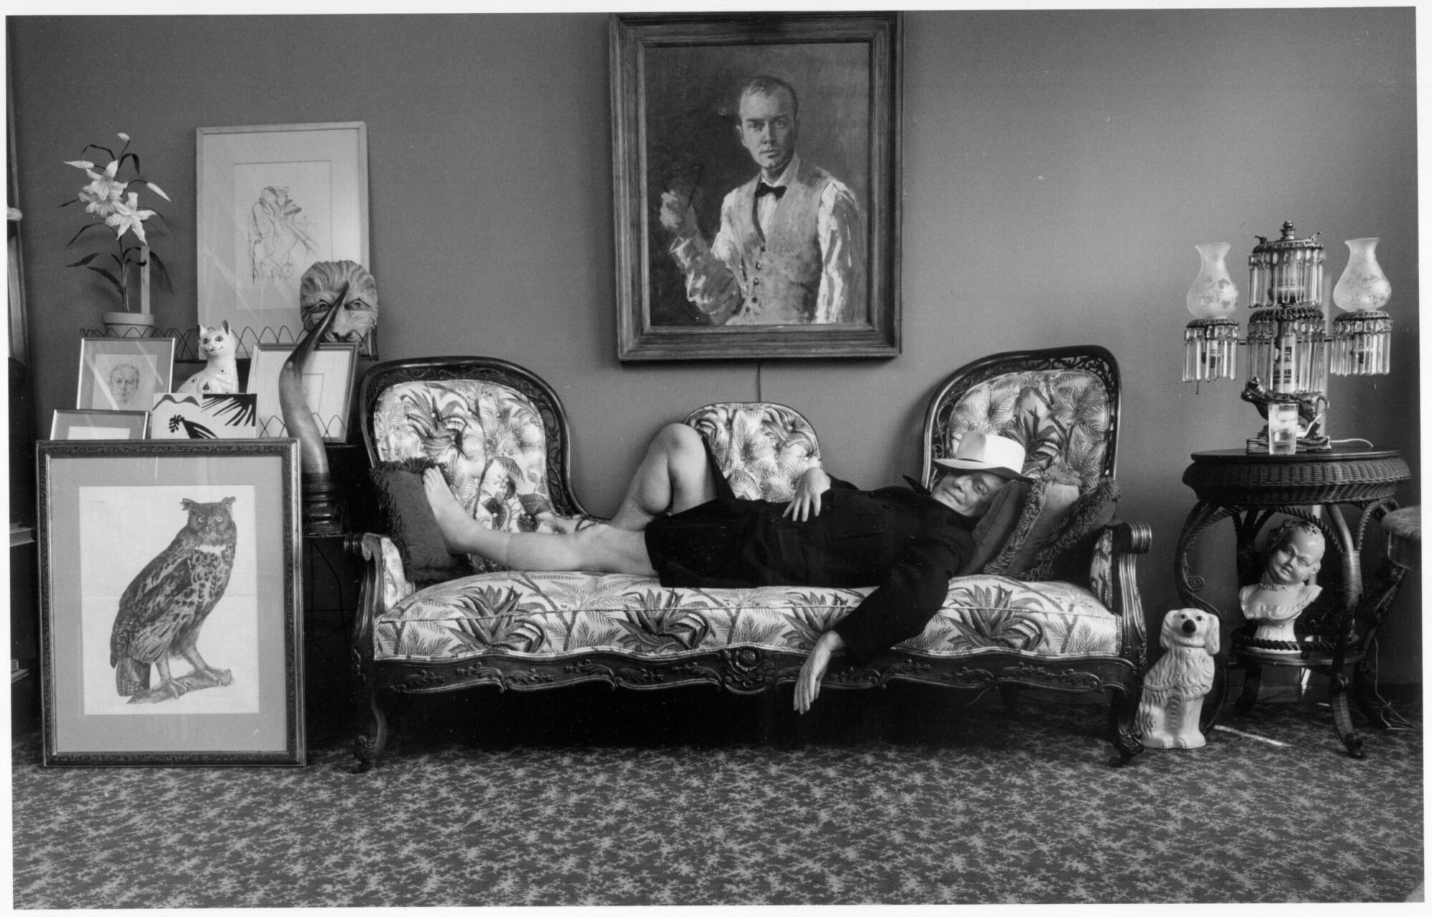

New Orleans, Truman Capote

NEW ORLEANS

In the courtyard there was an angel of black stone, and its angel head rose above giant elephant leaves; the stark glass angel eyes, bright as the bleached blue of sailor eyes, stared upward.

One observed the angel from an intricate green balcony—mine, this balcony, for I lived beyond in three old white rooms, rooms with elaborate wedding-cake ceilings, wide sliding doors, tall French windows. On warm evenings, with these windows open, conversation was pleasant there, tuneful, for wind rustled the interior like fan-breeze made by ancient ladies.

And on such warm evenings the town is quiet. Only voices: family talk weaving on an ivy-curtained porch; a barefoot woman humming as she rocks a sidewalk chair, lulling to sleep a baby she nurses quite publicly; the complaining foreign tongue of an irritated lady who, sitting on her balcony, plucks a fryer, the loosened feathers floating from her hands, slipping into air, sliding lazily downward.

One morning—it was December, I think, a cold Sunday with a sad gray sun—I went up through the Quarter to the old market, where at that time of year there are exquisite winter fruits, sweet satsumas, twenty cents a dozen, and winter flowers, Christmas poinsettia and snow japonica.

New Orleans streets have long, lonesome perspectives; in empty hours their atmosphere is like Chirico, and things innocent, ordinarily (a face behind the slanted light of shutters, nuns moving in the distance, a fat dark arm lolling lopsidedly out some window, a lonely black boy squatting in an alley, blowing soap bubbles and watching sadly as they rise to burst), acquire qualities of violence. Now, on that morning, I stopped still in the middle of a block, for I’d caught out of the corner of my eye a tunnel-passage, an overgrown courtyard.

A crazy-looking white hound stood stiffly in the green fern light shining at the tunnel’s end, and compulsively I went toward it. Inside there was a fountain; water spilled delicately from a monkey-statue’s bronze mouth and made on pool pebbles desolate bell-like sounds. He was hanging from a willow, a bandit-faced man with kinky platinum hair; he hung so limply, like the willow itself.

There was terror in that silent suffocated garden. Closed windows looked on blindly; snail tracks glittered silver on elephant ears, nothing moved except his shadow. It swung a little, back and forth, yet there was no wind. A rhinestone ring he wore winked in the sun, and on his arm was tattooed a name, “Francy.” The hound lowered its head to drink in the fountain, and I ran. Francy—was it for her he’d killed himself? I do not know. N.O. is a secret place.

My rock angel’s glass eyes were like sundials, for they told, by the amount of light focused on them, time: white at noon, they grew gradually dimmer, dark at dusk, black—nightfall eyes in a nightfall head.

The torn lips of golden-haired girls leer luridly on faded leaning house fronts: Drink Dr. Nutt, Dr. Pepper, NEHI, Grapeade, 7-Up, Koke, Coca-Cola. N.O., like every Southern town, is a city of soft-drink signs; the streets of forlorn neighborhoods are paved with Coca-Cola caps, and after rain, they glint in the dust like lost dimes.

Posters peel away, lie mangled until storm wind blows them along the street, like desert sage—and there are those who think them beautiful; there are those who paper their walls with Dr. Nutt and Dr. Pepper, with Coca-Cola beauties who, smiling above tenement beds, are night guardians and saints of the morning.

Signs everywhere, chalked, printed, painted: Madame Ortega—Readings, Love-potions, Magic Literature, C Me; If You Haven’t Anything To Do … Don’t Do It Here; Are You Ready To Meet Your Maker?; B Ware, Bad Dog; Pity The Poor Little Orphans; I Am A Deaf & Dumb Widow With 2 Mouths To Feed; Attention; Blue Wing Singers At Our Church Tonight (signed) The Reverend.

There was once this notice on a door in the Irish Channel district, “Come In And See Where Jesus Stood.”

“And so?” said a woman who answered when I rang the bell. “I’d like to see where Jesus stood,” I told her, and for a moment she looked blank; her face, cut in razorlike lines, was marshmallow-white; she had no eyebrows, no lashes, and she wore a calico kimono. “You too little, honey,” she said, a jerky laugh bouncing her breasts, “you too damn little for to see where Jesus stood.”

In my neighborhood there was a certain café no fun whatever, for it was the emptiest café around N.O., a regular funeral place. The proprietress, Mrs. Morris Otto Kunze, did not, however, seem to mind; she sat all day behind her bar, cooling herself with a palmetto fan, and seldom stirred except to swat flies. Now glued over an old cracked mirror backing the bar were seven little signs all alike: Don’t Worry About Life … You’ll Never Get Out Of It Alive.

July 3. An “at home” card last week from Miss Y., so I made a call this afternoon. She is delightful in her archaic way, amusing, too, though not by intent. The first time we met, I thought: Edna May Oliver; and there is a resemblance most certainly. Miss Y. speaks in premeditated tones but what she says is haphazard, and her sherry-colored eyes are forever searching the surroundings. Her posture is military, and she carries a man’s Malacca cane, one of her legs being shorter than the other, a condition which gives her walk a penguin-like lilt.

“It made me unhappy when I was your age; yes, I must say it did, for Papa had to squire me to all the balls, and there we sat on such pretty little gold chairs, and there we sat. None of the gentlemen ever asked Miss Y. to dance, indeed no, though a young man from Baltimore, a Mr. Jones, came here one winter, and gracious!—poor Mr. Jones—fell off a ladder, you know—broke his neck—died instantly.”

My interest in Miss Y. is rather clinical, and I am not, I embarrassedly confess, quite the friend she believes, for one cannot feel close to Miss Y.: she is too much a fairy tale, someone real—and improbable. She is like the piano in her parlor—elegant, but a little out of tune. Her house, old even for N.O., is guarded by a black broken iron fence; it is a poor neighborhood she lives in, one sprayed with room-for-rent signs, gasoline stations, jukebox cafés. And yet, in the days when her family first lived here—that, of course, was long ago—there was in all N.O. no finer place.

The house, smothered by slanting trees, has a graying exterior; but inside, the fantasy of Miss Y.’s heritage is everywhere visible: the tapping of her cane as she descends birdwing stairs trembles crystal; her face, a heart of wrinkled silk, reflects fumelike on ceiling-high mirrors; she lowers herself (notice, as this happens, how carefully she preserves the comfort of her bones) into father’s father’s father’s chair, a wickedly severe receptacle with lion-head hand-rests.

She is beautiful here in the cool dark of her house, and safe. These are the walls, the fence, the furniture of her childhood. “Some people are born to be old; I, for instance, was an atrocious child lacking any quality whatever. But I like being old. It makes me feel somehow more”—she paused, indicated with a gesture the dim parlor—“more suitable.”

Miss Y. does not believe in the world beyond N.O.; at times her insularity results, as it did today, in rather chilling remarks. I had mentioned a recent trip to New York, whereupon she, arching an eyebrow, replied gently, “Oh? And how are things in the country?”

1. Why is it, I wonder, that all N.O. cabdrivers sound as though they were imported from Brooklyn?

2. One hears so much about food here, and it is probably true that such restaurants as Arnaud’s and Kolb’s are the best in America. There is an attractive, lazy atmosphere about these restaurants: the slow-wheeling fans, the enormous tables and lack of crowding, the silence, the casual but expert waiters who all look as though they were sons of the management.

A friend of mine, discussing N.O. and New York, once pointed out that comparable meals in the East, aside from being considerably more expensive, would arrive elaborate with some chef’s mannerisms, with all kinds of froufrou and false accessories. Like most good things, the quality of N.O. cookery derived, he thought, from its essential simplicity.

3. I am more or less disgusted by that persistent phrase “old charm.” You will find it, I suppose, in the architecture here, and in the antique shops (where it rightly belongs), or in the minglings of dialect one hears around the French Market. But N.O. is no more charming than any other Southern city—less so, in fact, for it is the largest. The main portion of this city is made up of spiritual bottomland, streets and sections rather outside the tourist belt.

(From a letter to R.R.) There are new people in the apartment below, the third tenants in the last year; a transient place, this Quarter, hello and good-bye. A real bona-fide scoundrel lived there when I first came. He was unscrupulous, unclean and crooked—a kind of dissipated satyr. Mr. Buddy, the one-man band. More than likely you have seen him—not here of course, but in some other city, for he keeps on the move, he and his old banjo, drum, harmonica.

I used to come across him banging away on various street corners, a gang of loafers gathered round. Realizing he was my neighbor, these meetings always gave me rather a turn. Now, to tell the truth, he was not a bad musician—an extraordinary one, in fact, when, late of an afternoon, and for his own pleasure, he sang to his guitar, sang ghostly ballads in a grieving whiskey voice: how terrible it was for those in love.

“Hey, boy, you! You up there …” I was you, for he never knew my name, and never showed much interest in finding it out. “Come on down and help me kill a couple.”

His balcony, smaller than mine, was screened with sweet-smelling wisteria; as there was no furniture to speak of, we would sit on the floor in the green shade, drinking a brand of gin close kin to rubbing alcohol, and he would finger his guitar, its steady plaintive whine emphasizing the deep roll of his voice. “Been all over, been in and out, all around; sixty-five, and any woman takes up with me ain’t got no use for nobody else; yessir, had myself a lota wives and a lota kids, but christamighty if I know what come of any of ’em—and don’t give a hoot in hell—’cept maybe about Rhonda Kay. There was a woman, man, sweet as swamp honey, and was she hot on me!

On fire all the time, and her married to a Baptist preacher, too, and her got four kids—five, countin’ mine. Always kinda wondered what it was—boy or girl—boy, I spec. I always give ’em boys … Now that’s all a long time ago, and it happened in Memphis, Tennessee. Yessir, been everywhere, been to the penitentiary, been in big fine houses like the Rockefellers’ houses, been in and out, been all around.”

And he could carry on this way until moonrise, his voice growing froggy, his words locking together to make a chant.

His face, stained and wrinkled, had a certain deceptive kindness, a childish twinkle, but his eyes slanted in an Oriental manner, and he kept his fingernails long, knife-sharp and polished as a Chinaman’s. “Good for scratching, and handy in a fight, too.”

He always wore a kind of costume: black trousers, engine-red socks, tennis shoes with the toes slit for comfort, a morning coat, a gray velvet waistcoat which, he said, had belonged to his ancestor Benjamin Franklin, and a beret studded with Vote for Roosevelt buttons. And there is no getting around it—he did have a good many lady friends—a different one each week, to be sure, but there was hardly ever a time when some woman wasn’t cooking his meals; and on those occasions when I came to visit he would invariably, and in a most courtly fashion, say, “Meet Mrs. Buddy.”

Late one night I woke with the feeling I was not alone; sure enough, there was someone in the room, and I could see him in the moonlight on my mirror. It was he, Mr. Buddy, furtively opening, closing bureau drawers, and suddenly my box of pennies splattered on the floor, rolled riotously in all directions. There was no use pretending then, so I turned on a lamp, and Mr. Buddy looked at me squarely, scarcely fazed, and grinned. “Listen,” he said, and he was the most sober I’d ever seen him. “Listen, I’ve got to get out of here in a hurry.”

I did not know what to say, and he looked down at the floor, his face turning slightly red. “Come on, be a good guy, have you got any money?”

I could only point to the spilt pennies; without another word he got down on his knees, gathered them and, walking very erectly, went out the door.

He was gone the next morning. Three women have come around asking for him, but I do not know his whereabouts. Maybe he is in Mobile. If you see him around there, R., won’t you drop me a card, please?

I want a big fat mama, yes yes! Shotgun’s fingers, long as bananas, thick as dill pickles, pound the keys, and his foot, pounding the floor, shakes the café. Shotgun! The biggest show in town! Can’t sing worth a damn, but man, can he rattle that piano—listen: She’s cool in the summer and warm in the fall, she’s a four-season mama and that ain’t all … There he goes, his fat mouth yawning like a crocodile’s, his wicked red tongue tasting the tune, loving it, making love to it; jelly, Shotgun, jelly-jelly-jelly. Look at him laugh, that black, crazy face all scarred with bullet-shot, all glistening with sweat. Is there any human vice he doesn’t know about? A shame, though … Hardly any white folks ever see Shotgun, for this is a Negro café.

Last year’s dusty Christmas decorations color the peeling arsenic walls; orange-green-purple strips of fluted paper, dangling from naked light bulbs, flutter in the wind of a tired fan; the proprietor, a handsome quadroon with hooded milk-blue eyes, leans over the bar, squalling, “Look here, what you think this is, some kinda charity? Get up that two-bits, nigger, and mighty quick.”

And tonight is Saturday. The room floats in cigarette smoke and Saturday-night perfume. All the little greasy wood tables have double rings of chairs, and everyone knows everyone, and for a moment the world is this room, this dark, jazzy, terrible room; our heartbeat is Shotgun’s stamping foot, every joyous element of our lives is focused in the shine of his malicious eyes.

I want a big fat mama, yes yes! He rocks forward on his stool, and as he lifts his face to look straight at us, a great riding holler goes up in the night: I want a big fat mama with the meat shakin’ on her, yes!

1946

The end