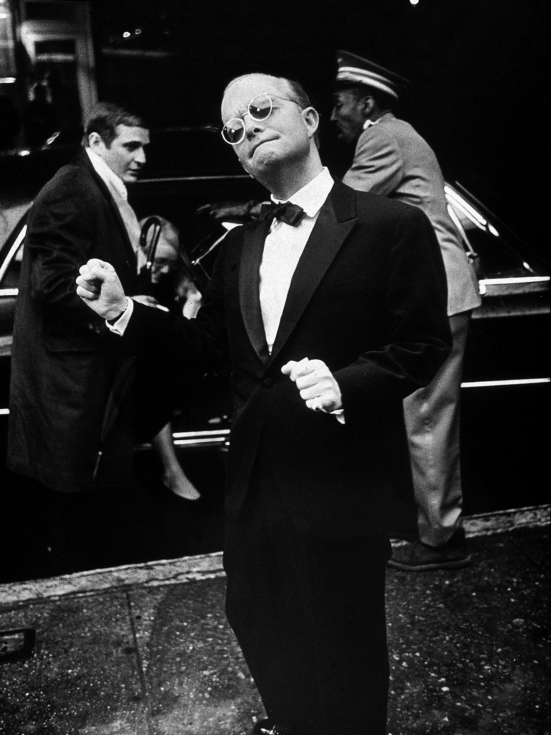

New York, Truman Capote

NEW YORK

It is a myth, the city, the rooms and windows, the steam-spitting streets; for anyone, everyone, a different myth, an idol-head with traffic-light eyes winking a tender green, a cynical red. This island, floating in river water like a diamond iceberg, call it New York, name it whatever you like; the name hardly matters because, entering from the greater reality of elsewhere, one is only in search of a city, a place to hide, to lose or discover oneself, to make a dream wherein you prove that perhaps after all you are not an ugly duckling, but wonderful, and worthy of love, as you thought sitting on the stoop where the Fords went by; as you thought planning your search for a city.

Have seen Garbo twice in the last week, once at the theater, where she sat in the next seat, and again at a Third Avenue antique shop. When I was twelve I had a tiresome series of mishaps, and so stayed a good deal in bed, spending most of my time in the writing of a play that was to star the most beautiful woman in the world, which is how I described Miss Garbo in the letter accompanying my script.

But neither play nor letter was ever acknowledged, and for a long time I bore a desperate grudge, one which was indeed not dispelled until the other night when, with an absolute turning over of the heart, I identified the woman in the adjoining seat. It was surprising to find her so small, and so vividly colored: as Loren MacIver pointed out, along with those lines one scarcely expects color, too.

Someone asked, “Do you suppose she is at all intelligent?,” which seems to me an outrageous question; really, who cares whether or not she is intelligent? Surely it is enough that such a face could even exist, though Garbo herself must have come to regret the rather tragic responsibility of owning it. Nor is it any joke about her wanting to be alone; of course she does. I imagine it is the only time she does not feel alone: if you walk a singular path, you carry always a certain grief, and one does not mourn in public.

Yesterday, at the antique store, she roamed around, quite intent about everything, not really interested in anything, and for one mad moment I thought I might speak to her, just to hear her voice, you know; the moment passed, thank heaven, and presently she was out the door.

I went to the window and watched her hurrying along the blue dusk street with that long, loping step. At the corner she hesitated, as if uncertain which direction she wanted. The street lights went on, and a trick of glare created suddenly on the avenue a blank white wall: wind lashing her coat, and alone, Garbo, still the most beautiful woman in the world, Garbo, a symbol, walked directly toward it.

Lunch today with M. Whatever is one to do about her? She says the money is gone finally, and unless she goes home, her family refuse absolutely to help. Cruel, I suppose, but I told her I did not see the alternative. On one level, to be sure, I do not think going home possible for her. She belongs to that sect most swiftly, irrevocably trapped by New York, the talented untalented; too acute to accept a more provincial climate, yet not quite acute enough to breathe freely within the one so desired, they go along neurotically feeding upon the fringes of the New York scene.

Only success, and that at a perilous peak, can give relief, but for artists without an art, it is always tension without release, irritation with no resulting pearl. Possibly there would be if the pressure to succeed were not so tremendous. They feel compelled to prove something, because middle-class America, from which they mostly spring, has withering words for its men of feeling, for its young of experimental intelligence, who do not show immediately that these endeavors pay off on a cash basis. But if a civilization falls, is it cash the inheritors find among the ruins? Or is it a statue, a poem, a play?

Which is not to say that the world owes M., or anyone, a living; alas, the way things are with her, she most likely could not make a poem, a good one, that is; still she is important, her values are balanced by more than the usual measure of truth, she deserves a finer destiny than to pass from belated adolescence to premature middle age, with no intervening period, and nothing to show.

Down the street there is a radio-repair shop run by an elderly Italian, Joe Vitale. Early in the summer there appeared across the front of his store a strange sign: The Black Wido. And in smaller lettering: WATCH THIS WINDOW FOR NEWS OF THE BLACK WIDO. So our neighborhood wondered, waited. A few days later two yellowed photographs were added to the display; these, taken some twenty years before, showed Mr. Vitale as a husky man dressed in a black knee-length bathing suit, a black swimming cap and a mask.

Typed captions below the pictures explained that Joe Vitale, whom we’d all known only as a stoop-shouldered, sad-eyed radio-repair man, had once been, in a more supreme incarnation, a champion swimmer and a lifeguard at Rockaway Beach.

We were warned to continue watching the windows; our reward came the following week: in a bold streamer, Mr. Vitale announced that The Black Wido was about to resume his career. There was a poem in the window, and the poem was called “The Dream of Joe Vitale”; it told of how he’d dreamed of again breasting the waves, conquering the sea.

On the next day appeared a final notice; it was an invitation, really, one which said we were all welcome to come to Rockaway on August 20, for this day he planned to swim from that beach to Jones Beach, a far piece. Through the intervening summer days, Mr. Vitale sat outside his store on a camp stool, observing the reactions of passers-by to his various declarations, sat there, dreamy and detached, nodding, smiling politely when neighbors stopped to wish him luck. A smart-aleck kid asked him why he’d left out the last letter of Wido, and he answered very gently that widow with a w is for ladies.

For a while nothing more happened. Then one morning the world woke up and laughed at the dream of Joe Vitale. His story was in every paper; the tabloids put his picture on the front pages. And sorry pictures they were, too, for here he was, in a moment not of triumph, but agony, here he was standing on the beach at Rockaway with policemen on either side.

And in their accounts this is the attitude most of the papers took: once upon a time there was a mad silly old man who rubbed himself with grease and trotted down to the sea, but when the lifeguards saw him out swimming so far, they put to their boats and brought him to shore; such a shy one, this comical old man, for the instant their backs were turned, he was off again, and so out the lifeguards rowed once more, and The Black Wido, forced upon the beach like a half-dead shark, returned to hear not the mermaids singing, but curses, catcalls, police whistles.

The proper thing to do would be to go and tell Joe Vitale how sorry you are, how brave you think him, and say, well, whatever you can; the death of a dream is no less sad than death, and, indeed, demands of those who have lost as deep a mourning. But his radio store is closed; it has been for a long time; there is no sign of him anywhere, and his poem has slipped from place, has fallen beyond view.

Hilary said to come and have tea before the other guests arrived. Even though he had an extravagant cold, he insisted on going ahead with the party; naturally, why not? Playing host is his cure-all. No matter whose house you may be in, if Hilary is there, it is his house, you are his guest.

Some think this a too high-handed attitude, but the real hosts are always pleased, for Hilary, with his large, spectacular appearance and roaring, giggling monologues, gives even the dreariest occasions a bubbling glamour.

Hilary so wants everyone to be glamorous, to be a story-book creature; somehow he persuades himself that the grayest folk are coated with legend-making glitter; what is more, he persuades them, too, and that in part accounts for the tenderness with which a usually not soft-hearted public refers to him.

Another appealing point is that Hilary is always the same; always making you laugh when you damn well want to cry; and there is this curious feeling that after you have gone, he does your crying for you. Hilary with a velvet lap robe spread over his knees, a telephone in one hand, a book in the other, a radio, a music box, another telephone and a phonograph all sounding in surrounding rooms.

When I arrived for tea, Hilary was propped up in bed, from which he intended to conduct his party. The walls of this room are papered with photographs, almost everyone he has ever known: maiden ladies, debutantes, somebody’s secretary, film stars, college professors, chorus girls, circus freaks, Westchester couples, businessmen: they may part with him, but he cannot bear to lose anyone; or anything. Books are piled in the corners, are sagging on shelves, among them his old school texts, and ancient theater programs, mounds of sea shells, broken records, dead flowers, amusement-park souvenirs turn the apartment into a wonderland attic.

A time may come when there is no Hilary; it would be easy to destroy him—it may be that someone will. Could it be that the transition from innocence to wisdom happens in that moment when we discover not all the world loves us? Most of us learn this too early. But Hilary does not know it yet. I hope he never does, for I should hate it if suddenly he saw he was playing in a playground all alone, and spending love upon an audience that had never been there.

August. Although the morning papers said simply fair and warm, it was apparent by noon that something exceptional was happening, and office workers, drifting back from lunch with the dazed, desperate expression of children being bullied, began to dial Weather. Toward midafternoon, as the heat closed in like a hand over a murder victim’s mouth, the city thrashed and twisted, but with its outcry muffled, its hurry hampered, its ambitions hindered, it was like a dry fountain, some useless monument, and so sank into a coma.

The steaming willow-limp stretches of Central Park were like a battlefield where many have fallen: rows of exhausted casualties lay crumpled in the dead-still shade, while newspaper photographers, documenting the disaster, moved sepulchrally among them. At night, hot weather opens the skull of a city, exposing its white brain and its central nerves, which sizzle like the inside of an electric-light bulb.

I should probably get a good deal more work done if I left New York. However, more than likely that is not true either. Until one is a certain age, the country seems a bore; and anyway, I like nature not in general, but in particular. Nevertheless, unless one is in love, or satisfied, or ambition-driven, or without curiosity, or reconciled (which appears to be the modern synonym for happiness), the city is like a monumental machine restlessly devised for wasting time, devouring illusions. After a little, the search, the exploration, can become sinisterly hurried, sweatingly anxious, a race over hurdles of Benzedrine and Nembutal.

Where is what you were looking for? And by the way, what are you looking for? It is misery to refuse an invitation; one is always declining them, only to put in a surprise appearance; after all, it is difficult to stay away when whispers eerily persist to suggest that in keeping to yourself, you’ve let love fly out the window, denied your answer, forever lost what you were looking for: oh to think! all this awaits a mere ten blocks away: hurry, put on your hat, don’t bother with the bus, grab a taxi, there now, hurry, ring the doorbell: hello, sucker, April fool.

Today is my birthday and, as always, Selma remembered: her customary offering, a dime carefully wadded in a sheet of john paper, arrived with the morning mail. In both time and age, Selma is my oldest friend; for eighty-three years she has lived in the same small Alabama town; a hooked little woman with parched cinder-dark skin and spicy, hooded eyes, she was for forty-seven years a cook in the house of my three aunts; but now that they are dead, she has moved to her daughter’s farm, just, as she says, to sit quiet and take her ease. But accompanying her gift there was a sort of note, and in it she said to make ready, for any day now she was going to take a Greyhound bus for that “grandus city.” It does not mean anything; she will never come; but she has been threatening to for as long as memory.

The summer before I first saw New York, and that was fourteen years ago, we used to sit talking in the kitchen, our voices strumming away the whole lazy day; and what we talked about mostly was the city where I was soon to go. It was her understanding that there were no trees there, nor flowers, and she’d heard it said that most of the people lived underground or, if not underground, in the sky. Furthermore, there were “no nourishin’ vittles,” no good butterbeans, black-eyes, okra, yams, sausage—like we had at home. And it’s cold, she said, yessireebobtail, go on up in that cold country, time we see you again your nose will have freeze and fall off.

But then Mrs. Bobby Lee Kettle brought over some picture slides of New York, and after that Selma began telling her friends that when I went North she was going with me. The town seemed to her suddenly shriveled and mean. And so my aunts bought her a round-trip ticket, the idea being that she should ride up with me, turn around and go back. Everything was fine until we reached the depot; and there Selma began to cry, and say that she couldn’t go, that she would die so far from home.

It was a sad winter, inside and out. For a child the city is a joyless place. Later on, when one is older and in love, it is the double vision of sharing with your beloved which gives experience texture, shape, significance. To travel alone is to journey through a wasteland. But if you love enough, sometimes you can see for yourself, and for another, too. That is the way it was with Selma.

I saw twice over everything: the first snow, and skaters skimming in the park, the fine fur coats of the funny cold country children, the Chute-the-Chute at Coney, subway chewing-gum machines, the magical Automat, the islands in the river and the glitter upon the twilight bridge, the blue upward floating of a Paramount band, the men who came in the courtyard day after day and sang the same ragged, hoarse songs, the magnificent fairy tale of a ten-cent store where one went after school to steal things; I watched, listened, storing up for the quiet kitchen-hours when Selma would say, as she did, “Tell stories about that place, true stories now, none of them lies.”

But mostly they were lies I told; it wasn’t my fault, I couldn’t remember, because it was as though I’d been to one of those supernatural castles visited by characters in legends: once away, you do not remember, all that is left is the ghostly echo of haunting wonder.

1946

The End