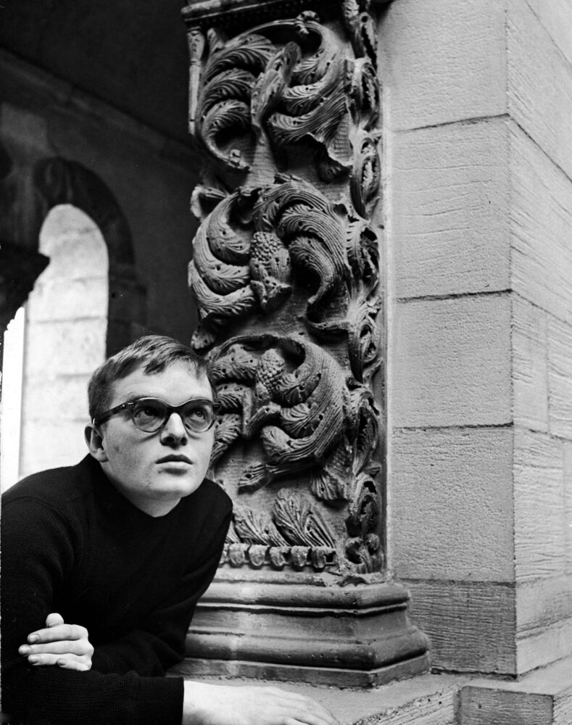

Remembering Tennessee, Truman Capote

REMEMBERING TENNESSEE

Tennessee Williams dead at 71.

So announced the headline on the front page of The New York Times. He had strangled, it turned out, while using a plastic bottle cap to take barbiturates; incredibly, the cap had popped down his throat and choked him to death. All of this had happened at the Elysée, a curious little hotel located in the East Fifties. Actually, Tennessee had an apartment in New York. But when he was in the city, he always stayed at the Elysée. The apartment, a small jumble of sparsely furnished rooms “conveniently” located on West 42nd Street, was reserved for the entertainment of kind strangers.

It was a strange end for a man obsessed with a rather poetic concept of death. Even as a young man, he was convinced that the next day would be his last. The only serious quarrel we ever had involved his hypochondriac sensitivity to this subject. At the time, he had a play in rehearsal: Summer and Smoke. We were having dinner together, and to amuse him (I thought), I began to tell him stories I had heard from members of the cast about the play’s director, a woman from Texas.

It seemed that at every rehearsal, she would assemble the cast and tell them what an effort they must make, how hard they must work, “because this flower of genius is Tenn’s last. He is dying. Yes, he is a dying man with only months left to live. He told me so himself. Of course, he’s always claiming to be dying. But this time I’m afraid it’s true. Even his agent believes it.”

Far from amusing my old friend, the anecdote enraged him. First he broke glasses and plates, then he turned over the entire table and stalked out of the restaurant, leaving me amazed—and also to pay for the destruction.

I was sixteen years old when I met him. He was thirteen years older than I was, a waiter at the Greenwich Village Café and a would-be playwright. We became great friends—it really was a sort of intellectual friendship, though people inevitably thought otherwise. In those early days he used to give me all of his short, one-act plays to read, and we would act them out together. Gradually, over the years, we built up The Glass Menagerie. I would play the daughter.

With his tendency toward around-the-clock sex and gin and general carousing, Tennessee, who was not a born survivor, probably would not have lasted beyond the age of forty if it hadn’t been for Frank Merlo.

Frank was a sailor, a wartime discovery of mine. Some five years after I met him, and when he was no longer involved with the Navy, Tennessee saw us lunching in a cozy Italian restaurant. I never saw him so excited, either before or since. He deserted his own luncheon companion—his agent, Audrey Wood—and swiftly, without any invitation, sat himself at our table. After I had introduced him to my friend, not two minutes passed before he said, “Could you have dinner with me tonight?”

The invitation clearly did not include me. But Frank was embarrassed; he didn’t know what to say. I answered for him: “Yes,” I said, “of course he’d like to have dinner with you.”

So he did. They were together for fourteen years, and those were the happiest years of Tennessee’s life. Frank was like a husband, a lover, a business agent to him. He also had a great gift for parties, which suited Tennessee just fine.

When Yukio Mishima, the brilliant Japanese writer—the one who formed an army and confronted the Japanese military commander and ended up committing hara-kiri—when he came to New York in 1952, Tennessee told Frank that he wanted to throw a party in Mishima’s honor. So Frank rounded up every geisha girl between New York and San Francisco, but he didn’t stop at that.

Then he outfitted about a hundred drag geishas. It was the most fantastic party I’d ever seen in my entire life. And Tennessee dressed up as a great geisha dame and they drove through the park all night till dawn, drinking champagne. This was Mishima’s first taste of life in the Western world, and he said, “I’m never going back to Japan.”

When Frank died of cancer in 1962, Tennessee died a little, too. I remember all too well the last hours of Frank’s life. He lived them in a New York hospital room, where crowds of friends drifted in and out. Finally, a stern doctor ordered the room rid of all visitors, including Tennessee. But he refused to leave. He knelt by the narrow bed and clutched Frank’s hand, pressing it against his cheek.

Nevertheless, the doctor told him he must go. But suddenly Frank whispered, “No. Let him stay. It can’t do me any harm. After all, I’m used to him.”

The doctor sighed and left them alone.

Tennessee was never the same after that. He had always drunk a good deal, but he started combining drugs and alcohol. He was also meeting some very strange people. I think he lived the last two decades of his life alone—with the ghost of Frank.

But now when I remember Tennessee, I think of the good times, the funny times. He was a person who, despite his inner sadness, never stopped laughing. He had a remarkable laugh. It wasn’t coarse or vulgar or even especially loud. It just had an amazing sort of throaty Mississippi-riverman ring to it. You could always tell when he had walked into a room, no matter how many people were there.

As for his sense of humor, normally it was pretty raucous. But when he got into a fury, he seemed to swing between two things: either very sick humor—laughing nonstop during those five-martini lunches of his—or deep bitterness, about himself, about his father, about his family. His father never understood him, his family seemed to blame him for his sister’s insanity, and Tennessee himself—well, I think he thought he was not very sane.

You could see all of this in his eyes, which had a changing in them, like a Ferris wheel of merriment and bitterness.

This isn’t to say that he wasn’t fun to be with. We used to go to the movies together, and I guess I’ve been thrown out of more movie houses with him than with anybody else in my life. He would always start reciting lines, making fun, doing Joan Crawford. Before long, the manager would come down and tell us to get out.

My funniest memory, though, is of four or five years ago, when I was staying with Tennessee in Key West. We were in a terrifically crowded bar—there were probably three hundred people in it, both gays and straights. A husband and wife were sitting at a little table in the corner, and they were both quite drunk. She had on a pair of slacks and a halter top, and she approached our table and held out an eyebrow pencil. She wanted me to autograph her belly button.

I just laughed and said, “Oh, no. Leave me alone.”

“How can you be so cruel?” Tennessee said to me, and as everyone in the place watched, he took the eyebrow pencil and wrote my name around her navel. When she got back to her table, her husband was furious. Before we knew it, he had grabbed the eyebrow pencil out of her hand and walked over to where we were sitting, whereupon he unzipped his pants and pulled out his cock and said—to me—“Since you’re autographing everything today, would you mind autographing mine?”

I had never heard a place with three hundred people in it get that quiet. I didn’t know what to say—I just looked at him.

Then Tennessee reached up and took the eyebrow pencil out of the stranger’s hand. “I don’t know that there’s room for Truman to autograph it,” he said, giving me a wink, “but I’ll initial it.”

It brought down the house.

The last time I saw him was a few weeks before he died. We had dinner together at a very private little place called Le Club, and Tennessee was fine physically, but sad. He said he had no friends anymore, that I was one of the few people in his life who really knew him. He wished we could be close the way we were in the old days.

And as he talked and the fireplace blazed, I thought, Yes, I did know him. And I remembered a night many, many years before when I first realized that that was true.

The year was 1947, and the opening night of A Streetcar Named Desire was a hauntingly dazzling event. As the lights dimmed on the final scene and Blanche DuBois, reaching out in the darkness for the guiding hands of a nurse and a doctor, whispered, “Whoever you are—I have always depended on the kindness of strangers,” a thrilling silence immobilized the audience. Terror and beauty had stopped their hearts. Even long after the curtain had descended, the hush continued. Then it was as if a cascade of balloons had exploded. The magnificent applause, the momentous rising of the audience to its feet, was as sudden and as breathtaking as a cyclone.

The stars, Jessica Tandy and Marlon Brando, took sixteen curtain calls before the “Author! Author!” demands were met. He was reluctant to be led onstage, this young Mr. Williams. He blushed as though it were the first time he had ever been kissed, and by strangers at that.

Certainly, he had not splurged on the evening (he had an overpowering fear of money, one so severe that even an occasion such as this could not make him succumb to thoughts of a new suit), so he was dressed in a dark blue that many a subway seat had shined; and his tie had become loosened; and one of the buttons on his shirt was dangling. But he was beguiling: short but trim, sturdy, healthy-colored. He held up two smallish plowman’s hands and quietened the ecstasy long enough to say, “Thank you.

Thank you very, very, very …” in a voice as sluggish and Southern as the Mississippi if the river were polluted with gin. What he felt, one felt, was joy, not happiness; joy is cocaine brief, but happiness has at least a little longer-lasting languor.

Tennessee was an unhappy man, even when he was smiling the most, laughing his loudest. And the truth was, at least to me, that Blanche and her creator were interchangeable; they shared the same sensitivity, the same insecurity, the same wistful lust. And suddenly, as one was thinking that and was watching his bows to the deafening clamor, he seemed to recede on the stage, to fade through the curtains—led by the same doctor who had guided Blanche DuBois toward undesirable shadows.

1983

The End