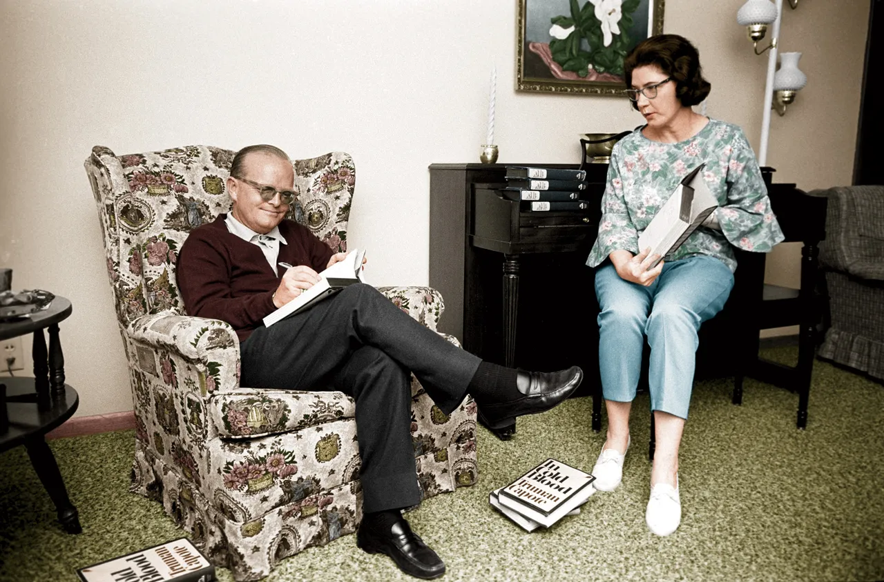

Remembering Willa Cather, Truman Capote

REMEMBERING WILLA CATHER

All of my relatives are southern, either from New Orleans or the rural regions of Alabama. At least 40 of the men, and possibly more, died during the Civil War, including my great-grandfather.

Long ago, when I was 10 or thereabouts, I became interested in these fallen soldiers because I read a large collection of their battlefield letters that our family had managed to keep. I was already interested in writing (in fact, had published small essays and stories in Scholastic magazine), and I decided to write an historical book based on the letters of these Confederate heroes.

Troubles interfered, and it was not until eight years later, when I was barely surviving as a very young journalist living in New York, that the subject of my Civil War kinfolk revived. Of course a great lot of research was necessary; the place I chose to do this research was the New York Society Library.

For several reasons. One being that it was winter, and this particular place, warm and clean and situated just off Park Avenue, provided a cozy haven the whole day long. Also, perhaps because of its location, the staff and clientele were a comfort in themselves: a bunch of upper-class, well-mannered literati. Some of the customers I saw frequently at the Library were more than that. Especially the blue-eyed lady.

Her eyes were the pale blue of a prairie dawn on a clear day. Also, there was something wholesome and countrified about her face, and it was not just an absence of cosmetics. She was of ordinary height and of a solid but not overly solid shape. Her clothing was composed of an unusual but somehow attractive combination of materials. She wore low-heeled shoes and thick stockings and a handsome turquoise necklace that went well with her soft tweed suits. Her hair was black and white and crisply, almost mannishly cut. The surprising, dominant factor was a beautiful sable coat which she almost never took off.

It was a good thing she had it on the day of the storm. When I left the library around four o’clock it looked as though the North Pole had moved to New York. Fist-sized snowballs pummeled the air.

The blue-eyed lady wearing the rich sable coat was standing at the curb. She was trying to hail a taxi. I decided to help her. But there were no taxis in view—indeed, very little traffic.

I said: “Maybe all the drivers have gone home.”

“It doesn’t matter. I live not too far from here.” Her deep soft voice drifted toward me through the heavy snow.

So I asked: “Then may I walk you home?”

She smiled. We walked together along Madison Avenue until we reached a Longchamps restaurant. She said: “I could use a cup of tea. Could you?” I said yes. But once we were settled at a table, I ordered a double martini. She laughed and asked if I was old enough to drink.

Whereupon I told her all about myself. My age. The fact I was born in New Orleans, and that I was an aspiring writer.

Really? What writers did I admire? (Obviously she was not a New Yorker: she had a Western accent.)

“Flaubert. Turgenev. Proust. Charles Dickens. E. M. Forster. Conan Doyle. Maupassant—”

She laughed. “Well. You certainly are varied. Except. Aren’t there any American writers you care for?”

“Like who?”

She didn’t hesitate. “Sarah Orne Jewett. Edith Wharton—”

“Miss Jewett wrote one good book: The Country of the Pointed Firs. And Edith Wharton wrote one good book: The House of Mirth. But. I like Henry James. Mark Twain. Melville. And I love Willa Cather. My Ántonia. Death Comes for the Archbishop. Have you ever read her two marvelous novellas—A Lost Lady and My Mortal Enemy?”

“Yes.” She sipped her tea, and put the cup down with a slightly nervous gesture. She seemed to be turning something over in her mind. “I ought to tell you—” She paused; then, in a rushing voice, more or less whispered: “I wrote those books.”

I was stunned. How could I have been so stupid? I had a photograph of her in my bedroom. Of course she was Willa Cather! Those flawless sky-like eyes. The bobbed hair; the square face with the firm chin. I hovered between laughter and tears. There was no living person I would rather have met; no one who could so have impressed me—not Garbo or Ghandi [sic] or Einstein or Churchill or Stalin. Nobody. She apparently realized that, and we were both left speechless. I swallowed my double martini in one gulp.

But soon we were on the street again. We trudged through the snow until we arrived at an expensive, old-fashioned address on Park Avenue. She said: “Well. Here is where I live”; then suddenly added: “If you’re free for dinner on Thursday, I’ll expect you at seven o’clock. And please bring some of your writing—I’d like to read it.”

Yes, I was thrilled. I bought a new suit, and retyped three of my short stories. And, come Thursday, I was on her doorstep promptly at seven.

I was still amazed to think that Willa Cather wore sable coats and occupied a Park Avenue apartment. (I had always imagined her as living on a quiet street in Red Cloud, Nebraska.) The apartment did not have many rooms, but they were large rooms which she shared with a lifelong companion, someone her own size and age, a discreetly elegant woman named Edith Lewis.

Miss Cather and Miss Lewis were so alike one could be certain they had decorated the apartment together. There were flowers everywhere—masses of winter lilac, peonies, and lavender-colored roses. Beautifully bound books lined all walls of the living room.

1984

The End