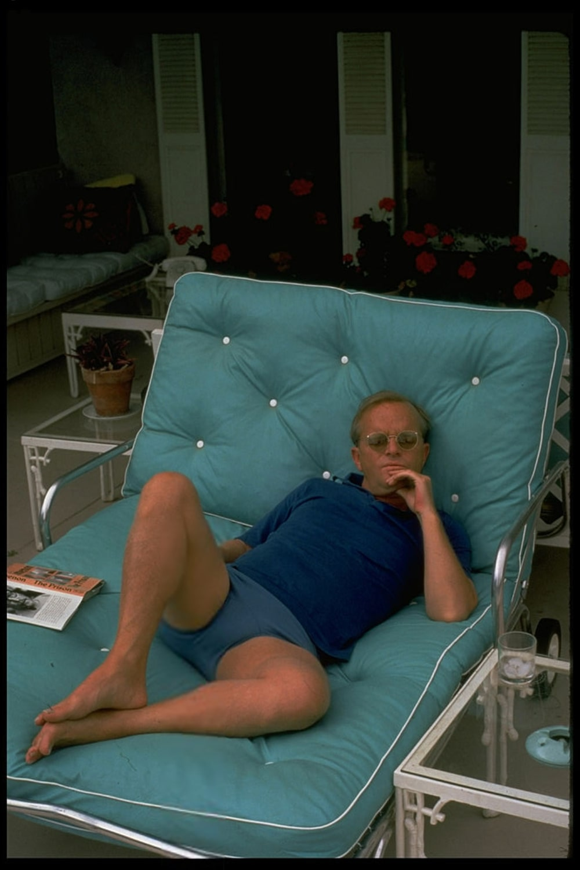

Tangier, Truman Capote

TANGIER

Tangier? It is two days by boat from Marseille, a charming trip that takes you along the coast of Spain, and if you are someone escaping from the police, or merely someone escaping, then by all means come here: hemmed with hills, confronted by the sea, and looking like a white cape draped on the shores of Africa, it is an international city with an excellent climate eight months of the year, roughly March to November.

There are magnificent beaches, really extraordinary stretches of sugar-soft sand and surf; and if you have a mind for that sort of thing, the nightlife, though neither particularly innocent nor especially varied, is dark to dawn, which, when you consider that most people nap all afternoon, and that very few dine before ten or eleven, is not too unusual.

Almost everything else in Tangier is unusual, however, and before coming here you should do three things: be inoculated for typhoid, withdraw your savings from the bank, say good-bye to your friends—heaven knows you may never see them again. This advice is quite serious, for it is alarming, the number of travelers who have landed here on a brief holiday, then settled down and let the years go by.

Because Tangier is a basin that holds you, a timeless place; the days slide by less noticed than foam in a waterfall; this, I imagine, is the way time passes in a monastery, unobtrusive and on slippered feet; for that matter, these two institutions, a monastery and Tangier, have another common denominator: self-containment. The average Arab, for example, thinks Europe and America are the same thing and in the same place, wherever that may be—in any event, he doesn’t care; and frequently Europeans, hypnotized by the tinkling of an oud and the swarming drama around them, come to agree.

One spends a great lot of time sitting in the Petit Soko, a café-cluttered square at the foot of the Casbah. Offhand, it seems to be a miniature version of the Galleria in Naples, but on closer acquaintance it assumes a character so grotesquely individual you cannot fairly compare it with any other place in the world. At no hour of the day or night is the Petit Soko not crowded; Broadway, Piccadilly, all these places have their off moments, but the little Soko booms around the clock.

Twenty steps away, and you are swallowed in the mists of the Casbah; the apparitions drifting out of these mists into the hurdy-gurdy clamor of the Soko make a lively show: it is a display ground for prostitutes, a depot for drug-peddlers, a spy center; it is also the place where some simpler folk drink their evening apéritif.

The Soko has its own celebrities, but it is a precarious honor, one is so likely at any second to be cut down and cast away, for the Soko audience, having seen just about everything, is excessively fickle. Currently, however, they are starring Estelle, a beautiful girl who walks like a rope unwinding. She is half-Chinese and half-Negro, and she works in a bordello called the Black Cat.

Rumor has it that she once was a Paris model, and that she arrived here on a private yacht, planning, of course, to leave by the same means; but it appears that the gentleman to whom the yacht belonged sailed away one fine morning, leaving Estelle stranded. For a while there Maumi was giving her rather a race; the Soko appreciated Maumi’s talents, both as a flamenco dancer and as a conversationalist: wherever he sat, there were always loud bursts of laughter.

Alas, poor Maumi, an exotic young man given to cooling his face with a lacy fan, was stabbed in a bar the other night, and is now out of the running. Less heralded, but to me more intriguing, are Lady Warbanks and her two hangers-on, a curious trio that arrive each morning and have their breakfast at one of the sidewalk tables: this breakfast is unvarying—a bowl of fried octopus and a bottle of Pernod.

Someone who ought really to know says that at one time the now very déclassé Lady Warbanks was considered the greatest beauty in London; probably it is true, her features are finely made and she has, despite the tight sailor suits she lumps herself into, a peculiar innate style. But her morals are not all they might be, and the same may be said of her companions.

About these two: one is a sassy-faced, busy youth whose tongue is like a ladle stirring in a cauldron of scandal—he knows everything; and the other friend is a tough Spanish girl with brief, slippery hair and leather-colored eyes. She is called Sunny, and I am told that financed by Lady Warbanks, she is on her way to becoming the only female in Morocco with an organized gang of smugglers: smuggling is a high-powered profession here, employing hundreds, and Sunny, it appears, has a boat and crew that nightly runs the Straits to Spain.

The precise relation of these three to each other is not altogether printable; suffice to say that between them they combine every known vice. But this does not interest the Soko, for the Soko is concerned by quite another angle: how soon will Lady Warbanks be murdered, and which of the two will do it, the young man or Sunny? She is very rich, the Englishwoman, and if it is greed, as so obviously it is, that holds her companions, then clearly violence is indicated. Everyone is waiting. Meanwhile, Lady Warbanks sits innocently nibbling octopus and sipping her morning Pernod.

The Soko is also something of a fashion center, a proving ground for the latest fads. One innovation that has got off to a popular start among the flashier types are shoes with ribbon laces that wind right up to the knee. They are unbecoming, but not nearly so regrettable as the passion for dark glasses that has developed among Arab women, whose eyes, peering just above their veiling, have been always so provocative. Now all one sees are these great black lenses imbedded like coal-hunks in a snowball of cloth.

Of an evening at seven the Soko reaches its height. It is the crowded apéritif hour, some twenty nationalities are rubbing elbows in the tiny square, and the hum of their voices is like the singing of giant mosquitoes. Once, when we were sitting there, a sudden silence fell: an Arab orchestra, trumpeting in a gay style, moved along up the street past the bright cafés—it was the only cheerful Moorish music I’ve ever heard, all the rest sounds like a sad and fragmentary wailing.

But death, it would seem, is not an unhappy event among Arabs, for this orchestra proved to be the vanguard of a funeral procession that then came joyfully winding through the throng. Presently the corpse, a half-naked man carried on an open litter, wobbled past, and a rhinestone lady, leaning from her table, sentimentally saluted him with a glass of Tio Pepe: a moment later she was laughing gold-toothed laughter, plotting, planning. And so was the little Soko.

“If you are going to write something about Tangier,” said a person to whom I applied for certain information, “please leave out the riffraff; we have a lot of nice people here, and it’s hard on us that the town has such a bad reputation.”

Well, and though I’m not at all sure our definitions coincide, there are at least three people I think eminently nice. Jonny Winner, for instance. A sweet, funny girl, Jonny Winner. She is very young, very American, and you would never believe, looking at her clouded, wistful face, that she is able to take care of herself: to tell the truth, I don’t think she is.

Nevertheless, she has lived here two years, been across Morocco and to the Sahara alone. Why Jonny Winner wants to spend the rest of her life in Tangier is of course her own business; obviously she is in love: “But don’t you love it, too? to wake up and know that you’re here, and know that you can always be yourself, never be anyone that isn’t you?

And always to have flowers, and to look out your window and see the hills getting dark and the lights in the harbor? Don’t you love it, too?” On the other hand, she and the town are always at war; whenever you meet her she is undergoing a new crise: “Have you heard? the most awful mess: some fool in the Casbah painted his house yellow, and now everybody’s doing it—I’m just on my way to see if I can’t put a stop to the whole thing.”

The Casbah, traditionally blue and white, like snow at twilight, would be hideous painted yellow, and I hope Jonny gets her way—though certainly she has had no success in her campaign to keep them from clearing the Grand Soko, a heartrending business that has reduced her to prowling the streets, in tears. The Grand Soko is the great Arab market square: Berbers, down from the mountains with their goatskins and baskets, squat in circles under the trees listening to storytellers, flute players, magicians; cornucopia stalls spill over with flowers and fruit; hashish fume and the minty scent of thé Arabe cling to the air; vivid spices burn in the sun.

All this is to be moved elsewhere, presumably to make way for a park, and Jonny is wringing her hands: “Why shouldn’t I be upset? I feel as though Tangier were my house, and how would you like it if somebody came into your house and started moving the furniture around?”

So she has been out saving the Soko in four languages, French, Spanish, English and Arabic; though she speaks all of these exceedingly well, the closest she has come to official sympathy is the doorman at the Dutch consulate, and her only real emotional support has been an Arab taxi driver, who thinks her not the least mad and drives her around free of charge. One late afternoon a few days ago we saw Jonny dragging along through her beloved, dissolving Grand Soko; she looked absolutely done in, and she was carrying a mangy, sore-covered kitten.

Jonny has a way of launching right into what she wants to say, and she said, “I was feeling just as though I couldn’t go on living, and then I found Monroe. This is Monroe”—she patted the kitten—“and he’s made me ashamed: he’s so interested in living, and if he can be, why shouldn’t I?”

Looking at them, Jonny and the kitten, both so bedraggled and bruised, you knew that somehow something would see them through: if not common sense, then their interest in life.

Ferida Green has plenty of common sense. When Jonny spoke to her about the situation in the Grand Soko, Miss Green said, “Oh, my dear, you mustn’t worry. They are always tearing down the Soko, but it never really happens; I remember in 1906 they wanted to make it into a whaling center: imagine the odor!”

Miss Ferida is one of the three great Green ladies of Tangier, which includes her cousin, Miss Jessie, and her sister-in-law, Mrs. Ada Green; between them they manage more often than not to have the last say here. All three are past seventy: Mrs. Ada Green is famous for her chic, Miss Jessie for her wit, and Miss Ferida, the oldest, for her wisdom. She has not visited her native England in over fifty years; even so, observing the straw skimmer skewered to her hair and the black ribbon trailing from her pince-nez, one knows she goes out in the noonday sun and has never given up tea at five. Every Friday in her life there is a ritual known as Flour Morning.

Seated at a table at the foot of her garden, and judging each case as it is presented, she rations flour to Arab applicants, usually old women who otherwise would starve: from the flour they make a paste which must last them until the next Friday. There is much joking and laughter, for the Arabs adore Miss Ferida, and for her, all these old women, such anonymous bundles of laundry to the rest of us, are friends whose personalities she comments on in a large ledger. “Fathma has a bad temper but is not bad,” she writes of one, and of another: “Halima is a good girl. One can take her at face value.”

And that, I suppose, is what you would have to say about Miss Ferida.

Anyone in Tangier longer than overnight is bound to hear about Nysa: how at the edge of twelve she was taken off the streets by an Australian who, in true Pygmalion fashion, created out of this raggedy Arab child an accomplished, extremely elegant personage. Nysa is, as far as I know, the only example in Tangier of a Europeanized Arab woman, a fact which, strangely, no one quite forgives her, neither the Europeans, nor the Arabs, who are avowedly bitter and who, because she lives in the Casbah, have constant opportunity to vent their malice: women send their children to scrawl obscenities on her door, men do not hesitate to spit at her on the street—for in their eyes she has committed the gravest sin possible: become a Christian.

Such a situation must make for terrible resentment, but Nysa, at least as far as surface appearances go, never seems aware that there is anything to resent. She is a charming, calm girl of twenty-three; it is in itself an entertainment just to sit quietly and marvel over her beauty, the tilted eyes and the flowerlike hands. She does not see many people; like the princess in a storybook, she stays behind the walls and in the shade of her patio, reading, playing with her cats and a large white cockatoo who mimics whatever she does: sometimes the cockatoo flares forward and kisses her on the lips.

The Australian lives with her; since he found her as a child she has never for a moment been separated from him; if something should happen to him, there really would be no way for Nysa to turn: she could not ever be an Arab again, and it isn’t likely that she could pass completely into a European world.

But the Australian is an old man now. One day I rang Nysa’s bell; no one came to answer. There is a grillwork at the top of the door; peering, I saw her through a veil of vine and leaves standing in the shadows of her patio. When I rang again she remained dark and still as a statue. Later I heard that during the night the Australian had had a stroke.

At the end of June, and with the start of a new moon, Ramadan begins. For the Arabs, Ramadan is a month of abstinence. As dark comes on, a colored string is stretched in the air, and when the string grows invisible, conch horns signal the Arabs to the food and drink that during the day they cannot touch.

These dark-night feasts emanate a festive spirit that lasts until dawn. From distant towers oboe players serenade before prayers; drums, hidden but heard, tom-tom behind closed doors, and the voices of men, singsonging the Koran, carry out of the mosques into the narrow, moon-bright streets. Even high on the mountain above Tangier you can hear the oboe player wailing in the far-off dark, a solemn thread of melody winding across Africa from here to Mecca and back.

Sidi Kacem is a limitless, Sahara-like beach bordered by olive groves; at the end of Ramadan, Arabs from all over Morocco arrive at Sidi Kacem in trucks, astride donkeys, on foot: for three days a city appears there, a fragile dream city of colored lights and cafés under lantern-lighted trees. We drove out there around midnight; the first glimpse of the city was like seeing a birthday cake blazing in a darkened room, and it filled you with the same exciting awe: you knew you could not blow out all the candles.

Right away we got separated from the people we’d come with, but in the surge and sway it was impossible to stay together, and after the first few frightened moments we never bothered looking for them; the night caught us in its hand and there was nothing to do but become another of the masked, ecstatic faces flashing in the torch-flare. Everywhere little orchestras played.

Voices, sweet and sultry as kif smoke, chanted over drums, and somewhere, stumbling through the silver, floating trees, we got smothered in a crowd of dancers: a circle of old bearded men beat the rhythm, and the dancers, so concentrated you could put a pin in them, rippled as though wind were moving them around. According to the Arab calendar this is the year 1370; seeing a shadow through the silk of a tent, watching a family fry honeycakes on a flat twig fire, moving among the dancers and hearing the trill of a lonely flute on the beach, it was simple to believe that one was living in 1370 and that time would never move forward.

Occasionally we had to rest; there were straw mats under the olive trees, and if you sat on one of these, a man would bring you a glass of hot mint tea. It was while we were drinking tea that we saw a curious line of men file past. They wore beautiful robes, and the man in front, old like a piece of ivory, carried a bowl of rose water which, to the accompaniment of bagpipes, he sprinkled from side to side.

We got up to follow them, and they took us out of the grove onto the beach. The sand was as cold as the moon; humped dunes of it drifted toward the water, and flickers of light burst in the dark like fallen stars. At last the priest and his followers went into a temple which it was forbidden us to enter, and so we wandered down across the beach. J. said, “Look, a shooting star”; and then we counted the shooting stars, there were so many. Wind whispered on the sand like the sound of the seas; cutthroat figures outlined themselves against the kneeling orange moon, and the beach was as cold as a snowfield, but J. said, “Oh, I can’t keep my eyes open any longer.”

We woke up in a blue, almost dawn light. We were high on a dune, and there below us, spread along the shore, were all the celebrants, their brilliant clothes fluttering in the morning breeze. Just as the sun touched the horizon a great roar went up, and two horsemen, riding bareback, splashed through the surf and swept down the beach. Like a lifting curtain sunrise crept toward us across the sand, and we shuddered at its coming, knowing that when it reached us we would be back in our own century.

1950

The end