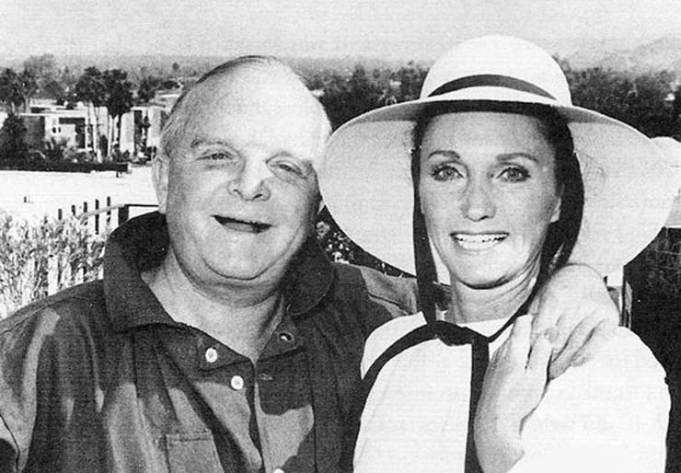

The Bargain, Truman Capote

The Bargain

Several things about her husband irritated Mrs. Chase. For instance, his voice: he sounded always as though he were bidding in a poker game. To hear his unresponsive drawl was exasperating, especially now when, talking to him on the telephone, she herself was strident with excitement. “Of course I already have one, I know that. But you don’t understand, dear—it’s a bargain,” she said, stressing the last word, then pausing to let its magic develop. Simply silence happened. “Well, you could say something. No, I’m not in a shop, I’m at home. Alice Severn is coming for lunch. It’s her coat that I’m trying to tell you about. Certainly you remember Alice Severn.” His leaky memory was another irritant, and though she reminded him that out in Greenwich they had often seen Arthur and Alice Severn, had, in fact, entertained them, he pretended no knowledge of the name. “It doesn’t matter,” she sighed. “I’m only going to look at the coat anyway. Have a good lunch, dear.”

Later, as she fussed with the precise waves of her touched-up hair, Mrs. Chase admitted that really there was no reason why her husband should have remembered the Severns too clearly. She realized this when, with faulty success, she tried to arouse an image of Alice Severn. There, she almost had it: a rosy, gangling woman, less than thirty, and always riding in a station-wagon accompanied by an Irish setter and two beautiful, gold-red children. It was said that her husband drank; or was it the other way round? Then, too, they were supposed to be a bad credit risk, at least Mrs. Chase recalled once hearing of incredible debts, and someone, was it herself?, had described Alice Severn as just too bohemian.

Before moving into the city, the Chases had kept a house in Greenwich, which was a bore to Mrs. Chase, for she disliked the hint of nature there and preferred the amusement of New York shop windows. In Greenwich, at a cocktail party, at the railway station, they’d now and again encountered the Severns, that was all it had amounted to. We were not even friends, she concluded, somewhat surprised. As so often happens when one hears suddenly from a person of the past, and someone known in a different context, she had been startled into a feeling of intimacy. On second thought, however, it seemed extraordinary of Alice Severn, whom she’d not seen in over a year, to have called offering for sale a mink coat.

Mrs. Chase stopped in the kitchen to order a soup and salad lunch: it never occurred to her that not everyone was on a diet. She filled a sherry decanter and brought it with her into the living room. It was a green glass–bright room, rather like her too-youthful taste in clothes. Wind bustled the windows, for the apartment was high-up with an aeroplane view of downtown Manhattan. She put a linguaphone record on a phonograph, and sat in an unrelaxed position listening to the strained voice pronouncing French phrases. In April the Chases planned to celebrate their twentieth anniversary with a trip to Paris; for this reason she had undertaken the linguaphone lessons, and for this reason, too, she considered Alice Severn’s coat: it was more practical, she felt, to travel in a second-hand mink; later on, she might have it made into a stole.

Alice Severn arrived a few minutes early, an accident, certainly, for she was not an anxious person, at least judging from her subdued, ambling manner. She wore sensible shoes, a tweed suit that had seen its best days, and carried a box tied with scrappy cord.

“I was so delighted when you called this morning. Heaven knows, it’s been an age, but of course we never get to Greenwich anymore.”

Though smiling, her guest remained silent, and Mrs. Chase, keyed to an effusive style, was a little taken aback. As they seated themselves her eyes caught at the younger woman, and it occurred to her that if they had met casually she might not have known her, not because her appearance was so very altered, but because Mrs. Chase realized that she had never before looked closely at her, which seemed odd, for Alice Severn was someone you would notice. If she had been less long, more compact, one might have passed over her, perhaps remarking that she was attractive. As it was, with her red hair, the sense of distance in her eyes, her freckled, autumnal face and gaunt, strong hands, there was a distinction about her not easily disregarded.

“Sherry?”

Alice Severn nodded, and her head, balanced precariously on her thin neck, was like a chrysanthemum too heavy for its stalk.

“Cracker?” offered Mrs. Chase, observing that anyone so lean and stretched-out must eat like a horse. Her soup-and-salad skimpiness gave her a sudden qualm, and she told the following lie: “I don’t know what Martha’s making for lunch. You know how difficult it is on short notice. But tell me, dear, what is happening in Greenwich?”

“In Greenwich?” she said, her eyelids beating, as though an unexpected light had flared in the room. “I have no idea. We haven’t lived there for some while, six months or more.”

“Oh?” said Mrs. Chase. “You see how far behind I am. But where are you living, dear?”

Alice Severn lifted one of her bony awkward hands and waved it toward the windows. “Out there,” she said, peculiarly. Her voice was plain, but it had an exhausted quality, as though she were coming down with a cold. “In town, I mean. We don’t like it much, Fred especially.”

With the dimmest inflection, Mrs. Chase said, “Fred?” for she perfectly remembered Arthur as the name of her guest’s husband.

“Yes, Fred, my dog, an Irish setter, you must have seen him. He’s used to space, and the apartment is so small, a room really.”

Hard days indeed must have fallen if all the Severns were living in one room. Curious as she was, Mrs. Chase checked herself and did not inquire into this. She tasted her sherry and said, “Of course I remember your dog; and the children: all three of their red heads hanging out of your station-wagon.”

“The kids haven’t red hair. They’re blondes, like Arthur.”

The correction was given so humorlessly that Mrs. Chase was provoked into a puzzled small laugh. “And Arthur, how is he?” she said, preparing to stand and lead the way to lunch. But Alice Severn’s answer made her sit down again. Delivered with no change in her placidly undecorated expression, it consisted of only: “Fatter.

“Fatter,” she repeated after a moment. “The last time I saw him, I guess it was only a week ago, he was crossing a street, almost waddling. If he had seen me, I would’ve had to laugh: he was always so finicky about his figure.”

Mrs. Chase touched her hips. “You and Arthur. Separated? It’s simply remarkable.”

“We’re not separated.” She brushed her hand in the air as though to clear away cobwebs. “I’ve known him since I was a child, since we both were children: do you think,” she said quietly, “that we could ever be separate of each other, Mrs. Chase?”

The exact use of her name seemed to exclude Mrs. Chase; fleetingly she felt herself sealed off, and as they went together toward the dining room she imagined a hostility to move between them. Possibly it was the sight of Alice Severn’s gawky hands fumblingly unfolding a napkin that persuaded her this was not true. Except for courteous exchanges they ate in silence, and she was beginning to fear there was not to be a story.

At last, “As a matter of fact,” said Alice Severn, blurting it, “we were divorced last August.”

Mrs. Chase waited; then, between the dip and rise of her soup spoon, said, “How awful. His drinking, I suppose?”

“Arthur never drank,” she answered with a pleasant but astonished smile. “That is, we both did. We drank for fun, not to be mean. It was very nice in the summer. We used to go down to the brook and pick mint and make mint juleps, huge ones in fruitjars. Sometimes, on hot nights when we couldn’t sleep, we used to fill the thermos full of cold beer and wake up the kids, then we would drive out to the shore: it’s fun to drink beer and swim and sleep on the sand. Those were lovely times; I remember once we stayed till daylight.

No,” she said, some serious idea tightening her face, “I’ll tell you. I’m almost a head taller than Arthur, and I think it worried him. When we were children he always thought he would outgrow me, but then he never did. He hated to dance with me, and he loves to dance. And he liked a lot of people around, tiny little people with high voices. I’m not like that, I wanted just us. In those ways I wasn’t a pleasure to him. Now, you remember Jeannie Bjorkman? The one with the round face and the curls, about your height.”

“I should say I do,” said Mrs. Chase. “She was on the Red Cross committee. Dreadful.”

“No,” said Alice Severn, pondering, “Jeannie isn’t dreadful. We were very good friends. The strange thing is, Arthur used to say he hated her, but then I guess he was always crazy about her, certainly he is now, and the kids, too. Somehow I wish the kids didn’t like her, though I should be happy that they do, since they have to live with her.”

“It isn’t true: your husband married to that awful Bjorkman girl!”

“Since August.”

Mrs. Chase, pausing first to suggest that they have coffee in the living room, said, “It’s outrageous for you to be living alone in New York. At least you could have the children with you.”

“Arthur wanted them,” said Alice Severn simply. “But I’m not alone. Fred is one of my closest friends.”

Mrs. Chase gestured impatiently: she did not enjoy fantasy. “A dog. It’s nonsense. There is nothing to think except that you’re a fool: any man that tried to walk over me would get his feet cut to pieces. I suppose you haven’t even arranged that he should,” she hesitated, “should contribute.”

“You don’t understand, Arthur hasn’t any money,” said Alice Severn with the dismay of a child who has discovered that grownups after all are not very logical. “He’s even had to sell the car and walks back and forth between the station. But you know, I think he’s happy.”

“What you need is a good pinch,” said Mrs. Chase, as though she were ready to do the job.

“It’s Fred that bothers me. He’s used to space, and only one person doesn’t leave many bones. Do you suppose that when I finish my course I could get a job in California? I’m studying at a business school, but I’m not awfully quick, especially at typing, my fingers seem to hate it so. I guess it’s like playing the piano, you should learn when you’re very young.” She glanced speculatively at her hands, sighing. “I have a lesson at three; would you mind if I showed you the coat now?”

The festiveness of things coming out of a box could usually be counted on to cheer Mrs. Chase, but as she saw the lid taken off, a melancholy uneasiness cornered her.

“It belonged to my mother.”

Who must have worn it sixty years, thought Mrs. Chase, facing a mirror. The coat hung to her ankles. She rubbed her hand against the lusterless, balding fur and it was moldy, sour, as though it had lain in an attic by the seashore. It was cold inside the coat, she shivered, at the same time a flush heated her face, for just then she noticed that Alice Severn was gazing over her shoulder, and in her expression there was a drawn, undignified expectancy that had not been there before.

Where sympathy was concerned, Mrs. Chase knew thrift: before giving it she took the precaution of attaching a string, so that if necessary it could be yanked back. Looking at Alice Severn, however, it was as though the string had been severed, and for once she was confronted head-on with the obligations of sympathy. She wriggled even so, hunting a loophole, but then her eyes collided with those other eyes, and she saw there was none. The recollection of a word from her linguaphone lessons made a certain question easier: “Combien?” she said.

“It isn’t worth anything, is it?” There was confusion in the asking, not frankness.

“No, it isn’t,” she said tiredly, almost testily. “But I may have some use for it.” She did not inquire again; it was clear that part of her obligation was to be fulfilled by fixing a price herself.

Still trailing the clumsy coat, she went to a corner of the room where there was a desk and, writing with resentful jabs, made a check on her private account: she did not intend that her husband should know. More than most Mrs. Chase despised the sense of loss; a misplaced key, a dropped coin, quickened her awareness of theft and the cheats of life. Some similar sensation was with her as she handed the check to Alice Severn who, folding it, and without looking at it, put it in her suit pocket. It was for fifty dollars.

“Darling,” said Mrs. Chase, grim with spurious concern, “you must ring me and let me know how everything is going. You mustn’t feel lonely.”

Alice Severn did not thank her, and at the door she did not say goodbye. Instead, she took one of Mrs. Chase’s hands in her own and patted it, as though she were gently rewarding an animal, a dog. Closing the door, Mrs. Chase stared at her hand, brought it near her lips. The feel of the other hand was still upon it, and she stood there, waiting while it drained away: presently her hand was again quite cold.

1950

The End