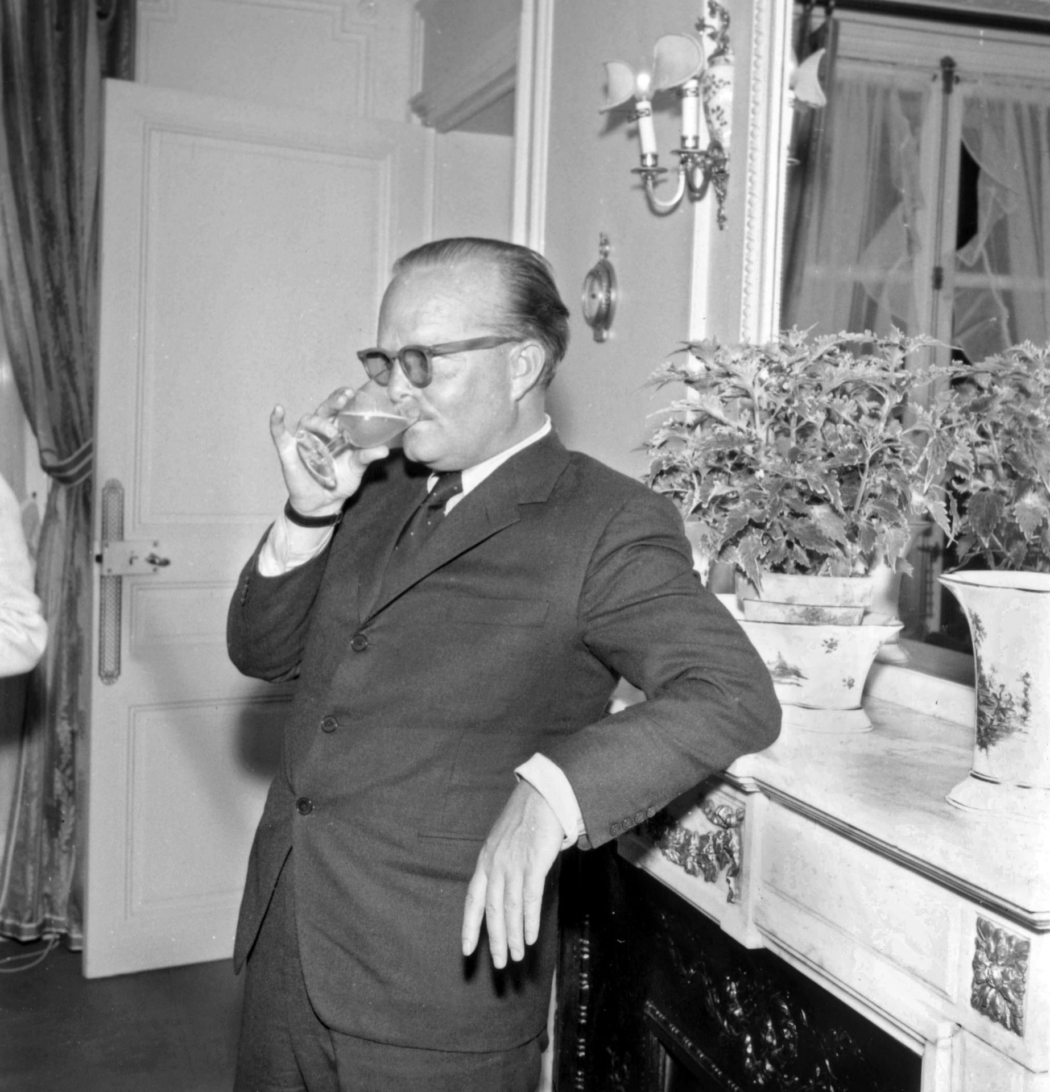

The Shape of Things, Truman Capote

The Shape of Things

A wispish-sized, white pompadoured woman swayed down the dining-car aisle and inched into a seat next to a window. She finished penciling her order and squinted near-sightedly across the table at a ruddy-cheeked Marine and a heart-faced girl. In one sweep she noted a gold band on the girl’s finger, a string of red cloth twisted in her hair and decided she was cheap; mentally labeled her war bride. She smiled faintly, inviting conversation.

The girl beamed back, “You was lucky you come so early on account of it’s so crowded. We didn’t get no lunch ’cause there was Russian soldiers eatin’ … or somethin’. Gosh you should’ve seen them, looked just like Boris Karloff, honest!”

It was a voice like a chirping teakettle and caused the woman to clear her throat. “Yes, I’m sure,” she said. “Before this trip I never dreamt there were so many in the world, soldiers, I mean. You just never realize until you get on a train. I keep asking myself, where do they all come from?”

“Draft boards,” the girl said, and then giggled foolishly.

Her husband blushed apologetically. “You goin’ all the way, ma’am?”

“Presumably, but this train’s as slow as … as …”

“Molasses!” the girl exclaimed and followed breathlessly with, “Gee, I’m so excited, you can’t imagine. All day I’ve been just glued to the scenery. Where I come from in Arkansas it’s all kinda flat, so I get an extra thrill right from my toes when I see these mountains.” And turning to her husband, “Honey, d’ya suppose we’re in Carolina?”

He looked out the window where the dusk was thickening on the pane. Gathering swiftly the blue light and the hill humps blending and echoing one another. He blinked back into the diner’s brightness. “Must be Virginia,” he guessed and shrugged his shoulders.

From the direction of the coaches a soldier suddenly lurched awkwardly toward them and collapsed in the table’s empty seat like a rag doll. He was small and his uniform spilled over him in crumpled folds. His face, lean and sharp featured, contrasted palely with the Marine’s and his black, crew-cropped hair shone under the light like a cap of sealskin. With tired eyes foggily studying the three as though there were a screen flung between them, he picked nervously at two chevrons sewn on his sleeve.

The woman shifted uncomfortably and pressed nearer the window. She thoughtfully tagged him drunk, and seeing the girl wrinkle up her nose knew she shared the verdict.

While the white-aproned negro unloaded his tray the Corporal said, “What I want is coffee, a big pot of it and a double jigger of cream.”

The girl dipped her fork into the creamed chicken. “Dontcha think what these folks charge for their stuff is awful, dear?”

And then it began. The Corporal’s head started to bob in short uncontrollable jerks. A lolling pause with his head bent grotesquely forward; a muscle convulsion snapping his neck sideways. His mouth stretched nastily and the neck veins tautened.

“Oh my God,” the girl cried and the woman dropped her butter knife and automatically shaded a sensitive hand over her eyes. The Marine stared vacantly for a moment, then quickly recovering he pulled out a pack of cigarettes.

“Here, fella,” he said, “you better have one.”

“Please, thanks … very kind,” the soldier muttered and then beat a knuckle-white fist against the table. Silverware trembled, water wasted over the glass tops. A stillness paused in the air and a distant burst of laughter sliced evenly through the car.

Then the girl, aware of attention, smoothed a lock of hair behind her ear. The woman looked up and bit her lip when she saw the Corporal trying to light his cigarette.

“Here, let me,” she volunteered.

Her hand shook so badly that the first match went out. When the second attempt connected she managed a trite smile. After a while he quieted. “I’m so ashamed … please forgive me.”

“Oh, we understand,” the woman said. “We understand perfectly.”

“Did it hurt?” the girl asked.

“No, no, it doesn’t hurt.”

“I was scared ’cause I thought it hurt. It sure looks that way. ’Spose it’s sorta like hiccups?” She gave a sudden start as though someone had kicked her.

The Corporal traced his finger along the table rim and presently he said, “I was all right till I got on the train. They said I’d be fine. Said, ‘You’re o.k., soldier.’ But it’s the excitement, the knowing you’re in the States and free and the goddamned waiting’s over.” He brushed at his eye.

“I’m sorry,” he said.

The waiter set the coffee down and the woman tried to help him. With a little angry push he shoved her hand away. “Now please don’t. I know how!” Embarrassingly confused she turned to the window and met her face mirrored there. The face was calm and it surprised her because she felt a dizzy unreality as if she were swinging between two dream points.

Channeling her thoughts elsewhere she followed the solemn trip of the Marine’s fork from plate to mouth. The girl was eating now very voraciously but her own food was growing cold.

Then it began again, not violently as before. In the rawish glare of an oncoming train’s searchlight distorted reflection blurred and the woman sighed.

He was swearing softly and it sounded more as though he were praying. Then he frantically clutched the sides of his head in a strong hand vise.

“Listen, fella, you betta get a doctor,” the Marine suggested.

The woman reached out and rested her hand on his upraised arm. “Is there anything I can do?” she said.

“What they used to do to stop it was look in my eyes … as long as I’m looking in somebody’s eyes it’ll quit.”

She leaned her face close to his. “There,” he said, quieting instantly, “there, now. You’re a sweetheart.”

“Where was it?” she said.

He frowned and said, “There was lots of places … it’s my nerves. They’re all torn up.”

“And where are you going now?”

“Virginia.”

“And that’s home, isn’t it?”

“Yeah, that’s where home is.”

The woman felt an ache in her fingers and loosened her suddenly intense grip on his arm. “That’s where home is and you must remember that the other is unimportant.”

“You know something,” he whispered. “I love you. I love you because you’re very silly and very innocent and ’cause you’ll never know anything but what you see in pictures. I love you ’cause we’re in Virginia and I’m almost home.” Abruptly the woman looked away. An offended tenseness embroidered on the silence.

“So you think that’s all?” he said. He leaned on the table and pawed his face sleepily. “There’s that but then there’s dignity. When it happens with people I’ve always known what then? D’ya think I want to sit down at a table with them or someone like you and make ’em sick? D’ya think I want to scare a kid like this one over here and put ideas in her head about her own guy! I’ve been waiting for months, and they tell me I’m well but the first time …” He stopped and his eyebrows concentrated.

The woman slipped two bills on top of her check and pushed her chair back. “Would you let me through now, please?” she said.

The Corporal heaved up and stood there looking down at the woman’s untouched plate. “Go on an’ eat, damn you,” he said. “You’ve got to eat!” And then, without looking back he disappeared in the direction of the coaches.

The woman paid for the coffee.

1944

The End