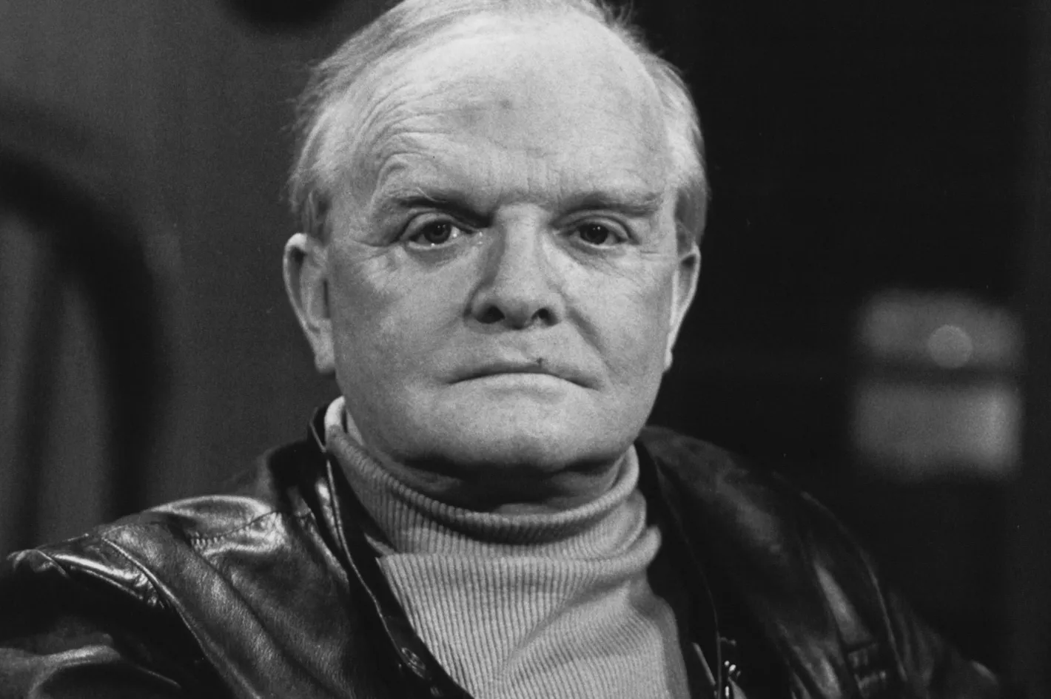

The White Rose, Truman Capote

THE WHITE ROSE

A silvery June afternoon. A June afternoon in Paris twenty-three years ago. And I am standing in the courtyard of the Palais Royal scanning its tall windows and wondering which of them belong to the apartment of Colette, the Grande Mademoiselle of French letters. And I keep consulting my watch, for at four o’clock I have an appointment with this legendary artist, an invitation to tea obligingly obtained for me by Jean Cocteau after I had told him, with youthful maladroitness, that Colette was the only living French writer I entirely respected—and that included Gide, Genet, Camus and Montherlant, not to mention M. Cocteau.

Certainly, without the generous intervention of the latter, I would never have been invited to meet the great woman, for I was merely a young American writer who had published a single book, Other Voices, Other Rooms, of which she had never heard at all.

Now it was four o’clock and I hastened to present myself, for I’d been told not to be late, and not to stay long, as my hostess was an elderly partial invalid who seldom left her bed.

She received me in her bedroom. I was astonished. Because she looked precisely as Colette ought to have looked. And that was astonishing indeed. Reddish, frizzly, rather African-looking hair; slanting, alley-cat eyes rimmed with kohl; a finely made face flexible as water … rouged cheeks … lips thin and tense as wire but painted a really brazen hussy scarlet.

And the room reflected the cloistered luxury of her worldlier work—say, Chéri and La fin de Chéri. Velvet curtains were drawn against the June light. One was aware of silken walls. Of warm, rosy light filtering out of lamps draped with pale, rosy scarves. A perfume—some combination of roses and oranges and limes and musk—hovered in the air like a mist, a haze.

So there she lay, propped up by layers of lace-edged pillows, her eyes liquid with life, with kindness, with malice. A cat of peculiar gray was stretched across her legs, rather like an additional comforter.

But the most stunning display in the room was neither the cat nor its mistress. Shyness, nerves, I don’t know what it was, but after the first quick study I couldn’t really look at Colette, and was somewhat tongue-tied to boot. Instead, I concentrated on what seemed to me a magical exhibition, some fragment of a dream. It was a collection of antique crystal paperweights.

There were perhaps a hundred of them covering two tables situated on either side of the bed: crystal spheres imprisoning green lizards, salamanders, millefiori bouquets, dragonflies, a basket of pears, butterflies alighted on a frond of fern, swirls of pink and white and blue and white, shimmering like fireworks, cobras coiled to strike, pretty little arrangements of pansies, magnificent poinsettias.

At last Madame Colette said, “Ah, I see my snowflakes interest you?”

Yes, I knew what she meant: these objects were rather like permanent snowflakes, dazzling patterns frozen forever. “Yes,” I said. “Beautiful. Beautiful. But what are they?”

She explained that they were the utmost refinement of the crystal-maker’s art: glass jewels contrived by the premier craftsmen of the greatest French crystal factories—Baccarat and St. Louis and Clichy. Selecting at random one of the weights, a big beauty exploding with thousand-flower colors, she showed where the date of creation, 1842, was concealed inside one of the tiny buds. “All the finest weights,” she told me, “were made between 1840 and 1880. After that the whole art disintegrated.

I started collecting them about forty years ago. They were out of fashion then and one could find great prizes in the flea market and pay very little for them. Now, of course, a first-class weight costs the earth. There are hundreds of collectors, and all in all only perhaps three or four thousand weights in existence worth a glance. This one, for instance.” She handed me a piece of crystal about the size of a baseball. “It’s a Baccarat weight. It’s called the White Rose.”

It was a faceted weight of marvelous, bubble-free purity with a single decoration: a simple white rose with green leaves sunk dead-center.

“What does it remind you of? What thoughts run through your mind?” Madame Colette asked me.

“I don’t know. I like the way it feels. Cool and peaceful.”

“Peaceful. Yes, that’s very true. I’ve often thought I would like to carry them with me in my coffin, like a pharaoh. But what images occur to you?”

I turned the weight this way and that in the dim, rosy light. “Young girls in their communion dresses.”

She smiled. “Very charming. Very apt. Now I can see what Jean told me is true. He said. ‘Don’t be fooled, my dear. He looks like a ten-year-old angel. But he’s ageless, and has a very wicked mind.’ ”

But not as wicked as my hostess, who tapped the weight in my hand and said, “Now I want you to keep that. As a souvenir.”

By so doing she arranged for a financially ruinous destiny, for from that moment I became a “collector,” and over the years have done arduous duty searching out fine French weights everywhere, from the opulent salesrooms at Sotheby’s to obscure antiquaries in Copenhagen and Hong Kong. It is an expensive pastime (currently the cost of these objets, depending on quality and rarity, runs between $600 and $15,000), and in all the while that I have pursued it I have found only two bargains, but these both were staggering coups and more than compensated for many cruel disappointments.

The first was in a huge and dusty junkshop in Brooklyn. I was looking at a bunch of odds and bits in a dark glass cabinet when I saw a St. Louis flower weight with a tomato-colored porcelain overlay. When I sought out the proprietor and asked him about it, it was obvious he had no idea of what it was or what it was worth, which was about $4,000. He sold it to me for $20, and I did feel slightly crooked, but what the hell, it was the first and last time I ever got the best of a dealer.

My second great coup was at an auction in East Hampton on Long Island. I just happened to wander into it, not expecting much, and indeed it was mostly bad paintings and indifferent furniture culled from an old Long Island sea house. But suddenly, just sitting there amid a lot of pottery and boring plates was an electrifying spectacle: an absolutely spectacular millefiori weight made in the form of an inkwell.

I knew it was the real thing, and by searching carefully I found the date, 1840, and signature of the maker, J.C., deep inside the lower bouquet. It was about eleven o’clock in the morning when I made this discovery, and the inkwell did not appear on the auctioneer’s podium until three that afternoon. While waiting, I walked around in a daze of anxiety, wondering if the auctioneer or any of his customers had any notion of the inkwell’s rarity and value, which was enough to finance a pair of Siamese twins through college. If all this sounds rather unattractive, and I suppose it does, I can only say that that’s what collecting does to you.

Anyway, the auctioneer opened the bidding on the inkwell-weight at $25, so I knew right away he didn’t know what he was selling; the question was, did anyone in the audience? There were perhaps three hundred people there, a great many of them with very sophisticated eyes. As it turned out, there was one who had an inkling: a young dealer from New York who had come to bid on furniture and knew very little about paperweights, but was shrewd enough to realize this was something special.

When we reached $300 the others in the auditorium began to whisper and stare; they couldn’t fathom what it was that made this hunk of glass worth that kind of money. When we arrived at $600 the auctioneer was fairly excited himself, and my rival was sweating; he was having second thoughts, he wasn’t really sure. In a faltering voice he bid $650 and I said $700, and that finished him. Afterward he came over and asked if I thought it worth $700, and I said, “No, seven thousand.”

Some people, when traveling, carry with them photographs of friends and family, of loves; I do, too. But I also take along a small black bag that will hold six weights, each wrapped in flannel, for the weights, despite their seeming solidity, are quite fragile, and also, like a crowd of quarrelsome siblings, inimical; one of the easiest ways to chip or shatter a weight is to have it collide with another.

So why do I cart them around on, say, a two-day trip to Chicago or Los Angeles? Because, when spread about, they can for me make the most sinisterly anonymous hotel room seem warm and personal and secure. And because, when it’s a quarter to two and sleep hasn’t come, a restfulness arises from contemplating a quiet white rose until the rose expands into the whiteness of sleep.

Occasionally I have given a weight as a gift to some very particular friend, and always it is from among those I treasure most, for as Colette said that long-ago afternoon, when I protested that I couldn’t accept as a present something she so clearly adored, “My dear, really there is no point in giving a gift unless one also treasures it oneself.”

1970

The end